A Characterization of the Australian Financial Assistance Grants System

Sreehari Pulickamadhom Sreedhar

Euan Maclean

2025-09-11

Table of contents

# Preface

This is a repository - a knowledge base if you will, of the Financial Assistance Grants system to Local Government Councils.

In the first section of the book, we explore the different methods employed by state grants commissions to determine the quantum of the grant allocaiton.

The second section then explores issues commonly reported by councils. We also explore debates surrounding optimal grant allocation strategies.

# 1. Abstract

# 2. An introduction to the FA Grants System

## 2.1 Executive Summary

Local Government is a key provider of services to communities around Australia. Across 538 local governments, $424 Billion worth of community infrastructure is serviced and maintained by councils.

The Australian Local Government Association (ALGA) is the peak body for councils at the federal level. ALGA represents councils and their interests to the Commonwealth, advocating for greater support for the local government space.

The last fifteen years have seen a period of declining intergovernmental support for local governments. The Commonwealth Government has slashed financial assistance grants, an essential part of local government funding, and state governments have sought to undermine councils through arbitrary caps on revenue sources and cost shifting.

Despite this declining support, local governments maintain their position as an important part of providing services to communities. Whether that be supporting communities in the face of bushfires, or planning our cities to house future generations, local governments are a key piece of the puzzle.

This paper seeks to evaluate one critical aspect of the debate surrounding grants issued by the Commonwealth Government to councils - the minimum grant allocation requirement.

In order to answer this question, this paper will model the impacts of a change to the minimum grant allocation and its impacts on councils. Our analysis will examine the modelled changes, ascertaining what types of councils are most impacted and performing a qualitative assessment of those impacts.

## 2.2 An introduction to FA Grants

Financial Assistance Grants (FA Grants) are a funding mechanism used by the Commonwealth government to distribute funding to Australia’s 538 local councils. Every year, the federal government allocates a pull of money to be distributed to councils nation wide. FA Grants are untied, meaning that councils spend money from the FA Grant program autonomously.

FA Grants are essential to local government, providing critical funding that supports the delivery of community services, infrastructure, and local development projects. Without these grants, many councils - particularly those in regional and rural areas - would struggle to maintain the service levels expected by their communities.

## 2.3 Allocation of FA Grants

FA Grants are allocated according to the “Local Government (Financial Assistance) Act” (1995). The FA Grant distribution process consists of three components: a local road network component; a general purpose component; and a per capita minimum grant component. This final component requires every council to be given at least 30% of what their grant would be if distributed on a purely per capita basis.

Whilst the Commonwealth is responsible for providing FA Grants, it is state government appointed grant commissions which decide how FA Grant money will be distributed, and the more intricate details of the general purpose and roads components. This means councils are assessed differently depending on their state jurisdiction.

The federal government directs states to allocate FA grants based on two principles: horizontal equilisation and effort neutrality. Horizontal equilisation refers to allocating funds in a way that takes into consideration the differing revenue raising capacities of councils, and effort neutrality directs grant commissions not to punish councils for political or accounting decisions.

## 2.4 FA Grants as they stand today

Funding for the FA grant program has evolved since its initial introduction, and the program has not kept up with the expanding role that local councils play. Over the past 30 years, FA grants have been cut from equaling 1% of Commonwealth taxation revenue in 1996, to the present day, where they are worth 0.5% of Commonwealth taxation revenue.

This decline in real value has been due to a number of factors; including the pausing of the program’s indexing between 2014 and 2017.

The requirement for each council to receive at least 30% of a per capita equivelant grant program is controversial with our members (Australia’s 538 local governments). Regional and rural councils see it as a way to funnel money towards urban and peri-urban councils, even though they are not as financially reliant on FA grants as their regional and rural counterparts. This is an understandable perspective, given inner city councils often run in surplus, with a wide range of revenue streams due to high economic activity and a more dense populus.

ALGA holds a long standing view that a more practical way to achieve greater financial sustainability for councils is to increase the size of the pie rather than how it is sliced. This is reflected in ALGA’s call for a return to FA Grants being equal to 1% of Commonwealth taxation revenue.

ALGA has also long suspected that the removal of the 30% minimum allocation would not necessarily benefit the councils most in need, and would likely serve in detriment of those in growth areas.

## 2.5 Moving Forward

In this report, we break from this view to consider the impacts of a change to the minimum allocation. We achieve this through modelling the per capita gains and losses of a shift from 30%, considering a set of lower minimum alternatives; and the removal of a minimum allocation in its entirety.

The goal of this analysis is to provide insights into what type of change to the distribution process would optimise the financial sustainability of local governments.

# 3. Historical Context

Financial Assistance Grants were originally introduced by the Whitlam government, to allow general purpose grants to councils that were untied.

This sytem of general purpose grants was legislated in 1986, before its final form was reached in 1995 under the Keating government. Since then, the principles and methods for allocating FA grants have not changed.

During the Abbott Government, and for parts of the Turnbull Government, between 2014-2017, FA grant indexing was paused. This resulted in a real decline in money for councils.

Since the program’s inception, the federal government has provided over $74 billion of untied funding. This funding has gone towards the critical work that local councils do to provide livable, sustainable communities and essential services across Australia.

# 4. Jurisdictions and Methodologies

30% of the General Purpose Component grant is allocated on a per capita basis.

## 4.1 At the Federal Level

**General Purpose Component** - Allocation to states on a per capital basis **Roads Component** - Allocation to states based on fixed ratios:

| State | Roads Component % |
| --- | --- |
| New South Wales | 29.0% |
| Victoria | 20.6% |
| Queensland | 18.7% |
| South Australia | 5.5% |
| Western Australia | 15.3% |
| Tasmania | 5.3% |
| Northern Territory | 2.3% |
| Australian Capital Territory | 3.2% |

## 4.2 New South Wales

Consult [Local Government National Report](https://www.infrastructure.gov.au/territories-regions-cities/local-government/publications/national-reports) for a high level overview of methodology.

## 4.3 Victoria

* <https://www.localgovernment.vic.gov.au/funding-programs/victoria-grants-commission/financial-assistance-grants>
* <https://www.localgovernment.vic.gov.au/funding-programs/victoria-grants-commission/publications>
* <https://www.localgovernment.vic.gov.au/__data/assets/pdf_file/0019/210727/2024-25-VLGGC-Annual-Allocation-Report-Sept-2024.pdf>

## 4.4 Queensland

* <https://www.localgovernment.qld.gov.au/for-councils/governance/queensland-local-government-grants-commission/financial-assistance-grant>
* <https://www.localgovernment.qld.gov.au/__data/assets/pdf_file/0030/99174/commission-report-2024.pdf>

Population > 80,000 $→$ Minimum grant council

## 4.5 South Australia

* <https://dit.sa.gov.au/local-government/grants-commission/methodology-review>
* [https://www.dit.sa.gov.au/local-government/grants-commission/general-purpose-grants](https://dit.sa.gov.au/local-government/grants-commission/methodology-review)
* [https://www.dit.sa.gov.au/local-government/documents/office-of-local-government/grants-commission/general_purpose_grants-adelaide-holdfast_bay.pdf](https://dit.sa.gov.au/local-government/grants-commission/methodology-review)
* [https://www.dit.sa.gov.au/local-government/grants-commission/publications](https://dit.sa.gov.au/local-government/grants-commission/methodology-review)
* [https://www.dit.sa.gov.au/__data/assets/pdf_file/0008/1275470/Database-Reports-2021-22.pdf](https://dit.sa.gov.au/local-government/grants-commission/methodology-review)

## 4.6 Western Australia

* <https://www.dlgsc.wa.gov.au/local-government/local-governments/financial-assistance-grants>

## 4.7 Tasmania

* <https://www.treasury.tas.gov.au/state-grants-commission/publications>
* <https://www.treasury.tas.gov.au/Documents/State%20Grants%20Commission%20Annual%20Report%202023-24.pdf>
* <https://www.treasury.tas.gov.au/Documents/State%20Grants%20Commission%202024-25%20Financial%20Assistance%20Grant%20Data%20Tables.pdf>

## 4.8 Northern Territory

* [https://dhlgcd.nt.gov.au/funding-and-support/grants-commission/methodology](https://www.treasury.tas.gov.au/Documents/State%20Grants%20Commission%202024-25%20Financial%20Assistance%20Grant%20Data%20Tables.pdf)
* Consult [Territory Stories](https://territorystories.nt.gov.au/10070/988490) for a lower level exploration.

The 2023-24 allocation data tables can used since the NT Grants Commission annual report is not out yet.

# 5. Discussed Issues

This is the content for # Discussed Issues.

# 6. A look at different scenarios - Gains and Losses

## 6.1 A 20% Per Capita Minimum Grant

### 6.1.1 New South Wales

|  |  |  | Expected Change in GPG ($) | Expected Change in GPG Per Capita ($) | Population |
| --- | --- | --- | --- | --- | --- |
| Jurisdiction | ACLG | Year |  |  |  |
| New South Wales | RAL | 2025 | 558839.5 | 76.1 | 163742.0 |
| 2026 | 580321.8 | 78.5 | 164894.0 |
| 2027 | 601572.1 | 80.8 | 165966.0 |
| 2028 | 623151.5 | 83.1 | 167079.0 |
| RAM | 2025 | 524289.7 | 166.0 | 42204.0 |
| 2026 | 544799.7 | 171.3 | 42501.0 |
| 2027 | 565064.6 | 176.5 | 42776.0 |
| 2028 | 585616.7 | 181.7 | 43063.0 |
| RAS | 2025 | 726324.0 | 505.8 | 1436.0 |
| 2026 | 752173.7 | 520.2 | 1446.0 |
| 2027 | 781749.4 | 537.3 | 1455.0 |
| 2028 | 810088.6 | 553.0 | 1465.0 |
| RAV | 2025 | 564304.4 | 39.1 | 279964.0 |
| 2026 | 585428.5 | 40.3 | 281932.0 |
| 2027 | 608617.9 | 41.6 | 283771.0 |
| 2028 | 630929.8 | 42.8 | 285675.0 |
| RTL | 2025 | 828164.1 | 199.6 | 4150.0 |
| 2026 | 858960.9 | 205.5 | 4179.0 |
| 2027 | 887476.9 | 211.0 | 4206.0 |
| 2028 | 922655.2 | 217.9 | 4235.0 |
| RTM | 2025 | 921292.7 | 515.3 | 1788.0 |
| 2026 | 950500.5 | 527.8 | 1801.0 |
| 2027 | 987852.3 | 545.2 | 1812.0 |
| 2028 | 1031463.7 | 565.5 | 1824.0 |
| RTX | 2025 | 38523.5 | 112.9 | 586.0 |
| 2026 | 39965.3 | 116.5 | 589.0 |
| 2027 | 41375.6 | 119.8 | 593.0 |
| 2028 | 42996.4 | 123.6 | 597.0 |
| UCC | 2025 | -2082509.3 | -8.7 | 240565.0 |
| 2026 | -2164906.0 | -8.9 | 243927.0 |
| 2027 | -2248760.1 | -9.1 | 247111.0 |
| 2028 | -2334804.7 | -9.3 | 250350.0 |
| UDL | 2025 | -711911.5 | -8.7 | 325512.0 |
| 2026 | -740081.1 | -8.9 | 330062.0 |
| 2027 | -768746.2 | -9.1 | 334370.0 |
| 2028 | -798161.6 | -9.3 | 338753.0 |
| UDM | 2025 | -393809.0 | -8.4 | 224445.0 |
| 2026 | -409439.4 | -8.6 | 227581.0 |
| 2027 | -425309.1 | -8.8 | 230552.0 |
| 2028 | -441619.0 | -9.1 | 233576.0 |
| UDS | 2025 | -114141.4 | -7.8 | 14612.0 |
| 2026 | -118748.1 | -8.0 | 14816.0 |
| 2027 | -123413.9 | -8.2 | 15009.0 |
| 2028 | -128146.1 | -8.4 | 15206.0 |
| UDV | 2025 | -2218240.9 | -8.2 | 3346629.0 |
| 2026 | -2306393.9 | -8.4 | 3393400.0 |
| 2027 | -2396312.3 | -8.7 | 3437693.0 |
| 2028 | -2488009.4 | -8.9 | 3482759.0 |
| UFL | 2025 | -638714.8 | -3.9 | 222005.0 |
| 2026 | -664739.1 | -4.0 | 225107.0 |
| 2027 | -690320.2 | -4.1 | 228046.0 |
| 2028 | -717821.3 | -4.2 | 231034.0 |
| UFM | 2025 | -372636.7 | -5.6 | 130931.0 |
| 2026 | -388157.6 | -5.8 | 132761.0 |
| 2027 | -404232.4 | -5.9 | 134493.0 |
| 2028 | -420005.0 | -6.1 | 136257.0 |
| UFV | 2025 | -1201471.8 | -5.5 | 1169304.0 |
| 2026 | -1252872.6 | -5.6 | 1185647.0 |
| 2027 | -1304130.0 | -5.8 | 1201123.0 |
| 2028 | -1357894.3 | -5.9 | 1216868.0 |
| URL | 2025 | 151228.8 | 1.4 | 743177.0 |
| 2026 | 158557.3 | 1.5 | 748407.0 |
| 2027 | 167755.2 | 1.5 | 753281.0 |
| 2028 | 177643.9 | 1.6 | 758331.0 |
| URM | 2025 | 273608.4 | 5.5 | 861014.0 |
| 2026 | 286127.9 | 5.7 | 867072.0 |
| 2027 | 297836.6 | 5.9 | 872716.0 |
| 2028 | 310461.4 | 6.1 | 878571.0 |
| URS | 2025 | 457561.2 | 19.1 | 220852.0 |
| 2026 | 476929.1 | 19.8 | 222407.0 |
| 2027 | 494479.5 | 20.4 | 223855.0 |
| 2028 | 514305.7 | 21.0 | 225356.0 |
| URV | 2025 | -150880.5 | -0.8 | 623489.0 |
| 2026 | -148692.9 | -0.8 | 627874.0 |
| 2027 | -145830.1 | -0.8 | 631965.0 |
| 2028 | -143691.6 | -0.7 | 636202.0 |

### 6.1.2 Victoria

|  |  |  | Expected Change in GPG ($) | Expected Change in GPG Per Capita ($) | Population |
| --- | --- | --- | --- | --- | --- |
| Jurisdiction | ACLG | Year |  |  |  |
| Victoria | RAL | 2025 | 424492.2 | 60.4 | 50462.0 |
| 2026 | 442319.2 | 62.5 | 50851.0 |
| 2027 | 461017.8 | 64.6 | 51217.0 |
| 2028 | 480081.7 | 66.8 | 51602.0 |
| RAM | 2025 | 473788.8 | 121.0 | 3917.0 |
| 2026 | 492849.5 | 124.9 | 3947.0 |
| 2027 | 513640.2 | 129.2 | 3976.0 |
| 2028 | 534970.5 | 133.6 | 4005.0 |
| RAV | 2025 | 407456.8 | 26.4 | 246987.0 |
| 2026 | 425808.7 | 27.3 | 248887.0 |
| 2027 | 444558.3 | 28.3 | 250677.0 |
| 2028 | 464080.7 | 29.3 | 252562.0 |
| UCC | 2025 | -1622527.7 | -8.6 | 187853.0 |
| 2026 | -1693812.6 | -8.9 | 191227.0 |
| 2027 | -1765786.3 | -9.1 | 194377.0 |
| 2028 | -1839477.0 | -9.3 | 197569.0 |
| UDL | 2025 | -838333.4 | -7.6 | 768272.0 |
| 2026 | -875212.1 | -7.8 | 782068.0 |
| 2027 | -912774.2 | -8.0 | 794951.0 |
| 2028 | -950749.4 | -8.2 | 808003.0 |
| UDV | 2025 | -1005794.3 | -5.5 | 2812934.0 |
| 2026 | -1052022.3 | -5.6 | 2863449.0 |
| 2027 | -1099803.9 | -5.8 | 2910621.0 |
| 2028 | -1145979.3 | -5.9 | 2958411.0 |
| UFL | 2025 | 288754.4 | 2.1 | 134444.0 |
| 2026 | 291199.8 | 2.1 | 136858.0 |
| 2027 | 295878.8 | 2.1 | 139113.0 |
| 2028 | 304354.2 | 2.2 | 141397.0 |
| UFM | 2025 | -6545.5 | 1.1 | 148680.0 |
| 2026 | -7619.3 | 1.2 | 150511.0 |
| 2027 | -9124.2 | 1.2 | 152228.0 |
| 2028 | -7872.6 | 1.4 | 153989.0 |
| UFS | 2025 | 310776.8 | 12.8 | 28938.0 |
| 2026 | 324352.1 | 13.3 | 29161.0 |
| 2027 | 338709.0 | 13.8 | 29370.0 |
| 2028 | 350510.6 | 14.2 | 29591.0 |
| UFV | 2025 | -133870.1 | -0.6 | 1447465.0 |
| 2026 | -143229.7 | -0.6 | 1473457.0 |
| 2027 | -153072.1 | -0.7 | 1497731.0 |
| 2028 | -166450.9 | -0.7 | 1522322.0 |
| URL | 2025 | 837821.1 | 7.8 | 319161.0 |
| 2026 | 877590.1 | 8.1 | 321614.0 |
| 2027 | 920356.4 | 8.5 | 323931.0 |
| 2028 | 962072.0 | 8.8 | 326365.0 |
| URM | 2025 | 685880.7 | 13.4 | 548093.0 |
| 2026 | 716914.1 | 13.8 | 552880.0 |
| 2027 | 747384.9 | 14.3 | 557392.0 |
| 2028 | 778853.0 | 14.8 | 562097.0 |
| URS | 2025 | 574892.0 | 20.9 | 134536.0 |
| 2026 | 600852.8 | 21.7 | 135570.0 |
| 2027 | 629336.6 | 22.6 | 136545.0 |
| 2028 | 654656.0 | 23.3 | 137571.0 |
| URV | 2025 | 305145.0 | 1.1 | 281658.0 |
| 2026 | 337138.6 | 1.2 | 283823.0 |
| 2027 | 360863.6 | 1.3 | 285868.0 |
| 2028 | 383581.0 | 1.3 | 288015.0 |

### 6.1.3 Queensland

|  |  |  | Expected Change in GPG ($) | Expected Change in GPG Per Capita ($) | Population |
| --- | --- | --- | --- | --- | --- |
| Jurisdiction | ACLG | Year |  |  |  |
| Queensland | RAM | 2025 | 1356134.8 | 301.9 | 4492.0 |
| 2026 | 1404182.4 | 308.7 | 4548.0 |
| 2027 | 1463763.3 | 318.1 | 4601.0 |
| 2028 | 1519110.3 | 326.4 | 4654.0 |
| RAV | 2025 | 833876.1 | 62.6 | 105395.0 |
| 2026 | 870121.4 | 64.5 | 106725.0 |
| 2027 | 903062.7 | 66.2 | 107956.0 |
| 2028 | 939058.3 | 68.0 | 109216.0 |
| RTL | 2025 | 1160340.1 | 219.7 | 47507.0 |
| 2026 | 1207226.7 | 225.7 | 48105.0 |
| 2027 | 1253568.1 | 231.6 | 48660.0 |
| 2028 | 1302204.0 | 237.6 | 49227.0 |
| RTM | 2025 | 852297.1 | 477.7 | 25129.0 |
| 2026 | 886897.6 | 491.1 | 25444.0 |
| 2027 | 922030.5 | 504.6 | 25737.0 |
| 2028 | 957231.9 | 517.9 | 26041.0 |
| RTS | 2025 | 841916.8 | 1109.3 | 6210.0 |
| 2026 | 875996.4 | 1139.6 | 6288.0 |
| 2027 | 911450.9 | 1172.1 | 6361.0 |
| 2028 | 946434.7 | 1203.2 | 6435.0 |
| RTX | 2025 | 837035.6 | 2369.6 | 2483.0 |
| 2026 | 871305.6 | 2436.9 | 2514.0 |
| 2027 | 905619.6 | 2505.9 | 2542.0 |
| 2028 | 939995.4 | 2571.5 | 2572.0 |
| UCC | 2025 | -12019933.1 | -8.6 | 1391417.0 |
| 2026 | -12536627.4 | -8.9 | 1414593.0 |
| 2027 | -13047239.9 | -9.1 | 1435417.0 |
| 2028 | -13569107.2 | -9.3 | 1456730.0 |
| UFM | 2025 | -353126.0 | -7.7 | 90901.0 |
| 2026 | -367805.1 | -7.9 | 92240.0 |
| 2027 | -382330.9 | -8.1 | 93458.0 |
| 2028 | -397264.8 | -8.3 | 94706.0 |
| UFS | 2025 | -161491.8 | -5.9 | 27605.0 |
| 2026 | -168547.9 | -6.0 | 28065.0 |
| 2027 | -175643.4 | -6.2 | 28478.0 |
| 2028 | -182744.3 | -6.3 | 28901.0 |
| URL | 2025 | -988898.6 | -8.6 | 448150.0 |
| 2026 | -1027295.6 | -8.9 | 453798.0 |
| 2027 | -1065786.1 | -9.1 | 459035.0 |
| 2028 | -1104964.1 | -9.3 | 464400.0 |
| URM | 2025 | -260667.4 | -4.6 | 384185.0 |
| 2026 | -270202.1 | -4.7 | 389027.0 |
| 2027 | -279932.2 | -4.8 | 393517.0 |
| 2028 | -289465.2 | -5.0 | 398116.0 |
| URS | 2025 | 255610.6 | 10.4 | 137412.0 |
| 2026 | 267424.8 | 10.8 | 139143.0 |
| 2027 | 278332.8 | 11.1 | 140751.0 |
| 2028 | 288100.5 | 11.3 | 142395.0 |
| URV | 2025 | -3649633.3 | -8.6 | 3017517.0 |
| 2026 | -3797448.6 | -8.9 | 3061112.0 |
| 2027 | -3944761.0 | -9.1 | 3100885.0 |
| 2028 | -4094976.7 | -9.3 | 3141604.0 |

### 6.1.4 South Australia

|  |  |  | Expected Change in GPG ($) | Expected Change in GPG Per Capita ($) | Population |
| --- | --- | --- | --- | --- | --- |
| Jurisdiction | ACLG | Year |  |  |  |
| South Australia | RAL | 2025 | 212365.0 | 25.0 | 83192.0 |
| 2026 | 219396.4 | 25.8 | 83414.0 |
| 2027 | 226739.6 | 26.6 | 83495.0 |
| 2028 | 234562.6 | 27.5 | 83617.0 |
| RAM | 2025 | 162894.1 | 45.3 | 32607.0 |
| 2026 | 168270.6 | 46.7 | 32694.0 |
| 2027 | 173834.4 | 48.2 | 32725.0 |
| 2028 | 179011.5 | 49.5 | 32774.0 |
| RAS | 2025 | 134364.6 | 103.9 | 13135.0 |
| 2026 | 138713.8 | 107.1 | 13167.0 |
| 2027 | 143420.0 | 110.6 | 13181.0 |
| 2028 | 148067.9 | 114.0 | 13200.0 |
| RAV | 2025 | 291646.7 | 20.7 | 96502.0 |
| 2026 | 302093.7 | 21.4 | 96759.0 |
| 2027 | 312503.2 | 22.1 | 96852.0 |
| 2028 | 324415.8 | 22.9 | 96994.0 |
| RSG | 2025 | -38900.3 | -6.4 | 6063.0 |
| 2026 | -39847.5 | -6.6 | 6079.0 |
| 2027 | -40783.9 | -6.7 | 6085.0 |
| 2028 | -41777.7 | -6.9 | 6094.0 |
| UCC | 2025 | -250849.5 | -8.7 | 28908.0 |
| 2026 | -259447.9 | -8.9 | 29173.0 |
| 2027 | -268100.8 | -9.1 | 29410.0 |
| 2028 | -277072.5 | -9.3 | 29654.0 |
| UDL | 2025 | -974991.1 | -8.4 | 341513.0 |
| 2026 | -1008276.2 | -8.6 | 344642.0 |
| 2027 | -1041976.6 | -8.9 | 347449.0 |
| 2028 | -1076810.5 | -9.1 | 350326.0 |
| UDM | 2025 | -450446.0 | -8.6 | 349998.5 |
| 2026 | -465910.0 | -8.8 | 353205.0 |
| 2027 | -481442.5 | -9.0 | 356081.5 |
| 2028 | -497482.4 | -9.2 | 359030.0 |
| UDS | 2025 | -172712.9 | -8.7 | 32696.0 |
| 2026 | -178634.9 | -8.9 | 32996.0 |
| 2027 | -184595.9 | -9.1 | 33265.0 |
| 2028 | -190770.8 | -9.3 | 33540.0 |
| UDV | 2025 | -800878.7 | -5.5 | 298185.0 |
| 2026 | -829321.2 | -5.6 | 300917.0 |
| 2027 | -859995.8 | -5.8 | 303368.0 |
| 2028 | -890304.4 | -5.9 | 305880.0 |
| UFL | 2025 | 957825.3 | 8.6 | 110933.0 |
| 2026 | 990201.9 | 8.8 | 111949.0 |
| 2027 | 1012680.9 | 9.0 | 112861.0 |
| 2028 | 1042917.5 | 9.2 | 113796.0 |
| UFM | 2025 | -376187.4 | -8.7 | 43352.0 |
| 2026 | -389078.5 | -8.9 | 43749.0 |
| 2027 | -402069.2 | -9.1 | 44106.0 |
| 2028 | -415515.3 | -9.3 | 44471.0 |
| UFS | 2025 | 23487.6 | 1.0 | 56246.0 |
| 2026 | 25039.2 | 1.0 | 56397.0 |
| 2027 | 27676.5 | 1.1 | 56451.0 |
| 2028 | 29237.1 | 1.2 | 56533.0 |
| UFV | 2025 | -909544.5 | -4.9 | 187392.0 |
| 2026 | -939387.5 | -5.0 | 189109.0 |
| 2027 | -971142.4 | -5.1 | 190650.0 |
| 2028 | -1009807.1 | -5.3 | 192228.0 |
| URM | 2025 | -236594.1 | -5.4 | 43823.0 |
| 2026 | -245491.0 | -5.6 | 44225.0 |
| 2027 | -253250.5 | -5.7 | 44585.0 |
| 2028 | -262378.4 | -5.8 | 44954.0 |
| URS | 2025 | 273826.0 | 14.4 | 123858.0 |
| 2026 | 283808.0 | 14.9 | 124190.0 |
| 2027 | 294825.0 | 15.4 | 124310.0 |
| 2028 | 305642.3 | 16.0 | 124490.0 |

### 6.1.5 Western Australia

|  |  |  | Expected Change in GPG ($) | Expected Change in GPG Per Capita ($) | Population |
| --- | --- | --- | --- | --- | --- |
| Jurisdiction | ACLG | Year |  |  |  |
| Western Australia | RAL | 2025 | 200070.5 | 28.8 | 62427.0 |
| 2026 | 209422.8 | 29.9 | 62882.0 |
| 2027 | 218231.0 | 31.0 | 63189.0 |
| 2028 | 228028.9 | 32.2 | 63540.0 |
| RAM | 2025 | 110843.9 | 28.0 | 46971.5 |
| 2026 | 116453.3 | 29.1 | 47314.5 |
| 2027 | 121598.5 | 30.2 | 47546.0 |
| 2028 | 126694.6 | 31.3 | 47809.5 |
| RAS | 2025 | 155088.7 | 157.6 | 51936.0 |
| 2026 | 161941.7 | 163.4 | 52313.0 |
| 2027 | 168539.0 | 169.2 | 52567.0 |
| 2028 | 175201.8 | 174.9 | 52862.0 |
| RAV | 2025 | 202569.4 | 14.5 | 48518.0 |
| 2026 | 210888.4 | 15.0 | 49107.0 |
| 2027 | 219810.6 | 15.5 | 49587.0 |
| 2028 | 228770.4 | 16.0 | 50097.0 |
| RSG | 2025 | -91509.9 | -4.8 | 19197.0 |
| 2026 | -93647.4 | -4.8 | 19338.0 |
| 2027 | -95891.0 | -4.9 | 19432.0 |
| 2028 | -98421.6 | -5.0 | 19540.0 |
| RTL | 2025 | 206431.2 | 28.0 | 81242.0 |
| 2026 | 216238.3 | 29.0 | 81835.0 |
| 2027 | 225803.3 | 30.1 | 82236.0 |
| 2028 | 236048.6 | 31.2 | 82691.0 |
| RTM | 2025 | 274071.5 | 158.9 | 9702.0 |
| 2026 | 286505.5 | 164.9 | 9773.0 |
| 2027 | 298381.9 | 171.0 | 9821.0 |
| 2028 | 309959.6 | 176.7 | 9875.0 |
| RTS | 2025 | 241880.6 | 323.3 | 3789.0 |
| 2026 | 252222.4 | 335.1 | 3816.0 |
| 2027 | 262432.8 | 347.2 | 3835.0 |
| 2028 | 272461.6 | 358.8 | 3856.0 |
| RTX | 2025 | 365354.7 | 1852.6 | 1042.0 |
| 2026 | 381336.9 | 1918.1 | 1050.0 |
| 2027 | 397489.7 | 1985.6 | 1056.0 |
| 2028 | 413026.5 | 2053.5 | 1061.0 |
| UCC | 2025 | -299424.0 | -8.6 | 34722.0 |
| 2026 | -313151.1 | -8.9 | 35363.0 |
| 2027 | -326483.4 | -9.1 | 35935.0 |
| 2028 | -340066.3 | -9.3 | 36524.0 |
| UDL | 2025 | -1056293.1 | -8.6 | 363953.0 |
| 2026 | -1104736.8 | -8.9 | 370678.0 |
| 2027 | -1151759.5 | -9.1 | 376670.0 |
| 2028 | -1199674.0 | -9.3 | 382843.0 |
| UDM | 2025 | -476927.9 | -8.6 | 256691.0 |
| 2026 | -498798.0 | -8.9 | 261433.0 |
| 2027 | -520030.9 | -9.1 | 265659.0 |
| 2028 | -541663.0 | -9.3 | 270012.0 |
| UDS | 2025 | -222418.4 | -8.6 | 181800.0 |
| 2026 | -232622.8 | -8.9 | 185158.0 |
| 2027 | -242521.2 | -9.1 | 188152.0 |
| 2028 | -252608.7 | -9.3 | 191235.0 |
| UDV | 2025 | -1698195.1 | -8.1 | 582162.0 |
| 2026 | -1775773.4 | -8.3 | 592916.0 |
| 2027 | -1851318.3 | -8.5 | 602504.0 |
| 2028 | -1928434.1 | -8.8 | 612375.0 |
| UFL | 2025 | -904679.2 | -8.6 | 104909.0 |
| 2026 | -946165.5 | -8.9 | 106847.0 |
| 2027 | -986436.7 | -9.1 | 108574.0 |
| 2028 | -1027470.7 | -9.3 | 110353.0 |
| UFM | 2025 | -424214.3 | -5.5 | 276123.0 |
| 2026 | -444636.7 | -5.7 | 281226.0 |
| 2027 | -463586.4 | -5.8 | 285771.0 |
| 2028 | -483704.7 | -6.0 | 290455.0 |
| UFS | 2025 | -81437.2 | -2.1 | 38825.0 |
| 2026 | -86222.1 | -2.2 | 39542.0 |
| 2027 | -90623.8 | -2.3 | 40182.0 |
| 2028 | -95598.6 | -2.3 | 40840.0 |
| UFV | 2025 | -1642693.8 | -8.1 | 581068.0 |
| 2026 | -1718132.0 | -8.3 | 591803.0 |
| 2027 | -1791702.7 | -8.5 | 601371.0 |
| 2028 | -1866354.4 | -8.7 | 611225.0 |
| URM | 2025 | -20530.8 | -0.6 | 194970.0 |
| 2026 | -18910.6 | -0.5 | 196393.0 |
| 2027 | -17143.3 | -0.5 | 197353.5 |
| 2028 | -13732.9 | -0.4 | 198446.5 |
| URS | 2025 | 131900.6 | 5.0 | 51680.0 |
| 2026 | 141052.6 | 5.3 | 52057.0 |
| 2027 | 148018.9 | 5.5 | 52311.0 |
| 2028 | 156617.9 | 5.8 | 52601.0 |

### 6.1.6 Tasmania

|  |  |  | Expected Change in GPG ($) | Expected Change in GPG Per Capita ($) | Population |
| --- | --- | --- | --- | --- | --- |
| Jurisdiction | ACLG | Year |  |  |  |
| Tasmania | RAL | 2025 | 150410.1 | 22.3 | 41480.0 |
| 2026 | 154622.4 | 22.9 | 41569.0 |
| 2027 | 158934.3 | 23.5 | 41646.0 |
| 2028 | 164222.9 | 24.2 | 41736.0 |
| RAM | 2025 | 64120.4 | 13.6 | 23683.0 |
| 2026 | 65697.1 | 13.9 | 23735.0 |
| 2027 | 67534.5 | 14.3 | 23779.0 |
| 2028 | 69306.8 | 14.7 | 23831.0 |
| RAS | 2025 | 128493.6 | 98.0 | 2672.0 |
| 2026 | 132136.7 | 100.6 | 2678.0 |
| 2027 | 135790.2 | 103.3 | 2683.0 |
| 2028 | 139866.4 | 106.2 | 2688.0 |
| RAV | 2025 | 79462.0 | 6.0 | 105349.0 |
| 2026 | 81691.9 | 6.2 | 105628.0 |
| 2027 | 84300.9 | 6.3 | 105922.0 |
| 2028 | 86575.0 | 6.5 | 106243.0 |
| UCC | 2025 | -591722.8 | -8.7 | 68013.0 |
| 2026 | -608956.7 | -8.9 | 68307.0 |
| 2027 | -626868.2 | -9.1 | 68707.0 |
| 2028 | -647099.3 | -9.4 | 69107.0 |
| UFM | 2025 | -546946.2 | -8.7 | 173305.0 |
| 2026 | -562844.4 | -8.9 | 173977.0 |
| 2027 | -579350.5 | -9.1 | 174856.0 |
| 2028 | -598003.7 | -9.4 | 175746.0 |
| UFS | 2025 | 44060.2 | 2.0 | 46278.0 |
| 2026 | 45627.9 | 2.1 | 46431.0 |
| 2027 | 46315.1 | 2.1 | 46615.0 |
| 2028 | 47458.9 | 2.2 | 46806.0 |
| URM | 2025 | -501049.9 | -8.7 | 57591.0 |
| 2026 | -514537.9 | -8.9 | 57716.0 |
| 2027 | -527564.9 | -9.1 | 57823.0 |
| 2028 | -542609.4 | -9.4 | 57948.0 |
| URS | 2025 | 115560.6 | 6.2 | 58631.0 |
| 2026 | 118704.3 | 6.3 | 58759.0 |
| 2027 | 122049.1 | 6.5 | 58868.0 |
| 2028 | 126141.2 | 6.7 | 58996.0 |

### 6.1.7 Northern Territory

|  |  |  | Expected Change in GPG ($) | Expected Change in GPG Per Capita ($) | Population |
| --- | --- | --- | --- | --- | --- |
| Jurisdiction | ACLG | Year |  |  |  |
| Northern Territory | RTL | 2025 | 253775.2 | 30.9 | 54094.0 |
| 2026 | 262121.7 | 31.8 | 54201.0 |
| 2027 | 270508.1 | 32.8 | 54306.0 |
| 2028 | 280067.7 | 33.9 | 54410.0 |
| RTM | 2025 | 18980.6 | 4.9 | 4537.0 |
| 2026 | 19528.7 | 5.1 | 4546.0 |
| 2027 | 20414.6 | 5.3 | 4555.0 |
| 2028 | 21303.0 | 5.5 | 4564.0 |
| RTS | 2025 | -4393.9 | -8.7 | 505.0 |
| 2026 | -4509.1 | -8.9 | 506.0 |
| 2027 | -4614.4 | -9.1 | 507.0 |
| 2028 | -4734.1 | -9.3 | 508.0 |
| RTX | 2025 | 2377.5 | 13.1 | 181.0 |
| 2026 | 2471.4 | 13.7 | 181.0 |
| 2027 | 2583.0 | 14.3 | 181.0 |
| 2028 | 2698.5 | 14.8 | 182.0 |
| UCC | 2025 | -760500.0 | -8.7 | 87406.0 |
| 2026 | -787022.9 | -8.9 | 88318.0 |
| 2027 | -814704.0 | -9.1 | 89515.0 |
| 2028 | -846407.0 | -9.3 | 90825.0 |
| UFS | 2025 | -208357.5 | -8.7 | 23947.0 |
| 2026 | -215625.3 | -8.9 | 24197.0 |
| 2027 | -223209.7 | -9.1 | 24525.0 |
| 2028 | -231896.4 | -9.3 | 24884.0 |
| URM | 2025 | -365841.5 | -8.7 | 42047.0 |
| 2026 | -378594.0 | -8.9 | 42485.0 |
| 2027 | -391911.6 | -9.1 | 43061.0 |
| 2028 | -407160.7 | -9.3 | 43691.0 |
| URS | 2025 | -222907.0 | -8.1 | 43582.0 |
| 2026 | -228716.8 | -8.3 | 43667.0 |
| 2027 | -234002.1 | -8.5 | 43752.0 |
| 2028 | -239992.5 | -8.7 | 43837.0 |

## 6.2 A 10% Per Capita Minimum Grant

### 6.2.1 New South Wales

|  |  |  | Expected Change in GPG ($) | Expected Change in GPG Per Capita ($) | Population |
| --- | --- | --- | --- | --- | --- |
| Jurisdiction | ACLG | Year |  |  |  |
| New South Wales | RAL | 2025 | 1119251.8 | 152.4 | 163742.0 |
| 2026 | 1162505.5 | 157.2 | 164894.0 |
| 2027 | 1206160.5 | 162.0 | 165966.0 |
| 2028 | 1251113.2 | 167.0 | 167079.0 |
| RAM | 2025 | 1049926.2 | 332.4 | 42204.0 |
| 2026 | 1088815.7 | 342.2 | 42501.0 |
| 2027 | 1129918.3 | 352.9 | 42776.0 |
| 2028 | 1168820.5 | 362.7 | 43063.0 |
| RAS | 2025 | 1449173.6 | 1009.2 | 1436.0 |
| 2026 | 1503607.3 | 1039.8 | 1446.0 |
| 2027 | 1558971.1 | 1071.5 | 1455.0 |
| 2028 | 1616999.3 | 1103.8 | 1465.0 |
| RAV | 2025 | 1125803.8 | 78.0 | 279964.0 |
| 2026 | 1167934.3 | 80.4 | 281932.0 |
| 2027 | 1209798.6 | 82.7 | 283771.0 |
| 2028 | 1256290.7 | 85.3 | 285675.0 |
| RTL | 2025 | 1658795.8 | 399.7 | 4150.0 |
| 2026 | 1721845.5 | 412.0 | 4179.0 |
| 2027 | 1792358.8 | 426.1 | 4206.0 |
| 2028 | 1850286.8 | 436.9 | 4235.0 |
| RTM | 2025 | 1845095.1 | 1031.9 | 1788.0 |
| 2026 | 1912893.3 | 1062.1 | 1801.0 |
| 2027 | 1982855.6 | 1094.3 | 1812.0 |
| 2028 | 2061627.0 | 1130.3 | 1824.0 |
| RTX | 2025 | 76851.1 | 225.3 | 586.0 |
| 2026 | 79806.2 | 232.5 | 589.0 |
| 2027 | 82759.9 | 239.5 | 593.0 |
| 2028 | 85215.2 | 245.3 | 597.0 |
| UCC | 2025 | -4165018.6 | -17.3 | 240565.0 |
| 2026 | -4329811.9 | -17.8 | 243927.0 |
| 2027 | -4497520.3 | -18.2 | 247111.0 |
| 2028 | -4669609.3 | -18.7 | 250350.0 |
| UDL | 2025 | -1423822.9 | -17.3 | 325512.0 |
| 2026 | -1480162.1 | -17.8 | 330062.0 |
| 2027 | -1537492.3 | -18.2 | 334370.0 |
| 2028 | -1596323.1 | -18.7 | 338753.0 |
| UDM | 2025 | -787566.6 | -16.8 | 224445.0 |
| 2026 | -818766.3 | -17.2 | 227581.0 |
| 2027 | -850513.4 | -17.7 | 230552.0 |
| 2028 | -883106.3 | -18.1 | 233576.0 |
| UDS | 2025 | -228291.7 | -15.6 | 14612.0 |
| 2026 | -237389.4 | -16.0 | 14816.0 |
| 2027 | -246602.5 | -16.4 | 15009.0 |
| 2028 | -256100.4 | -16.8 | 15206.0 |
| UDV | 2025 | -4435689.5 | -16.5 | 3346629.0 |
| 2026 | -4611463.5 | -16.9 | 3393400.0 |
| 2027 | -4790841.0 | -17.3 | 3437693.0 |
| 2028 | -4974506.8 | -17.8 | 3482759.0 |
| UFL | 2025 | -1283750.0 | -7.9 | 222005.0 |
| 2026 | -1331196.5 | -8.0 | 225107.0 |
| 2027 | -1386355.5 | -8.3 | 228046.0 |
| 2028 | -1441204.8 | -8.5 | 231034.0 |
| UFM | 2025 | -745242.2 | -11.2 | 130931.0 |
| 2026 | -774827.7 | -11.5 | 132761.0 |
| 2027 | -804976.4 | -11.8 | 134493.0 |
| 2028 | -836420.1 | -12.1 | 136257.0 |
| UFV | 2025 | -2411049.9 | -11.0 | 1169304.0 |
| 2026 | -2509184.3 | -11.3 | 1185647.0 |
| 2027 | -2612439.5 | -11.6 | 1201123.0 |
| 2028 | -2728564.1 | -11.9 | 1216868.0 |
| URL | 2025 | 301384.6 | 2.8 | 743177.0 |
| 2026 | 322633.3 | 3.0 | 748407.0 |
| 2027 | 342244.0 | 3.2 | 753281.0 |
| 2028 | 368063.3 | 3.4 | 758331.0 |
| URM | 2025 | 546519.7 | 11.0 | 861014.0 |
| 2026 | 571378.9 | 11.4 | 867072.0 |
| 2027 | 597184.7 | 11.9 | 872716.0 |
| 2028 | 621693.8 | 12.3 | 878571.0 |
| URS | 2025 | 918625.9 | 38.4 | 220852.0 |
| 2026 | 953597.6 | 39.5 | 222407.0 |
| 2027 | 991186.3 | 40.8 | 223855.0 |
| 2028 | 1027000.0 | 42.0 | 225356.0 |
| URV | 2025 | -296347.6 | -1.5 | 623489.0 |
| 2026 | -300488.6 | -1.6 | 627874.0 |
| 2027 | -301484.2 | -1.6 | 631965.0 |
| 2028 | -302816.2 | -1.6 | 636202.0 |

### 6.2.2 Victoria

|  |  |  | Expected Change in GPG ($) | Expected Change in GPG Per Capita ($) | Population |
| --- | --- | --- | --- | --- | --- |
| Jurisdiction | ACLG | Year |  |  |  |
| Victoria | RAL | 2025 | 848291.5 | 120.7 | 50462.0 |
| 2026 | 882246.9 | 124.5 | 50851.0 |
| 2027 | 919235.5 | 128.9 | 51217.0 |
| 2028 | 956076.9 | 133.0 | 51602.0 |
| RAM | 2025 | 951103.1 | 242.8 | 3917.0 |
| 2026 | 989454.4 | 250.7 | 3947.0 |
| 2027 | 1033622.7 | 260.0 | 3976.0 |
| 2028 | 1076365.9 | 268.8 | 4005.0 |
| RAV | 2025 | 814152.1 | 52.6 | 246987.0 |
| 2026 | 848545.7 | 54.5 | 248887.0 |
| 2027 | 885637.5 | 56.5 | 250677.0 |
| 2028 | 925126.0 | 58.5 | 252562.0 |
| UCC | 2025 | -3245055.3 | -17.3 | 187853.0 |
| 2026 | -3387625.3 | -17.7 | 191227.0 |
| 2027 | -3531572.6 | -18.2 | 194377.0 |
| 2028 | -3678954.0 | -18.6 | 197569.0 |
| UDL | 2025 | -1676903.8 | -15.3 | 768272.0 |
| 2026 | -1751554.5 | -15.7 | 782068.0 |
| 2027 | -1825729.8 | -16.1 | 794951.0 |
| 2028 | -1901733.2 | -16.5 | 808003.0 |
| UDV | 2025 | -2009717.5 | -11.0 | 2812934.0 |
| 2026 | -2103872.3 | -11.3 | 2863449.0 |
| 2027 | -2196000.7 | -11.6 | 2910621.0 |
| 2028 | -2289807.5 | -11.9 | 2958411.0 |
| UFL | 2025 | 586109.7 | 4.4 | 134444.0 |
| 2026 | 618707.1 | 4.5 | 136858.0 |
| 2027 | 629937.9 | 4.5 | 139113.0 |
| 2028 | 639384.7 | 4.5 | 141397.0 |
| UFM | 2025 | -11569.6 | 2.3 | 148680.0 |
| 2026 | -9379.6 | 2.5 | 150511.0 |
| 2027 | -13655.8 | 2.6 | 152228.0 |
| 2028 | -14349.3 | 2.7 | 153989.0 |
| UFS | 2025 | 626121.7 | 25.9 | 28938.0 |
| 2026 | 651537.4 | 26.7 | 29161.0 |
| 2027 | 682096.7 | 27.8 | 29370.0 |
| 2028 | 709958.6 | 28.7 | 29591.0 |
| UFV | 2025 | -267868.0 | -1.2 | 1447465.0 |
| 2026 | -288013.5 | -1.3 | 1473457.0 |
| 2027 | -317726.5 | -1.3 | 1497731.0 |
| 2028 | -334211.2 | -1.4 | 1522322.0 |
| URL | 2025 | 1681567.9 | 15.7 | 319161.0 |
| 2026 | 1777195.1 | 16.4 | 321614.0 |
| 2027 | 1867372.1 | 17.1 | 323931.0 |
| 2028 | 1944986.1 | 17.7 | 326365.0 |
| URM | 2025 | 1368983.5 | 26.6 | 548093.0 |
| 2026 | 1430346.9 | 27.6 | 552880.0 |
| 2027 | 1494825.2 | 28.6 | 557392.0 |
| 2028 | 1557436.9 | 29.6 | 562097.0 |
| URS | 2025 | 1150728.7 | 41.9 | 134536.0 |
| 2026 | 1201414.9 | 43.4 | 135570.0 |
| 2027 | 1251806.6 | 44.9 | 136545.0 |
| 2028 | 1306037.2 | 46.4 | 137571.0 |
| URV | 2025 | 606611.8 | 2.2 | 281658.0 |
| 2026 | 681310.3 | 2.4 | 283823.0 |
| 2027 | 730295.3 | 2.6 | 285868.0 |
| 2028 | 763451.0 | 2.7 | 288015.0 |

### 6.2.3 Queensland

|  |  |  | Expected Change in GPG ($) | Expected Change in GPG Per Capita ($) | Population |
| --- | --- | --- | --- | --- | --- |
| Jurisdiction | ACLG | Year |  |  |  |
| Queensland | RAM | 2025 | 2672025.8 | 594.8 | 4492.0 |
| 2026 | 2781381.8 | 611.6 | 4548.0 |
| 2027 | 2876717.3 | 625.2 | 4601.0 |
| 2028 | 2992848.8 | 643.1 | 4654.0 |
| RAV | 2025 | 1666705.9 | 125.1 | 105395.0 |
| 2026 | 1732214.3 | 128.4 | 106725.0 |
| 2027 | 1804943.4 | 132.2 | 107956.0 |
| 2028 | 1877399.9 | 135.9 | 109216.0 |
| RTL | 2025 | 2329912.0 | 440.4 | 47507.0 |
| 2026 | 2421735.0 | 452.1 | 48105.0 |
| 2027 | 2515252.0 | 464.1 | 48660.0 |
| 2028 | 2609332.4 | 475.8 | 49227.0 |
| RTM | 2025 | 1704771.5 | 955.8 | 25129.0 |
| 2026 | 1778079.2 | 984.9 | 25444.0 |
| 2027 | 1848343.4 | 1011.9 | 25737.0 |
| 2028 | 1916833.3 | 1037.5 | 26041.0 |
| RTS | 2025 | 1684804.2 | 2219.8 | 6210.0 |
| 2026 | 1752629.2 | 2280.5 | 6288.0 |
| 2027 | 1823284.5 | 2345.2 | 6361.0 |
| 2028 | 1897119.5 | 2412.0 | 6435.0 |
| RTX | 2025 | 1670495.9 | 4732.1 | 2483.0 |
| 2026 | 1736580.7 | 4859.3 | 2514.0 |
| 2027 | 1804971.8 | 4992.6 | 2542.0 |
| 2028 | 1874020.3 | 5124.4 | 2572.0 |
| UCC | 2025 | -24039866.1 | -17.3 | 1391417.0 |
| 2026 | -25073254.7 | -17.7 | 1414593.0 |
| 2027 | -26094479.8 | -18.2 | 1435417.0 |
| 2028 | -27138214.3 | -18.6 | 1456730.0 |
| UFM | 2025 | -705926.7 | -15.4 | 90901.0 |
| 2026 | -734832.8 | -15.8 | 92240.0 |
| 2027 | -764065.4 | -16.2 | 93458.0 |
| 2028 | -794154.9 | -16.6 | 94706.0 |
| UFS | 2025 | -322155.0 | -11.7 | 27605.0 |
| 2026 | -336855.4 | -12.0 | 28065.0 |
| 2027 | -350768.2 | -12.3 | 28478.0 |
| 2028 | -365211.8 | -12.6 | 28901.0 |
| URL | 2025 | -1977797.3 | -17.3 | 448150.0 |
| 2026 | -2054591.2 | -17.7 | 453798.0 |
| 2027 | -2131572.2 | -18.2 | 459035.0 |
| 2028 | -2209928.1 | -18.6 | 464400.0 |
| URM | 2025 | -521229.6 | -9.3 | 384185.0 |
| 2026 | -540388.2 | -9.5 | 389027.0 |
| 2027 | -560330.1 | -9.7 | 393517.0 |
| 2028 | -579113.8 | -9.9 | 398116.0 |
| URS | 2025 | 512475.3 | 20.9 | 137412.0 |
| 2026 | 538195.9 | 21.6 | 139143.0 |
| 2027 | 557353.6 | 22.1 | 140751.0 |
| 2028 | 577655.7 | 22.7 | 142395.0 |
| URV | 2025 | -7299266.5 | -17.3 | 3017517.0 |
| 2026 | -7594897.2 | -17.7 | 3061112.0 |
| 2027 | -7889522.0 | -18.2 | 3100885.0 |
| 2028 | -8189953.4 | -18.6 | 3141604.0 |

### 6.2.4 South Australia

|  |  |  | Expected Change in GPG ($) | Expected Change in GPG Per Capita ($) | Population |
| --- | --- | --- | --- | --- | --- |
| Jurisdiction | ACLG | Year |  |  |  |
| South Australia | RAL | 2025 | 425088.0 | 50.1 | 83192.0 |
| 2026 | 440671.5 | 51.8 | 83414.0 |
| 2027 | 455349.7 | 53.4 | 83495.0 |
| 2028 | 470150.3 | 55.1 | 83617.0 |
| RAM | 2025 | 325166.1 | 90.4 | 32607.0 |
| 2026 | 337200.1 | 93.5 | 32694.0 |
| 2027 | 348734.9 | 96.6 | 32725.0 |
| 2028 | 360985.8 | 99.8 | 32774.0 |
| RAS | 2025 | 268394.5 | 207.5 | 13135.0 |
| 2026 | 277418.5 | 214.0 | 13167.0 |
| 2027 | 286437.4 | 220.8 | 13181.0 |
| 2028 | 295388.8 | 227.5 | 13200.0 |
| RAV | 2025 | 580767.1 | 41.2 | 96502.0 |
| 2026 | 602362.3 | 42.6 | 96759.0 |
| 2027 | 622660.9 | 44.0 | 96852.0 |
| 2028 | 645303.7 | 45.5 | 96994.0 |
| RSG | 2025 | -77859.6 | -12.8 | 6063.0 |
| 2026 | -79841.0 | -13.1 | 6079.0 |
| 2027 | -81760.8 | -13.4 | 6085.0 |
| 2028 | -83767.5 | -13.7 | 6094.0 |
| UCC | 2025 | -501698.9 | -17.4 | 28908.0 |
| 2026 | -518895.8 | -17.8 | 29173.0 |
| 2027 | -536201.6 | -18.2 | 29410.0 |
| 2028 | -554145.0 | -18.7 | 29654.0 |
| UDL | 2025 | -1949777.0 | -16.9 | 341513.0 |
| 2026 | -2016558.2 | -17.3 | 344642.0 |
| 2027 | -2083844.3 | -17.7 | 347449.0 |
| 2028 | -2153837.0 | -18.2 | 350326.0 |
| UDM | 2025 | -900865.3 | -17.2 | 349998.5 |
| 2026 | -931747.9 | -17.6 | 353205.0 |
| 2027 | -962906.6 | -18.0 | 356081.5 |
| 2028 | -995185.8 | -18.5 | 359030.0 |
| UDS | 2025 | -345425.7 | -17.4 | 32696.0 |
| 2026 | -357269.7 | -17.8 | 32996.0 |
| 2027 | -369191.7 | -18.2 | 33265.0 |
| 2028 | -381541.7 | -18.7 | 33540.0 |
| UDV | 2025 | -1601845.7 | -11.0 | 298185.0 |
| 2026 | -1657766.9 | -11.2 | 300917.0 |
| 2027 | -1712049.1 | -11.5 | 303368.0 |
| 2028 | -1771118.6 | -11.8 | 305880.0 |
| UFL | 2025 | 1909022.5 | 17.2 | 110933.0 |
| 2026 | 1951797.5 | 17.4 | 111949.0 |
| 2027 | 2008469.9 | 17.8 | 112861.0 |
| 2028 | 2072176.1 | 18.2 | 113796.0 |
| UFM | 2025 | -752374.9 | -17.4 | 43352.0 |
| 2026 | -778156.9 | -17.8 | 43749.0 |
| 2027 | -804138.3 | -18.2 | 44106.0 |
| 2028 | -831030.6 | -18.7 | 44471.0 |
| UFS | 2025 | 49187.2 | 2.0 | 56246.0 |
| 2026 | 51979.5 | 2.1 | 56397.0 |
| 2027 | 57031.5 | 2.3 | 56451.0 |
| 2028 | 61617.7 | 2.5 | 56533.0 |
| UFV | 2025 | -1814370.8 | -9.7 | 187392.0 |
| 2026 | -1885621.2 | -10.0 | 189109.0 |
| 2027 | -1952498.5 | -10.2 | 190650.0 |
| 2028 | -2029331.8 | -10.6 | 192228.0 |
| URM | 2025 | -469704.8 | -10.7 | 43823.0 |
| 2026 | -485588.4 | -11.0 | 44225.0 |
| 2027 | -501541.7 | -11.2 | 44585.0 |
| 2028 | -518302.9 | -11.5 | 44954.0 |
| URS | 2025 | 549970.5 | 28.9 | 123858.0 |
| 2026 | 569828.1 | 29.9 | 124190.0 |
| 2027 | 589541.2 | 30.9 | 124310.0 |
| 2028 | 610832.4 | 31.9 | 124490.0 |

### 6.2.5 Western Australia

|  |  |  | Expected Change in GPG ($) | Expected Change in GPG Per Capita ($) | Population |
| --- | --- | --- | --- | --- | --- |
| Jurisdiction | ACLG | Year |  |  |  |
| Western Australia | RAL | 2025 | 401360.6 | 57.8 | 62427.0 |
| 2026 | 419639.8 | 60.0 | 62882.0 |
| 2027 | 438579.8 | 62.4 | 63189.0 |
| 2028 | 457354.1 | 64.8 | 63540.0 |
| RAM | 2025 | 221105.3 | 55.8 | 46971.5 |
| 2026 | 231344.3 | 58.0 | 47314.5 |
| 2027 | 241653.4 | 60.2 | 47546.0 |
| 2028 | 251897.1 | 62.3 | 47809.5 |
| RAS | 2025 | 310094.0 | 315.1 | 51936.0 |
| 2026 | 324344.4 | 327.1 | 52313.0 |
| 2027 | 337549.7 | 338.7 | 52567.0 |
| 2028 | 351294.0 | 350.5 | 52862.0 |
| RAV | 2025 | 407068.9 | 29.0 | 48518.0 |
| 2026 | 423416.2 | 30.0 | 49107.0 |
| 2027 | 440921.8 | 31.1 | 49587.0 |
| 2028 | 457370.5 | 32.0 | 50097.0 |
| RSG | 2025 | -182879.2 | -9.5 | 19197.0 |
| 2026 | -187074.2 | -9.7 | 19338.0 |
| 2027 | -191388.2 | -9.8 | 19432.0 |
| 2028 | -195206.6 | -10.0 | 19540.0 |
| RTL | 2025 | 413492.5 | 56.0 | 81242.0 |
| 2026 | 432863.5 | 58.1 | 81835.0 |
| 2027 | 452988.2 | 60.3 | 82236.0 |
| 2028 | 471658.3 | 62.3 | 82691.0 |
| RTM | 2025 | 547553.7 | 317.5 | 9702.0 |
| 2026 | 571663.6 | 329.5 | 9773.0 |
| 2027 | 595101.8 | 341.1 | 9821.0 |
| 2028 | 619186.7 | 353.3 | 9875.0 |
| RTS | 2025 | 483528.7 | 646.3 | 3789.0 |
| 2026 | 503756.0 | 668.7 | 3816.0 |
| 2027 | 524848.2 | 692.9 | 3835.0 |
| 2028 | 545582.3 | 716.9 | 3856.0 |
| RTX | 2025 | 731694.7 | 3713.1 | 1042.0 |
| 2026 | 763913.1 | 3842.8 | 1050.0 |
| 2027 | 794793.6 | 3976.5 | 1056.0 |
| 2028 | 824221.3 | 4106.8 | 1061.0 |
| UCC | 2025 | -598848.0 | -17.2 | 34722.0 |
| 2026 | -626302.1 | -17.7 | 35363.0 |
| 2027 | -652966.7 | -18.2 | 35935.0 |
| 2028 | -680132.7 | -18.6 | 36524.0 |
| UDL | 2025 | -2112586.2 | -17.2 | 363953.0 |
| 2026 | -2209473.7 | -17.7 | 370678.0 |
| 2027 | -2303518.9 | -18.2 | 376670.0 |
| 2028 | -2399348.0 | -18.6 | 382843.0 |
| UDM | 2025 | -953855.9 | -17.2 | 256691.0 |
| 2026 | -997595.9 | -17.7 | 261433.0 |
| 2027 | -1040061.8 | -18.2 | 265659.0 |
| 2028 | -1083325.9 | -18.6 | 270012.0 |
| UDS | 2025 | -444836.9 | -17.2 | 181800.0 |
| 2026 | -465245.6 | -17.7 | 185158.0 |
| 2027 | -485042.5 | -18.2 | 188152.0 |
| 2028 | -505217.5 | -18.6 | 191235.0 |
| UDV | 2025 | -3395662.3 | -16.2 | 582162.0 |
| 2026 | -3552322.8 | -16.7 | 592916.0 |
| 2027 | -3704066.5 | -17.1 | 602504.0 |
| 2028 | -3857696.6 | -17.5 | 612375.0 |
| UFL | 2025 | -1809358.5 | -17.2 | 104909.0 |
| 2026 | -1892331.1 | -17.7 | 106847.0 |
| 2027 | -1972873.5 | -18.2 | 108574.0 |
| 2028 | -2054941.4 | -18.6 | 110353.0 |
| UFM | 2025 | -847473.8 | -11.0 | 276123.0 |
| 2026 | -887813.1 | -11.4 | 281226.0 |
| 2027 | -927771.5 | -11.7 | 285771.0 |
| 2028 | -966492.7 | -12.0 | 290455.0 |
| UFS | 2025 | -163414.1 | -4.2 | 38825.0 |
| 2026 | -170554.4 | -4.3 | 39542.0 |
| 2027 | -180059.1 | -4.5 | 40182.0 |
| 2028 | -189053.2 | -4.6 | 40840.0 |
| UFV | 2025 | -3284524.1 | -16.2 | 581068.0 |
| 2026 | -3436512.1 | -16.6 | 591803.0 |
| 2027 | -3583898.6 | -17.0 | 601371.0 |
| 2028 | -3732793.4 | -17.5 | 611225.0 |
| URM | 2025 | -43837.7 | -1.2 | 194970.0 |
| 2026 | -40205.1 | -1.1 | 196393.0 |
| 2027 | -36543.3 | -1.0 | 197353.5 |
| 2028 | -30275.8 | -0.9 | 198446.5 |
| URS | 2025 | 263116.8 | 9.9 | 51680.0 |
| 2026 | 280236.7 | 10.5 | 52057.0 |
| 2027 | 293828.1 | 10.9 | 52311.0 |
| 2028 | 308796.6 | 11.4 | 52601.0 |

### 6.2.6 Tasmania

|  |  |  | Expected Change in GPG ($) | Expected Change in GPG Per Capita ($) | Population |
| --- | --- | --- | --- | --- | --- |
| Jurisdiction | ACLG | Year |  |  |  |
| Tasmania | RAL | 2025 | 301207.8 | 44.7 | 41480.0 |
| 2026 | 310449.5 | 46.0 | 41569.0 |
| 2027 | 317584.9 | 47.0 | 41646.0 |
| 2028 | 327220.7 | 48.3 | 41736.0 |
| RAM | 2025 | 128600.3 | 27.3 | 23683.0 |
| 2026 | 132285.4 | 28.1 | 23735.0 |
| 2027 | 135366.7 | 28.7 | 23779.0 |
| 2028 | 140378.2 | 29.6 | 23831.0 |
| RAS | 2025 | 257175.9 | 196.2 | 2672.0 |
| 2026 | 264430.6 | 201.3 | 2678.0 |
| 2027 | 272084.7 | 206.8 | 2683.0 |
| 2028 | 280155.6 | 212.6 | 2688.0 |
| RAV | 2025 | 159444.9 | 12.0 | 105349.0 |
| 2026 | 162950.7 | 12.3 | 105628.0 |
| 2027 | 168588.9 | 12.7 | 105922.0 |
| 2028 | 173120.9 | 13.0 | 106243.0 |
| UCC | 2025 | -1183445.7 | -17.4 | 68013.0 |
| 2026 | -1217913.3 | -17.8 | 68307.0 |
| 2027 | -1253736.4 | -18.2 | 68707.0 |
| 2028 | -1294198.5 | -18.7 | 69107.0 |
| UFM | 2025 | -1093892.3 | -17.4 | 173305.0 |
| 2026 | -1125688.9 | -17.8 | 173977.0 |
| 2027 | -1158701.1 | -18.2 | 174856.0 |
| 2028 | -1196007.3 | -18.7 | 175746.0 |
| UFS | 2025 | 88150.8 | 4.0 | 46278.0 |
| 2026 | 91503.9 | 4.2 | 46431.0 |
| 2027 | 95497.0 | 4.4 | 46615.0 |
| 2028 | 97765.5 | 4.5 | 46806.0 |
| URM | 2025 | -1002099.9 | -17.4 | 57591.0 |
| 2026 | -1029075.9 | -17.8 | 57716.0 |
| 2027 | -1055129.7 | -18.2 | 57823.0 |
| 2028 | -1085218.8 | -18.7 | 57948.0 |
| URS | 2025 | 228523.5 | 12.2 | 58631.0 |
| 2026 | 234253.4 | 12.5 | 58759.0 |
| 2027 | 240623.2 | 12.8 | 58868.0 |
| 2028 | 249071.8 | 13.3 | 58996.0 |

### 6.2.7 Northern Territory

|  |  |  | Expected Change in GPG ($) | Expected Change in GPG Per Capita ($) | Population |
| --- | --- | --- | --- | --- | --- |
| Jurisdiction | ACLG | Year |  |  |  |
| Northern Territory | RTL | 2025 | 507247.6 | 61.7 | 54094.0 |
| 2026 | 523810.5 | 63.6 | 54201.0 |
| 2027 | 540694.8 | 65.5 | 54306.0 |
| 2028 | 560016.2 | 67.8 | 54410.0 |
| RTM | 2025 | 37991.0 | 9.8 | 4537.0 |
| 2026 | 39308.6 | 10.2 | 4546.0 |
| 2027 | 41130.9 | 10.7 | 4555.0 |
| 2028 | 42808.1 | 11.2 | 4564.0 |
| RTS | 2025 | -8787.8 | -17.4 | 505.0 |
| 2026 | -9018.2 | -17.8 | 506.0 |
| 2027 | -9228.7 | -18.2 | 507.0 |
| 2028 | -9468.2 | -18.6 | 508.0 |
| RTX | 2025 | 4781.6 | 26.4 | 181.0 |
| 2026 | 4985.1 | 27.5 | 181.0 |
| 2027 | 5127.3 | 28.3 | 181.0 |
| 2028 | 5303.6 | 29.1 | 182.0 |
| UCC | 2025 | -1520999.9 | -17.4 | 87406.0 |
| 2026 | -1574045.8 | -17.8 | 88318.0 |
| 2027 | -1629408.0 | -18.2 | 89515.0 |
| 2028 | -1692814.0 | -18.6 | 90825.0 |
| UFS | 2025 | -416714.9 | -17.4 | 23947.0 |
| 2026 | -431250.6 | -17.8 | 24197.0 |
| 2027 | -446419.4 | -18.2 | 24525.0 |
| 2028 | -463792.8 | -18.6 | 24884.0 |
| URM | 2025 | -731683.0 | -17.4 | 42047.0 |
| 2026 | -757188.1 | -17.8 | 42485.0 |
| 2027 | -783823.2 | -18.2 | 43061.0 |
| 2028 | -814321.4 | -18.6 | 43691.0 |
| URS | 2025 | -445814.0 | -16.3 | 43582.0 |
| 2026 | -457378.3 | -16.7 | 43667.0 |
| 2027 | -468049.7 | -17.0 | 43752.0 |
| 2028 | -480039.8 | -17.4 | 43837.0 |

## 6.3 A World With No Per Capita Minimum Grant

### 6.3.1 New South Wales

|  |  |  | Expected Change in GPG ($) | Expected Change in GPG Per Capita ($) | Population |
| --- | --- | --- | --- | --- | --- |
| Jurisdiction | ACLG | Year |  |  |  |
| New South Wales | RAL | 2025 | 1678644.0 | 228.5 | 163742.0 |
| 2026 | 1742768.5 | 235.6 | 164894.0 |
| 2027 | 1806188.9 | 242.5 | 165966.0 |
| 2028 | 1872150.4 | 249.7 | 167079.0 |
| RAM | 2025 | 1572900.5 | 497.9 | 42204.0 |
| 2026 | 1632548.9 | 513.0 | 42501.0 |
| 2027 | 1692855.9 | 528.4 | 42776.0 |
| 2028 | 1753792.3 | 543.6 | 43063.0 |
| RAS | 2025 | 2182511.4 | 1519.9 | 1436.0 |
| 2026 | 2257816.9 | 1561.4 | 1446.0 |
| 2027 | 2332784.4 | 1603.3 | 1455.0 |
| 2028 | 2411376.6 | 1646.0 | 1465.0 |
| RAV | 2025 | 1692441.0 | 117.3 | 279964.0 |
| 2026 | 1757071.7 | 120.9 | 281932.0 |
| 2027 | 1821606.6 | 124.5 | 283771.0 |
| 2028 | 1889700.4 | 128.3 | 285675.0 |
| RTL | 2025 | 2501841.4 | 602.9 | 4150.0 |
| 2026 | 2594864.3 | 620.9 | 4179.0 |
| 2027 | 2687315.6 | 638.9 | 4206.0 |
| 2028 | 2790240.1 | 658.9 | 4235.0 |
| RTM | 2025 | 2776107.6 | 1552.6 | 1788.0 |
| 2026 | 2860614.7 | 1588.3 | 1801.0 |
| 2027 | 2955699.2 | 1631.2 | 1812.0 |
| 2028 | 3073849.3 | 1685.2 | 1824.0 |
| RTX | 2025 | 116488.2 | 340.6 | 586.0 |
| 2026 | 121264.3 | 352.3 | 589.0 |
| 2027 | 125537.5 | 362.9 | 593.0 |
| 2028 | 129563.0 | 372.3 | 597.0 |
| UCC | 2025 | -6247527.8 | -26.0 | 240565.0 |
| 2026 | -6494717.9 | -26.6 | 243927.0 |
| 2027 | -6746280.4 | -27.3 | 247111.0 |
| 2028 | -7004414.0 | -28.0 | 250350.0 |
| UDL | 2025 | -2135734.4 | -26.0 | 325512.0 |
| 2026 | -2220243.2 | -26.6 | 330062.0 |
| 2027 | -2306238.5 | -27.3 | 334370.0 |
| 2028 | -2394484.7 | -28.0 | 338753.0 |
| UDM | 2025 | -1181434.1 | -25.2 | 224445.0 |
| 2026 | -1228304.3 | -25.9 | 227581.0 |
| 2027 | -1275954.4 | -26.5 | 230552.0 |
| 2028 | -1324798.2 | -27.2 | 233576.0 |
| UDS | 2025 | -342372.8 | -23.4 | 14612.0 |
| 2026 | -355836.1 | -24.0 | 14816.0 |
| 2027 | -369941.9 | -24.6 | 15009.0 |
| 2028 | -384425.1 | -25.3 | 15206.0 |
| UDV | 2025 | -6652781.0 | -24.7 | 3346629.0 |
| 2026 | -6916793.8 | -25.3 | 3393400.0 |
| 2027 | -7184748.6 | -26.0 | 3437693.0 |
| 2028 | -7460153.9 | -26.6 | 3482759.0 |
| UFL | 2025 | -1925060.3 | -11.8 | 222005.0 |
| 2026 | -2007689.8 | -12.2 | 225107.0 |
| 2027 | -2091326.1 | -12.5 | 228046.0 |
| 2028 | -2169695.2 | -12.8 | 231034.0 |
| UFM | 2025 | -1115018.2 | -16.8 | 130931.0 |
| 2026 | -1159674.1 | -17.2 | 132761.0 |
| 2027 | -1204900.5 | -17.7 | 134493.0 |
| 2028 | -1253546.0 | -18.1 | 136257.0 |
| UFV | 2025 | -3629881.1 | -16.5 | 1169304.0 |
| 2026 | -3784333.3 | -17.0 | 1185647.0 |
| 2027 | -3930557.9 | -17.4 | 1201123.0 |
| 2028 | -4092984.0 | -17.8 | 1216868.0 |
| URL | 2025 | 454847.5 | 4.2 | 743177.0 |
| 2026 | 486271.1 | 4.5 | 748407.0 |
| 2027 | 520680.2 | 4.8 | 753281.0 |
| 2028 | 552412.2 | 5.1 | 758331.0 |
| URM | 2025 | 820114.1 | 16.6 | 861014.0 |
| 2026 | 857727.3 | 17.2 | 867072.0 |
| 2027 | 897300.7 | 17.8 | 872716.0 |
| 2028 | 933805.1 | 18.5 | 878571.0 |
| URS | 2025 | 1371871.7 | 57.3 | 220852.0 |
| 2026 | 1424817.5 | 59.1 | 222407.0 |
| 2027 | 1481844.0 | 61.1 | 223855.0 |
| 2028 | 1537032.8 | 62.9 | 225356.0 |
| URV | 2025 | -447718.8 | -2.3 | 623489.0 |
| 2026 | -439491.7 | -2.3 | 627874.0 |
| 2027 | -445867.9 | -2.3 | 631965.0 |
| 2028 | -433733.2 | -2.2 | 636202.0 |

### 6.3.2 Victoria

|  |  |  | Expected Change in GPG ($) | Expected Change in GPG Per Capita ($) | Population |
| --- | --- | --- | --- | --- | --- |
| Jurisdiction | ACLG | Year |  |  |  |
| Victoria | RAL | 2025 | 1270902.4 | 180.9 | 50462.0 |
| 2026 | 1326625.2 | 187.4 | 50851.0 |
| 2027 | 1381191.1 | 193.8 | 51217.0 |
| 2028 | 1436028.0 | 199.9 | 51602.0 |
| RAM | 2025 | 1420600.5 | 362.7 | 3917.0 |
| 2026 | 1478583.0 | 374.6 | 3947.0 |
| 2027 | 1533071.6 | 385.6 | 3976.0 |
| 2028 | 1596612.8 | 398.7 | 4005.0 |
| RAV | 2025 | 1220790.2 | 79.0 | 246987.0 |
| 2026 | 1272530.2 | 81.7 | 248887.0 |
| 2027 | 1326846.9 | 84.6 | 250677.0 |
| 2028 | 1384435.1 | 87.6 | 252562.0 |
| UCC | 2025 | -4867583.0 | -25.9 | 187853.0 |
| 2026 | -5081437.9 | -26.6 | 191227.0 |
| 2027 | -5297359.0 | -27.3 | 194377.0 |
| 2028 | -5518431.0 | -27.9 | 197569.0 |
| UDL | 2025 | -2516861.8 | -22.9 | 768272.0 |
| 2026 | -2629245.4 | -23.5 | 782068.0 |
| 2027 | -2742520.0 | -24.1 | 794951.0 |
| 2028 | -2857626.0 | -24.7 | 808003.0 |
| UDV | 2025 | -3015116.9 | -16.5 | 2812934.0 |
| 2026 | -3151316.4 | -16.9 | 2863449.0 |
| 2027 | -3280757.5 | -17.3 | 2910621.0 |
| 2028 | -3424032.1 | -17.8 | 2958411.0 |
| UFL | 2025 | 874877.2 | 6.5 | 134444.0 |
| 2026 | 898415.0 | 6.6 | 136858.0 |
| 2027 | 940669.6 | 6.8 | 139113.0 |
| 2028 | 985925.9 | 7.0 | 141397.0 |
| UFM | 2025 | -16715.3 | 3.5 | 148680.0 |
| 2026 | -20263.8 | 3.6 | 150511.0 |
| 2027 | -29244.6 | 3.7 | 152228.0 |
| 2028 | -29279.8 | 3.9 | 153989.0 |
| UFS | 2025 | 933208.1 | 38.6 | 28938.0 |
| 2026 | 977056.9 | 40.1 | 29161.0 |
| 2027 | 1018544.2 | 41.5 | 29370.0 |
| 2028 | 1060355.2 | 42.9 | 29591.0 |
| UFV | 2025 | -397127.1 | -1.8 | 1447465.0 |
| 2026 | -423025.5 | -1.9 | 1473457.0 |
| 2027 | -465309.8 | -2.0 | 1497731.0 |
| 2028 | -506583.4 | -2.1 | 1522322.0 |
| URL | 2025 | 2513220.8 | 23.4 | 319161.0 |
| 2026 | 2640263.2 | 24.4 | 321614.0 |
| 2027 | 2767892.7 | 25.4 | 323931.0 |
| 2028 | 2894740.8 | 26.4 | 326365.0 |
| URM | 2025 | 2060219.2 | 40.1 | 548093.0 |
| 2026 | 2153759.2 | 41.5 | 552880.0 |
| 2027 | 2249395.5 | 43.1 | 557392.0 |
| 2028 | 2344485.5 | 44.5 | 562097.0 |
| URS | 2025 | 1728584.0 | 62.9 | 134536.0 |
| 2026 | 1804921.0 | 65.2 | 135570.0 |
| 2027 | 1878603.2 | 67.4 | 136545.0 |
| 2028 | 1962674.1 | 69.8 | 137571.0 |
| URV | 2025 | 886969.8 | 3.1 | 281658.0 |
| 2026 | 981762.8 | 3.5 | 283823.0 |
| 2027 | 1075604.8 | 3.8 | 285868.0 |
| 2028 | 1207678.1 | 4.2 | 288015.0 |

### 6.3.3 Queensland

|  |  |  | Expected Change in GPG ($) | Expected Change in GPG Per Capita ($) | Population |
| --- | --- | --- | --- | --- | --- |
| Jurisdiction | ACLG | Year |  |  |  |
| Queensland | RAM | 2025 | 4062653.5 | 904.4 | 4492.0 |
| 2026 | 4229440.4 | 930.0 | 4548.0 |
| 2027 | 4400465.6 | 956.4 | 4601.0 |
| 2028 | 4557257.0 | 979.2 | 4654.0 |
| RAV | 2025 | 2496063.6 | 187.4 | 105395.0 |
| 2026 | 2598877.0 | 192.6 | 106725.0 |
| 2027 | 2700091.2 | 197.8 | 107956.0 |
| 2028 | 2797658.5 | 202.6 | 109216.0 |
| RTL | 2025 | 3488180.0 | 660.1 | 47507.0 |
| 2026 | 3637023.9 | 679.3 | 48105.0 |
| 2027 | 3780571.4 | 698.0 | 48660.0 |
| 2028 | 3927301.1 | 716.7 | 49227.0 |
| RTM | 2025 | 2562064.1 | 1434.7 | 25129.0 |
| 2026 | 2669176.4 | 1476.3 | 25444.0 |
| 2027 | 2776766.8 | 1517.3 | 25737.0 |
| 2028 | 2887653.8 | 1559.1 | 26041.0 |
| RTS | 2025 | 2533760.7 | 3337.8 | 6210.0 |
| 2026 | 2635015.9 | 3429.1 | 6288.0 |
| 2027 | 2736292.8 | 3520.2 | 6361.0 |
| 2028 | 2838587.6 | 3610.7 | 6435.0 |
| RTX | 2025 | 2499624.2 | 7081.3 | 2483.0 |
| 2026 | 2600678.5 | 7275.1 | 2514.0 |
| 2027 | 2700063.3 | 7472.5 | 2542.0 |
| 2028 | 2803384.5 | 7668.7 | 2572.0 |
| UCC | 2025 | -36059799.2 | -25.9 | 1391417.0 |
| 2026 | -37609882.1 | -26.6 | 1414593.0 |
| 2027 | -39141719.8 | -27.3 | 1435417.0 |
| 2028 | -40707321.6 | -27.9 | 1456730.0 |
| UFM | 2025 | -1059168.1 | -23.1 | 90901.0 |
| 2026 | -1103736.1 | -23.7 | 92240.0 |
| 2027 | -1147205.9 | -24.3 | 93458.0 |
| 2028 | -1191781.9 | -25.0 | 94706.0 |
| UFS | 2025 | -482358.5 | -17.5 | 27605.0 |
| 2026 | -502572.8 | -17.9 | 28065.0 |
| 2027 | -522910.8 | -18.4 | 28478.0 |
| 2028 | -543627.4 | -18.8 | 28901.0 |
| URL | 2025 | -2966695.9 | -25.9 | 448150.0 |
| 2026 | -3081886.9 | -26.6 | 453798.0 |
| 2027 | -3197358.3 | -27.3 | 459035.0 |
| 2028 | -3314892.2 | -27.9 | 464400.0 |
| URM | 2025 | -782786.5 | -13.9 | 384185.0 |
| 2026 | -813256.8 | -14.3 | 389027.0 |
| 2027 | -841945.0 | -14.6 | 393517.0 |
| 2028 | -871367.7 | -14.9 | 398116.0 |
| URS | 2025 | 763554.2 | 31.1 | 137412.0 |
| 2026 | 790387.0 | 31.8 | 139143.0 |
| 2027 | 821533.2 | 32.7 | 140751.0 |
| 2028 | 857396.2 | 33.7 | 142395.0 |
| URV | 2025 | -10948899.8 | -25.9 | 3017517.0 |
| 2026 | -11392345.8 | -26.6 | 3061112.0 |
| 2027 | -11834283.0 | -27.3 | 3100885.0 |
| 2028 | -12284930.1 | -27.9 | 3141604.0 |

### 6.3.4 South Australia

|  |  |  | Expected Change in GPG ($) | Expected Change in GPG Per Capita ($) | Population |
| --- | --- | --- | --- | --- | --- |
| Jurisdiction | ACLG | Year |  |  |  |
| South Australia | RAL | 2025 | 637055.6 | 75.1 | 83192.0 |
| 2026 | 658409.9 | 77.3 | 83414.0 |
| 2027 | 680382.5 | 79.8 | 83495.0 |
| 2028 | 703028.2 | 82.3 | 83617.0 |
| RAM | 2025 | 488438.5 | 135.8 | 32607.0 |
| 2026 | 504134.4 | 139.9 | 32694.0 |
| 2027 | 521120.0 | 144.4 | 32725.0 |
| 2028 | 538475.8 | 149.0 | 32774.0 |
| RAS | 2025 | 402787.6 | 311.7 | 13135.0 |
| 2026 | 416637.3 | 321.6 | 13167.0 |
| 2027 | 429692.2 | 331.2 | 13181.0 |
| 2028 | 443696.3 | 341.4 | 13200.0 |
| RAV | 2025 | 873618.7 | 62.0 | 96502.0 |
| 2026 | 907025.2 | 64.1 | 96759.0 |
| 2027 | 936762.3 | 66.2 | 96852.0 |
| 2028 | 968165.8 | 68.3 | 96994.0 |
| RSG | 2025 | -116551.7 | -19.2 | 6063.0 |
| 2026 | -119496.5 | -19.7 | 6079.0 |
| 2027 | -122732.6 | -20.2 | 6085.0 |
| 2028 | -125709.1 | -20.6 | 6094.0 |
| UCC | 2025 | -752548.4 | -26.0 | 28908.0 |
| 2026 | -778343.7 | -26.7 | 29173.0 |
| 2027 | -804302.4 | -27.3 | 29410.0 |
| 2028 | -831217.4 | -28.0 | 29654.0 |
| UDL | 2025 | -2924476.2 | -25.3 | 341513.0 |
| 2026 | -3024815.8 | -25.9 | 344642.0 |
| 2027 | -3125571.9 | -26.6 | 347449.0 |
| 2028 | -3229609.2 | -27.2 | 350326.0 |
| UDM | 2025 | -1351333.0 | -25.8 | 349998.5 |
| 2026 | -1397684.0 | -26.4 | 353205.0 |
| 2027 | -1444452.7 | -27.1 | 356081.5 |
| 2028 | -1492816.4 | -27.8 | 359030.0 |
| UDS | 2025 | -518138.6 | -26.0 | 32696.0 |
| 2026 | -535904.6 | -26.7 | 32996.0 |
| 2027 | -553787.6 | -27.3 | 33265.0 |
| 2028 | -572312.5 | -28.0 | 33540.0 |
| UDV | 2025 | -2395047.5 | -16.4 | 298185.0 |
| 2026 | -2482611.9 | -16.8 | 300917.0 |
| 2027 | -2571306.8 | -17.3 | 303368.0 |
| 2028 | -2662910.0 | -17.8 | 305880.0 |
| UFL | 2025 | 2842146.4 | 25.6 | 110933.0 |
| 2026 | 2930421.2 | 26.2 | 111949.0 |
| 2027 | 3025307.9 | 26.8 | 112861.0 |
| 2028 | 3123272.1 | 27.4 | 113796.0 |
| UFM | 2025 | -1128562.3 | -26.0 | 43352.0 |
| 2026 | -1167235.4 | -26.7 | 43749.0 |
| 2027 | -1206207.5 | -27.3 | 44106.0 |
| 2028 | -1246545.9 | -28.0 | 44471.0 |
| UFS | 2025 | 71277.4 | 2.9 | 56246.0 |
| 2026 | 78291.8 | 3.2 | 56397.0 |
| 2027 | 86124.3 | 3.5 | 56451.0 |
| 2028 | 94193.8 | 3.7 | 56533.0 |
| UFV | 2025 | -2715899.6 | -14.5 | 187392.0 |
| 2026 | -2811254.4 | -14.9 | 189109.0 |
| 2027 | -2909561.7 | -15.3 | 190650.0 |
| 2028 | -3009048.0 | -15.7 | 192228.0 |
| URM | 2025 | -708872.1 | -16.2 | 43823.0 |
| 2026 | -736119.9 | -16.6 | 44225.0 |
| 2027 | -761798.0 | -17.1 | 44585.0 |
| 2028 | -786560.1 | -17.5 | 44954.0 |
| URS | 2025 | 824396.7 | 43.3 | 123858.0 |
| 2026 | 854277.8 | 44.7 | 124190.0 |
| 2027 | 886499.4 | 46.4 | 124310.0 |
| 2028 | 918322.7 | 47.9 | 124490.0 |

### 6.3.5 Western Australia

|  |  |  | Expected Change in GPG ($) | Expected Change in GPG Per Capita ($) | Population |
| --- | --- | --- | --- | --- | --- |
| Jurisdiction | ACLG | Year |  |  |  |
| Western Australia | RAL | 2025 | 600891.3 | 86.5 | 62427.0 |
| 2026 | 628236.9 | 89.7 | 62882.0 |
| 2027 | 655206.1 | 93.0 | 63189.0 |
| 2028 | 684390.7 | 96.6 | 63540.0 |
| RAM | 2025 | 331961.6 | 83.9 | 46971.5 |
| 2026 | 348192.7 | 87.2 | 47314.5 |
| 2027 | 364025.3 | 90.6 | 47546.0 |
| 2028 | 380139.8 | 93.9 | 47809.5 |
| RAS | 2025 | 464741.7 | 472.2 | 51936.0 |
| 2026 | 485743.4 | 489.9 | 52313.0 |
| 2027 | 505662.9 | 507.6 | 52567.0 |
| 2028 | 525983.4 | 524.9 | 52862.0 |
| RAV | 2025 | 612023.2 | 43.6 | 48518.0 |
| 2026 | 634557.4 | 44.9 | 49107.0 |
| 2027 | 656561.7 | 46.2 | 49587.0 |
| 2028 | 682739.8 | 47.7 | 50097.0 |
| RSG | 2025 | -274719.8 | -14.3 | 19197.0 |
| 2026 | -282175.5 | -14.6 | 19338.0 |
| 2027 | -288851.7 | -14.9 | 19432.0 |
| 2028 | -295032.4 | -15.1 | 19540.0 |
| RTL | 2025 | 619852.8 | 84.0 | 81242.0 |
| 2026 | 650617.1 | 87.3 | 81835.0 |
| 2027 | 678553.3 | 90.6 | 82236.0 |
| 2028 | 709656.5 | 94.0 | 82691.0 |
| RTM | 2025 | 821557.4 | 476.2 | 9702.0 |
| 2026 | 857643.7 | 493.3 | 9773.0 |
| 2027 | 890249.4 | 509.7 | 9821.0 |
| 2028 | 925565.2 | 526.8 | 9875.0 |
| RTS | 2025 | 723193.2 | 966.6 | 3789.0 |
| 2026 | 755216.8 | 1002.1 | 3816.0 |
| 2027 | 787190.5 | 1038.7 | 3835.0 |
| 2028 | 817312.9 | 1072.0 | 3856.0 |
| RTX | 2025 | 1099721.7 | 5577.2 | 1042.0 |
| 2026 | 1149454.3 | 5780.0 | 1050.0 |
| 2027 | 1198123.0 | 5984.2 | 1056.0 |
| 2028 | 1244077.6 | 6187.9 | 1061.0 |
| UCC | 2025 | -898272.0 | -25.9 | 34722.0 |
| 2026 | -939453.2 | -26.6 | 35363.0 |
| 2027 | -979450.1 | -27.3 | 35935.0 |
| 2028 | -1020199.0 | -27.9 | 36524.0 |
| UDL | 2025 | -3168879.3 | -25.9 | 363953.0 |
| 2026 | -3314210.5 | -26.6 | 370678.0 |
| 2027 | -3455278.4 | -27.3 | 376670.0 |
| 2028 | -3599022.0 | -27.9 | 382843.0 |
| UDM | 2025 | -1430783.8 | -25.9 | 256691.0 |
| 2026 | -1496393.9 | -26.6 | 261433.0 |
| 2027 | -1560092.7 | -27.3 | 265659.0 |
| 2028 | -1624988.9 | -27.9 | 270012.0 |
| UDS | 2025 | -667255.3 | -25.9 | 181800.0 |
| 2026 | -697868.5 | -26.6 | 185158.0 |
| 2027 | -727563.7 | -27.3 | 188152.0 |
| 2028 | -757826.2 | -27.9 | 191235.0 |
| UDV | 2025 | -5094461.5 | -24.3 | 582162.0 |
| 2026 | -5329928.2 | -25.0 | 592916.0 |
| 2027 | -5557249.7 | -25.7 | 602504.0 |
| 2028 | -5791058.1 | -26.3 | 612375.0 |
| UFL | 2025 | -2714037.7 | -25.9 | 104909.0 |
| 2026 | -2838496.6 | -26.6 | 106847.0 |
| 2027 | -2959310.2 | -27.3 | 108574.0 |
| 2028 | -3082412.1 | -27.9 | 110353.0 |
| UFM | 2025 | -1273712.6 | -16.6 | 276123.0 |
| 2026 | -1332329.5 | -17.0 | 281226.0 |
| 2027 | -1392892.7 | -17.5 | 285771.0 |
| 2028 | -1451386.9 | -18.0 | 290455.0 |
| UFS | 2025 | -246533.1 | -6.3 | 38825.0 |
| 2026 | -262627.5 | -6.6 | 39542.0 |
| 2027 | -275975.3 | -6.9 | 40182.0 |
| 2028 | -286978.7 | -7.0 | 40840.0 |
| UFV | 2025 | -4926496.1 | -24.2 | 581068.0 |
| 2026 | -5152240.7 | -24.9 | 591803.0 |
| 2027 | -5371013.1 | -25.5 | 601371.0 |
| 2028 | -5595196.6 | -26.2 | 611225.0 |
| URM | 2025 | -56605.7 | -1.6 | 194970.0 |
| 2026 | -49883.2 | -1.5 | 196393.0 |
| 2027 | -39163.3 | -1.2 | 197353.5 |
| 2028 | -30554.9 | -1.0 | 198446.5 |
| URS | 2025 | 395382.2 | 14.9 | 51680.0 |
| 2026 | 411294.7 | 15.5 | 52057.0 |
| 2027 | 441050.9 | 16.5 | 52311.0 |
| 2028 | 464191.5 | 17.3 | 52601.0 |

### 6.3.6 Tasmania

|  |  |  | Expected Change in GPG ($) | Expected Change in GPG Per Capita ($) | Population |
| --- | --- | --- | --- | --- | --- |
| Jurisdiction | ACLG | Year |  |  |  |
| Tasmania | RAL | 2025 | 452174.1 | 67.2 | 41480.0 |
| 2026 | 464704.4 | 68.9 | 41569.0 |
| 2027 | 477617.2 | 70.7 | 41646.0 |
| 2028 | 493694.3 | 72.9 | 41736.0 |
| RAM | 2025 | 191650.3 | 40.8 | 23683.0 |
| 2026 | 197796.2 | 41.9 | 23735.0 |
| 2027 | 203424.4 | 43.0 | 23779.0 |
| 2028 | 211236.8 | 44.5 | 23831.0 |
| RAS | 2025 | 385199.8 | 294.1 | 2672.0 |
| 2026 | 395791.0 | 301.5 | 2678.0 |
| 2027 | 409720.4 | 311.6 | 2683.0 |
| 2028 | 421591.7 | 320.1 | 2688.0 |
| RAV | 2025 | 239844.2 | 18.1 | 105349.0 |
| 2026 | 246673.1 | 18.6 | 105628.0 |
| 2027 | 251180.1 | 19.0 | 105922.0 |
| 2028 | 258539.3 | 19.5 | 106243.0 |
| UCC | 2025 | -1775168.5 | -26.1 | 68013.0 |
| 2026 | -1826870.0 | -26.7 | 68307.0 |
| 2027 | -1880604.5 | -27.4 | 68707.0 |
| 2028 | -1941297.8 | -28.1 | 69107.0 |
| UFM | 2025 | -1640838.5 | -26.1 | 173305.0 |
| 2026 | -1688533.3 | -26.7 | 173977.0 |
| 2027 | -1738051.6 | -27.4 | 174856.0 |
| 2028 | -1794011.0 | -28.1 | 175746.0 |
| UFS | 2025 | 132701.6 | 6.1 | 46278.0 |
| 2026 | 136575.9 | 6.3 | 46431.0 |
| 2027 | 140048.8 | 6.4 | 46615.0 |
| 2028 | 143552.7 | 6.6 | 46806.0 |
| URM | 2025 | -1503149.8 | -26.1 | 57591.0 |
| 2026 | -1543613.8 | -26.7 | 57716.0 |
| 2027 | -1582694.6 | -27.4 | 57823.0 |
| 2028 | -1627828.2 | -28.1 | 57948.0 |
| URS | 2025 | 342079.0 | 18.3 | 58631.0 |
| 2026 | 350746.4 | 18.7 | 58759.0 |
| 2027 | 362988.3 | 19.3 | 58868.0 |
| 2028 | 371826.8 | 19.7 | 58996.0 |

### 6.3.7 Northern Territory

|  |  |  | Expected Change in GPG ($) | Expected Change in GPG Per Capita ($) | Population |
| --- | --- | --- | --- | --- | --- |
| Jurisdiction | ACLG | Year |  |  |  |
| Northern Territory | RTL | 2025 | 761006.2 | 92.6 | 54094.0 |
| 2026 | 785692.2 | 95.4 | 54201.0 |
| 2027 | 810990.7 | 98.3 | 54306.0 |
| 2028 | 839706.1 | 101.7 | 54410.0 |
| RTM | 2025 | 56604.9 | 14.6 | 4537.0 |
| 2026 | 58758.7 | 15.2 | 4546.0 |
| 2027 | 60815.5 | 15.8 | 4555.0 |
| 2028 | 63100.7 | 16.4 | 4564.0 |
| RTS | 2025 | -13181.7 | -26.1 | 505.0 |
| 2026 | -13527.3 | -26.7 | 506.0 |
| 2027 | -13843.1 | -27.3 | 507.0 |
| 2028 | -14202.3 | -28.0 | 508.0 |
| RTX | 2025 | 7167.7 | 39.6 | 181.0 |
| 2026 | 7383.0 | 40.8 | 181.0 |
| 2027 | 7626.7 | 42.1 | 181.0 |
| 2028 | 7944.5 | 43.7 | 182.0 |
| UCC | 2025 | -2281499.9 | -26.1 | 87406.0 |
| 2026 | -2361068.7 | -26.7 | 88318.0 |
| 2027 | -2444112.0 | -27.3 | 89515.0 |
| 2028 | -2539221.0 | -28.0 | 90825.0 |
| UFS | 2025 | -625072.4 | -26.1 | 23947.0 |
| 2026 | -646875.8 | -26.7 | 24197.0 |
| 2027 | -669629.1 | -27.3 | 24525.0 |
| 2028 | -695689.3 | -28.0 | 24884.0 |
| URM | 2025 | -1097524.5 | -26.1 | 42047.0 |
| 2026 | -1135782.1 | -26.7 | 42485.0 |
| 2027 | -1175734.9 | -27.3 | 43061.0 |
| 2028 | -1221482.0 | -28.0 | 43691.0 |
| URS | 2025 | -668748.5 | -24.4 | 43582.0 |
| 2026 | -686025.8 | -25.0 | 43667.0 |
| 2027 | -701743.5 | -25.5 | 43752.0 |
| 2028 | -719694.2 | -26.1 | 43837.0 |

## 6.4 And for sanity reasons, status quo

### 6.4.1 New South Wales

|  |  |  | Expected Change in GPG ($) | Expected Change in GPG Per Capita ($) | Population |
| --- | --- | --- | --- | --- | --- |
| Jurisdiction | ACLG | Year |  |  |  |
| New South Wales | RAL | 2025 | 0.0 | 0.0 | 163742.0 |
| 2026 | 0.0 | 0.0 | 164894.0 |
| 2027 | 0.0 | 0.0 | 165966.0 |
| 2028 | 0.0 | 0.0 | 167079.0 |
| RAM | 2025 | 0.0 | 0.0 | 42204.0 |
| 2026 | 0.0 | 0.0 | 42501.0 |
| 2027 | 0.0 | 0.0 | 42776.0 |
| 2028 | 0.0 | 0.0 | 43063.0 |
| RAS | 2025 | 0.0 | 0.0 | 1436.0 |
| 2026 | 0.0 | 0.0 | 1446.0 |
| 2027 | 0.0 | 0.0 | 1455.0 |
| 2028 | 0.0 | 0.0 | 1465.0 |
| RAV | 2025 | 0.0 | 0.0 | 279964.0 |
| 2026 | 0.0 | 0.0 | 281932.0 |
| 2027 | 0.0 | 0.0 | 283771.0 |
| 2028 | 0.0 | 0.0 | 285675.0 |
| RTL | 2025 | 0.0 | 0.0 | 4150.0 |
| 2026 | 0.0 | 0.0 | 4179.0 |
| 2027 | 0.0 | 0.0 | 4206.0 |
| 2028 | 0.0 | 0.0 | 4235.0 |
| RTM | 2025 | 0.0 | 0.0 | 1788.0 |
| 2026 | 0.0 | 0.0 | 1801.0 |
| 2027 | 0.0 | 0.0 | 1812.0 |
| 2028 | 0.0 | 0.0 | 1824.0 |
| RTX | 2025 | 0.0 | 0.0 | 586.0 |
| 2026 | 0.0 | 0.0 | 589.0 |
| 2027 | 0.0 | 0.0 | 593.0 |
| 2028 | 0.0 | 0.0 | 597.0 |
| UCC | 2025 | 0.0 | 0.0 | 240565.0 |
| 2026 | 0.0 | 0.0 | 243927.0 |
| 2027 | 0.0 | 0.0 | 247111.0 |
| 2028 | 0.0 | 0.0 | 250350.0 |
| UDL | 2025 | 0.0 | 0.0 | 325512.0 |
| 2026 | 0.0 | 0.0 | 330062.0 |
| 2027 | 0.0 | 0.0 | 334370.0 |
| 2028 | 0.0 | 0.0 | 338753.0 |
| UDM | 2025 | 0.0 | 0.0 | 224445.0 |
| 2026 | 0.0 | 0.0 | 227581.0 |
| 2027 | 0.0 | 0.0 | 230552.0 |
| 2028 | 0.0 | 0.0 | 233576.0 |
| UDS | 2025 | 0.0 | 0.0 | 14612.0 |
| 2026 | 0.0 | 0.0 | 14816.0 |
| 2027 | 0.0 | 0.0 | 15009.0 |
| 2028 | 0.0 | 0.0 | 15206.0 |
| UDV | 2025 | 0.0 | 0.0 | 3346629.0 |
| 2026 | 0.0 | 0.0 | 3393400.0 |
| 2027 | 0.0 | 0.0 | 3437693.0 |
| 2028 | 0.0 | 0.0 | 3482759.0 |
| UFL | 2025 | 0.0 | 0.0 | 222005.0 |
| 2026 | 0.0 | 0.0 | 225107.0 |
| 2027 | 0.0 | 0.0 | 228046.0 |
| 2028 | 0.0 | 0.0 | 231034.0 |
| UFM | 2025 | 0.0 | 0.0 | 130931.0 |
| 2026 | 0.0 | 0.0 | 132761.0 |
| 2027 | 0.0 | 0.0 | 134493.0 |
| 2028 | 0.0 | 0.0 | 136257.0 |
| UFV | 2025 | 0.0 | 0.0 | 1169304.0 |
| 2026 | 0.0 | 0.0 | 1185647.0 |
| 2027 | 0.0 | 0.0 | 1201123.0 |
| 2028 | 0.0 | 0.0 | 1216868.0 |
| URL | 2025 | 0.0 | 0.0 | 743177.0 |
| 2026 | 0.0 | 0.0 | 748407.0 |
| 2027 | 0.0 | 0.0 | 753281.0 |
| 2028 | 0.0 | 0.0 | 758331.0 |
| URM | 2025 | 0.0 | 0.0 | 861014.0 |
| 2026 | 0.0 | 0.0 | 867072.0 |
| 2027 | 0.0 | 0.0 | 872716.0 |
| 2028 | 0.0 | 0.0 | 878571.0 |
| URS | 2025 | 0.0 | 0.0 | 220852.0 |
| 2026 | 0.0 | 0.0 | 222407.0 |
| 2027 | 0.0 | 0.0 | 223855.0 |
| 2028 | 0.0 | 0.0 | 225356.0 |
| URV | 2025 | 0.0 | 0.0 | 623489.0 |
| 2026 | 0.0 | 0.0 | 627874.0 |
| 2027 | 0.0 | 0.0 | 631965.0 |
| 2028 | 0.0 | 0.0 | 636202.0 |

### 6.4.2 Victoria

|  |  |  | Expected Change in GPG ($) | Expected Change in GPG Per Capita ($) | Population |
| --- | --- | --- | --- | --- | --- |
| Jurisdiction | ACLG | Year |  |  |  |
| Victoria | RAL | 2025 | 0.0 | 0.0 | 50462.0 |
| 2026 | 0.0 | 0.0 | 50851.0 |
| 2027 | 0.0 | 0.0 | 51217.0 |
| 2028 | 0.0 | 0.0 | 51602.0 |
| RAM | 2025 | 0.0 | 0.0 | 3917.0 |
| 2026 | 0.0 | 0.0 | 3947.0 |
| 2027 | 0.0 | 0.0 | 3976.0 |
| 2028 | 0.0 | 0.0 | 4005.0 |
| RAV | 2025 | 0.0 | 0.0 | 246987.0 |
| 2026 | 0.0 | 0.0 | 248887.0 |
| 2027 | 0.0 | 0.0 | 250677.0 |
| 2028 | 0.0 | 0.0 | 252562.0 |
| UCC | 2025 | 0.0 | 0.0 | 187853.0 |
| 2026 | 0.0 | 0.0 | 191227.0 |
| 2027 | 0.0 | 0.0 | 194377.0 |
| 2028 | 0.0 | 0.0 | 197569.0 |
| UDL | 2025 | 0.0 | 0.0 | 768272.0 |
| 2026 | 0.0 | 0.0 | 782068.0 |
| 2027 | 0.0 | 0.0 | 794951.0 |
| 2028 | 0.0 | 0.0 | 808003.0 |
| UDV | 2025 | 0.0 | 0.0 | 2812934.0 |
| 2026 | 0.0 | 0.0 | 2863449.0 |
| 2027 | 0.0 | 0.0 | 2910621.0 |
| 2028 | 0.0 | 0.0 | 2958411.0 |
| UFL | 2025 | 0.0 | 0.0 | 134444.0 |
| 2026 | 0.0 | 0.0 | 136858.0 |
| 2027 | 0.0 | 0.0 | 139113.0 |
| 2028 | 0.0 | 0.0 | 141397.0 |
| UFM | 2025 | 0.0 | 0.0 | 148680.0 |
| 2026 | 0.0 | 0.0 | 150511.0 |
| 2027 | 0.0 | 0.0 | 152228.0 |
| 2028 | 0.0 | 0.0 | 153989.0 |
| UFS | 2025 | 0.0 | 0.0 | 28938.0 |
| 2026 | 0.0 | 0.0 | 29161.0 |
| 2027 | 0.0 | 0.0 | 29370.0 |
| 2028 | 0.0 | 0.0 | 29591.0 |
| UFV | 2025 | 0.0 | 0.0 | 1447465.0 |
| 2026 | 0.0 | 0.0 | 1473457.0 |
| 2027 | 0.0 | 0.0 | 1497731.0 |
| 2028 | 0.0 | 0.0 | 1522322.0 |
| URL | 2025 | 0.0 | 0.0 | 319161.0 |
| 2026 | 0.0 | 0.0 | 321614.0 |
| 2027 | 0.0 | 0.0 | 323931.0 |
| 2028 | 0.0 | 0.0 | 326365.0 |
| URM | 2025 | 0.0 | 0.0 | 548093.0 |
| 2026 | 0.0 | 0.0 | 552880.0 |
| 2027 | 0.0 | 0.0 | 557392.0 |
| 2028 | 0.0 | 0.0 | 562097.0 |
| URS | 2025 | 0.0 | 0.0 | 134536.0 |
| 2026 | 0.0 | 0.0 | 135570.0 |
| 2027 | 0.0 | 0.0 | 136545.0 |
| 2028 | 0.0 | 0.0 | 137571.0 |
| URV | 2025 | 0.0 | 0.0 | 281658.0 |
| 2026 | 0.0 | 0.0 | 283823.0 |
| 2027 | 0.0 | 0.0 | 285868.0 |
| 2028 | 0.0 | 0.0 | 288015.0 |

### 6.4.3 Queensland

|  |  |  | Expected Change in GPG ($) | Expected Change in GPG Per Capita ($) | Population |
| --- | --- | --- | --- | --- | --- |
| Jurisdiction | ACLG | Year |  |  |  |
| Queensland | RAM | 2025 | 0.0 | 0.0 | 4492.0 |
| 2026 | 0.0 | 0.0 | 4548.0 |
| 2027 | 0.0 | 0.0 | 4601.0 |
| 2028 | 0.0 | 0.0 | 4654.0 |
| RAV | 2025 | 0.0 | 0.0 | 105395.0 |
| 2026 | 0.0 | 0.0 | 106725.0 |
| 2027 | 0.0 | 0.0 | 107956.0 |
| 2028 | 0.0 | 0.0 | 109216.0 |
| RTL | 2025 | 0.0 | 0.0 | 47507.0 |
| 2026 | 0.0 | 0.0 | 48105.0 |
| 2027 | 0.0 | 0.0 | 48660.0 |
| 2028 | 0.0 | 0.0 | 49227.0 |
| RTM | 2025 | 0.0 | 0.0 | 25129.0 |
| 2026 | 0.0 | 0.0 | 25444.0 |
| 2027 | 0.0 | 0.0 | 25737.0 |
| 2028 | 0.0 | 0.0 | 26041.0 |
| RTS | 2025 | 0.0 | 0.0 | 6210.0 |
| 2026 | 0.0 | 0.0 | 6288.0 |
| 2027 | 0.0 | 0.0 | 6361.0 |
| 2028 | 0.0 | 0.0 | 6435.0 |
| RTX | 2025 | 0.0 | 0.0 | 2483.0 |
| 2026 | 0.0 | 0.0 | 2514.0 |
| 2027 | 0.0 | 0.0 | 2542.0 |
| 2028 | 0.0 | 0.0 | 2572.0 |
| UCC | 2025 | 0.0 | 0.0 | 1391417.0 |
| 2026 | 0.0 | 0.0 | 1414593.0 |
| 2027 | 0.0 | 0.0 | 1435417.0 |
| 2028 | 0.0 | 0.0 | 1456730.0 |
| UFM | 2025 | 0.0 | 0.0 | 90901.0 |
| 2026 | 0.0 | 0.0 | 92240.0 |
| 2027 | 0.0 | 0.0 | 93458.0 |
| 2028 | 0.0 | 0.0 | 94706.0 |
| UFS | 2025 | 0.0 | 0.0 | 27605.0 |
| 2026 | 0.0 | 0.0 | 28065.0 |
| 2027 | 0.0 | 0.0 | 28478.0 |
| 2028 | 0.0 | 0.0 | 28901.0 |
| URL | 2025 | 0.0 | 0.0 | 448150.0 |
| 2026 | 0.0 | 0.0 | 453798.0 |
| 2027 | 0.0 | 0.0 | 459035.0 |
| 2028 | 0.0 | 0.0 | 464400.0 |
| URM | 2025 | 0.0 | 0.0 | 384185.0 |
| 2026 | 0.0 | 0.0 | 389027.0 |
| 2027 | 0.0 | 0.0 | 393517.0 |
| 2028 | 0.0 | 0.0 | 398116.0 |
| URS | 2025 | 0.0 | 0.0 | 137412.0 |
| 2026 | 0.0 | 0.0 | 139143.0 |
| 2027 | 0.0 | 0.0 | 140751.0 |
| 2028 | 0.0 | 0.0 | 142395.0 |
| URV | 2025 | 0.0 | 0.0 | 3017517.0 |
| 2026 | 0.0 | 0.0 | 3061112.0 |
| 2027 | 0.0 | 0.0 | 3100885.0 |
| 2028 | 0.0 | 0.0 | 3141604.0 |

### 6.4.4 South Australia

|  |  |  | Expected Change in GPG ($) | Expected Change in GPG Per Capita ($) | Population |
| --- | --- | --- | --- | --- | --- |
| Jurisdiction | ACLG | Year |  |  |  |
| South Australia | RAL | 2025 | 0.0 | 0.0 | 83192.0 |
| 2026 | 0.0 | 0.0 | 83414.0 |
| 2027 | 0.0 | 0.0 | 83495.0 |
| 2028 | 0.0 | 0.0 | 83617.0 |
| RAM | 2025 | 0.0 | 0.0 | 32607.0 |
| 2026 | 0.0 | 0.0 | 32694.0 |
| 2027 | 0.0 | 0.0 | 32725.0 |
| 2028 | 0.0 | 0.0 | 32774.0 |
| RAS | 2025 | 0.0 | 0.0 | 13135.0 |
| 2026 | 0.0 | 0.0 | 13167.0 |
| 2027 | 0.0 | 0.0 | 13181.0 |
| 2028 | 0.0 | 0.0 | 13200.0 |
| RAV | 2025 | 0.0 | 0.0 | 96502.0 |
| 2026 | 0.0 | 0.0 | 96759.0 |
| 2027 | 0.0 | 0.0 | 96852.0 |
| 2028 | 0.0 | 0.0 | 96994.0 |
| RSG | 2025 | 0.0 | 0.0 | 6063.0 |
| 2026 | 0.0 | 0.0 | 6079.0 |
| 2027 | 0.0 | 0.0 | 6085.0 |
| 2028 | 0.0 | 0.0 | 6094.0 |
| UCC | 2025 | 0.0 | 0.0 | 28908.0 |
| 2026 | 0.0 | 0.0 | 29173.0 |
| 2027 | 0.0 | 0.0 | 29410.0 |
| 2028 | 0.0 | 0.0 | 29654.0 |
| UDL | 2025 | 0.0 | 0.0 | 341513.0 |
| 2026 | 0.0 | 0.0 | 344642.0 |
| 2027 | 0.0 | 0.0 | 347449.0 |
| 2028 | 0.0 | 0.0 | 350326.0 |
| UDM | 2025 | 0.0 | 0.0 | 349998.5 |
| 2026 | 0.0 | 0.0 | 353205.0 |
| 2027 | 0.0 | 0.0 | 356081.5 |
| 2028 | 0.0 | 0.0 | 359030.0 |
| UDS | 2025 | 0.0 | 0.0 | 32696.0 |
| 2026 | 0.0 | 0.0 | 32996.0 |
| 2027 | 0.0 | 0.0 | 33265.0 |
| 2028 | 0.0 | 0.0 | 33540.0 |
| UDV | 2025 | 0.0 | 0.0 | 298185.0 |
| 2026 | 0.0 | 0.0 | 300917.0 |
| 2027 | 0.0 | 0.0 | 303368.0 |
| 2028 | 0.0 | 0.0 | 305880.0 |
| UFL | 2025 | 0.0 | 0.0 | 110933.0 |
| 2026 | 0.0 | 0.0 | 111949.0 |
| 2027 | 0.0 | 0.0 | 112861.0 |
| 2028 | 0.0 | 0.0 | 113796.0 |
| UFM | 2025 | 0.0 | 0.0 | 43352.0 |
| 2026 | 0.0 | 0.0 | 43749.0 |
| 2027 | 0.0 | 0.0 | 44106.0 |
| 2028 | 0.0 | 0.0 | 44471.0 |
| UFS | 2025 | 0.0 | 0.0 | 56246.0 |
| 2026 | 0.0 | 0.0 | 56397.0 |
| 2027 | 0.0 | 0.0 | 56451.0 |
| 2028 | 0.0 | 0.0 | 56533.0 |
| UFV | 2025 | 0.0 | 0.0 | 187392.0 |
| 2026 | 0.0 | 0.0 | 189109.0 |
| 2027 | 0.0 | 0.0 | 190650.0 |
| 2028 | 0.0 | 0.0 | 192228.0 |
| URM | 2025 | 0.0 | 0.0 | 43823.0 |
| 2026 | 0.0 | 0.0 | 44225.0 |
| 2027 | 0.0 | 0.0 | 44585.0 |
| 2028 | 0.0 | 0.0 | 44954.0 |
| URS | 2025 | 0.0 | 0.0 | 123858.0 |
| 2026 | 0.0 | 0.0 | 124190.0 |
| 2027 | 0.0 | 0.0 | 124310.0 |
| 2028 | 0.0 | 0.0 | 124490.0 |

### 6.4.5 Western Australia

|  |  |  | Expected Change in GPG ($) | Expected Change in GPG Per Capita ($) | Population |
| --- | --- | --- | --- | --- | --- |
| Jurisdiction | ACLG | Year |  |  |  |
| Western Australia | RAL | 2025 | 0.0 | 0.0 | 62427.0 |
| 2026 | 0.0 | 0.0 | 62882.0 |
| 2027 | 0.0 | 0.0 | 63189.0 |
| 2028 | 0.0 | 0.0 | 63540.0 |
| RAM | 2025 | 0.0 | 0.0 | 46971.5 |
| 2026 | 0.0 | 0.0 | 47314.5 |
| 2027 | 0.0 | 0.0 | 47546.0 |
| 2028 | 0.0 | 0.0 | 47809.5 |
| RAS | 2025 | 0.0 | 0.0 | 51936.0 |
| 2026 | 0.0 | 0.0 | 52313.0 |
| 2027 | 0.0 | 0.0 | 52567.0 |
| 2028 | 0.0 | 0.0 | 52862.0 |
| RAV | 2025 | 0.0 | 0.0 | 48518.0 |
| 2026 | 0.0 | 0.0 | 49107.0 |
| 2027 | 0.0 | 0.0 | 49587.0 |
| 2028 | 0.0 | 0.0 | 50097.0 |
| RSG | 2025 | 0.0 | 0.0 | 19197.0 |
| 2026 | 0.0 | 0.0 | 19338.0 |
| 2027 | 0.0 | 0.0 | 19432.0 |
| 2028 | 0.0 | 0.0 | 19540.0 |
| RTL | 2025 | 0.0 | 0.0 | 81242.0 |
| 2026 | 0.0 | 0.0 | 81835.0 |
| 2027 | 0.0 | 0.0 | 82236.0 |
| 2028 | 0.0 | 0.0 | 82691.0 |
| RTM | 2025 | 0.0 | 0.0 | 9702.0 |
| 2026 | 0.0 | 0.0 | 9773.0 |
| 2027 | 0.0 | 0.0 | 9821.0 |
| 2028 | 0.0 | 0.0 | 9875.0 |
| RTS | 2025 | 0.0 | 0.0 | 3789.0 |
| 2026 | 0.0 | 0.0 | 3816.0 |
| 2027 | 0.0 | 0.0 | 3835.0 |
| 2028 | 0.0 | 0.0 | 3856.0 |
| RTX | 2025 | 0.0 | 0.0 | 1042.0 |
| 2026 | 0.0 | 0.0 | 1050.0 |
| 2027 | 0.0 | 0.0 | 1056.0 |
| 2028 | 0.0 | 0.0 | 1061.0 |
| UCC | 2025 | 0.0 | 0.0 | 34722.0 |
| 2026 | 0.0 | 0.0 | 35363.0 |
| 2027 | 0.0 | 0.0 | 35935.0 |
| 2028 | 0.0 | 0.0 | 36524.0 |
| UDL | 2025 | 0.0 | 0.0 | 363953.0 |
| 2026 | 0.0 | 0.0 | 370678.0 |
| 2027 | 0.0 | 0.0 | 376670.0 |
| 2028 | 0.0 | 0.0 | 382843.0 |
| UDM | 2025 | 0.0 | 0.0 | 256691.0 |
| 2026 | 0.0 | 0.0 | 261433.0 |
| 2027 | 0.0 | 0.0 | 265659.0 |
| 2028 | 0.0 | 0.0 | 270012.0 |
| UDS | 2025 | 0.0 | 0.0 | 181800.0 |
| 2026 | 0.0 | 0.0 | 185158.0 |
| 2027 | 0.0 | 0.0 | 188152.0 |
| 2028 | 0.0 | 0.0 | 191235.0 |
| UDV | 2025 | 0.0 | 0.0 | 582162.0 |
| 2026 | 0.0 | 0.0 | 592916.0 |
| 2027 | 0.0 | 0.0 | 602504.0 |
| 2028 | 0.0 | 0.0 | 612375.0 |
| UFL | 2025 | 0.0 | 0.0 | 104909.0 |
| 2026 | 0.0 | 0.0 | 106847.0 |
| 2027 | 0.0 | 0.0 | 108574.0 |
| 2028 | 0.0 | 0.0 | 110353.0 |
| UFM | 2025 | 0.0 | 0.0 | 276123.0 |
| 2026 | 0.0 | 0.0 | 281226.0 |
| 2027 | 0.0 | 0.0 | 285771.0 |
| 2028 | 0.0 | 0.0 | 290455.0 |
| UFS | 2025 | 0.0 | 0.0 | 38825.0 |
| 2026 | 0.0 | 0.0 | 39542.0 |
| 2027 | 0.0 | 0.0 | 40182.0 |
| 2028 | 0.0 | 0.0 | 40840.0 |
| UFV | 2025 | 0.0 | 0.0 | 581068.0 |
| 2026 | 0.0 | 0.0 | 591803.0 |
| 2027 | 0.0 | 0.0 | 601371.0 |
| 2028 | 0.0 | 0.0 | 611225.0 |
| URM | 2025 | 0.0 | 0.0 | 194970.0 |
| 2026 | 0.0 | 0.0 | 196393.0 |
| 2027 | 0.0 | 0.0 | 197353.5 |
| 2028 | 0.0 | 0.0 | 198446.5 |
| URS | 2025 | 0.0 | 0.0 | 51680.0 |
| 2026 | 0.0 | 0.0 | 52057.0 |
| 2027 | 0.0 | 0.0 | 52311.0 |
| 2028 | 0.0 | 0.0 | 52601.0 |

### 6.4.6 Tasmania

|  |  |  | Expected Change in GPG ($) | Expected Change in GPG Per Capita ($) | Population |
| --- | --- | --- | --- | --- | --- |
| Jurisdiction | ACLG | Year |  |  |  |
| Tasmania | RAL | 2025 | 0.0 | 0.0 | 41480.0 |
| 2026 | 0.0 | 0.0 | 41569.0 |
| 2027 | 0.0 | 0.0 | 41646.0 |
| 2028 | 0.0 | 0.0 | 41736.0 |
| RAM | 2025 | 0.0 | 0.0 | 23683.0 |
| 2026 | 0.0 | 0.0 | 23735.0 |
| 2027 | 0.0 | 0.0 | 23779.0 |
| 2028 | 0.0 | 0.0 | 23831.0 |
| RAS | 2025 | 0.0 | 0.0 | 2672.0 |
| 2026 | 0.0 | 0.0 | 2678.0 |
| 2027 | 0.0 | 0.0 | 2683.0 |
| 2028 | 0.0 | 0.0 | 2688.0 |
| RAV | 2025 | 0.0 | 0.0 | 105349.0 |
| 2026 | 0.0 | 0.0 | 105628.0 |
| 2027 | 0.0 | 0.0 | 105922.0 |
| 2028 | 0.0 | 0.0 | 106243.0 |
| UCC | 2025 | 0.0 | 0.0 | 68013.0 |
| 2026 | 0.0 | 0.0 | 68307.0 |
| 2027 | 0.0 | 0.0 | 68707.0 |
| 2028 | 0.0 | 0.0 | 69107.0 |
| UFM | 2025 | 0.0 | 0.0 | 173305.0 |
| 2026 | 0.0 | 0.0 | 173977.0 |
| 2027 | 0.0 | 0.0 | 174856.0 |
| 2028 | 0.0 | 0.0 | 175746.0 |
| UFS | 2025 | 0.0 | 0.0 | 46278.0 |
| 2026 | 0.0 | 0.0 | 46431.0 |
| 2027 | 0.0 | 0.0 | 46615.0 |
| 2028 | 0.0 | 0.0 | 46806.0 |
| URM | 2025 | 0.0 | 0.0 | 57591.0 |
| 2026 | 0.0 | 0.0 | 57716.0 |
| 2027 | 0.0 | 0.0 | 57823.0 |
| 2028 | 0.0 | 0.0 | 57948.0 |
| URS | 2025 | 0.0 | 0.0 | 58631.0 |
| 2026 | 0.0 | 0.0 | 58759.0 |
| 2027 | 0.0 | 0.0 | 58868.0 |
| 2028 | 0.0 | 0.0 | 58996.0 |

### 6.4.7 Northern Territory

|  |  |  | Expected Change in GPG ($) | Expected Change in GPG Per Capita ($) | Population |
| --- | --- | --- | --- | --- | --- |
| Jurisdiction | ACLG | Year |  |  |  |
| Northern Territory | RTL | 2025 | 0.0 | 0.0 | 54094.0 |
| 2026 | 0.0 | 0.0 | 54201.0 |
| 2027 | 0.0 | 0.0 | 54306.0 |
| 2028 | 0.0 | 0.0 | 54410.0 |
| RTM | 2025 | 0.0 | 0.0 | 4537.0 |
| 2026 | 0.0 | 0.0 | 4546.0 |
| 2027 | 0.0 | 0.0 | 4555.0 |
| 2028 | 0.0 | 0.0 | 4564.0 |
| RTS | 2025 | 0.0 | 0.0 | 505.0 |
| 2026 | 0.0 | 0.0 | 506.0 |
| 2027 | 0.0 | 0.0 | 507.0 |
| 2028 | 0.0 | 0.0 | 508.0 |
| RTX | 2025 | 0.0 | 0.0 | 181.0 |
| 2026 | 0.0 | 0.0 | 181.0 |
| 2027 | 0.0 | 0.0 | 181.0 |
| 2028 | 0.0 | 0.0 | 182.0 |
| UCC | 2025 | 0.0 | 0.0 | 87406.0 |
| 2026 | 0.0 | 0.0 | 88318.0 |
| 2027 | 0.0 | 0.0 | 89515.0 |
| 2028 | 0.0 | 0.0 | 90825.0 |
| UFS | 2025 | 0.0 | 0.0 | 23947.0 |
| 2026 | 0.0 | 0.0 | 24197.0 |
| 2027 | 0.0 | 0.0 | 24525.0 |
| 2028 | 0.0 | 0.0 | 24884.0 |
| URM | 2025 | 0.0 | 0.0 | 42047.0 |
| 2026 | 0.0 | 0.0 | 42485.0 |
| 2027 | 0.0 | 0.0 | 43061.0 |
| 2028 | 0.0 | 0.0 | 43691.0 |
| URS | 2025 | 0.0 | 0.0 | 43582.0 |
| 2026 | 0.0 | 0.0 | 43667.0 |
| 2027 | 0.0 | 0.0 | 43752.0 |
| 2028 | 0.0 | 0.0 | 43837.0 |

# 7. Winners and Losers

This document explores the expected changes to the FA Grant General Purpose component entitlements.

The distribution of change across percentage categories only looks entitilements in the 2026-27 financial year.

Future entitlements have been discounted at $r=2.50\%$ when computing total expected gains and losses over the four year period.

## 7.1 A 20% Per Capita Minimum Grant

### 7.1.1 National

|  | Jurisdiction | ACLG | LGA | Expected Change in GPG ($) |
| --- | --- | --- | --- | --- |
| Largest total gains in the 2025-26 to 2028-29 period | Queensland | RTL | Torres Strait Island Regional Council | 9,419,851.3 |
| Largest total losses in the 2025-26 to 2028-29 period | Queensland | UCC | Brisbane City Council | -49,269,604.8 |

**Distribution of change in GPG entitlement in 2026-27**

| Expected Change in GPG (%) Bin | Decreased 20-40% | Decreased 10-20% | Decreased 5-10% | Decreased less than 5% | Increased less than 5% | Increased 5-10% | Increased 10-20% |
| --- | --- | --- | --- | --- | --- | --- | --- |
| Jurisdiction |  |  |  |  |  |  |  |
| New South Wales | 27 | 5 | 0 | 11 | 13 | 17 | 58 |
| Northern Territory | 6 | 1 | 0 | 0 | 0 | 6 | 4 |
| Queensland | 17 | 3 | 3 | 2 | 3 | 1 | 48 |
| South Australia | 17 | 3 | 1 | 3 | 2 | 18 | 23 |
| Tasmania | 5 | 0 | 1 | 2 | 6 | 10 | 5 |
| Victoria | 15 | 3 | 3 | 7 | 8 | 30 | 13 |
| Western Australia | 29 | 3 | 3 | 2 | 8 | 15 | 75 |

### 7.1.2 New South Wales

|  | ACLG | LGA | Expected Change in GPG ($) |
| --- | --- | --- | --- |
| Largest total gains in the 2025-26 to 2028-29 period | RAL | Lachlan Council | 4,634,642.5 |
| Largest total losses in the 2025-26 to 2028-29 period | UDV | Canterbury-Bankstown Council | -13,976,297.4 |

**Distribution of change in GPG entitlement in 2026-27**

| Expected Change in GPG (%) Bin | Decreased 20-40% | Decreased 10-20% | Decreased less than 5% | Increased less than 5% | Increased 5-10% | Increased 10-20% |
| --- | --- | --- | --- | --- | --- | --- |
| ACLG |  |  |  |  |  |  |
| RAL | 0 | 0 | 0 | 0 | 1 | 21 |
| RAM | 0 | 0 | 0 | 0 | 0 | 13 |
| RAS | 0 | 0 | 0 | 0 | 0 | 1 |
| RAV | 0 | 0 | 0 | 0 | 3 | 16 |
| RTL | 0 | 0 | 0 | 0 | 0 | 1 |
| RTM | 0 | 0 | 0 | 0 | 0 | 1 |
| RTX | 0 | 0 | 0 | 0 | 0 | 3 |
| UCC | 1 | 0 | 0 | 0 | 0 | 0 |
| UDL | 4 | 0 | 0 | 0 | 0 | 0 |
| UDM | 5 | 0 | 0 | 0 | 0 | 0 |
| UDS | 1 | 0 | 0 | 0 | 0 | 0 |
| UDV | 13 | 1 | 0 | 0 | 0 | 0 |
| UFL | 1 | 0 | 0 | 1 | 0 | 0 |
| UFM | 0 | 2 | 0 | 0 | 0 | 0 |
| UFV | 2 | 2 | 1 | 0 | 0 | 0 |
| URL | 0 | 0 | 4 | 3 | 1 | 0 |
| URM | 0 | 0 | 3 | 8 | 6 | 0 |
| URS | 0 | 0 | 1 | 0 | 6 | 2 |
| URV | 0 | 0 | 2 | 1 | 0 | 0 |

### 7.1.3 Victoria

|  | ACLG | LGA | Expected Change in GPG ($) |
| --- | --- | --- | --- |
| Largest total gains in the 2025-26 to 2028-29 period | URM | East Gippsland Shire Council | 5,047,133.4 |
| Largest total losses in the 2025-26 to 2028-29 period | UCC | Melbourne City Council (City of Melbourne) | -6,663,865.9 |

**Distribution of change in GPG entitlement in 2026-27**

| Expected Change in GPG (%) Bin | Decreased 20-40% | Decreased 10-20% | Decreased 5-10% | Decreased less than 5% | Increased less than 5% | Increased 5-10% | Increased 10-20% |
| --- | --- | --- | --- | --- | --- | --- | --- |
| ACLG |  |  |  |  |  |  |  |
| RAL | 0 | 0 | 0 | 0 | 0 | 1 | 6 |
| RAM | 0 | 0 | 0 | 0 | 0 | 0 | 1 |
| RAV | 0 | 0 | 0 | 0 | 0 | 10 | 6 |
| UCC | 1 | 0 | 0 | 0 | 0 | 0 | 0 |
| UDL | 5 | 1 | 1 | 0 | 0 | 0 | 0 |
| UDV | 9 | 1 | 1 | 4 | 0 | 0 | 0 |
| UFL | 0 | 0 | 0 | 0 | 1 | 0 | 0 |
| UFM | 0 | 0 | 1 | 0 | 1 | 1 | 0 |
| UFS | 0 | 0 | 0 | 0 | 0 | 2 | 0 |
| UFV | 0 | 1 | 0 | 3 | 2 | 0 | 0 |
| URL | 0 | 0 | 0 | 0 | 1 | 2 | 0 |
| URM | 0 | 0 | 0 | 0 | 2 | 9 | 0 |
| URS | 0 | 0 | 0 | 0 | 0 | 5 | 0 |
| URV | 0 | 0 | 0 | 0 | 1 | 0 | 0 |

### 7.1.4 Queensland

|  | ACLG | LGA | Expected Change in GPG ($) |
| --- | --- | --- | --- |
| Largest total gains in the 2025-26 to 2028-29 period | RTL | Torres Strait Island Regional Council | 9,419,851.3 |
| Largest total losses in the 2025-26 to 2028-29 period | UCC | Brisbane City Council | -49,269,604.8 |

**Distribution of change in GPG entitlement in 2026-27**

| Expected Change in GPG (%) Bin | Decreased 20-40% | Decreased 10-20% | Decreased 5-10% | Decreased less than 5% | Increased less than 5% | Increased 5-10% | Increased 10-20% |
| --- | --- | --- | --- | --- | --- | --- | --- |
| ACLG |  |  |  |  |  |  |  |
| RAM | 0 | 0 | 0 | 0 | 0 | 0 | 1 |
| RAV | 0 | 0 | 0 | 0 | 0 | 0 | 8 |
| RTL | 0 | 0 | 0 | 0 | 0 | 0 | 8 |
| RTM | 0 | 0 | 0 | 0 | 0 | 0 | 15 |
| RTS | 0 | 0 | 0 | 0 | 0 | 0 | 8 |
| RTX | 0 | 0 | 0 | 0 | 0 | 0 | 7 |
| UCC | 1 | 0 | 0 | 0 | 0 | 0 | 0 |
| UFM | 1 | 1 | 0 | 0 | 0 | 0 | 0 |
| UFS | 0 | 1 | 0 | 0 | 0 | 0 | 0 |
| URL | 4 | 0 | 0 | 0 | 0 | 0 | 0 |
| URM | 2 | 1 | 2 | 2 | 1 | 0 | 0 |
| URS | 0 | 0 | 1 | 0 | 2 | 1 | 1 |
| URV | 9 | 0 | 0 | 0 | 0 | 0 | 0 |

### 7.1.5 South Australia

|  | ACLG | LGA | Expected Change in GPG ($) |
| --- | --- | --- | --- |
| Largest total gains in the 2025-26 to 2028-29 period | UFL | City of Playford | 3,851,942.2 |
| Largest total losses in the 2025-26 to 2028-29 period | UDV | City of Port Adelaide Enfield | -5,048,686.2 |

**Distribution of change in GPG entitlement in 2026-27**

| Expected Change in GPG (%) Bin | Decreased 20-40% | Decreased 10-20% | Decreased 5-10% | Decreased less than 5% | Increased less than 5% | Increased 5-10% | Increased 10-20% |
| --- | --- | --- | --- | --- | --- | --- | --- |
| ACLG |  |  |  |  |  |  |  |
| RAL | 0 | 0 | 0 | 0 | 0 | 6 | 4 |
| RAM | 1 | 0 | 0 | 1 | 0 | 1 | 7 |
| RAS | 1 | 0 | 0 | 0 | 0 | 0 | 9 |
| RAV | 0 | 0 | 0 | 0 | 1 | 4 | 2 |
| RSG | 0 | 1 | 0 | 0 | 0 | 0 | 0 |
| UCC | 1 | 0 | 0 | 0 | 0 | 0 | 0 |
| UDL | 3 | 0 | 0 | 0 | 0 | 0 | 0 |
| UDM | 7 | 0 | 0 | 0 | 0 | 0 | 0 |
| UDS | 2 | 0 | 0 | 0 | 0 | 0 | 0 |
| UDV | 1 | 0 | 0 | 1 | 0 | 0 | 0 |
| UFL | 0 | 0 | 0 | 0 | 0 | 1 | 0 |
| UFM | 1 | 0 | 0 | 0 | 0 | 0 | 0 |
| UFS | 0 | 0 | 0 | 1 | 1 | 0 | 0 |
| UFV | 0 | 0 | 1 | 0 | 0 | 0 | 0 |
| URM | 0 | 1 | 0 | 0 | 0 | 0 | 0 |
| URS | 0 | 1 | 0 | 0 | 0 | 6 | 1 |

### 7.1.6 Western Australia

|  | ACLG | LGA | Expected Change in GPG ($) |
| --- | --- | --- | --- |
| Largest total gains in the 2025-26 to 2028-29 period | RTL | Shire of Derby-West Kimberley | 3,223,356.3 |
| Largest total losses in the 2025-26 to 2028-29 period | UDV | City of Stirling | -9,140,445.7 |

**Distribution of change in GPG entitlement in 2026-27**

| Expected Change in GPG (%) Bin | Decreased 20-40% | Decreased 10-20% | Decreased 5-10% | Decreased less than 5% | Increased less than 5% | Increased 5-10% | Increased 10-20% |
| --- | --- | --- | --- | --- | --- | --- | --- |
| ACLG |  |  |  |  |  |  |  |
| RAL | 0 | 0 | 1 | 0 | 0 | 5 | 3 |
| RAM | 0 | 0 | 0 | 0 | 2 | 3 | 5 |
| RAS | 1 | 0 | 0 | 0 | 0 | 1 | 49 |
| RAV | 0 | 0 | 0 | 0 | 1 | 2 | 0 |
| RSG | 0 | 0 | 1 | 0 | 0 | 0 | 0 |
| RTL | 1 | 0 | 0 | 0 | 1 | 2 | 4 |
| RTM | 0 | 0 | 0 | 0 | 0 | 1 | 4 |
| RTS | 0 | 0 | 0 | 0 | 0 | 0 | 5 |
| RTX | 0 | 0 | 0 | 0 | 0 | 0 | 5 |
| UCC | 1 | 0 | 0 | 0 | 0 | 0 | 0 |
| UDL | 3 | 0 | 0 | 0 | 0 | 0 | 0 |
| UDM | 5 | 0 | 0 | 0 | 0 | 0 | 0 |
| UDS | 10 | 0 | 0 | 0 | 0 | 0 | 0 |
| UDV | 2 | 1 | 0 | 0 | 0 | 0 | 0 |
| UFL | 1 | 0 | 0 | 0 | 0 | 0 | 0 |
| UFM | 1 | 1 | 1 | 1 | 0 | 0 | 0 |
| UFS | 0 | 0 | 0 | 1 | 0 | 0 | 0 |
| UFV | 2 | 1 | 0 | 0 | 0 | 0 | 0 |
| URM | 2 | 0 | 0 | 0 | 2 | 1 | 0 |
| URS | 0 | 0 | 0 | 0 | 2 | 0 | 0 |

### 7.1.7 Tasmania

|  | ACLG | LGA | Expected Change in GPG ($) |
| --- | --- | --- | --- |
| Largest total gains in the 2025-26 to 2028-29 period | URS | Central Coast Council | 938,616.8 |
| Largest total losses in the 2025-26 to 2028-29 period | UFM | Clarence City Council | -2,669,712.2 |

**Distribution of change in GPG entitlement in 2026-27**

| Expected Change in GPG (%) Bin | Decreased 20-40% | Decreased 5-10% | Decreased less than 5% | Increased less than 5% | Increased 5-10% | Increased 10-20% |
| --- | --- | --- | --- | --- | --- | --- |
| ACLG |  |  |  |  |  |  |
| RAL | 0 | 0 | 0 | 0 | 4 | 2 |
| RAM | 0 | 1 | 0 | 0 | 2 | 1 |
| RAS | 0 | 0 | 0 | 0 | 0 | 2 |
| RAV | 0 | 0 | 1 | 3 | 3 | 0 |
| UCC | 1 | 0 | 0 | 0 | 0 | 0 |
| UFM | 3 | 0 | 0 | 0 | 0 | 0 |
| UFS | 0 | 0 | 1 | 1 | 0 | 0 |
| URM | 1 | 0 | 0 | 0 | 0 | 0 |
| URS | 0 | 0 | 0 | 2 | 1 | 0 |

### 7.1.8 Northern Territory

|  | ACLG | LGA | Expected Change in GPG ($) |
| --- | --- | --- | --- |
| Largest total gains in the 2025-26 to 2028-29 period | RTL | East Arnhem Regional Council | 1,883,610.3 |
| Largest total losses in the 2025-26 to 2028-29 period | UCC | City of Darwin | -3,089,747.2 |

**Distribution of change in GPG entitlement in 2026-27**

| Expected Change in GPG (%) Bin | Decreased 20-40% | Decreased 10-20% | Increased 5-10% | Increased 10-20% |
| --- | --- | --- | --- | --- |
| ACLG |  |  |  |  |
| RTL | 0 | 0 | 4 | 4 |
| RTM | 1 | 0 | 1 | 0 |
| RTS | 1 | 0 | 0 | 0 |
| RTX | 0 | 0 | 1 | 0 |
| UCC | 1 | 0 | 0 | 0 |
| UFS | 1 | 0 | 0 | 0 |
| URM | 1 | 0 | 0 | 0 |
| URS | 1 | 1 | 0 | 0 |

## 7.2 A 10% Per Capita Minimum Grant

### 7.2.1 National

|  | Jurisdiction | ACLG | LGA | Expected Change in GPG ($) |
| --- | --- | --- | --- | --- |
| Largest total gains in the 2025-26 to 2028-29 period | Queensland | RTL | Torres Strait Island Regional Council | 18,781,751.7 |
| Largest total losses in the 2025-26 to 2028-29 period | Queensland | UCC | Brisbane City Council | -98,539,209.6 |

**Distribution of change in GPG entitlement in 2026-27**

| Expected Change in GPG (%) Bin | Decreased more than 40% | Decreased 20-40% | Decreased 10-20% | Decreased 5-10% | Decreased less than 5% | Increased less than 5% | Increased 5-10% | Increased 10-20% | Increased 20-40% |
| --- | --- | --- | --- | --- | --- | --- | --- | --- | --- |
| Jurisdiction |  |  |  |  |  |  |  |  |  |
| New South Wales | 27 | 5 | 0 | 6 | 4 | 7 | 7 | 17 | 58 |
| Northern Territory | 6 | 1 | 0 | 0 | 0 | 0 | 0 | 6 | 4 |
| Queensland | 17 | 3 | 3 | 1 | 1 | 1 | 2 | 1 | 48 |
| South Australia | 17 | 3 | 1 | 1 | 1 | 1 | 2 | 18 | 23 |
| Tasmania | 5 | 0 | 1 | 0 | 2 | 1 | 5 | 10 | 5 |
| Victoria | 15 | 3 | 3 | 0 | 7 | 4 | 4 | 30 | 13 |
| Western Australia | 29 | 3 | 3 | 2 | 0 | 5 | 3 | 15 | 75 |

### 7.2.2 New South Wales

|  | ACLG | LGA | Expected Change in GPG ($) |
| --- | --- | --- | --- |
| Largest total gains in the 2025-26 to 2028-29 period | RAL | Lachlan Council | 9,266,424.8 |
| Largest total losses in the 2025-26 to 2028-29 period | UDV | Canterbury-Bankstown Council | -27,952,594.7 |

**Distribution of change in GPG entitlement in 2026-27**

| Expected Change in GPG (%) Bin | Decreased more than 40% | Decreased 20-40% | Decreased 5-10% | Decreased less than 5% | Increased less than 5% | Increased 5-10% | Increased 10-20% | Increased 20-40% |
| --- | --- | --- | --- | --- | --- | --- | --- | --- |
| ACLG |  |  |  |  |  |  |  |  |
| RAL | 0 | 0 | 0 | 0 | 0 | 0 | 1 | 21 |
| RAM | 0 | 0 | 0 | 0 | 0 | 0 | 0 | 13 |
| RAS | 0 | 0 | 0 | 0 | 0 | 0 | 0 | 1 |
| RAV | 0 | 0 | 0 | 0 | 0 | 0 | 3 | 16 |
| RTL | 0 | 0 | 0 | 0 | 0 | 0 | 0 | 1 |
| RTM | 0 | 0 | 0 | 0 | 0 | 0 | 0 | 1 |
| RTX | 0 | 0 | 0 | 0 | 0 | 0 | 0 | 3 |
| UCC | 1 | 0 | 0 | 0 | 0 | 0 | 0 | 0 |
| UDL | 4 | 0 | 0 | 0 | 0 | 0 | 0 | 0 |
| UDM | 5 | 0 | 0 | 0 | 0 | 0 | 0 | 0 |
| UDS | 1 | 0 | 0 | 0 | 0 | 0 | 0 | 0 |
| UDV | 13 | 1 | 0 | 0 | 0 | 0 | 0 | 0 |
| UFL | 1 | 0 | 0 | 0 | 0 | 1 | 0 | 0 |
| UFM | 0 | 2 | 0 | 0 | 0 | 0 | 0 | 0 |
| UFV | 2 | 2 | 1 | 0 | 0 | 0 | 0 | 0 |
| URL | 0 | 0 | 2 | 1 | 4 | 0 | 1 | 0 |
| URM | 0 | 0 | 1 | 2 | 2 | 6 | 6 | 0 |
| URS | 0 | 0 | 1 | 0 | 0 | 0 | 6 | 2 |
| URV | 0 | 0 | 1 | 1 | 1 | 0 | 0 | 0 |

### 7.2.3 Victoria

|  | ACLG | LGA | Expected Change in GPG ($) |
| --- | --- | --- | --- |
| Largest total gains in the 2025-26 to 2028-29 period | URM | East Gippsland Shire Council | 10,038,071.9 |
| Largest total losses in the 2025-26 to 2028-29 period | UCC | Melbourne City Council (City of Melbourne) | -13,327,731.8 |

**Distribution of change in GPG entitlement in 2026-27**

| Expected Change in GPG (%) Bin | Decreased more than 40% | Decreased 20-40% | Decreased 10-20% | Decreased less than 5% | Increased less than 5% | Increased 5-10% | Increased 10-20% | Increased 20-40% |
| --- | --- | --- | --- | --- | --- | --- | --- | --- |
| ACLG |  |  |  |  |  |  |  |  |
| RAL | 0 | 0 | 0 | 0 | 0 | 0 | 1 | 6 |
| RAM | 0 | 0 | 0 | 0 | 0 | 0 | 0 | 1 |
| RAV | 0 | 0 | 0 | 0 | 0 | 0 | 10 | 6 |
| UCC | 1 | 0 | 0 | 0 | 0 | 0 | 0 | 0 |
| UDL | 5 | 1 | 1 | 0 | 0 | 0 | 0 | 0 |
| UDV | 9 | 1 | 1 | 4 | 0 | 0 | 0 | 0 |
| UFL | 0 | 0 | 0 | 0 | 1 | 0 | 0 | 0 |
| UFM | 0 | 0 | 1 | 0 | 1 | 0 | 1 | 0 |
| UFS | 0 | 0 | 0 | 0 | 0 | 0 | 2 | 0 |
| UFV | 0 | 1 | 0 | 3 | 1 | 1 | 0 | 0 |
| URL | 0 | 0 | 0 | 0 | 0 | 1 | 2 | 0 |
| URM | 0 | 0 | 0 | 0 | 0 | 2 | 9 | 0 |
| URS | 0 | 0 | 0 | 0 | 0 | 0 | 5 | 0 |
| URV | 0 | 0 | 0 | 0 | 1 | 0 | 0 | 0 |

### 7.2.4 Queensland

|  | ACLG | LGA | Expected Change in GPG ($) |
| --- | --- | --- | --- |
| Largest total gains in the 2025-26 to 2028-29 period | RTL | Torres Strait Island Regional Council | 18,781,751.7 |
| Largest total losses in the 2025-26 to 2028-29 period | UCC | Brisbane City Council | -98,539,209.6 |

**Distribution of change in GPG entitlement in 2026-27**

| Expected Change in GPG (%) Bin | Decreased more than 40% | Decreased 20-40% | Decreased 10-20% | Decreased 5-10% | Decreased less than 5% | Increased less than 5% | Increased 5-10% | Increased 10-20% | Increased 20-40% |
| --- | --- | --- | --- | --- | --- | --- | --- | --- | --- |
| ACLG |  |  |  |  |  |  |  |  |  |
| RAM | 0 | 0 | 0 | 0 | 0 | 0 | 0 | 0 | 1 |
| RAV | 0 | 0 | 0 | 0 | 0 | 0 | 0 | 0 | 8 |
| RTL | 0 | 0 | 0 | 0 | 0 | 0 | 0 | 0 | 8 |
| RTM | 0 | 0 | 0 | 0 | 0 | 0 | 0 | 0 | 15 |
| RTS | 0 | 0 | 0 | 0 | 0 | 0 | 0 | 0 | 8 |
| RTX | 0 | 0 | 0 | 0 | 0 | 0 | 0 | 0 | 7 |
| UCC | 1 | 0 | 0 | 0 | 0 | 0 | 0 | 0 | 0 |
| UFM | 1 | 1 | 0 | 0 | 0 | 0 | 0 | 0 | 0 |
| UFS | 0 | 1 | 0 | 0 | 0 | 0 | 0 | 0 | 0 |
| URL | 4 | 0 | 0 | 0 | 0 | 0 | 0 | 0 | 0 |
| URM | 2 | 1 | 2 | 1 | 1 | 0 | 1 | 0 | 0 |
| URS | 0 | 0 | 1 | 0 | 0 | 1 | 1 | 1 | 1 |
| URV | 9 | 0 | 0 | 0 | 0 | 0 | 0 | 0 | 0 |

### 7.2.5 South Australia

|  | ACLG | LGA | Expected Change in GPG ($) |
| --- | --- | --- | --- |
| Largest total gains in the 2025-26 to 2028-29 period | UFL | City of Playford | 7,641,706.0 |
| Largest total losses in the 2025-26 to 2028-29 period | UDV | City of Port Adelaide Enfield | -10,097,372.4 |

**Distribution of change in GPG entitlement in 2026-27**

| Expected Change in GPG (%) Bin | Decreased more than 40% | Decreased 20-40% | Decreased 10-20% | Decreased 5-10% | Decreased less than 5% | Increased less than 5% | Increased 5-10% | Increased 10-20% | Increased 20-40% |
| --- | --- | --- | --- | --- | --- | --- | --- | --- | --- |
| ACLG |  |  |  |  |  |  |  |  |  |
| RAL | 0 | 0 | 0 | 0 | 0 | 0 | 0 | 6 | 4 |
| RAM | 1 | 0 | 0 | 0 | 0 | 1 | 0 | 1 | 7 |
| RAS | 1 | 0 | 0 | 0 | 0 | 0 | 0 | 0 | 9 |
| RAV | 0 | 0 | 0 | 0 | 0 | 0 | 1 | 4 | 2 |
| RSG | 0 | 1 | 0 | 0 | 0 | 0 | 0 | 0 | 0 |
| UCC | 1 | 0 | 0 | 0 | 0 | 0 | 0 | 0 | 0 |
| UDL | 3 | 0 | 0 | 0 | 0 | 0 | 0 | 0 | 0 |
| UDM | 7 | 0 | 0 | 0 | 0 | 0 | 0 | 0 | 0 |
| UDS | 2 | 0 | 0 | 0 | 0 | 0 | 0 | 0 | 0 |
| UDV | 1 | 0 | 0 | 1 | 0 | 0 | 0 | 0 | 0 |
| UFL | 0 | 0 | 0 | 0 | 0 | 0 | 0 | 1 | 0 |
| UFM | 1 | 0 | 0 | 0 | 0 | 0 | 0 | 0 | 0 |
| UFS | 0 | 0 | 0 | 0 | 1 | 0 | 1 | 0 | 0 |
| UFV | 0 | 0 | 1 | 0 | 0 | 0 | 0 | 0 | 0 |
| URM | 0 | 1 | 0 | 0 | 0 | 0 | 0 | 0 | 0 |
| URS | 0 | 1 | 0 | 0 | 0 | 0 | 0 | 6 | 1 |

### 7.2.6 Western Australia

|  | ACLG | LGA | Expected Change in GPG ($) |
| --- | --- | --- | --- |
| Largest total gains in the 2025-26 to 2028-29 period | RTL | Shire of Derby-West Kimberley | 6,394,384.7 |
| Largest total losses in the 2025-26 to 2028-29 period | UDV | City of Stirling | -18,280,891.5 |

**Distribution of change in GPG entitlement in 2026-27**

| Expected Change in GPG (%) Bin | Decreased more than 40% | Decreased 20-40% | Decreased 10-20% | Decreased 5-10% | Increased less than 5% | Increased 5-10% | Increased 10-20% | Increased 20-40% |
| --- | --- | --- | --- | --- | --- | --- | --- | --- |
| ACLG |  |  |  |  |  |  |  |  |
| RAL | 0 | 0 | 1 | 0 | 0 | 0 | 5 | 3 |
| RAM | 0 | 0 | 0 | 0 | 1 | 1 | 3 | 5 |
| RAS | 1 | 0 | 0 | 0 | 0 | 0 | 1 | 49 |
| RAV | 0 | 0 | 0 | 0 | 1 | 0 | 2 | 0 |
| RSG | 0 | 0 | 1 | 0 | 0 | 0 | 0 | 0 |
| RTL | 1 | 0 | 0 | 0 | 1 | 0 | 2 | 4 |
| RTM | 0 | 0 | 0 | 0 | 0 | 0 | 1 | 4 |
| RTS | 0 | 0 | 0 | 0 | 0 | 0 | 0 | 5 |
| RTX | 0 | 0 | 0 | 0 | 0 | 0 | 0 | 5 |
| UCC | 1 | 0 | 0 | 0 | 0 | 0 | 0 | 0 |
| UDL | 3 | 0 | 0 | 0 | 0 | 0 | 0 | 0 |
| UDM | 5 | 0 | 0 | 0 | 0 | 0 | 0 | 0 |
| UDS | 10 | 0 | 0 | 0 | 0 | 0 | 0 | 0 |
| UDV | 2 | 1 | 0 | 0 | 0 | 0 | 0 | 0 |
| UFL | 1 | 0 | 0 | 0 | 0 | 0 | 0 | 0 |
| UFM | 1 | 1 | 1 | 1 | 0 | 0 | 0 | 0 |
| UFS | 0 | 0 | 0 | 1 | 0 | 0 | 0 | 0 |
| UFV | 2 | 1 | 0 | 0 | 0 | 0 | 0 | 0 |
| URM | 2 | 0 | 0 | 0 | 2 | 0 | 1 | 0 |
| URS | 0 | 0 | 0 | 0 | 0 | 2 | 0 | 0 |

### 7.2.7 Tasmania

|  | ACLG | LGA | Expected Change in GPG ($) |
| --- | --- | --- | --- |
| Largest total gains in the 2025-26 to 2028-29 period | URS | Central Coast Council | 1,887,919.7 |
| Largest total losses in the 2025-26 to 2028-29 period | UFM | Clarence City Council | -5,339,424.5 |

**Distribution of change in GPG entitlement in 2026-27**

| Expected Change in GPG (%) Bin | Decreased more than 40% | Decreased 10-20% | Decreased less than 5% | Increased less than 5% | Increased 5-10% | Increased 10-20% | Increased 20-40% |
| --- | --- | --- | --- | --- | --- | --- | --- |
| ACLG |  |  |  |  |  |  |  |
| RAL | 0 | 0 | 0 | 0 | 0 | 4 | 2 |
| RAM | 0 | 1 | 0 | 0 | 0 | 2 | 1 |
| RAS | 0 | 0 | 0 | 0 | 0 | 0 | 2 |
| RAV | 0 | 0 | 1 | 0 | 3 | 3 | 0 |
| UCC | 1 | 0 | 0 | 0 | 0 | 0 | 0 |
| UFM | 3 | 0 | 0 | 0 | 0 | 0 | 0 |
| UFS | 0 | 0 | 1 | 0 | 1 | 0 | 0 |
| URM | 1 | 0 | 0 | 0 | 0 | 0 | 0 |
| URS | 0 | 0 | 0 | 1 | 1 | 1 | 0 |

### 7.2.8 Northern Territory

|  | ACLG | LGA | Expected Change in GPG ($) |
| --- | --- | --- | --- |
| Largest total gains in the 2025-26 to 2028-29 period | RTL | East Arnhem Regional Council | 3,775,417.8 |
| Largest total losses in the 2025-26 to 2028-29 period | UCC | City of Darwin | -6,179,494.5 |

**Distribution of change in GPG entitlement in 2026-27**

| Expected Change in GPG (%) Bin | Decreased more than 40% | Decreased 20-40% | Increased 10-20% | Increased 20-40% |
| --- | --- | --- | --- | --- |
| ACLG |  |  |  |  |
| RTL | 0 | 0 | 4 | 4 |
| RTM | 1 | 0 | 1 | 0 |
| RTS | 1 | 0 | 0 | 0 |
| RTX | 0 | 0 | 1 | 0 |
| UCC | 1 | 0 | 0 | 0 |
| UFS | 1 | 0 | 0 | 0 |
| URM | 1 | 0 | 0 | 0 |
| URS | 1 | 1 | 0 | 0 |

## 7.3 A World With No Per Capita Minimum Grant

### 7.3.1 National

|  | Jurisdiction | ACLG | LGA | Expected Change in GPG ($) |
| --- | --- | --- | --- | --- |
| Largest total gains in the 2025-26 to 2028-29 period | Queensland | RTL | Torres Strait Island Regional Council | 27,919,245.6 |
| Largest total losses in the 2025-26 to 2028-29 period | Queensland | UCC | Brisbane City Council | -147,808,814.3 |

**Distribution of change in GPG entitlement in 2026-27**

| Expected Change in GPG (%) Bin | Decreased more than 40% | Decreased 20-40% | Decreased 10-20% | Decreased 5-10% | Decreased less than 5% | Increased less than 5% | Increased 5-10% | Increased 10-20% | Increased 20-40% | Increased more than 40% |
| --- | --- | --- | --- | --- | --- | --- | --- | --- | --- | --- |
| Jurisdiction |  |  |  |  |  |  |  |  |  |  |
| New South Wales | 30 | 2 | 2 | 7 | 2 | 4 | 4 | 8 | 64 | 8 |
| Northern Territory | 7 | 0 | 0 | 0 | 0 | 0 | 0 | 0 | 10 | 0 |
| Queensland | 19 | 3 | 2 | 1 | 0 | 1 | 2 | 0 | 12 | 37 |
| South Australia | 19 | 2 | 1 | 0 | 2 | 0 | 1 | 6 | 36 | 0 |
| Tasmania | 5 | 1 | 0 | 1 | 1 | 1 | 0 | 7 | 13 | 0 |
| Victoria | 18 | 2 | 1 | 3 | 4 | 2 | 2 | 12 | 35 | 0 |
| Western Australia | 32 | 3 | 1 | 1 | 0 | 3 | 3 | 4 | 48 | 40 |

### 7.3.2 New South Wales

|  | ACLG | LGA | Expected Change in GPG ($) |
| --- | --- | --- | --- |
| Largest total gains in the 2025-26 to 2028-29 period | RAL | Lachlan Council | 13,891,886.7 |
| Largest total losses in the 2025-26 to 2028-29 period | UDV | Canterbury-Bankstown Council | -41,928,892.1 |

**Distribution of change in GPG entitlement in 2026-27**

| Expected Change in GPG (%) Bin | Decreased more than 40% | Decreased 20-40% | Decreased 10-20% | Decreased 5-10% | Decreased less than 5% | Increased less than 5% | Increased 5-10% | Increased 10-20% | Increased 20-40% | Increased more than 40% |
| --- | --- | --- | --- | --- | --- | --- | --- | --- | --- | --- |
| ACLG |  |  |  |  |  |  |  |  |  |  |
| RAL | 0 | 0 | 0 | 0 | 0 | 0 | 0 | 0 | 21 | 1 |
| RAM | 0 | 0 | 0 | 0 | 0 | 0 | 0 | 0 | 9 | 4 |
| RAS | 0 | 0 | 0 | 0 | 0 | 0 | 0 | 0 | 0 | 1 |
| RAV | 0 | 0 | 0 | 0 | 0 | 0 | 0 | 1 | 18 | 0 |
| RTL | 0 | 0 | 0 | 0 | 0 | 0 | 0 | 0 | 0 | 1 |
| RTM | 0 | 0 | 0 | 0 | 0 | 0 | 0 | 0 | 0 | 1 |
| RTX | 0 | 0 | 0 | 0 | 0 | 0 | 0 | 0 | 3 | 0 |
| UCC | 1 | 0 | 0 | 0 | 0 | 0 | 0 | 0 | 0 | 0 |
| UDL | 4 | 0 | 0 | 0 | 0 | 0 | 0 | 0 | 0 | 0 |
| UDM | 5 | 0 | 0 | 0 | 0 | 0 | 0 | 0 | 0 | 0 |
| UDS | 1 | 0 | 0 | 0 | 0 | 0 | 0 | 0 | 0 | 0 |
| UDV | 14 | 0 | 0 | 0 | 0 | 0 | 0 | 0 | 0 | 0 |
| UFL | 1 | 0 | 0 | 0 | 0 | 0 | 0 | 1 | 0 | 0 |
| UFM | 1 | 1 | 0 | 0 | 0 | 0 | 0 | 0 | 0 | 0 |
| UFV | 3 | 1 | 0 | 1 | 0 | 0 | 0 | 0 | 0 | 0 |
| URL | 0 | 0 | 1 | 1 | 2 | 2 | 1 | 0 | 1 | 0 |
| URM | 0 | 0 | 1 | 2 | 0 | 1 | 3 | 5 | 5 | 0 |
| URS | 0 | 0 | 0 | 1 | 0 | 0 | 0 | 1 | 7 | 0 |
| URV | 0 | 0 | 0 | 2 | 0 | 1 | 0 | 0 | 0 | 0 |

### 7.3.3 Victoria

|  | ACLG | LGA | Expected Change in GPG ($) |
| --- | --- | --- | --- |
| Largest total gains in the 2025-26 to 2028-29 period | URM | East Gippsland Shire Council | 14,883,595.2 |
| Largest total losses in the 2025-26 to 2028-29 period | UCC | Melbourne City Council (City of Melbourne) | -19,991,597.7 |

**Distribution of change in GPG entitlement in 2026-27**

| Expected Change in GPG (%) Bin | Decreased more than 40% | Decreased 20-40% | Decreased 10-20% | Decreased 5-10% | Decreased less than 5% | Increased less than 5% | Increased 5-10% | Increased 10-20% | Increased 20-40% |
| --- | --- | --- | --- | --- | --- | --- | --- | --- | --- |
| ACLG |  |  |  |  |  |  |  |  |  |
| RAL | 0 | 0 | 0 | 0 | 0 | 0 | 0 | 0 | 7 |
| RAM | 0 | 0 | 0 | 0 | 0 | 0 | 0 | 0 | 1 |
| RAV | 0 | 0 | 0 | 0 | 0 | 0 | 0 | 0 | 16 |
| UCC | 1 | 0 | 0 | 0 | 0 | 0 | 0 | 0 | 0 |
| UDL | 6 | 1 | 0 | 0 | 0 | 0 | 0 | 0 | 0 |
| UDV | 10 | 0 | 1 | 2 | 2 | 0 | 0 | 0 | 0 |
| UFL | 0 | 0 | 0 | 0 | 0 | 0 | 1 | 0 | 0 |
| UFM | 0 | 1 | 0 | 0 | 0 | 0 | 1 | 1 | 0 |
| UFS | 0 | 0 | 0 | 0 | 0 | 0 | 0 | 1 | 1 |
| UFV | 1 | 0 | 0 | 1 | 2 | 1 | 0 | 1 | 0 |
| URL | 0 | 0 | 0 | 0 | 0 | 0 | 0 | 3 | 0 |
| URM | 0 | 0 | 0 | 0 | 0 | 0 | 0 | 6 | 5 |
| URS | 0 | 0 | 0 | 0 | 0 | 0 | 0 | 0 | 5 |
| URV | 0 | 0 | 0 | 0 | 0 | 1 | 0 | 0 | 0 |

### 7.3.4 Queensland

|  | ACLG | LGA | Expected Change in GPG ($) |
| --- | --- | --- | --- |
| Largest total gains in the 2025-26 to 2028-29 period | RTL | Torres Strait Island Regional Council | 27,919,245.6 |
| Largest total losses in the 2025-26 to 2028-29 period | UCC | Brisbane City Council | -147,808,814.3 |

**Distribution of change in GPG entitlement in 2026-27**

| Expected Change in GPG (%) Bin | Decreased more than 40% | Decreased 20-40% | Decreased 10-20% | Decreased 5-10% | Increased less than 5% | Increased 5-10% | Increased 20-40% | Increased more than 40% |
| --- | --- | --- | --- | --- | --- | --- | --- | --- |
| ACLG |  |  |  |  |  |  |  |  |
| RAM | 0 | 0 | 0 | 0 | 0 | 0 | 0 | 1 |
| RAV | 0 | 0 | 0 | 0 | 0 | 0 | 8 | 0 |
| RTL | 0 | 0 | 0 | 0 | 0 | 0 | 1 | 7 |
| RTM | 0 | 0 | 0 | 0 | 0 | 0 | 1 | 14 |
| RTS | 0 | 0 | 0 | 0 | 0 | 0 | 0 | 8 |
| RTX | 0 | 0 | 0 | 0 | 0 | 0 | 0 | 7 |
| UCC | 1 | 0 | 0 | 0 | 0 | 0 | 0 | 0 |
| UFM | 2 | 0 | 0 | 0 | 0 | 0 | 0 | 0 |
| UFS | 0 | 1 | 0 | 0 | 0 | 0 | 0 | 0 |
| URL | 4 | 0 | 0 | 0 | 0 | 0 | 0 | 0 |
| URM | 3 | 2 | 1 | 1 | 0 | 1 | 0 | 0 |
| URS | 0 | 0 | 1 | 0 | 1 | 1 | 2 | 0 |
| URV | 9 | 0 | 0 | 0 | 0 | 0 | 0 | 0 |

### 7.3.5 South Australia

|  | ACLG | LGA | Expected Change in GPG ($) |
| --- | --- | --- | --- |
| Largest total gains in the 2025-26 to 2028-29 period | UFL | City of Playford | 11,539,296.0 |
| Largest total losses in the 2025-26 to 2028-29 period | UDV | City of Port Adelaide Enfield | -15,146,058.6 |

**Distribution of change in GPG entitlement in 2026-27**

| Expected Change in GPG (%) Bin | Decreased more than 40% | Decreased 20-40% | Decreased 10-20% | Decreased less than 5% | Increased 5-10% | Increased 10-20% | Increased 20-40% |
| --- | --- | --- | --- | --- | --- | --- | --- |
| ACLG |  |  |  |  |  |  |  |
| RAL | 0 | 0 | 0 | 0 | 0 | 1 | 9 |
| RAM | 1 | 0 | 0 | 1 | 0 | 1 | 7 |
| RAS | 1 | 0 | 0 | 0 | 0 | 0 | 9 |
| RAV | 0 | 0 | 0 | 0 | 0 | 2 | 5 |
| RSG | 1 | 0 | 0 | 0 | 0 | 0 | 0 |
| UCC | 1 | 0 | 0 | 0 | 0 | 0 | 0 |
| UDL | 3 | 0 | 0 | 0 | 0 | 0 | 0 |
| UDM | 7 | 0 | 0 | 0 | 0 | 0 | 0 |
| UDS | 2 | 0 | 0 | 0 | 0 | 0 | 0 |
| UDV | 1 | 0 | 1 | 0 | 0 | 0 | 0 |
| UFL | 0 | 0 | 0 | 0 | 0 | 1 | 0 |
| UFM | 1 | 0 | 0 | 0 | 0 | 0 | 0 |
| UFS | 0 | 0 | 0 | 1 | 1 | 0 | 0 |
| UFV | 0 | 1 | 0 | 0 | 0 | 0 | 0 |
| URM | 0 | 1 | 0 | 0 | 0 | 0 | 0 |
| URS | 1 | 0 | 0 | 0 | 0 | 1 | 6 |

### 7.3.6 Western Australia

|  | ACLG | LGA | Expected Change in GPG ($) |
| --- | --- | --- | --- |
| Largest total gains in the 2025-26 to 2028-29 period | RTL | Shire of Derby-West Kimberley | 9,574,676.2 |
| Largest total losses in the 2025-26 to 2028-29 period | UDV | City of Stirling | -27,421,337.2 |

**Distribution of change in GPG entitlement in 2026-27**

| Expected Change in GPG (%) Bin | Decreased more than 40% | Decreased 20-40% | Decreased 10-20% | Decreased 5-10% | Increased less than 5% | Increased 5-10% | Increased 10-20% | Increased 20-40% | Increased more than 40% |
| --- | --- | --- | --- | --- | --- | --- | --- | --- | --- |
| ACLG |  |  |  |  |  |  |  |  |  |
| RAL | 0 | 1 | 0 | 0 | 0 | 0 | 0 | 8 | 0 |
| RAM | 0 | 0 | 0 | 0 | 1 | 1 | 0 | 8 | 0 |
| RAS | 1 | 0 | 0 | 0 | 0 | 0 | 0 | 23 | 27 |
| RAV | 0 | 0 | 0 | 0 | 1 | 0 | 0 | 2 | 0 |
| RSG | 0 | 1 | 0 | 0 | 0 | 0 | 0 | 0 | 0 |
| RTL | 1 | 0 | 0 | 0 | 0 | 1 | 0 | 6 | 0 |
| RTM | 0 | 0 | 0 | 0 | 0 | 0 | 1 | 1 | 3 |
| RTS | 0 | 0 | 0 | 0 | 0 | 0 | 0 | 0 | 5 |
| RTX | 0 | 0 | 0 | 0 | 0 | 0 | 0 | 0 | 5 |
| UCC | 1 | 0 | 0 | 0 | 0 | 0 | 0 | 0 | 0 |
| UDL | 3 | 0 | 0 | 0 | 0 | 0 | 0 | 0 | 0 |
| UDM | 5 | 0 | 0 | 0 | 0 | 0 | 0 | 0 | 0 |
| UDS | 10 | 0 | 0 | 0 | 0 | 0 | 0 | 0 | 0 |
| UDV | 3 | 0 | 0 | 0 | 0 | 0 | 0 | 0 | 0 |
| UFL | 1 | 0 | 0 | 0 | 0 | 0 | 0 | 0 | 0 |
| UFM | 2 | 1 | 1 | 0 | 0 | 0 | 0 | 0 | 0 |
| UFS | 0 | 0 | 0 | 1 | 0 | 0 | 0 | 0 | 0 |
| UFV | 3 | 0 | 0 | 0 | 0 | 0 | 0 | 0 | 0 |
| URM | 2 | 0 | 0 | 0 | 1 | 1 | 1 | 0 | 0 |
| URS | 0 | 0 | 0 | 0 | 0 | 0 | 2 | 0 | 0 |

### 7.3.7 Tasmania

|  | ACLG | LGA | Expected Change in GPG ($) |
| --- | --- | --- | --- |
| Largest total gains in the 2025-26 to 2028-29 period | URS | Central Coast Council | 2,797,392.2 |
| Largest total losses in the 2025-26 to 2028-29 period | UFM | Clarence City Council | -8,009,136.7 |

**Distribution of change in GPG entitlement in 2026-27**

| Expected Change in GPG (%) Bin | Decreased more than 40% | Decreased 20-40% | Decreased 5-10% | Decreased less than 5% | Increased less than 5% | Increased 10-20% | Increased 20-40% |
| --- | --- | --- | --- | --- | --- | --- | --- |
| ACLG |  |  |  |  |  |  |  |
| RAL | 0 | 0 | 0 | 0 | 0 | 0 | 6 |
| RAM | 0 | 1 | 0 | 0 | 0 | 1 | 2 |
| RAS | 0 | 0 | 0 | 0 | 0 | 0 | 2 |
| RAV | 0 | 0 | 1 | 0 | 0 | 4 | 2 |
| UCC | 1 | 0 | 0 | 0 | 0 | 0 | 0 |
| UFM | 3 | 0 | 0 | 0 | 0 | 0 | 0 |
| UFS | 0 | 0 | 0 | 1 | 0 | 1 | 0 |
| URM | 1 | 0 | 0 | 0 | 0 | 0 | 0 |
| URS | 0 | 0 | 0 | 0 | 1 | 1 | 1 |

### 7.3.8 Northern Territory

|  | ACLG | LGA | Expected Change in GPG ($) |
| --- | --- | --- | --- |
| Largest total gains in the 2025-26 to 2028-29 period | RTL | East Arnhem Regional Council | 5,700,740.9 |
| Largest total losses in the 2025-26 to 2028-29 period | UCC | City of Darwin | -9,269,241.7 |

**Distribution of change in GPG entitlement in 2026-27**

| Expected Change in GPG (%) Bin | Decreased more than 40% | Increased 20-40% |
| --- | --- | --- |
| ACLG |  |  |
| RTL | 0 | 8 |
| RTM | 1 | 1 |
| RTS | 1 | 0 |
| RTX | 0 | 1 |
| UCC | 1 | 0 |
| UFS | 1 | 0 |
| URM | 1 | 0 |
| URS | 2 | 0 |

## 7.4 And for sanity reasons, status quo

### 7.4.1 National

|  | Jurisdiction | ACLG | LGA | Expected Change in GPG ($) |
| --- | --- | --- | --- | --- |
| Largest total gains in the 2025-26 to 2028-29 period | New South Wales | RAL | Berrigan Shire Council | 0.0 |
| Largest total losses in the 2025-26 to 2028-29 period | New South Wales | RAL | Berrigan Shire Council | 0.0 |

**Distribution of change in GPG entitlement in 2026-27**

| Expected Change in GPG (%) Bin | Decreased less than 5% |
| --- | --- |
| Jurisdiction |  |
| New South Wales | 131 |
| Northern Territory | 17 |
| Queensland | 77 |
| South Australia | 67 |
| Tasmania | 29 |
| Victoria | 79 |
| Western Australia | 135 |

### 7.4.2 New South Wales

|  | ACLG | LGA | Expected Change in GPG ($) |
| --- | --- | --- | --- |
| Largest total gains in the 2025-26 to 2028-29 period | RAL | Berrigan Shire Council | 0.0 |
| Largest total losses in the 2025-26 to 2028-29 period | RAL | Berrigan Shire Council | 0.0 |

**Distribution of change in GPG entitlement in 2026-27**

| Expected Change in GPG (%) Bin | Decreased less than 5% |
| --- | --- |
| ACLG |  |
| RAL | 22 |
| RAM | 13 |
| RAS | 1 |
| RAV | 19 |
| RTL | 1 |
| RTM | 1 |
| RTX | 3 |
| UCC | 1 |
| UDL | 4 |
| UDM | 5 |
| UDS | 1 |
| UDV | 14 |
| UFL | 2 |
| UFM | 2 |
| UFV | 5 |
| URL | 8 |
| URM | 17 |
| URS | 9 |
| URV | 3 |

### 7.4.3 Victoria

|  | ACLG | LGA | Expected Change in GPG ($) |
| --- | --- | --- | --- |
| Largest total gains in the 2025-26 to 2028-29 period | RAL | Buloke Shire Council | 0.0 |
| Largest total losses in the 2025-26 to 2028-29 period | RAL | Buloke Shire Council | 0.0 |

**Distribution of change in GPG entitlement in 2026-27**

| Expected Change in GPG (%) Bin | Decreased less than 5% |
| --- | --- |
| ACLG |  |
| RAL | 7 |
| RAM | 1 |
| RAV | 16 |
| UCC | 1 |
| UDL | 7 |
| UDV | 15 |
| UFL | 1 |
| UFM | 3 |
| UFS | 2 |
| UFV | 6 |
| URL | 3 |
| URM | 11 |
| URS | 5 |
| URV | 1 |

### 7.4.4 Queensland

|  | ACLG | LGA | Expected Change in GPG ($) |
| --- | --- | --- | --- |
| Largest total gains in the 2025-26 to 2028-29 period | RAM | Balonne Shire Council | 0.0 |
| Largest total losses in the 2025-26 to 2028-29 period | RAM | Balonne Shire Council | 0.0 |

**Distribution of change in GPG entitlement in 2026-27**

| Expected Change in GPG (%) Bin | Decreased less than 5% |
| --- | --- |
| ACLG |  |
| RAM | 1 |
| RAV | 8 |
| RTL | 8 |
| RTM | 15 |
| RTS | 8 |
| RTX | 7 |
| UCC | 1 |
| UFM | 2 |
| UFS | 1 |
| URL | 4 |
| URM | 8 |
| URS | 5 |
| URV | 9 |

### 7.4.5 South Australia

|  | ACLG | LGA | Expected Change in GPG ($) |
| --- | --- | --- | --- |
| Largest total gains in the 2025-26 to 2028-29 period | RAL | Adelaide Plains Council | 0.0 |
| Largest total losses in the 2025-26 to 2028-29 period | RAL | Adelaide Plains Council | 0.0 |

**Distribution of change in GPG entitlement in 2026-27**

| Expected Change in GPG (%) Bin | Decreased less than 5% |
| --- | --- |
| ACLG |  |
| RAL | 10 |
| RAM | 10 |
| RAS | 10 |
| RAV | 7 |
| RSG | 1 |
| UCC | 1 |
| UDL | 3 |
| UDM | 7 |
| UDS | 2 |
| UDV | 2 |
| UFL | 1 |
| UFM | 1 |
| UFS | 2 |
| UFV | 1 |
| URM | 1 |
| URS | 8 |

### 7.4.6 Western Australia

|  | ACLG | LGA | Expected Change in GPG ($) |
| --- | --- | --- | --- |
| Largest total gains in the 2025-26 to 2028-29 period | RAL | Shire of Carnarvon | 0.0 |
| Largest total losses in the 2025-26 to 2028-29 period | RAL | Shire of Carnarvon | 0.0 |

**Distribution of change in GPG entitlement in 2026-27**

| Expected Change in GPG (%) Bin | Decreased less than 5% |
| --- | --- |
| ACLG |  |
| RAL | 9 |
| RAM | 10 |
| RAS | 51 |
| RAV | 3 |
| RSG | 1 |
| RTL | 8 |
| RTM | 5 |
| RTS | 5 |
| RTX | 5 |
| UCC | 1 |
| UDL | 3 |
| UDM | 5 |
| UDS | 10 |
| UDV | 3 |
| UFL | 1 |
| UFM | 4 |
| UFS | 1 |
| UFV | 3 |
| URM | 5 |
| URS | 2 |

### 7.4.7 Tasmania

|  | ACLG | LGA | Expected Change in GPG ($) |
| --- | --- | --- | --- |
| Largest total gains in the 2025-26 to 2028-29 period | RAL | Break O'day Council | 0.0 |
| Largest total losses in the 2025-26 to 2028-29 period | RAL | Break O'day Council | 0.0 |

**Distribution of change in GPG entitlement in 2026-27**

| Expected Change in GPG (%) Bin | Decreased less than 5% |
| --- | --- |
| ACLG |  |
| RAL | 6 |
| RAM | 4 |
| RAS | 2 |
| RAV | 7 |
| UCC | 1 |
| UFM | 3 |
| UFS | 2 |
| URM | 1 |
| URS | 3 |

### 7.4.8 Northern Territory

|  | ACLG | LGA | Expected Change in GPG ($) |
| --- | --- | --- | --- |
| Largest total gains in the 2025-26 to 2028-29 period | RTL | Barkly Regional Council | 0.0 |
| Largest total losses in the 2025-26 to 2028-29 period | RTL | Barkly Regional Council | 0.0 |

**Distribution of change in GPG entitlement in 2026-27**

| Expected Change in GPG (%) Bin | Decreased less than 5% |
| --- | --- |
| ACLG |  |
| RTL | 8 |
| RTM | 2 |
| RTS | 1 |
| RTX | 1 |
| UCC | 1 |
| UFS | 1 |
| URM | 1 |
| URS | 2 |

# References

# Appendix A — Methodology: Grants Simulation

This notebook simulates the allocation of Financial Assistance Grants to Australian states and territories.

For each region, the specific methodology is explained in markdown cells following the code implementation.

At a high level, we use whatever information we have out there to construct a profile of need in 2024-25 for each council.

Then, for the subsequent years, we sample movement of that need from a normal distribution centred at 1, with a standard deviation of 0.1 - essentially, a council can be expected to experience a change between -20% and +20% about 95% of the time.

A reduction in the gap implies improved financial sustainability.

For each year that follows, fund allocation methodology is implemented for each state based on that state’s Grant Commission’s methodology.

This process is repeated 1000 times for each council to capture as much of the variability as possible.

## A.1 Controls and constants

We first define two per_capita_minimum parameters for the simulation - one as the scenario under study and the other as a benchmark.

Then, we grab projected values for FA Grants and the Estimated Resident Population in June from the budget papers. The June ERP was chosen as a metric over methodology specific ERP values (some states use population data from up to 5 years before the allocation year in their allocation methodology) simply to standardize the variable and make the model easy to maintain.

## A.2 States with data constraints

Queensland and New South Wales do not release their “Funding Gap” variables. Hence, an analogue is reverse engineered from the gap between grant entitlement and minimum grant. Adjustments and normalizations applied to this should, in principle, give fairly robust numbers, especially at the high level.

Given the lack of published data, a synthetic metric of need - the scaled gap, for a council i in a state S is defined as

$$Gap_{i}=\frac{General Purpose Grant_{i}−Minimum Allocation_{i,per capita basis}}{Total General Purpose Grant_{S}−Total Per Capita Allocation_{S}}$$

### A.2.1 New South Wales

No explicit cap or collar has been defined.

### A.2.2 Queensland

There’s no cap/collar and minimum grant eligibility is based on population > 80,000.

## A.3 States with workable data

For these states, a simple algorithm for allocation is defined.

1. A raw allocation based on funding gap is made, respectful of minimum grant requirements.
2. This raw allocation is compared to funding from the previous year to determine the magnitude of movement.
3. An iterative process is used to reallocate funds away from “overfunded” (as defined by movement) councils.
4. The redistribution loop is run either until
   * all councils see movement within the defined caps and collars
   * there’s no change in the distribution over iterations.

For Victoria, South Australia, and Tasmania a constraint has been placed on the number of iterations run. For the first 100 iterations, both upper and lower limits are enforced. After that, only the lower limits are explicitly enforced.

### A.3.1 Victoria

Victorial uses a cap/collar of [2%, 10%] for councils.

### A.3.2 South Australia

South Australia OLG has a cap/collar of [-15%, 30%] for councils.

### A.3.3 Western Australia

WA State Grants Commission has no ceiling on change, but claims to limit year on year decrease. No explicit floor is given, but the biggest 2023-24 to 2024-25 decrease was about -60%. So, that’s the floor we’ll use.

### A.3.4 Tasmania

Tasmania State Grants Commission has a cap/collar of [-5%, 10%] for all councils.

### A.3.5 Northern Territory

Northern Territory has a collar of -5% for all councils.

# Appendix B — A 20% Per Capita Minimum Grant - Gains and Losses

* The model here applies a hypothetical per capita minimum grant constraint, set at 20%, to ensure that each jurisdiction receives at least this proportion of the funds if they were allocated on a per capita basis.
* The per capita minimum for the benchmark scenario is set to 30%, as is the status quo.

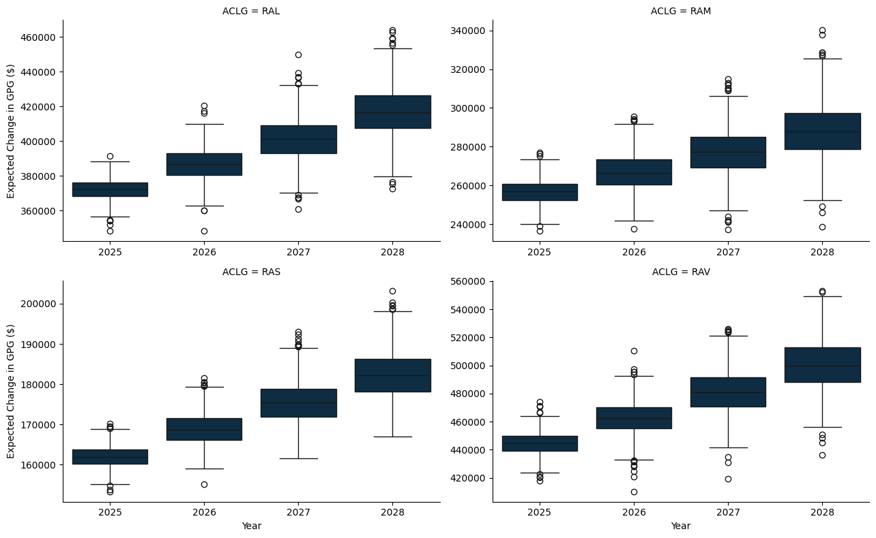

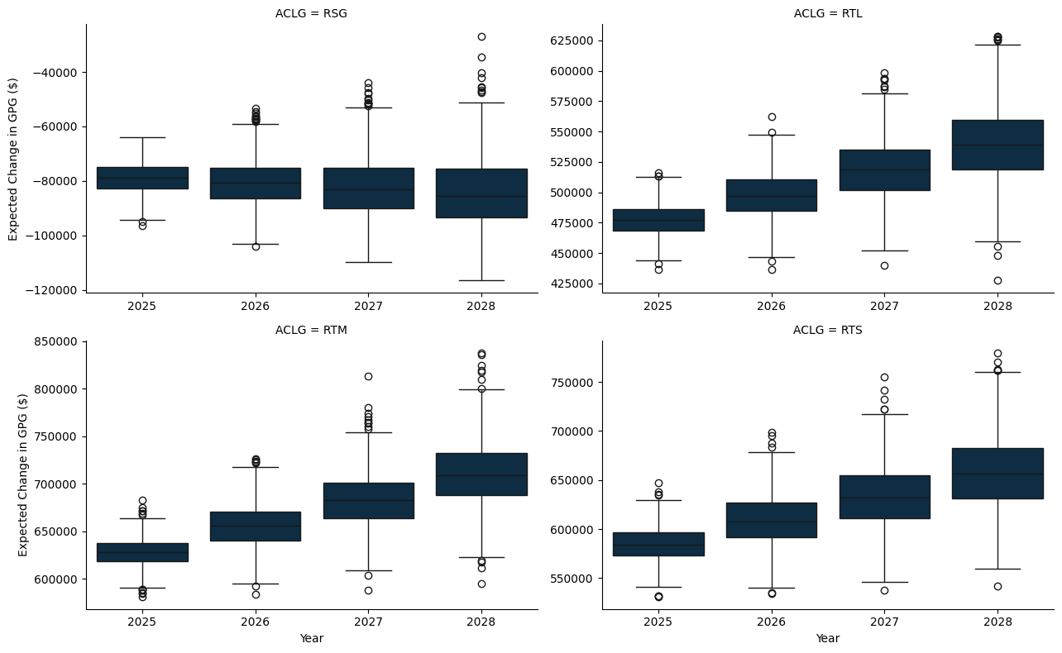

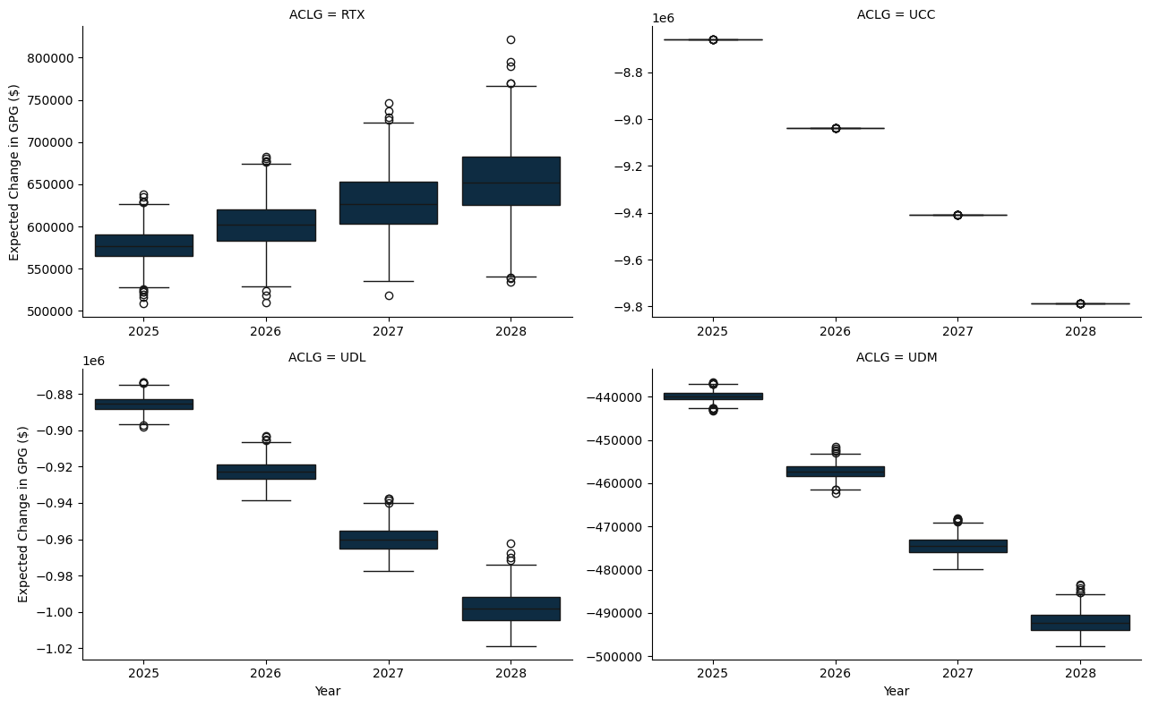

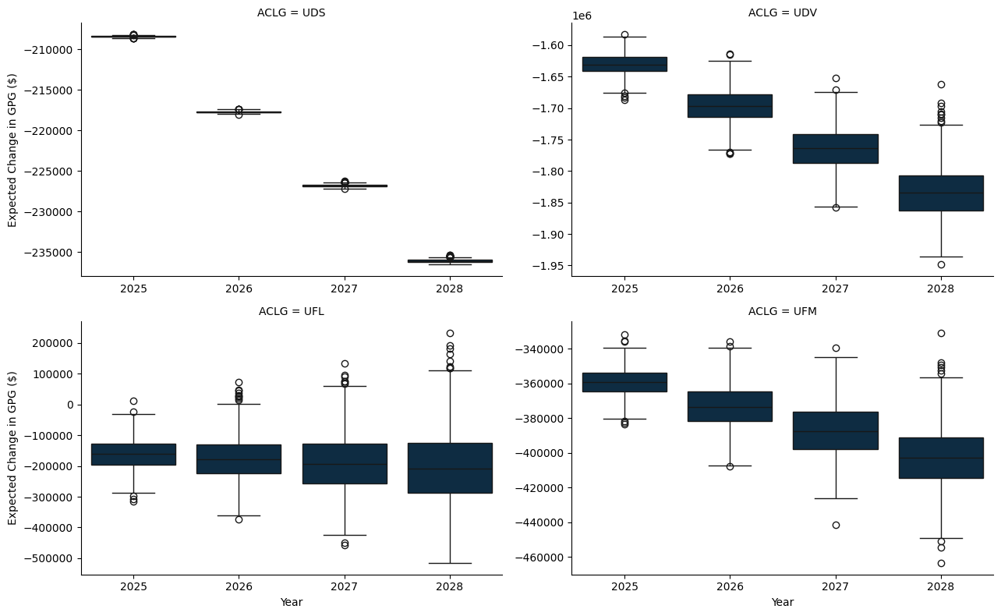

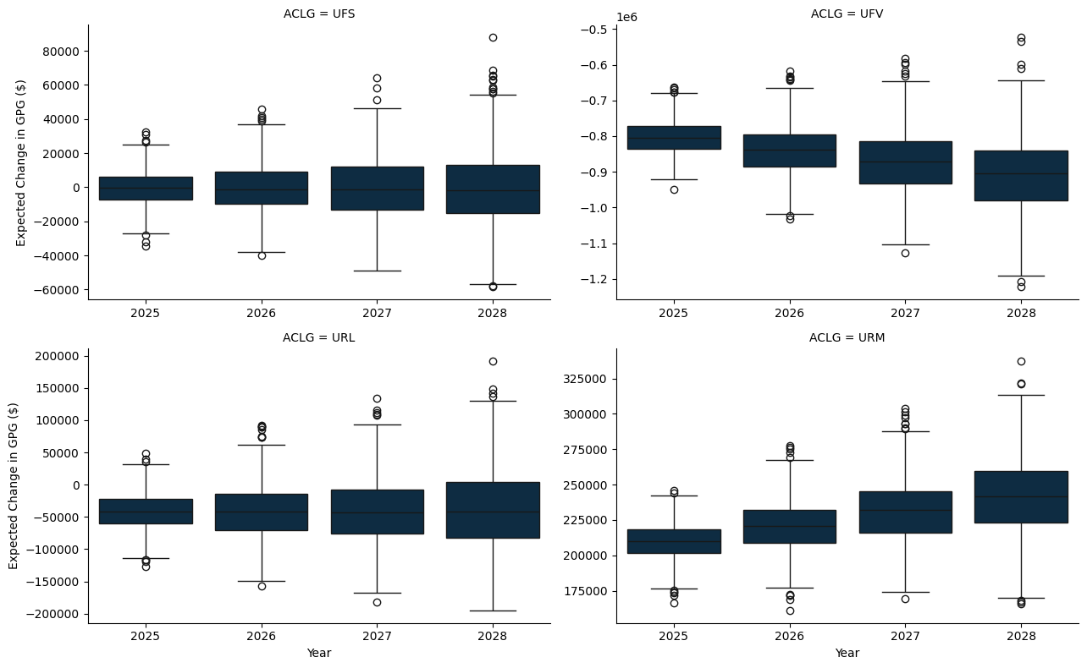

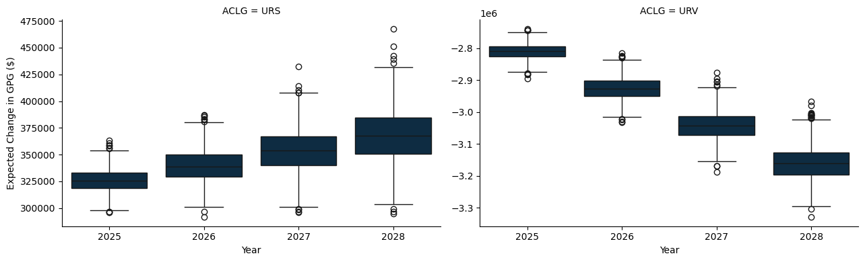

## B.1 A State and Territory breakdown

### B.1.1 New South Wales

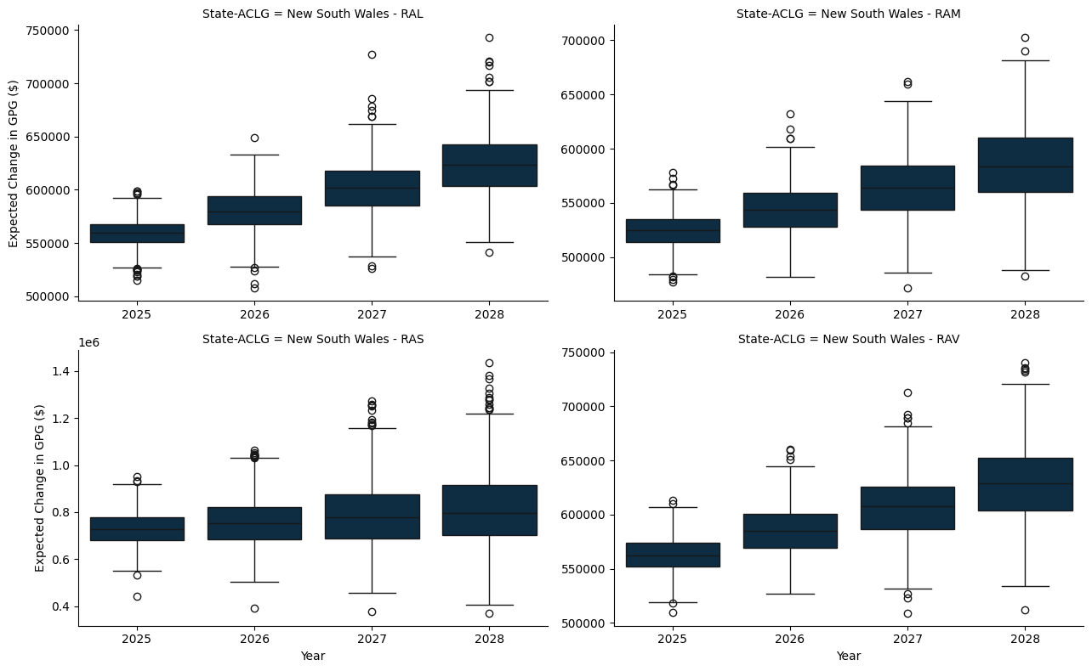

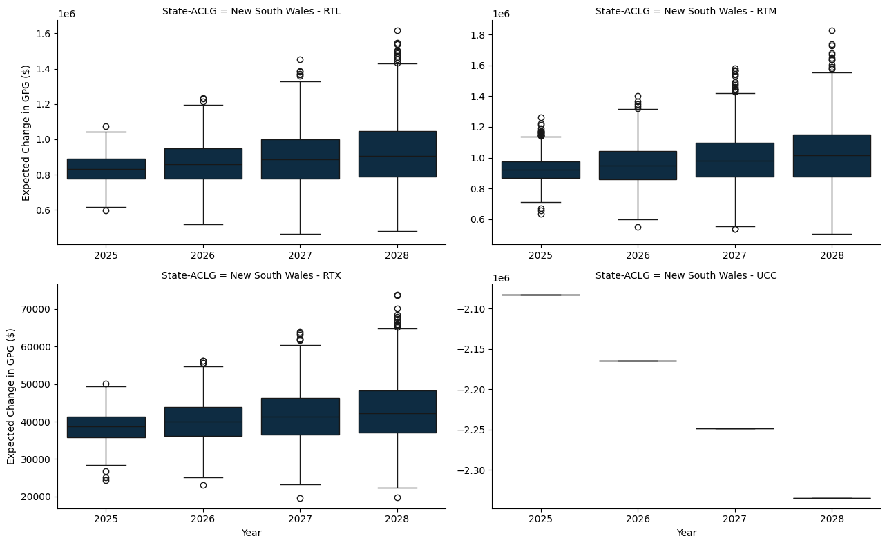

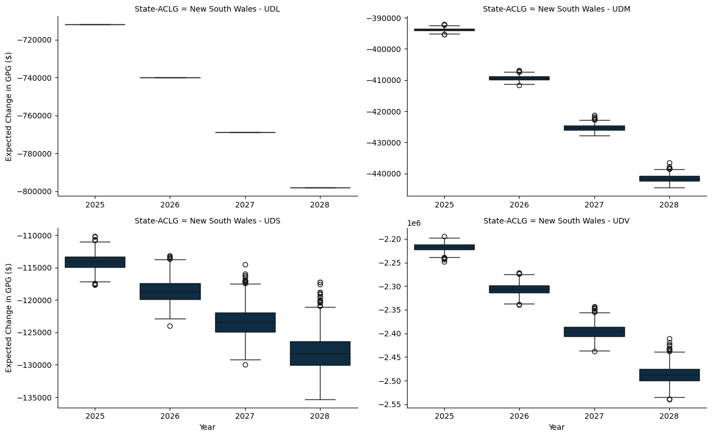

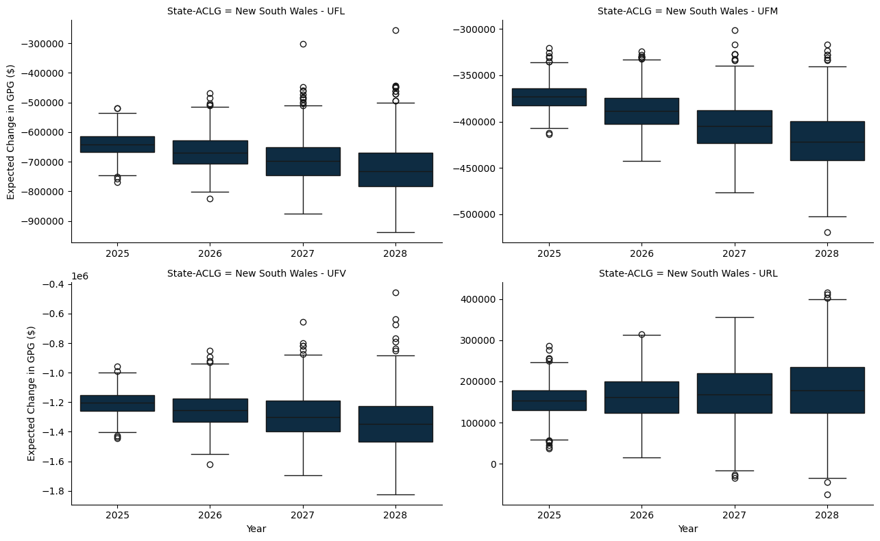

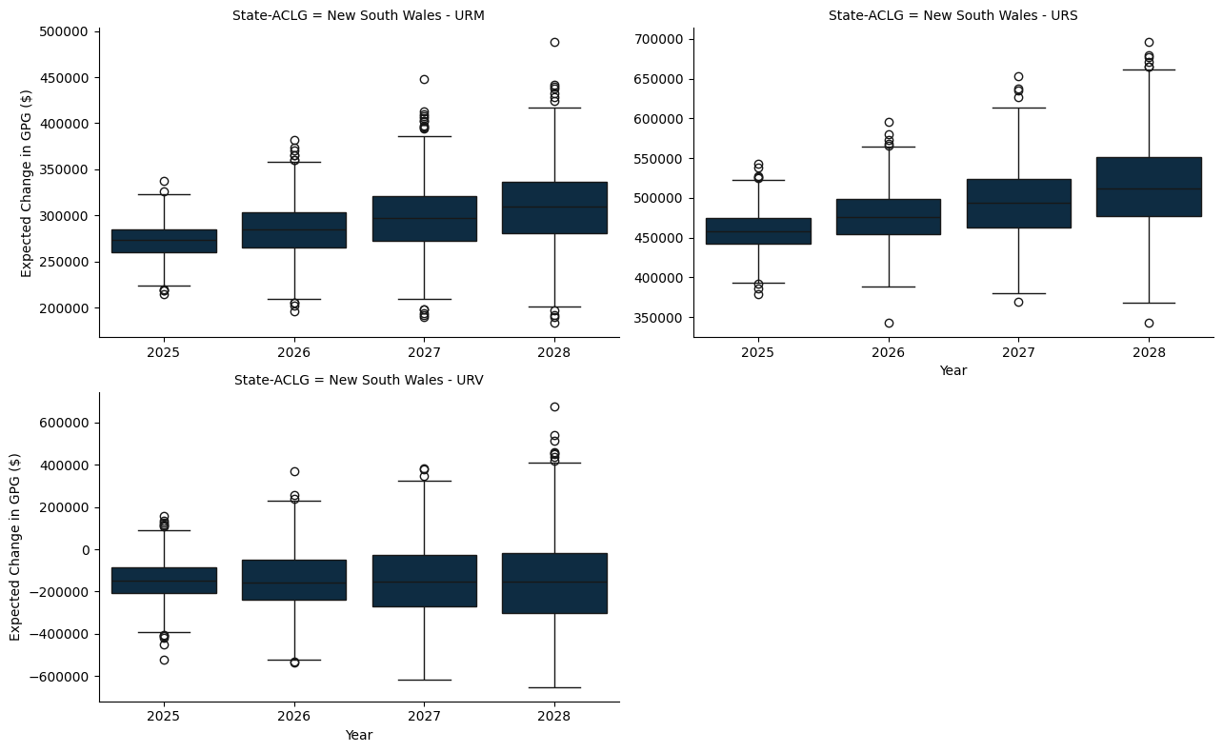

### B.1.2 Victoria

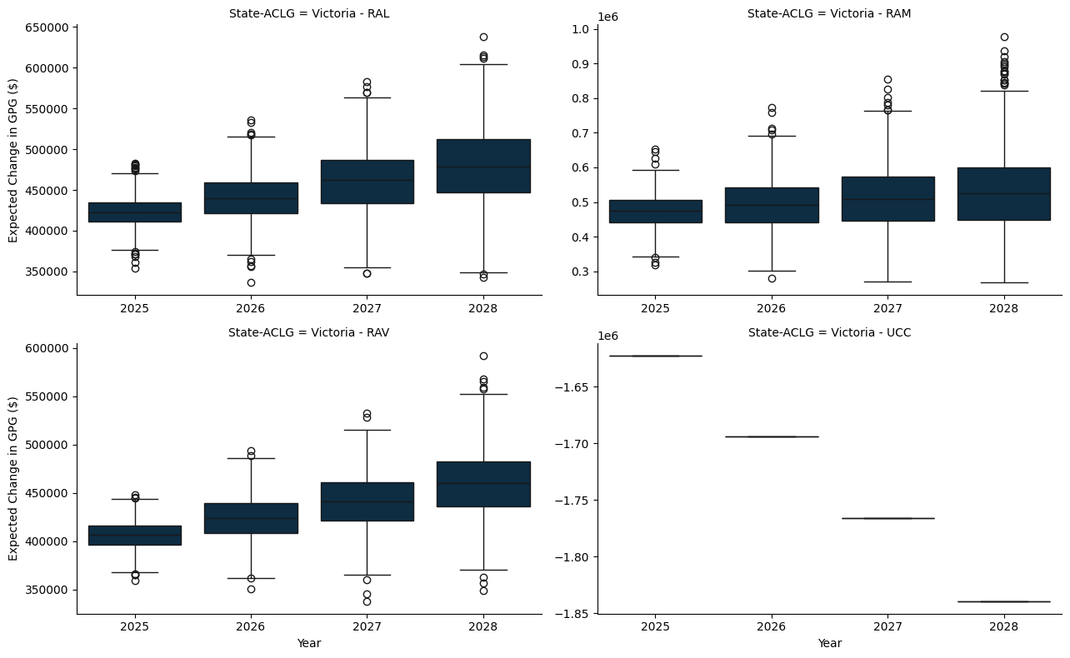

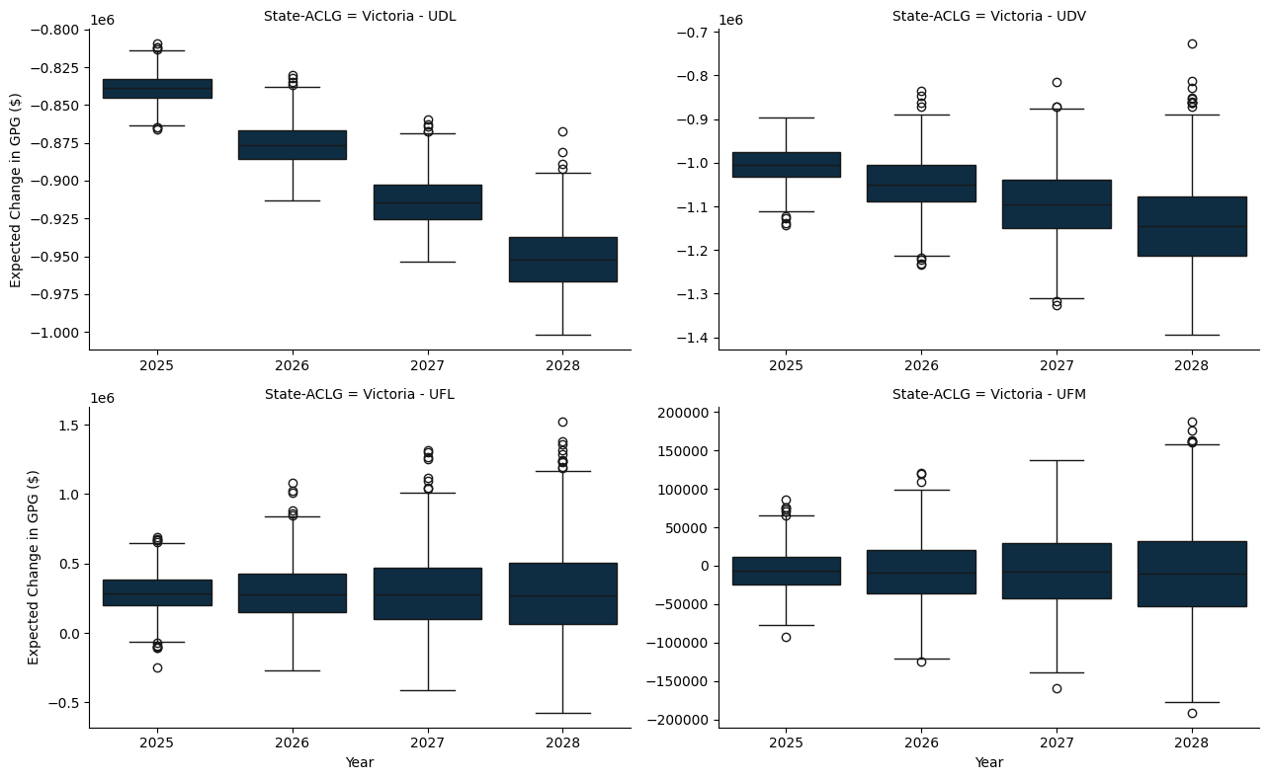

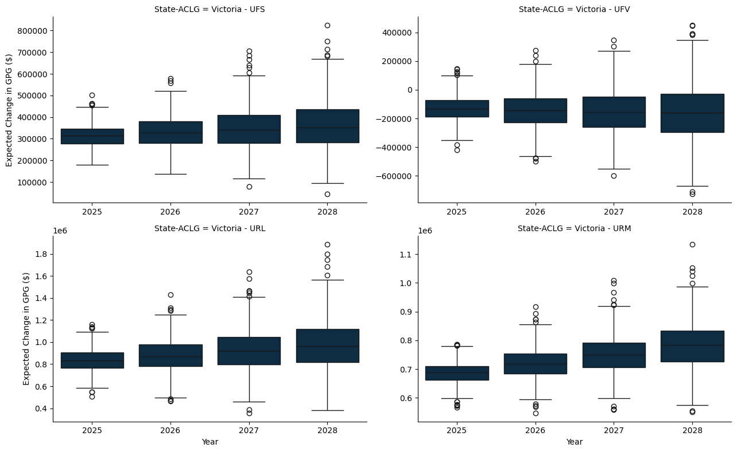

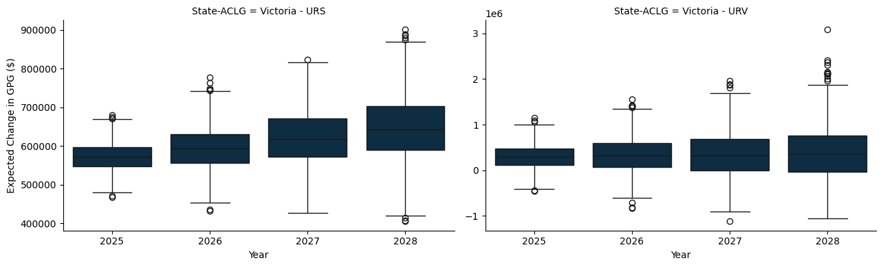

### B.1.3 Queensland

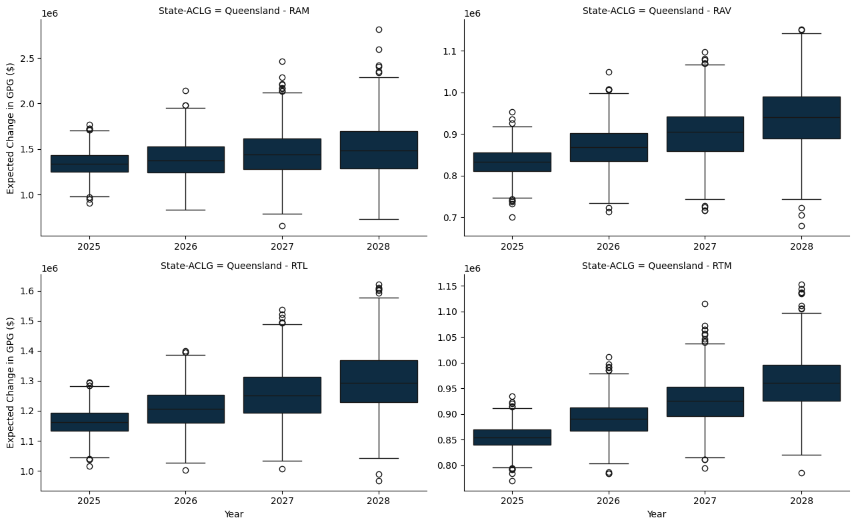

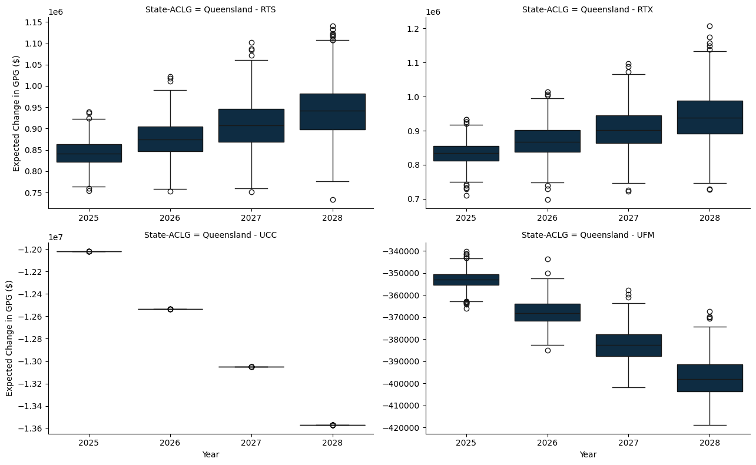

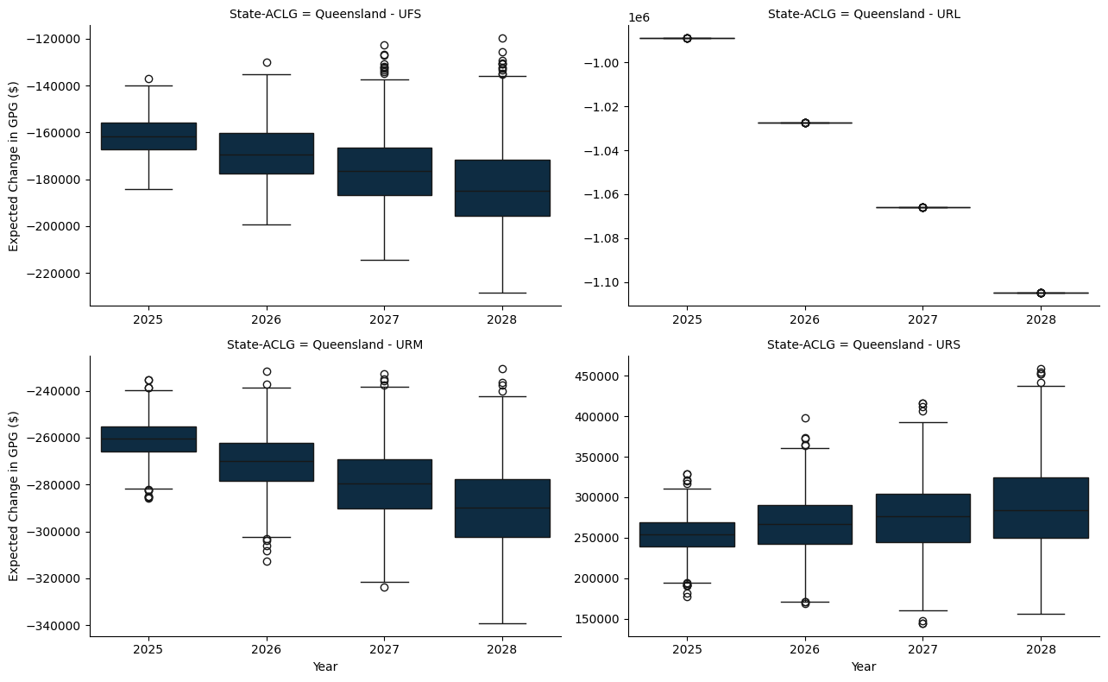

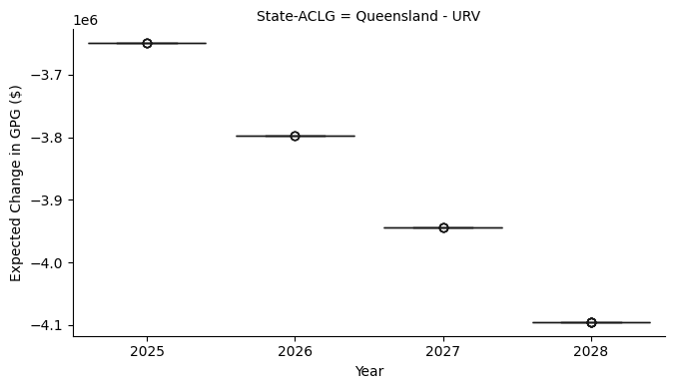

### B.1.4 South Austrlalia

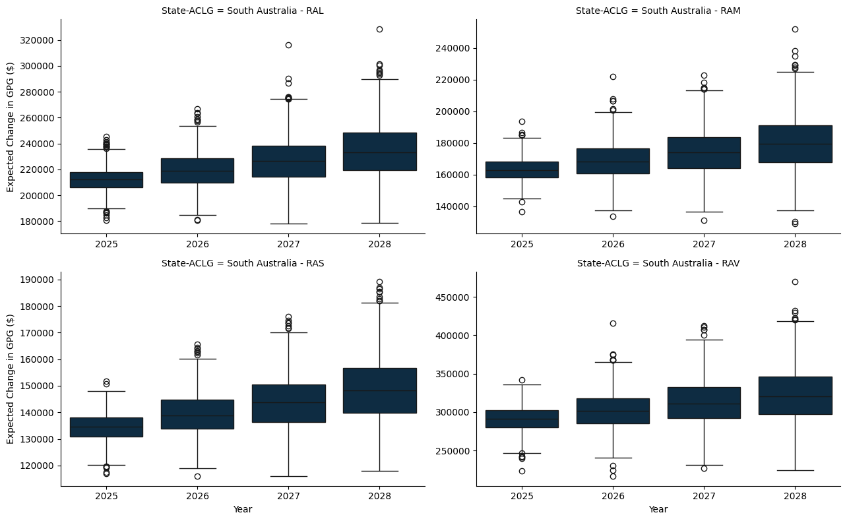

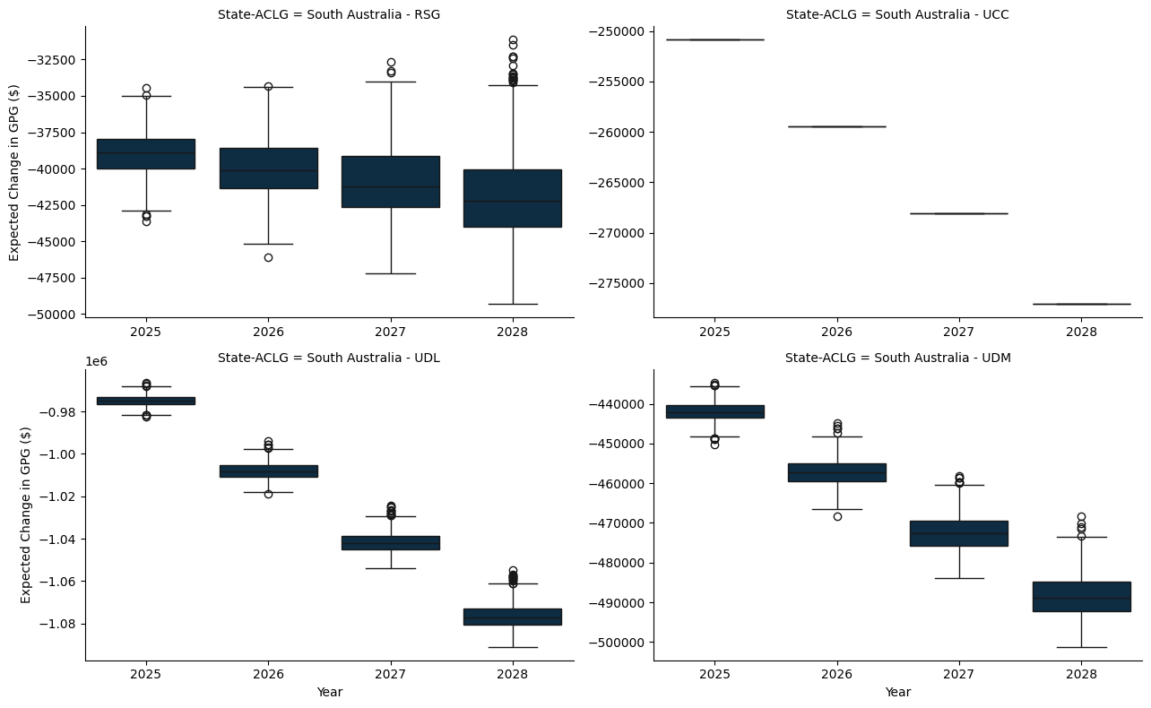

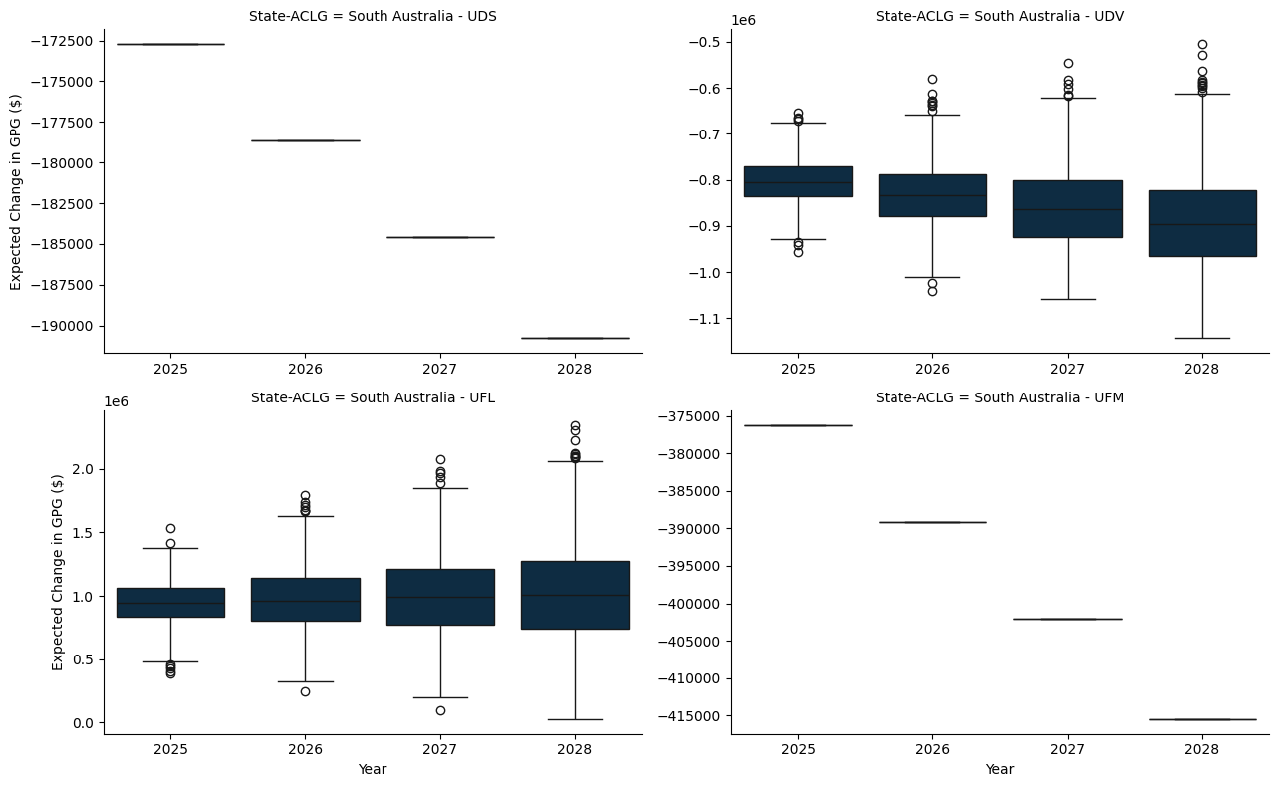

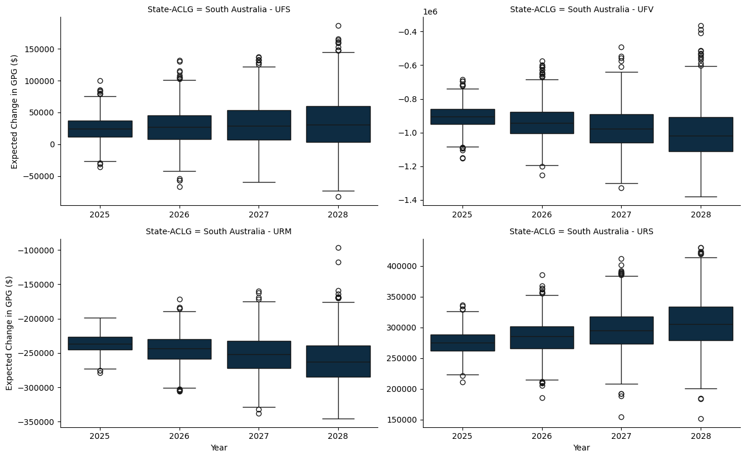

### B.1.5 Western Australia

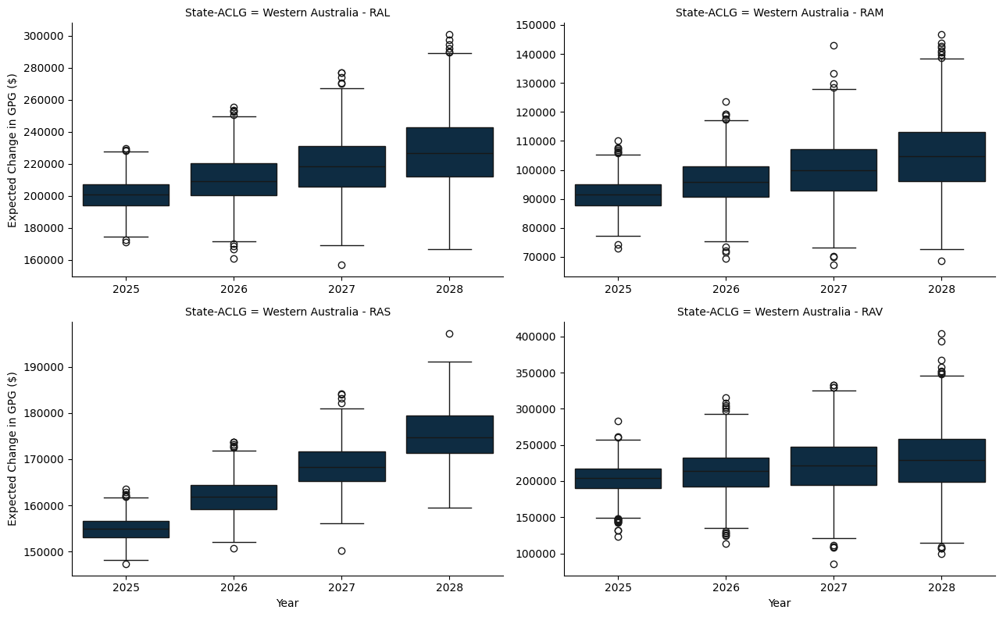

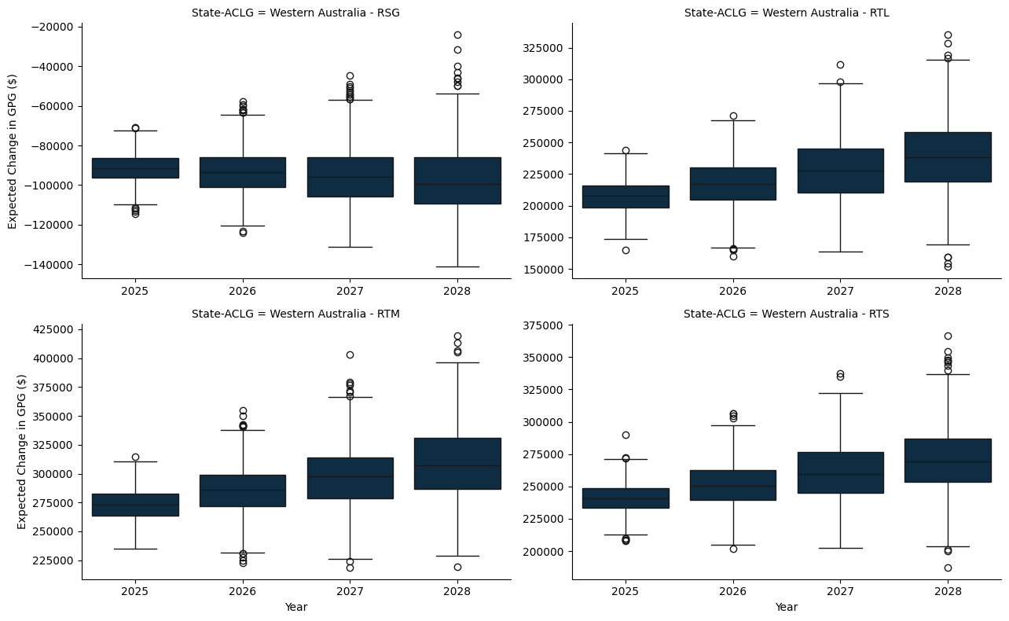

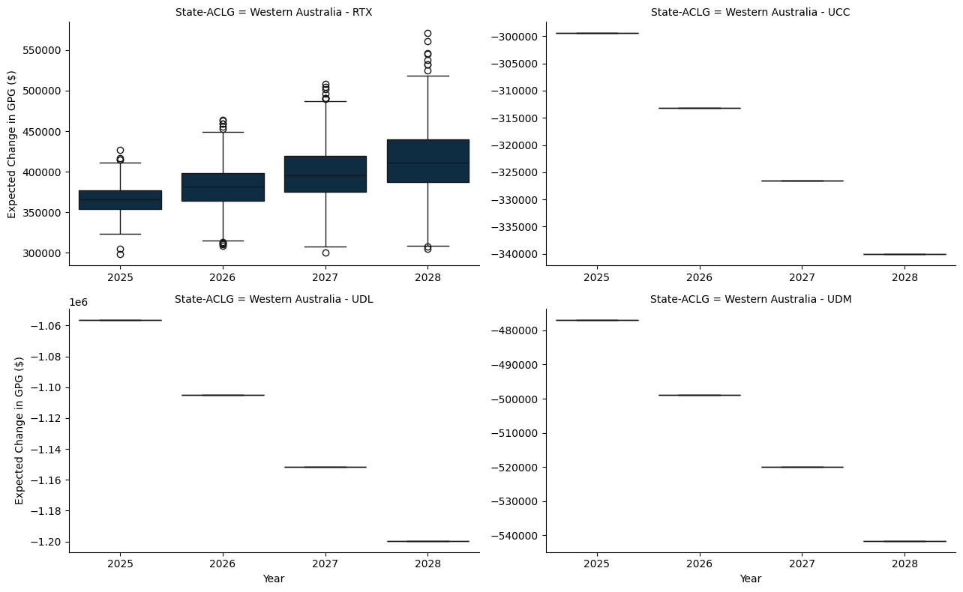

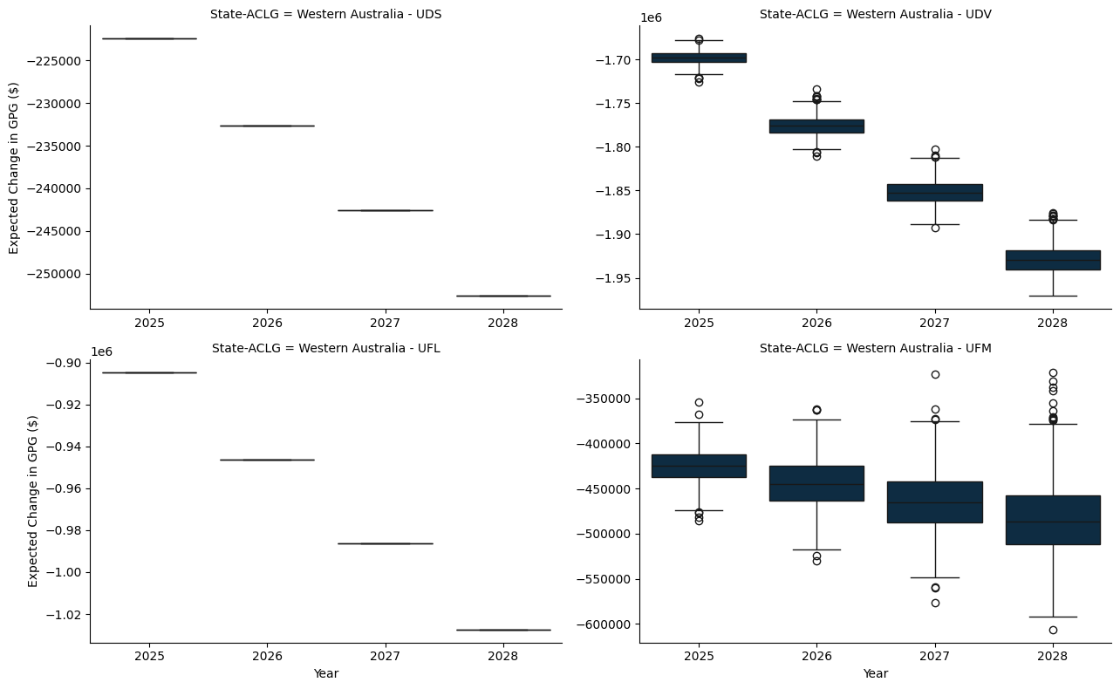

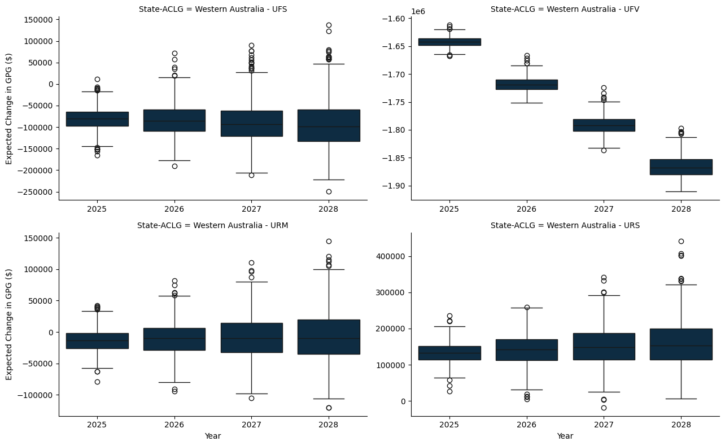

### B.1.6 Tasmania

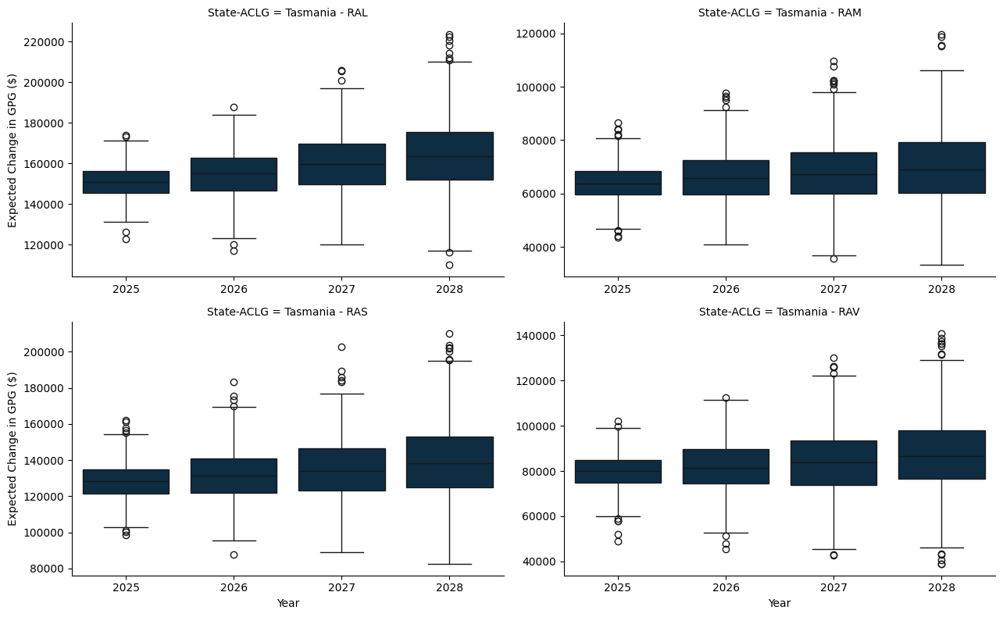

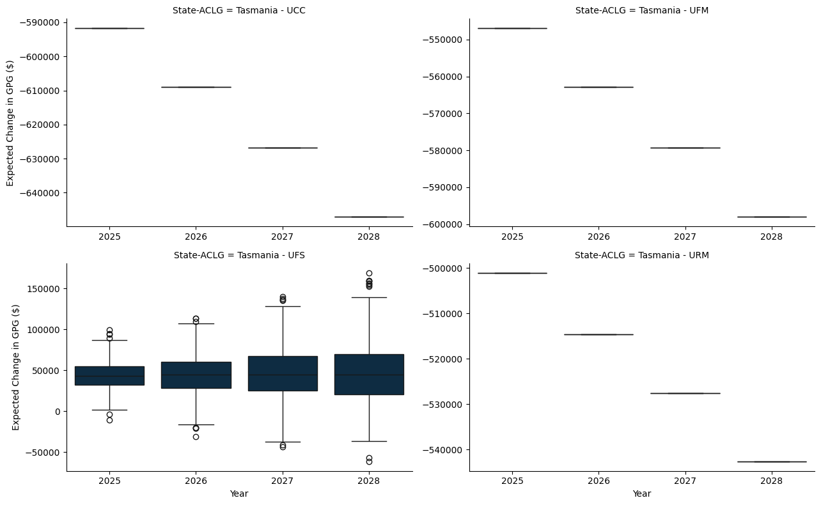

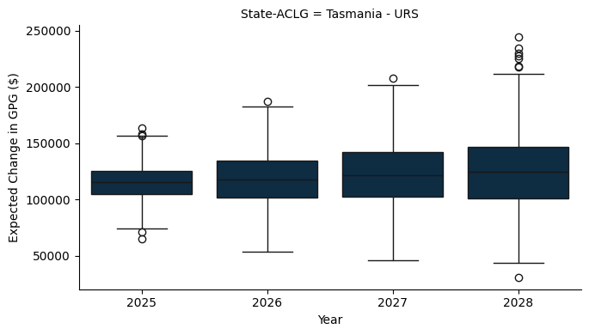

### B.1.7 Northern Territory

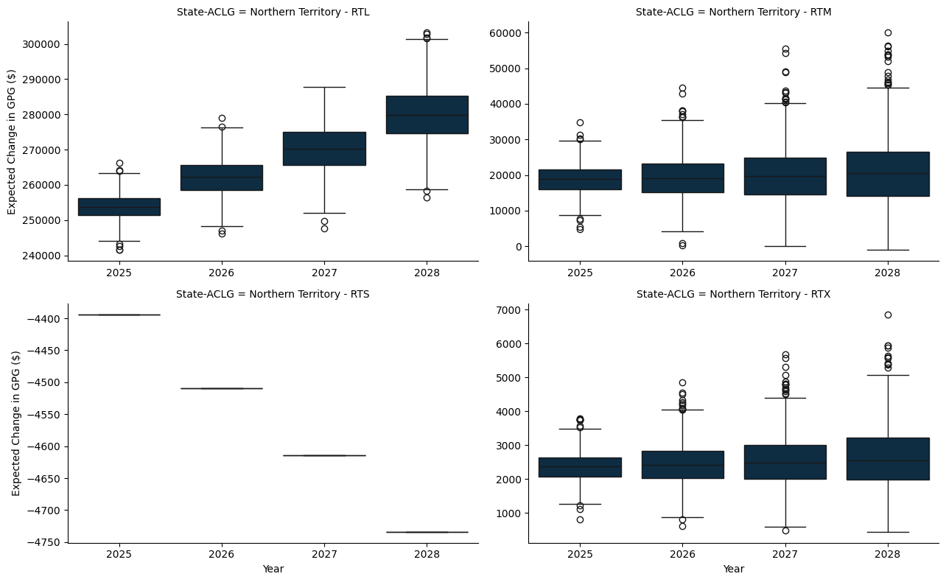

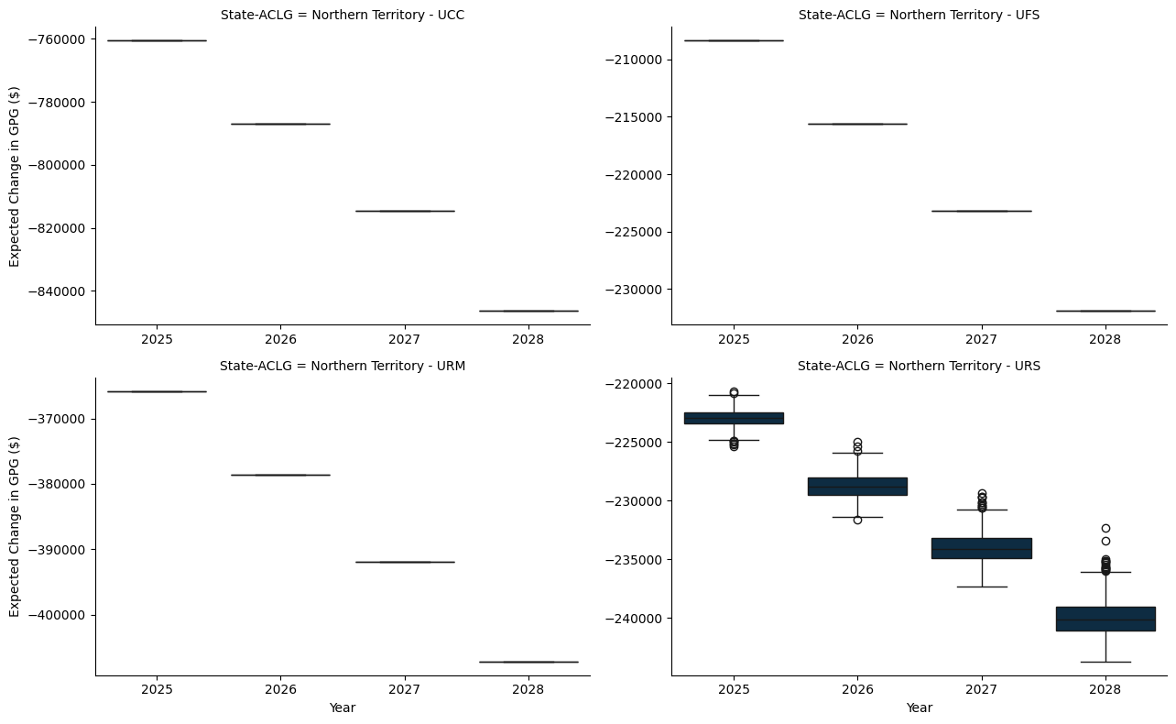

# Appendix C — A 20% Per Capita Minimum Grant - A per capita study

* The model here applies a hypothetical per capita minimum grant constraint, set at 20%, to ensure that each jurisdiction receives at least this proportion of the funds if they were allocated on a per capita basis.
* The per capita minimum for the benchmark scenario is set to 30%, as is the status quo.

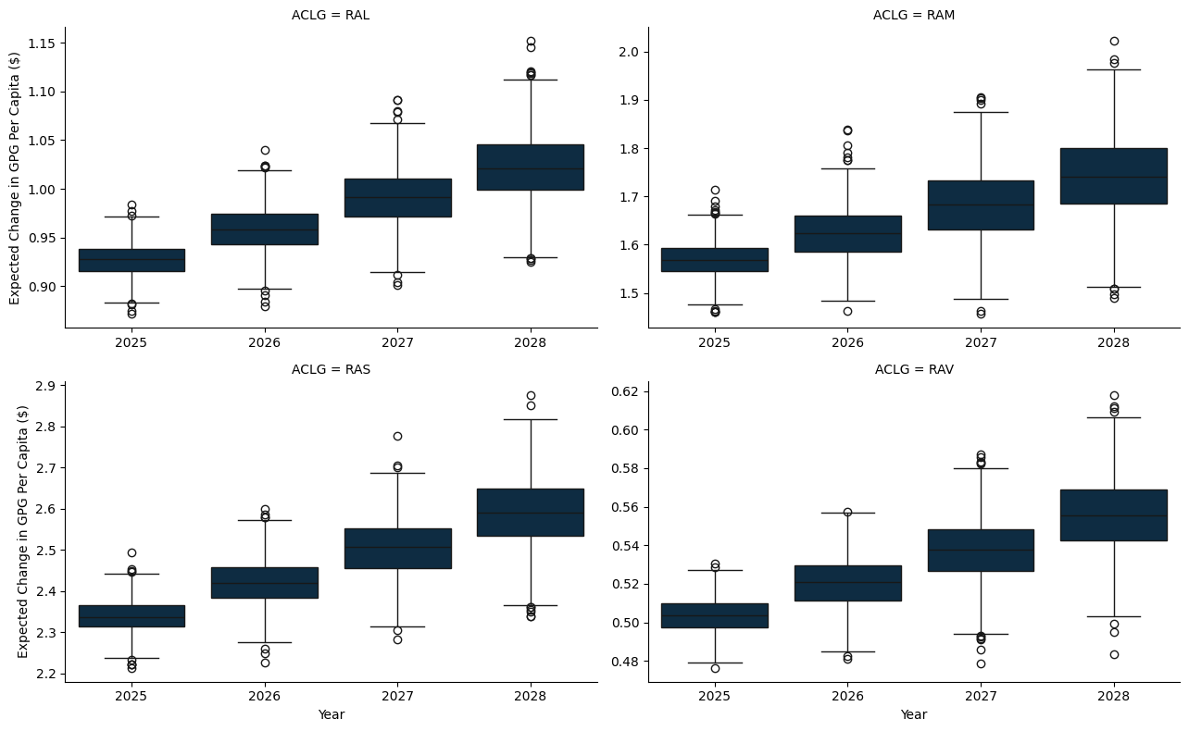

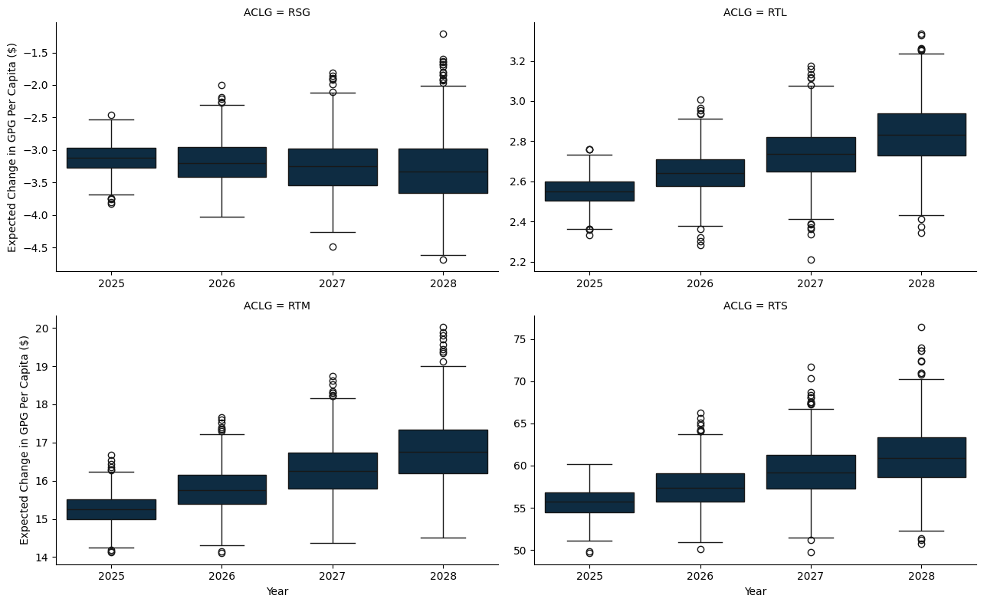

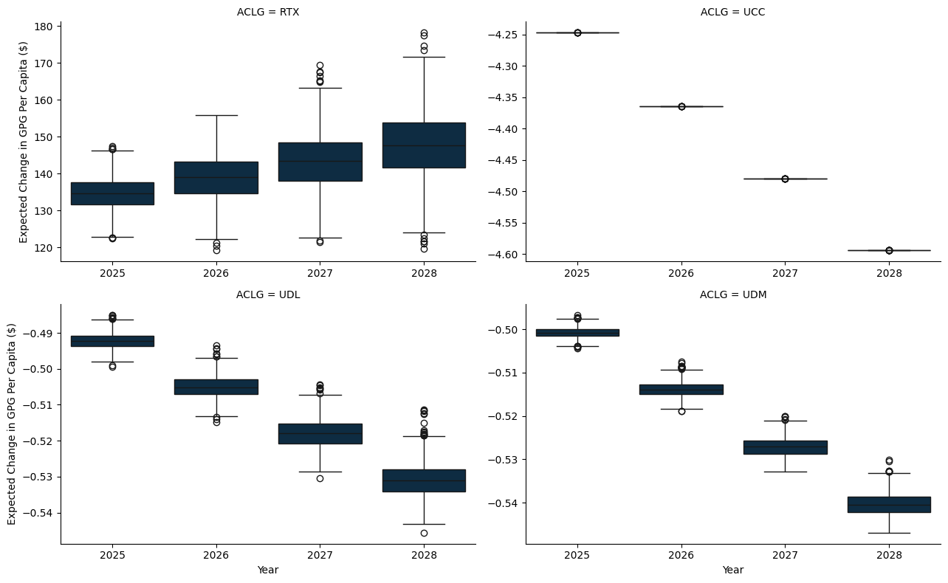

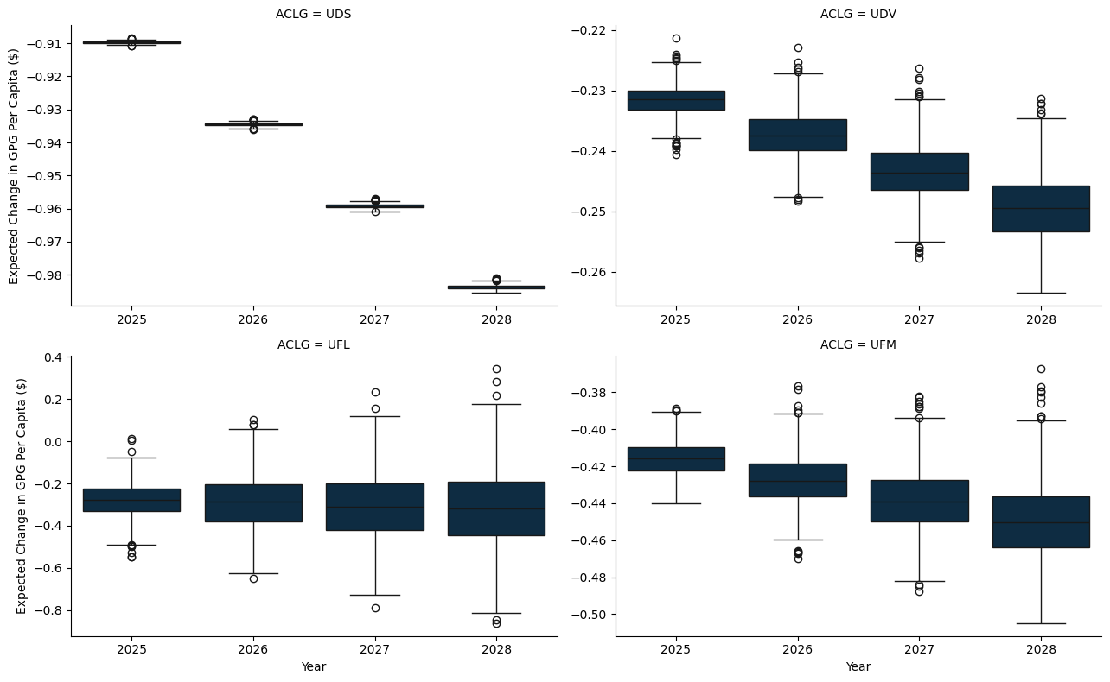

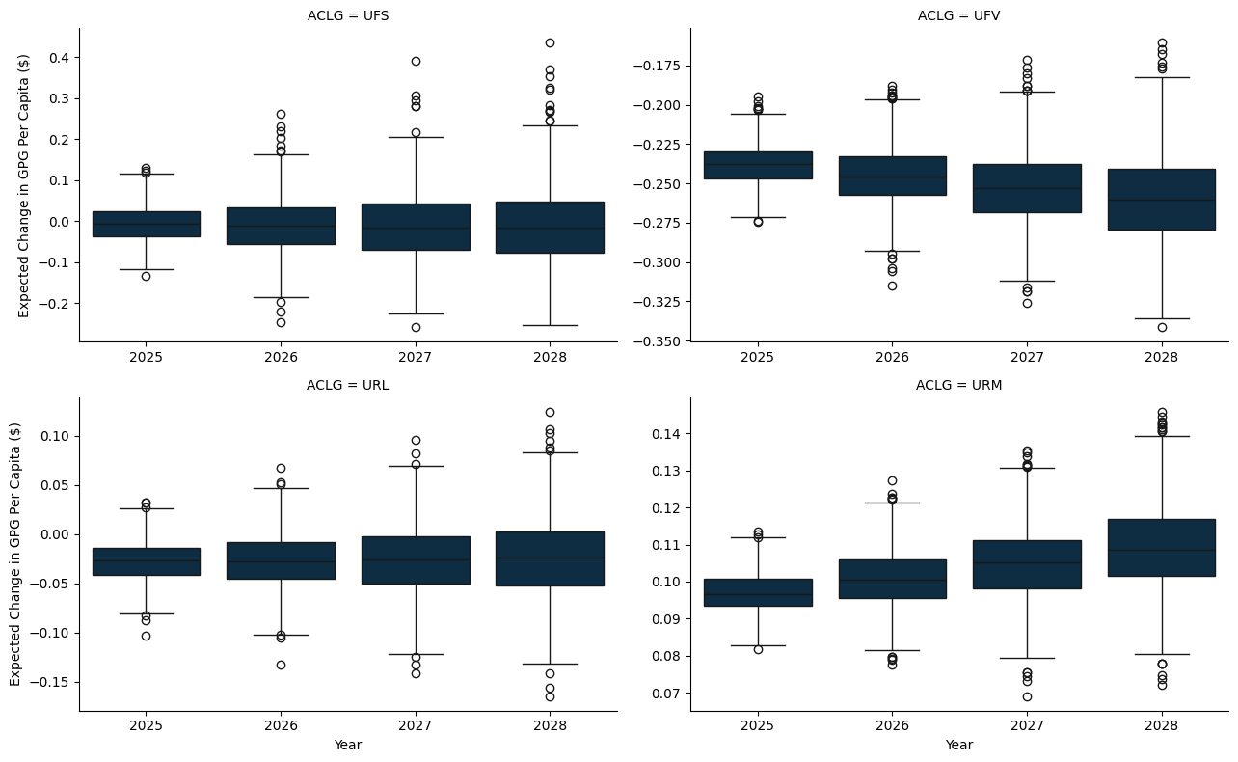

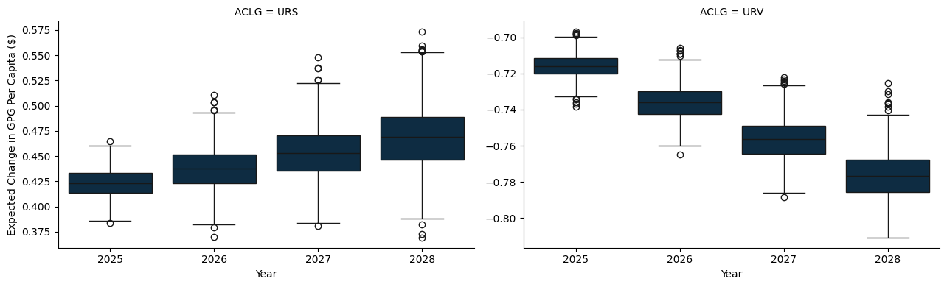

## C.1 A State and Territory breakdown

### C.1.1 New South Wales

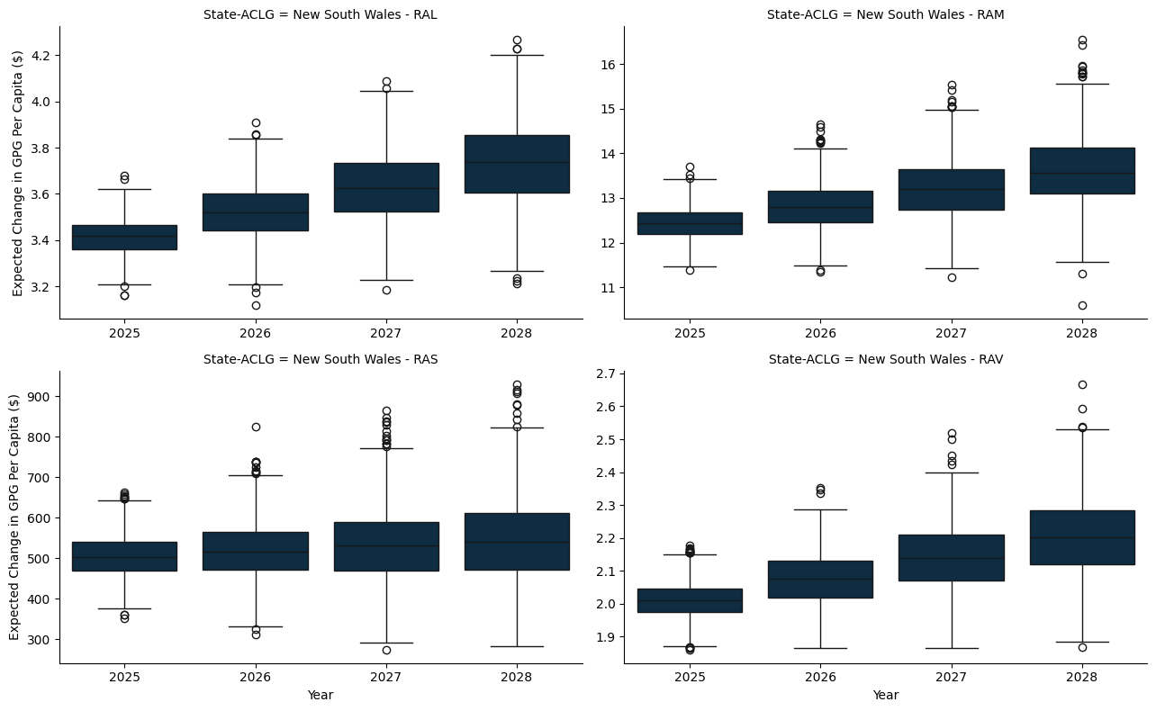

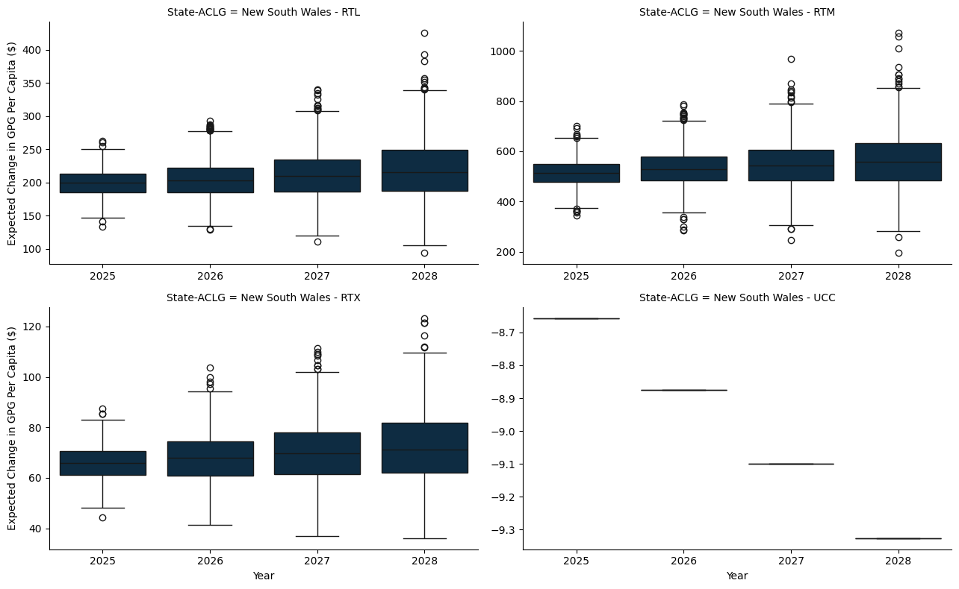

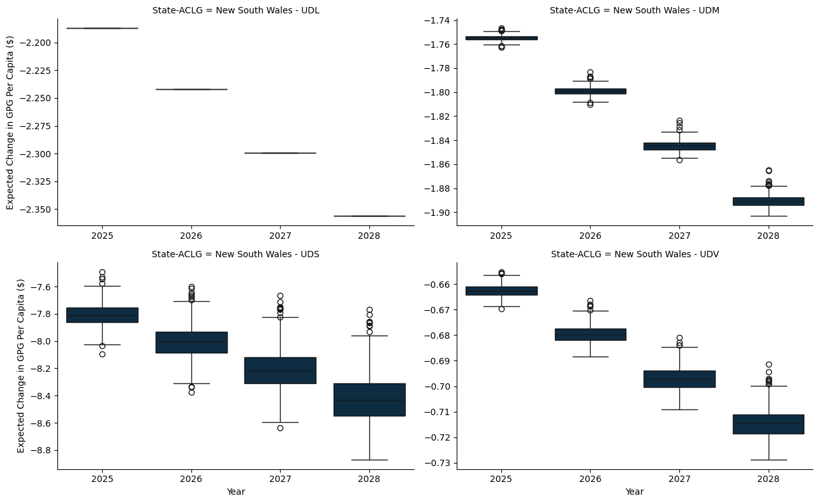

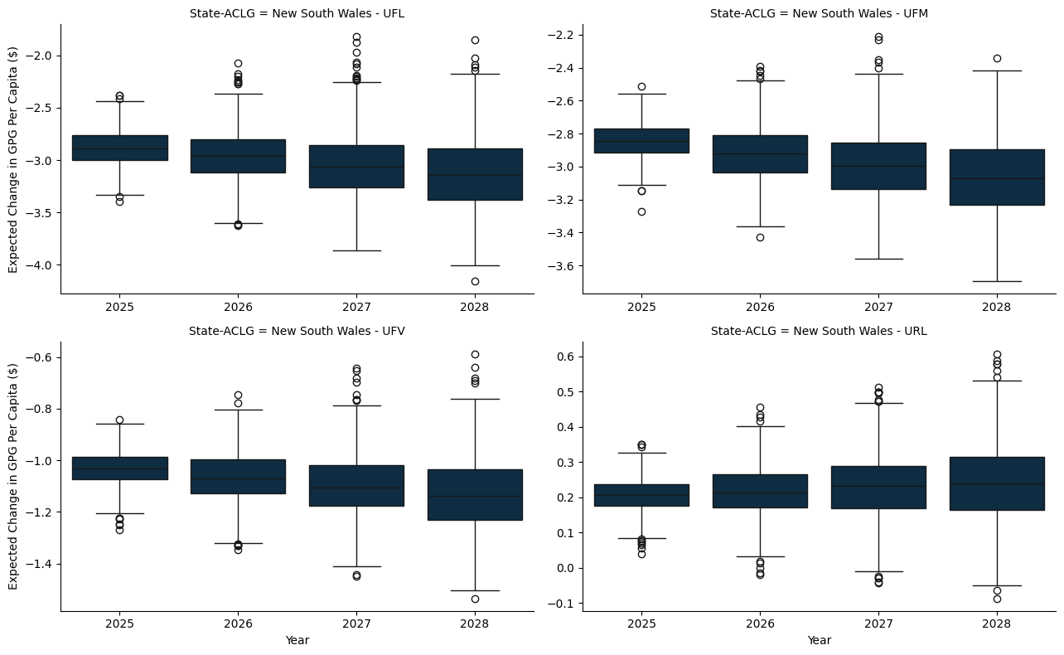

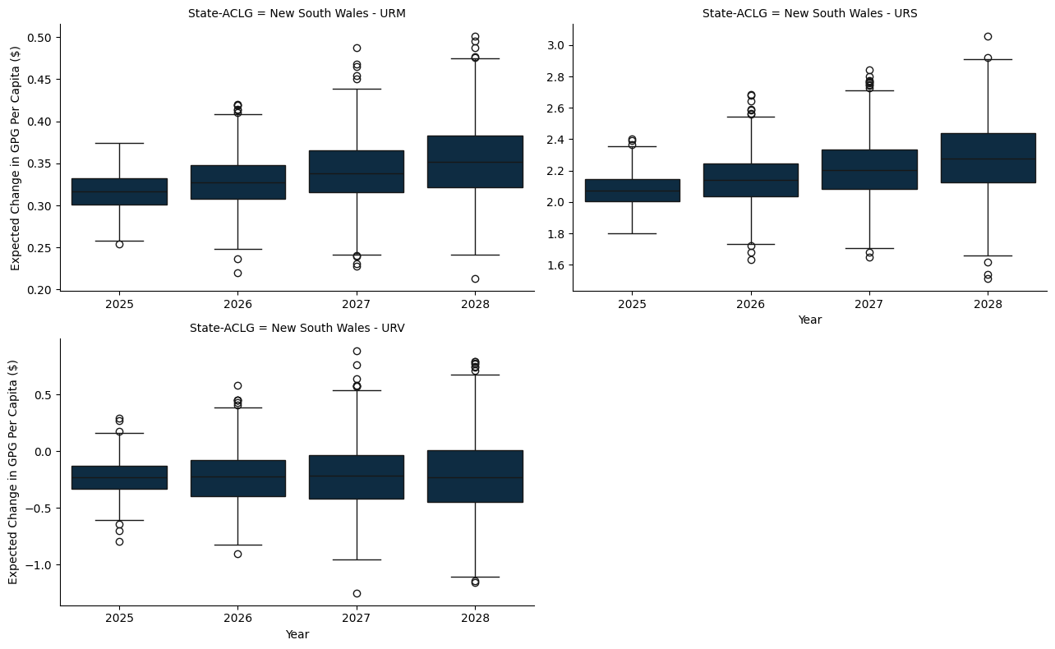

### C.1.2 Victoria

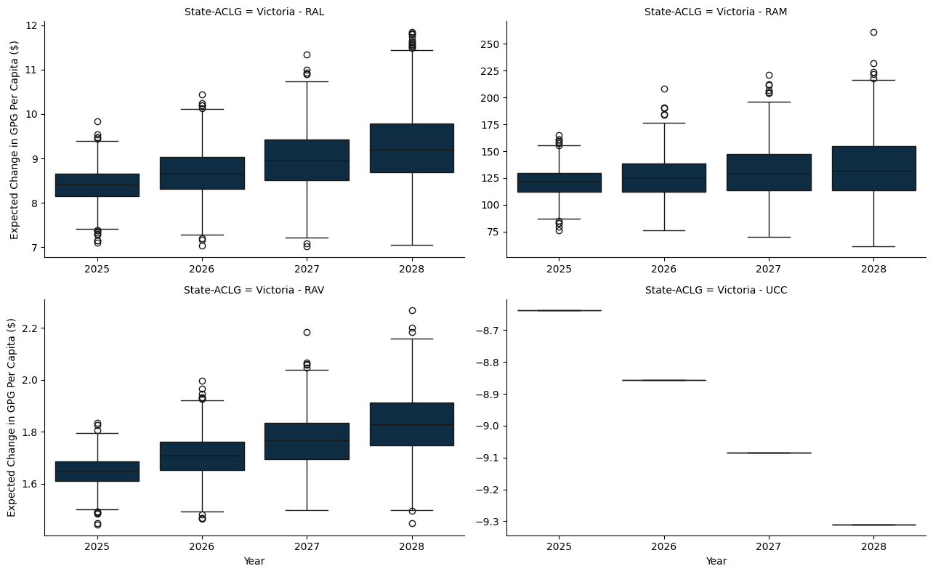

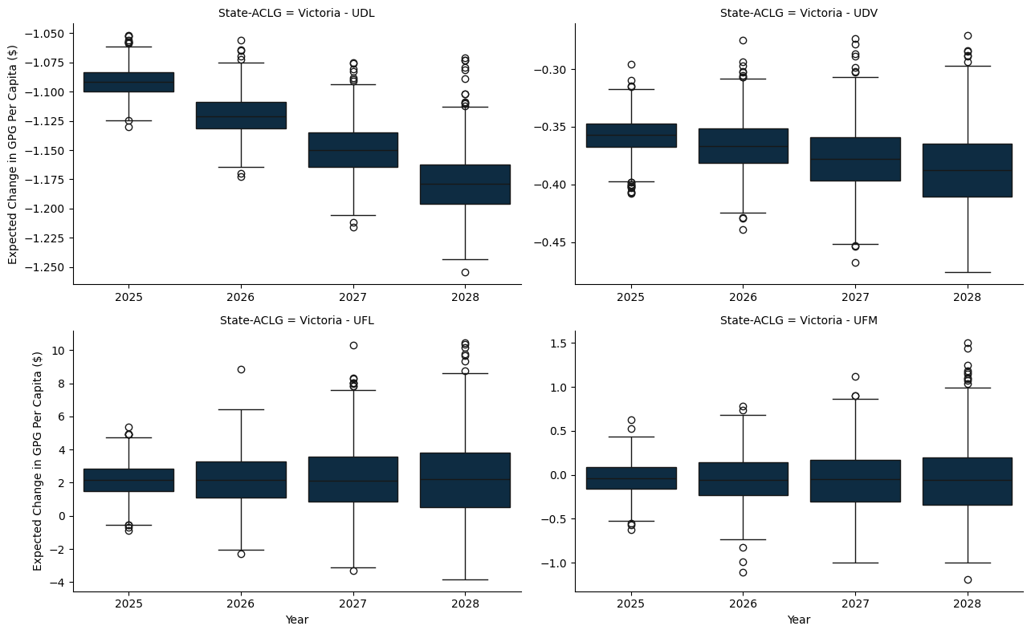

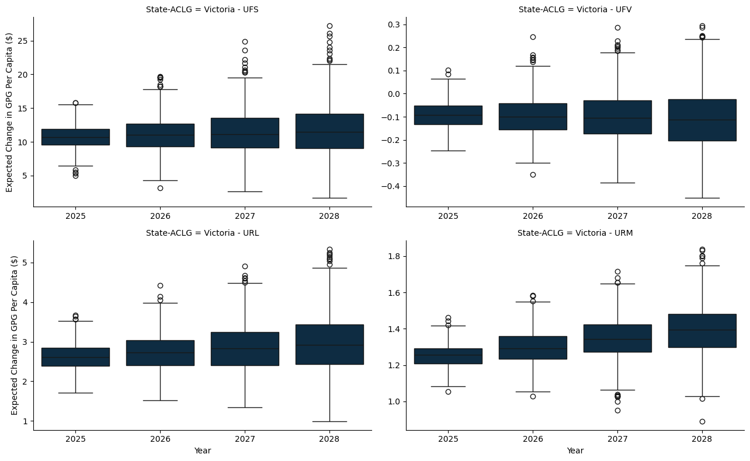

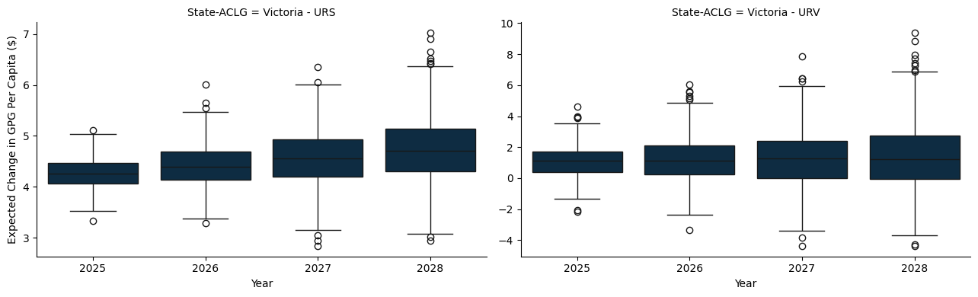

### C.1.3 Queensland

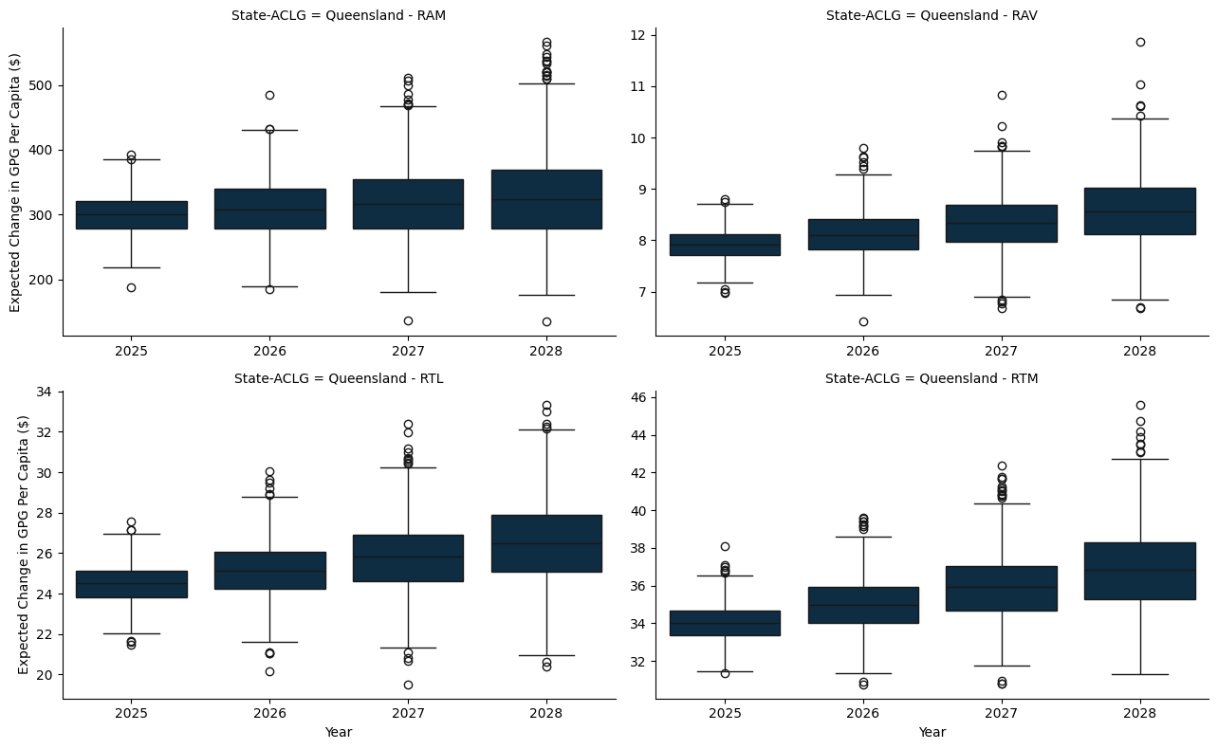

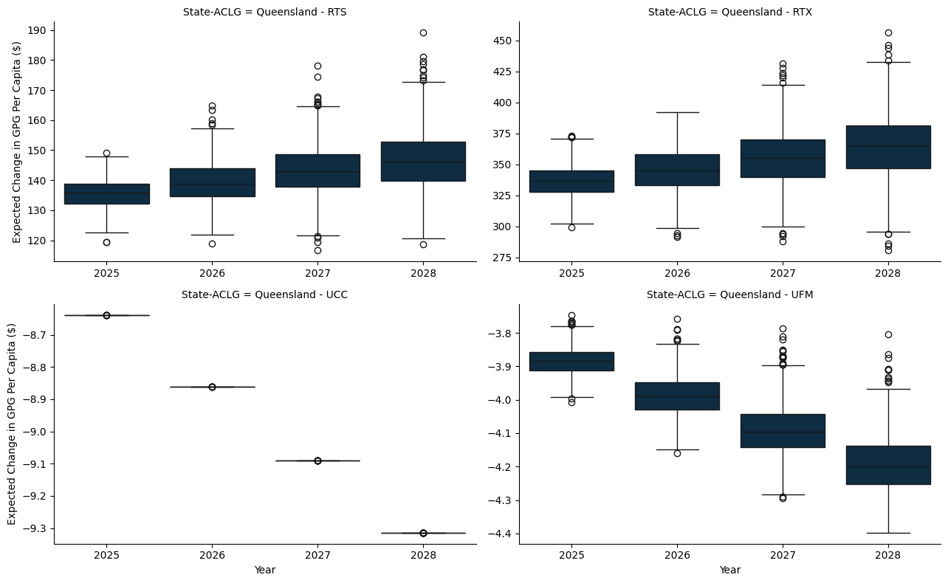

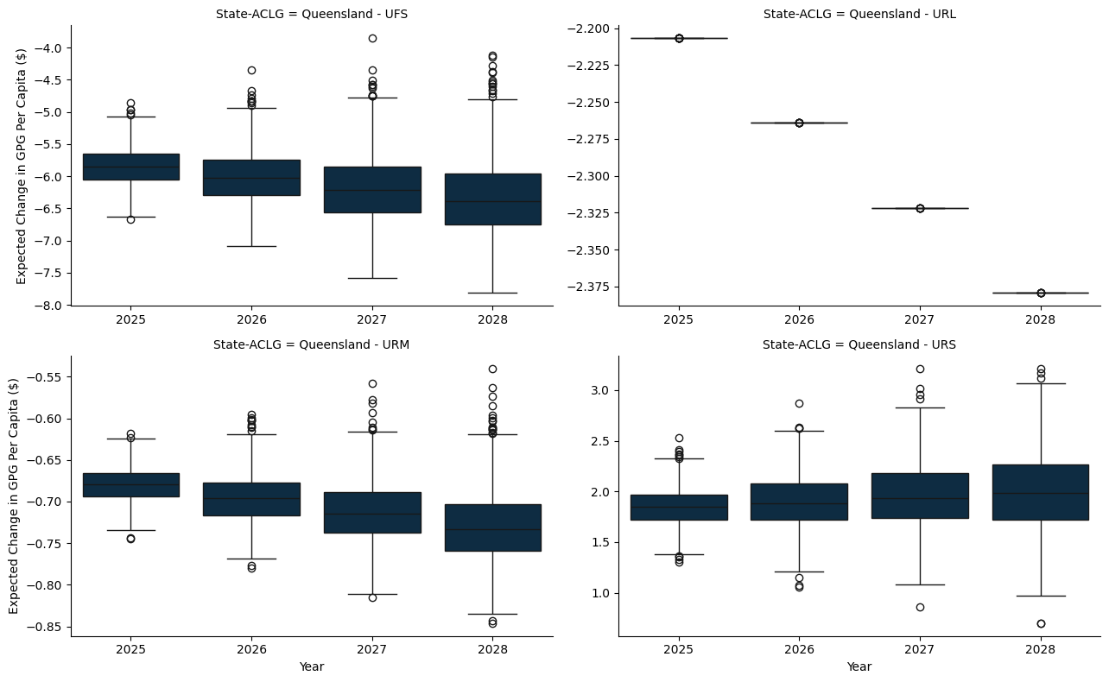

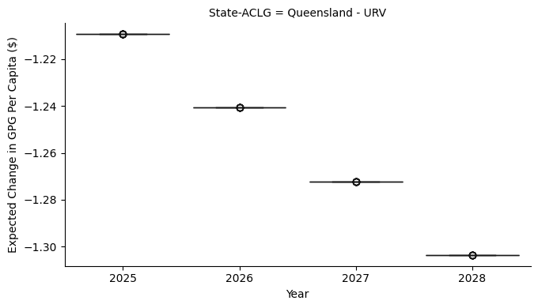

### C.1.4 South Austrlalia

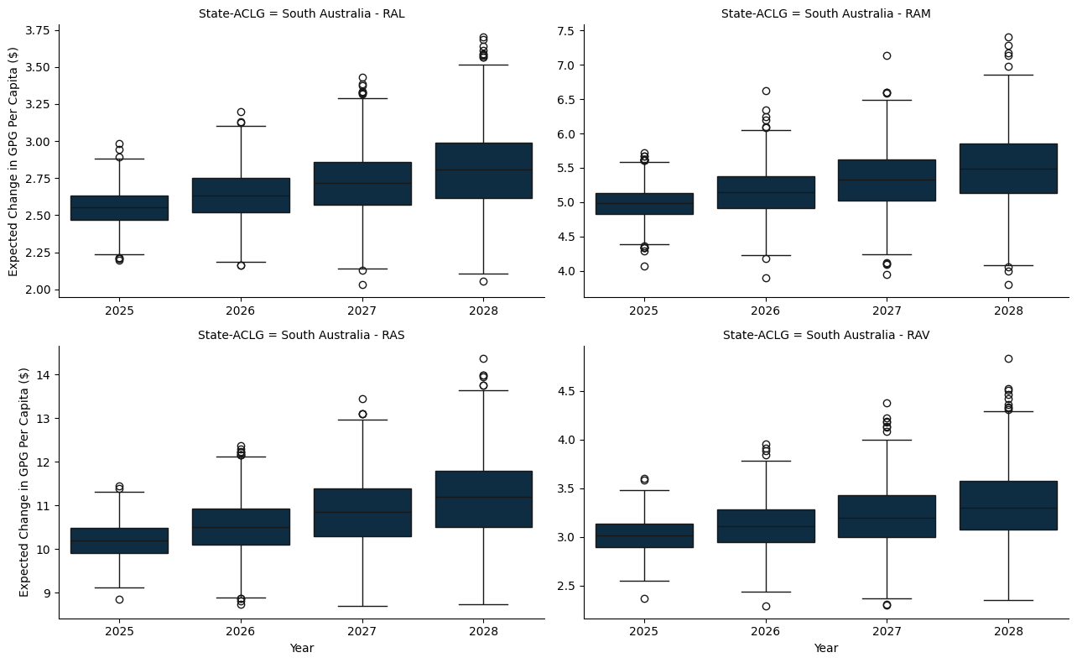

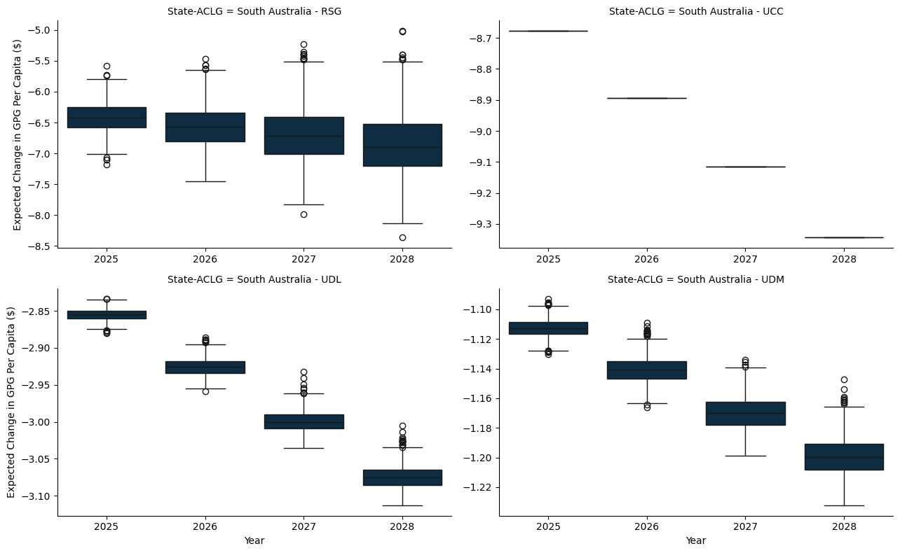

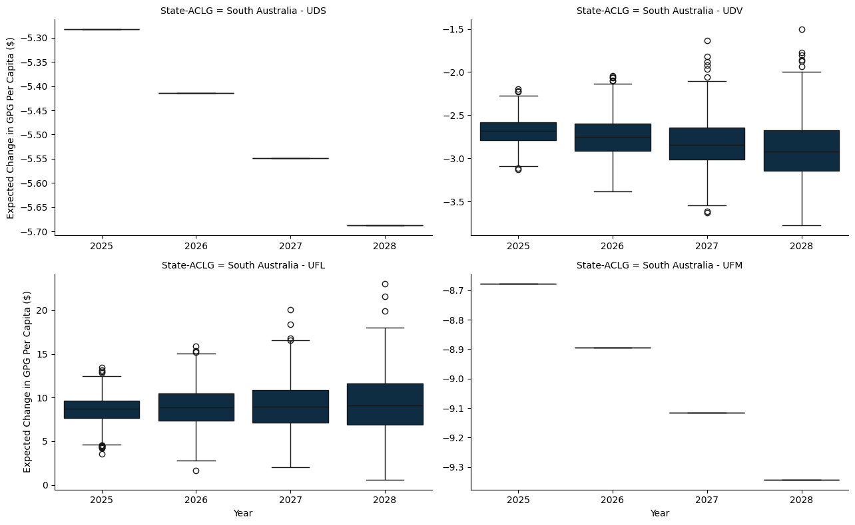

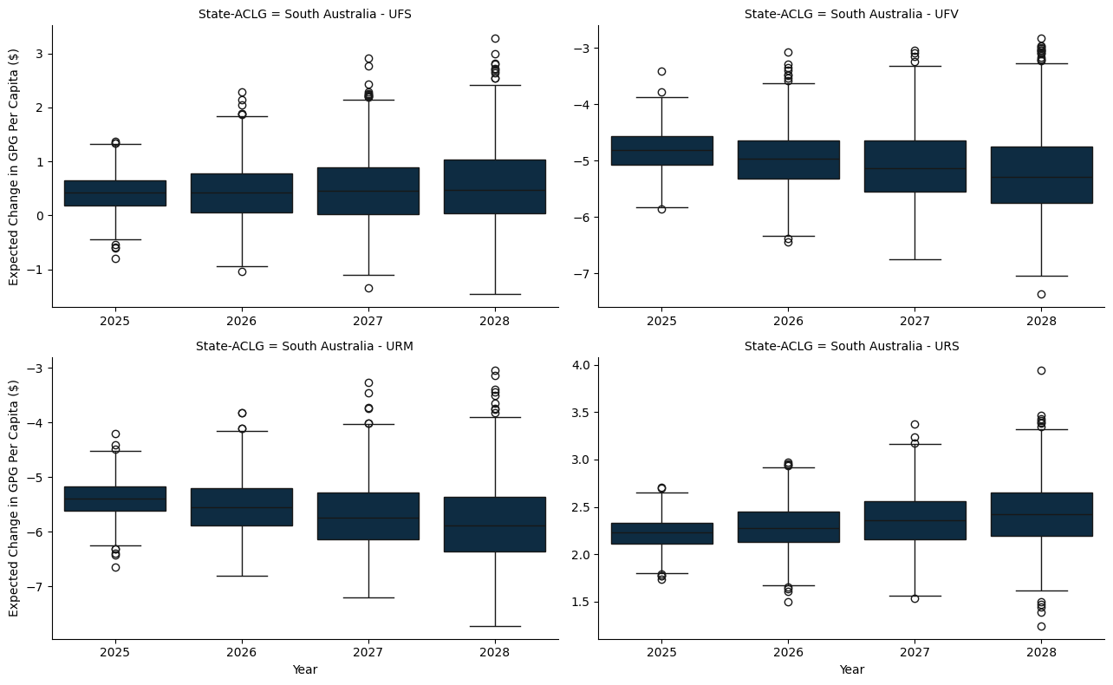

### C.1.5 Western Australia

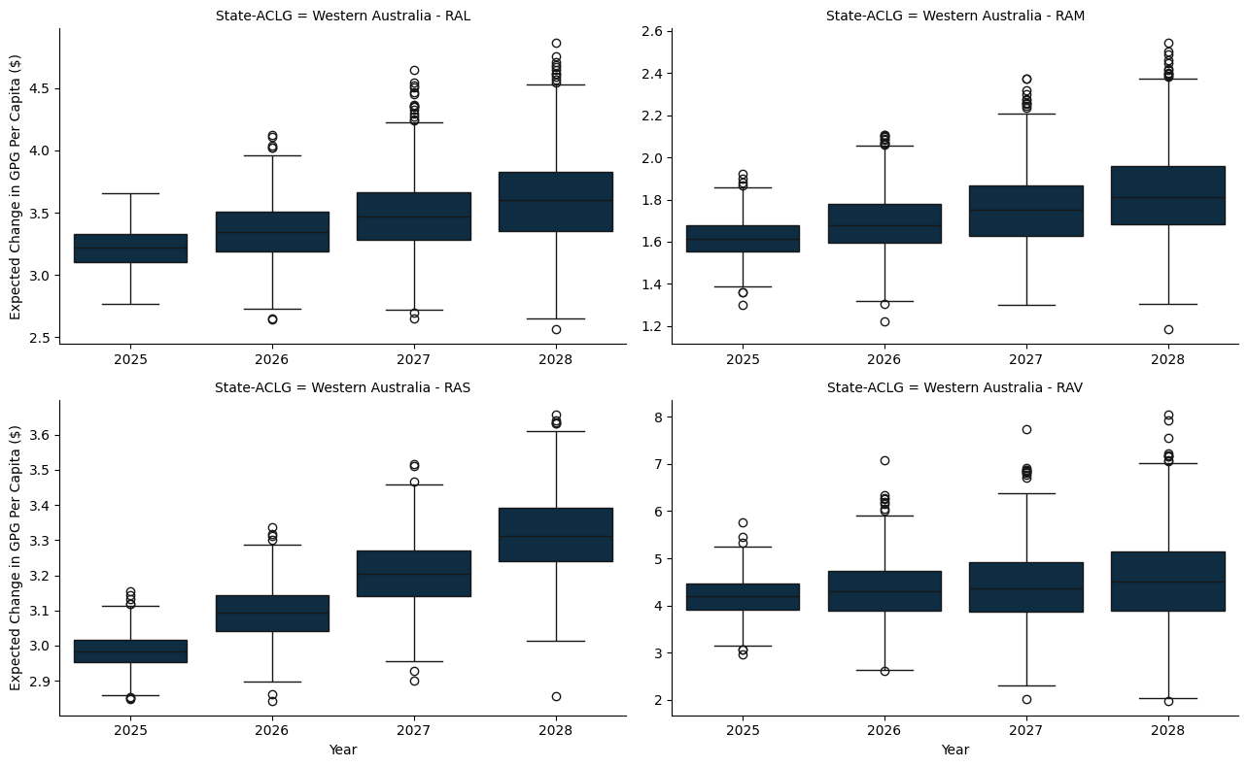

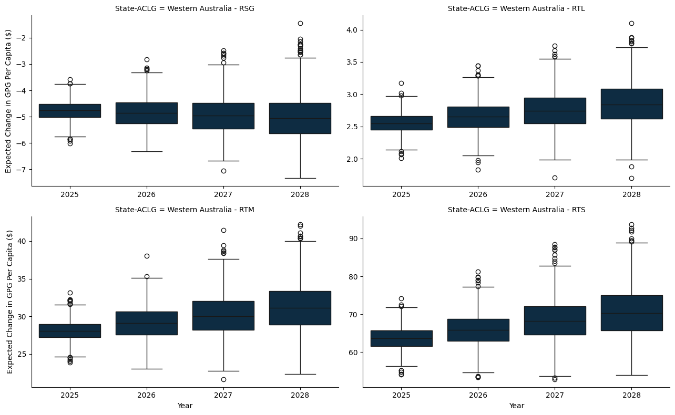

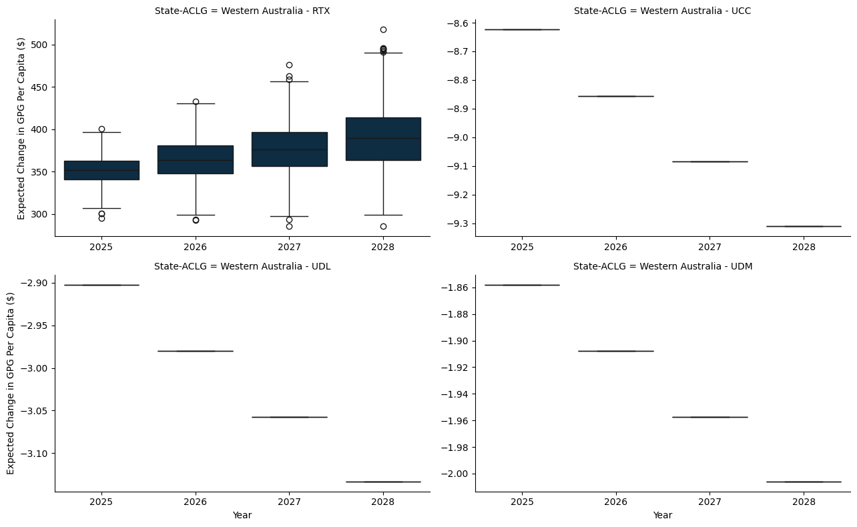

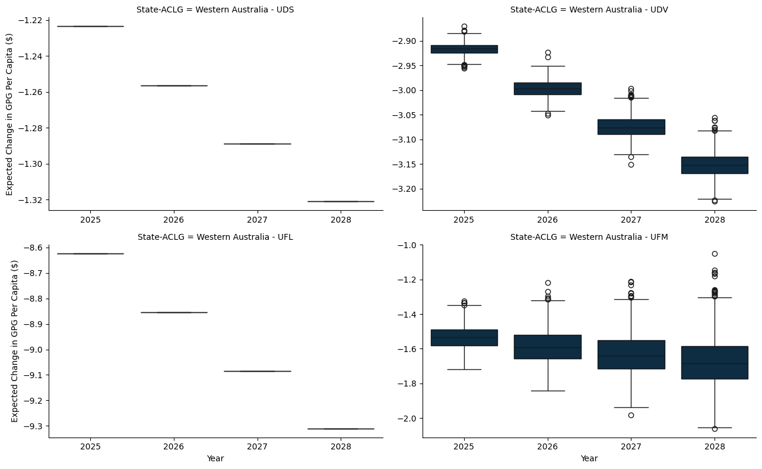

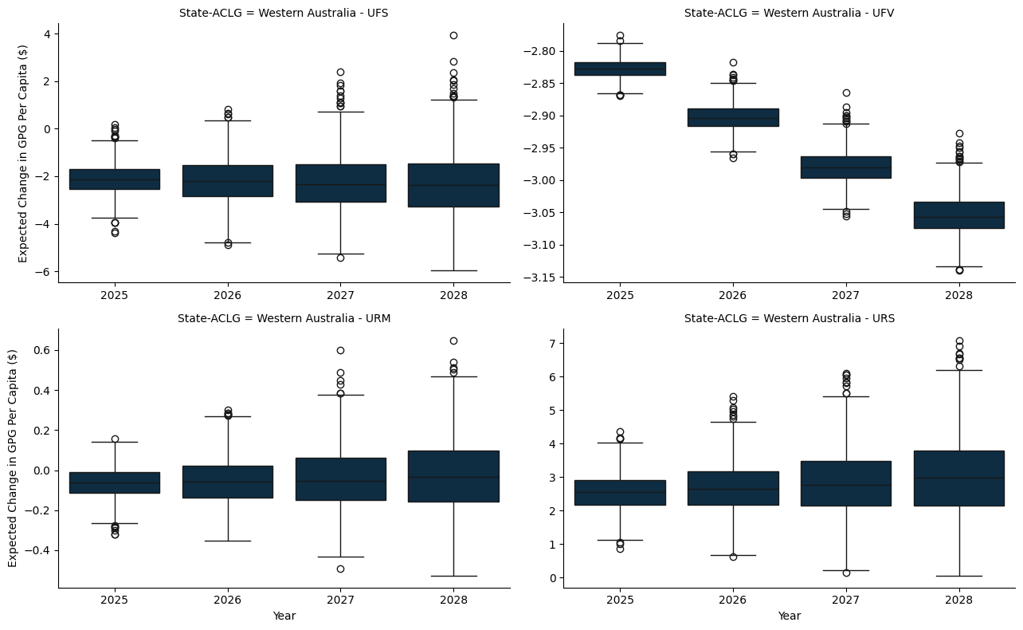

### C.1.6 Tasmania

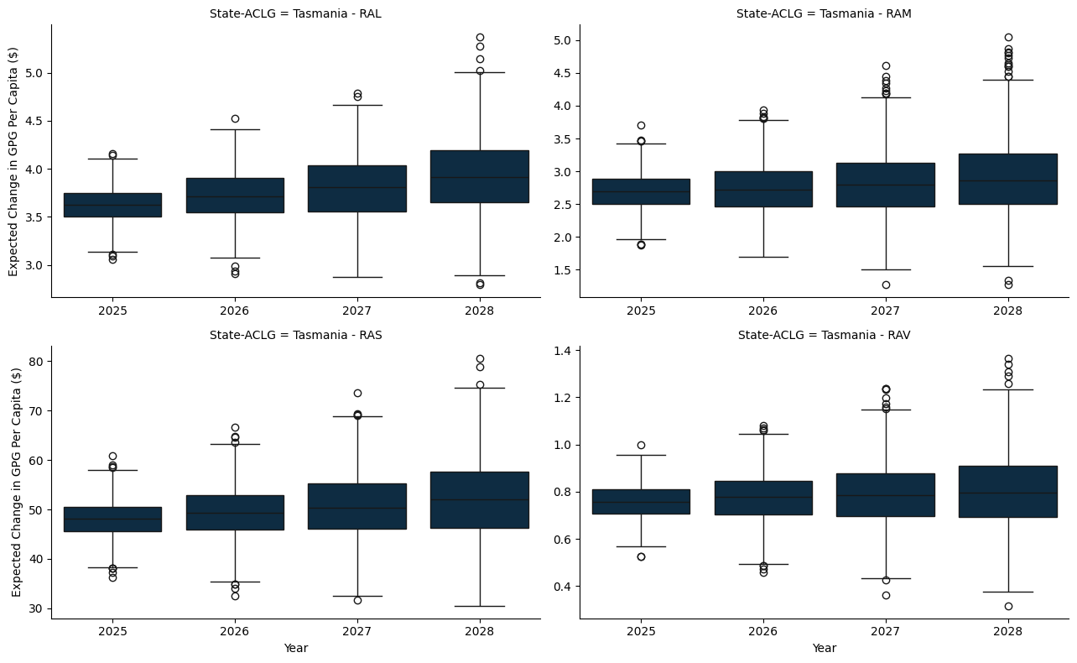

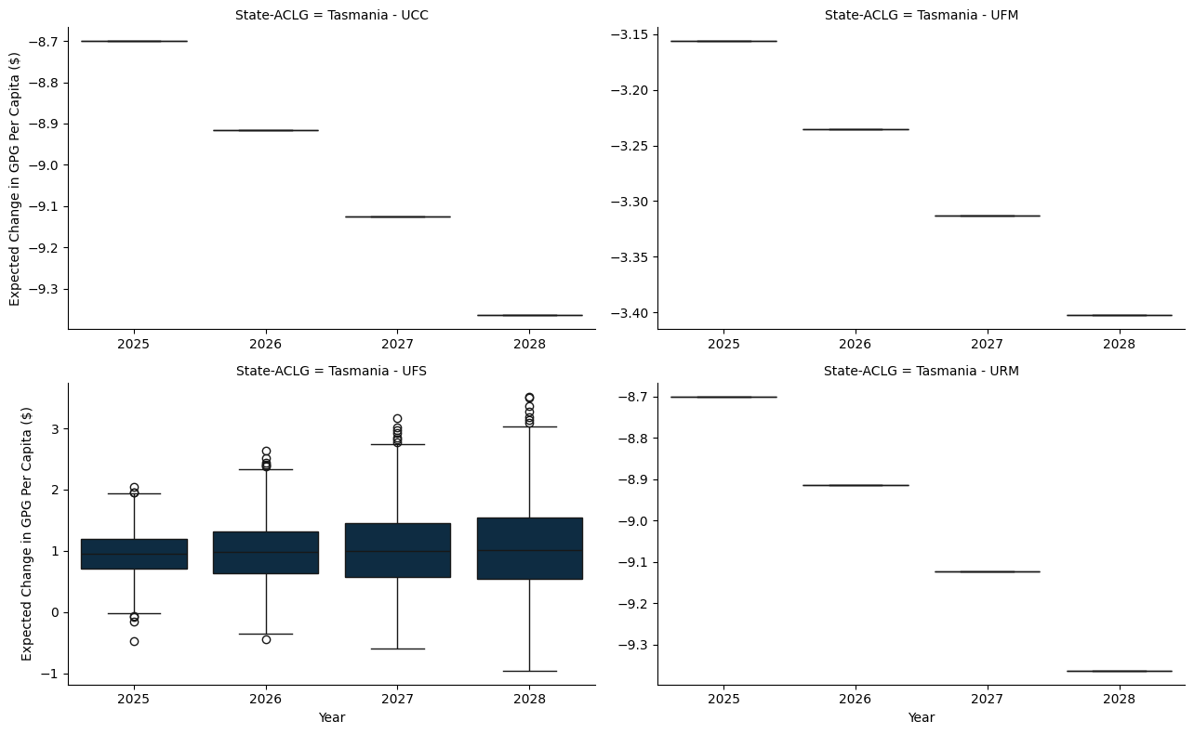

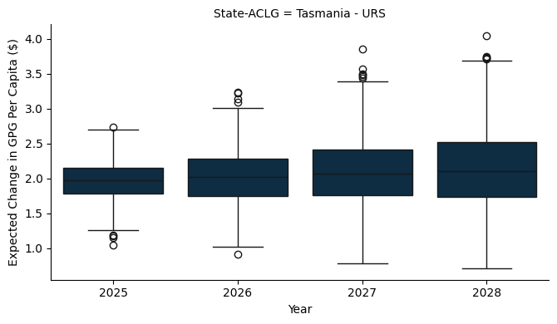

### C.1.7 Northern Territory

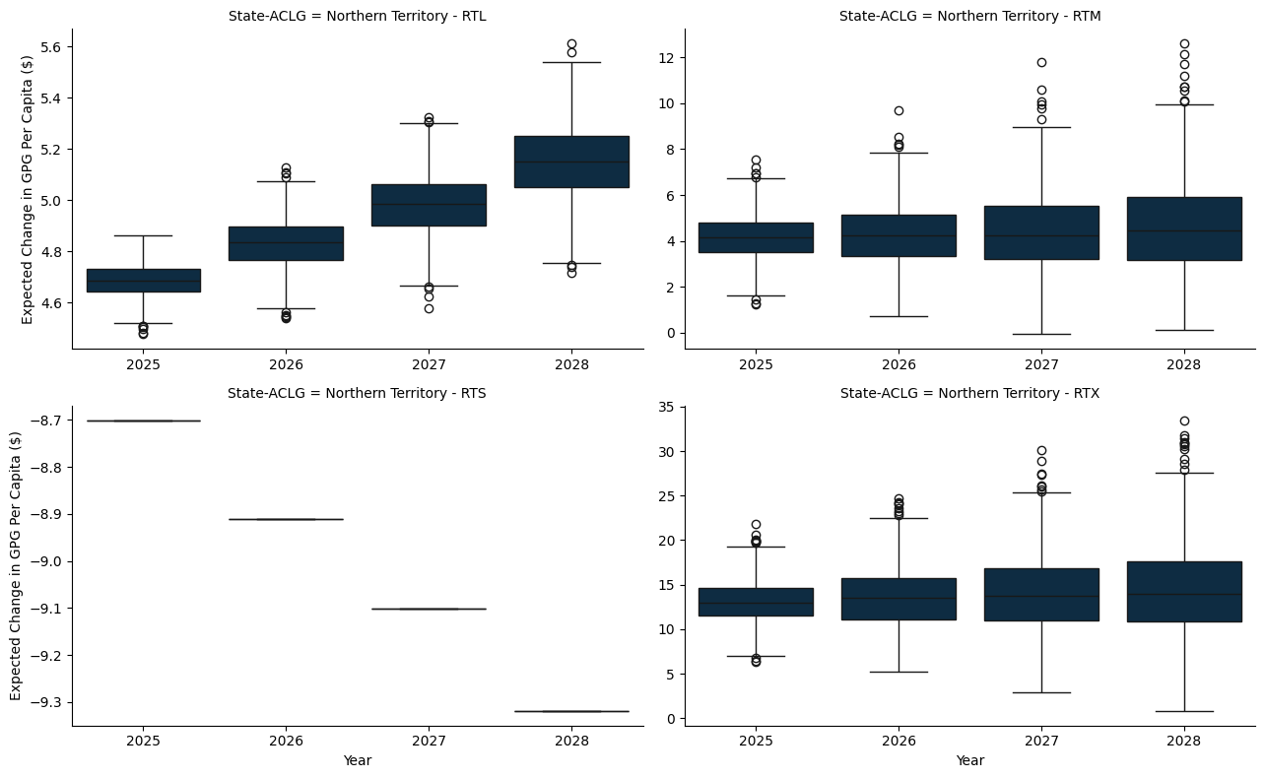

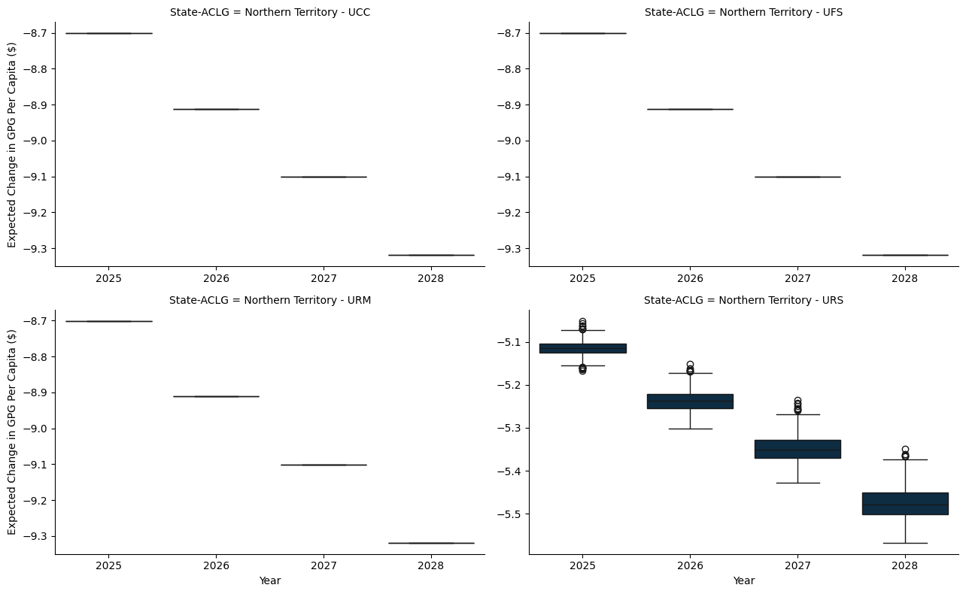

# Appendix D — A 10% Per Capita Minimum Grant - Gains and Losses

* The model here applies a hypothetical per capita minimum grant constraint, set at 10%, to ensure that each jurisdiction receives at least this proportion of the funds if they were allocated on a per capita basis.
* The per capita minimum for the benchmark scenario is set to 30%, as is the status quo.

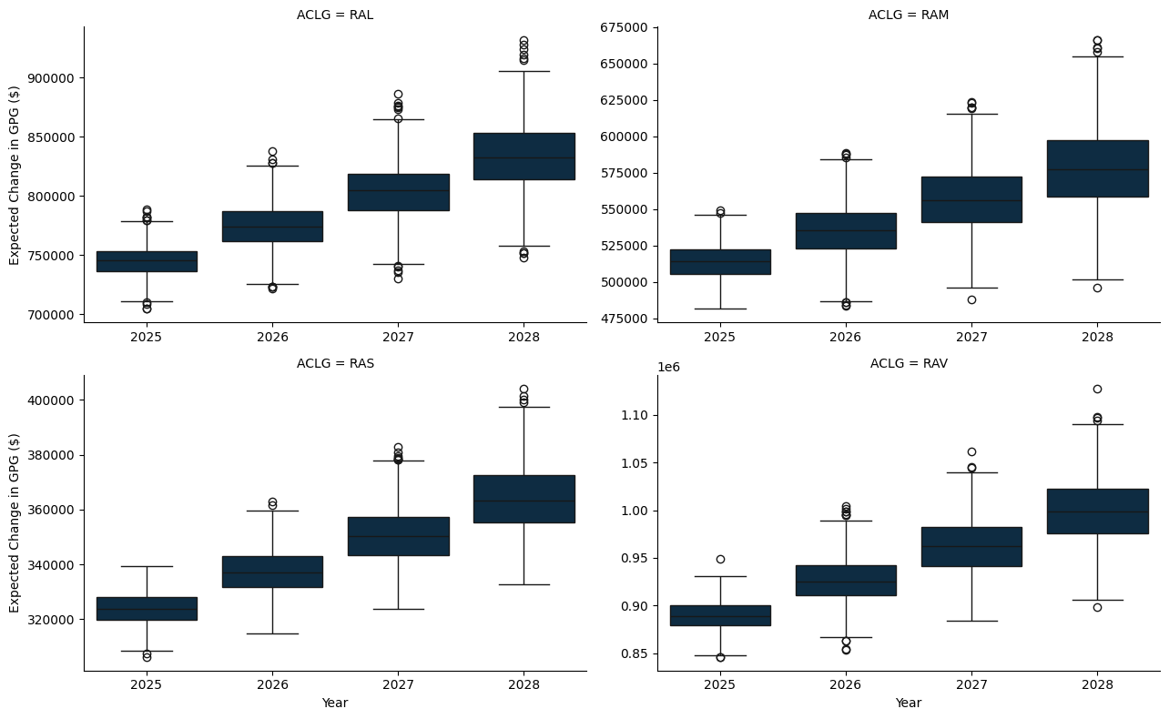

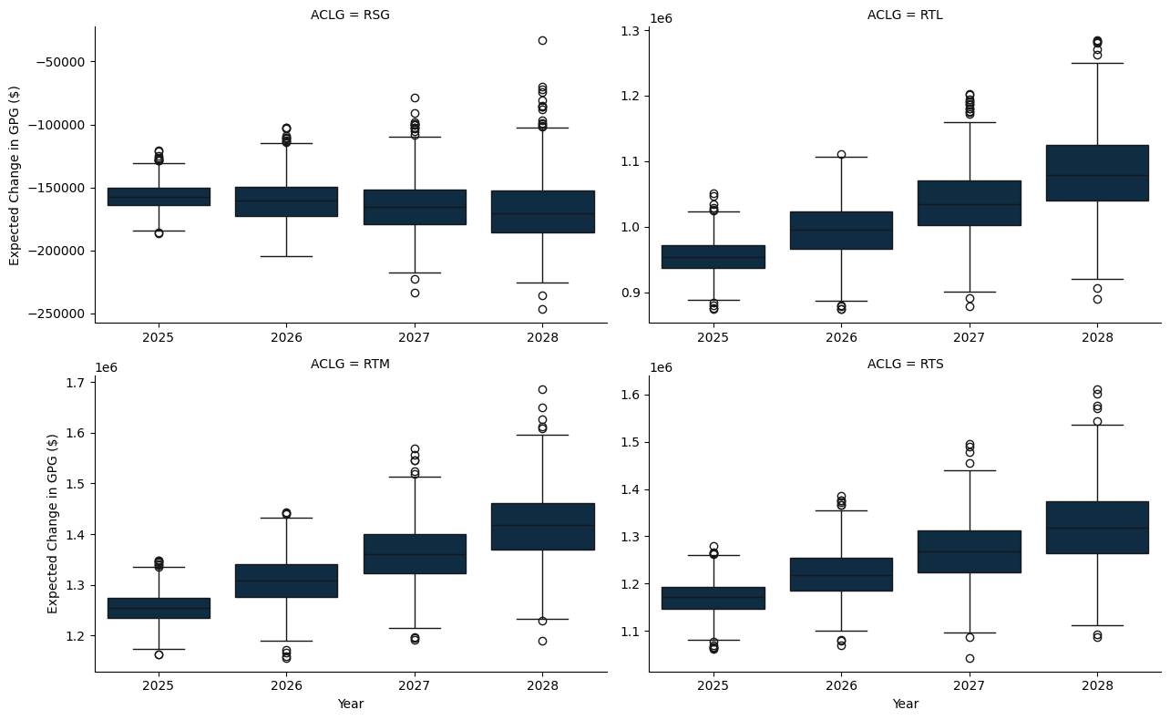

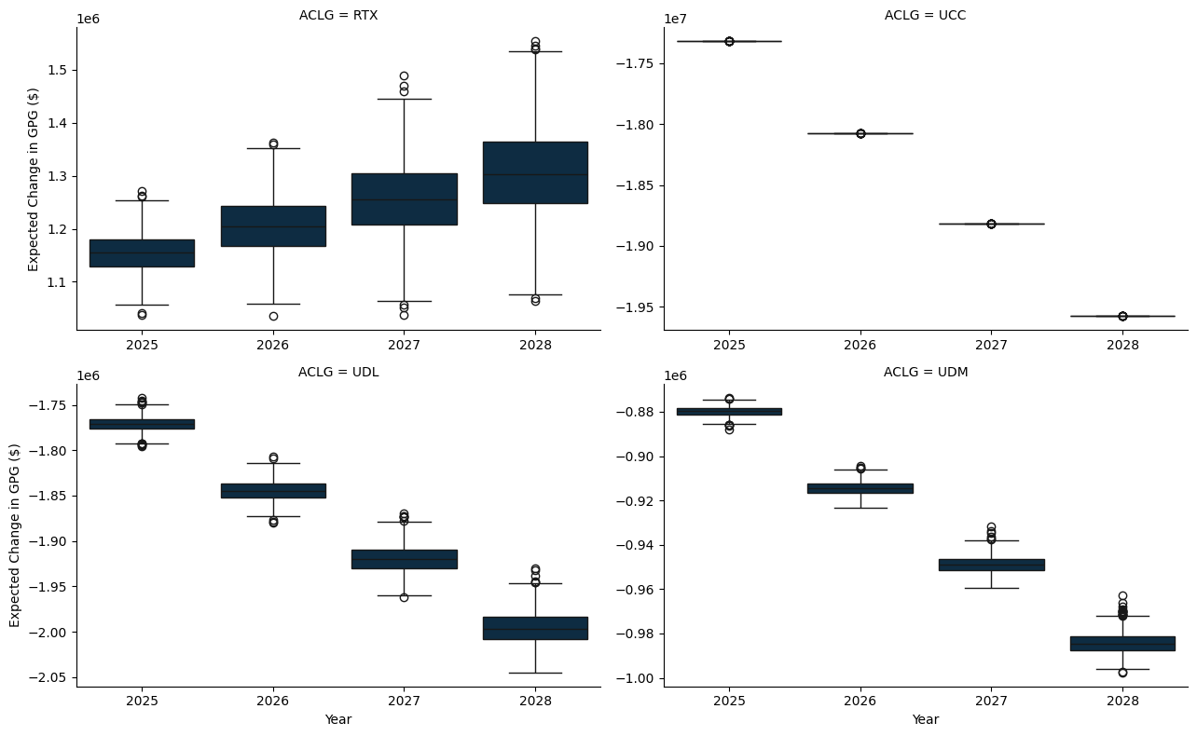

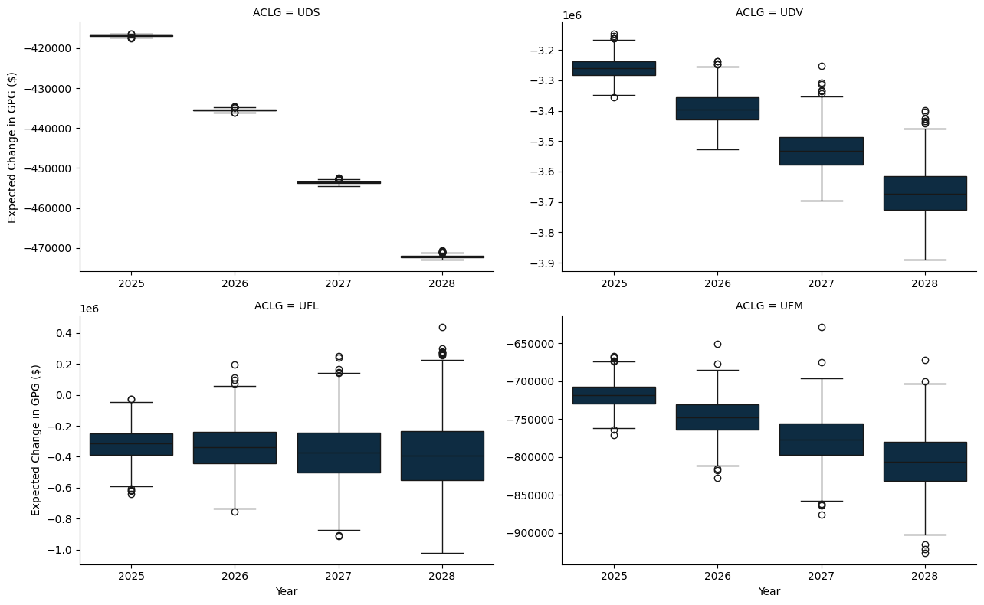

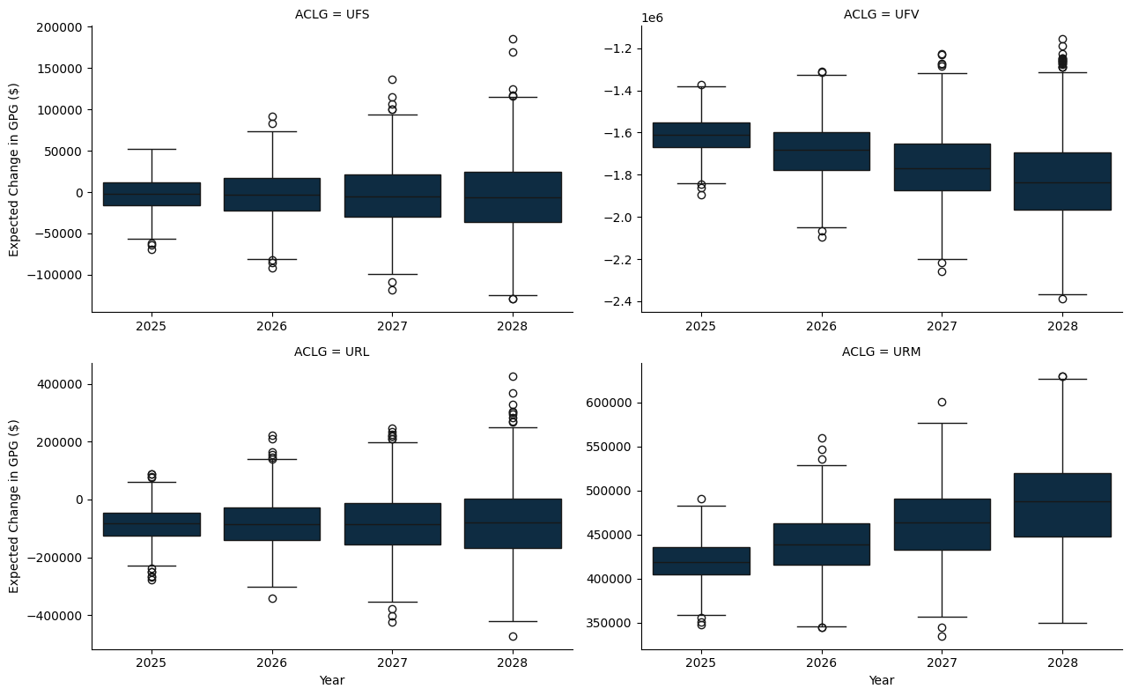

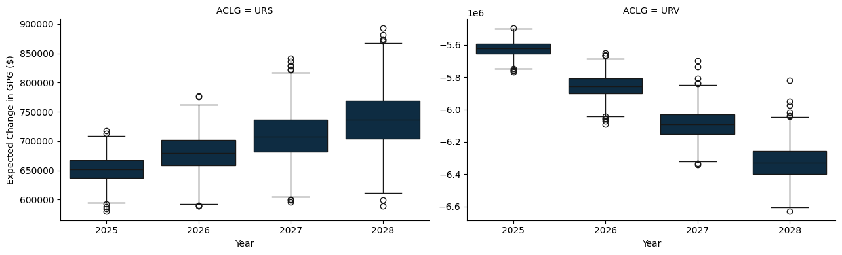

## D.1 A State and Territory breakdown

### D.1.1 New South Wales

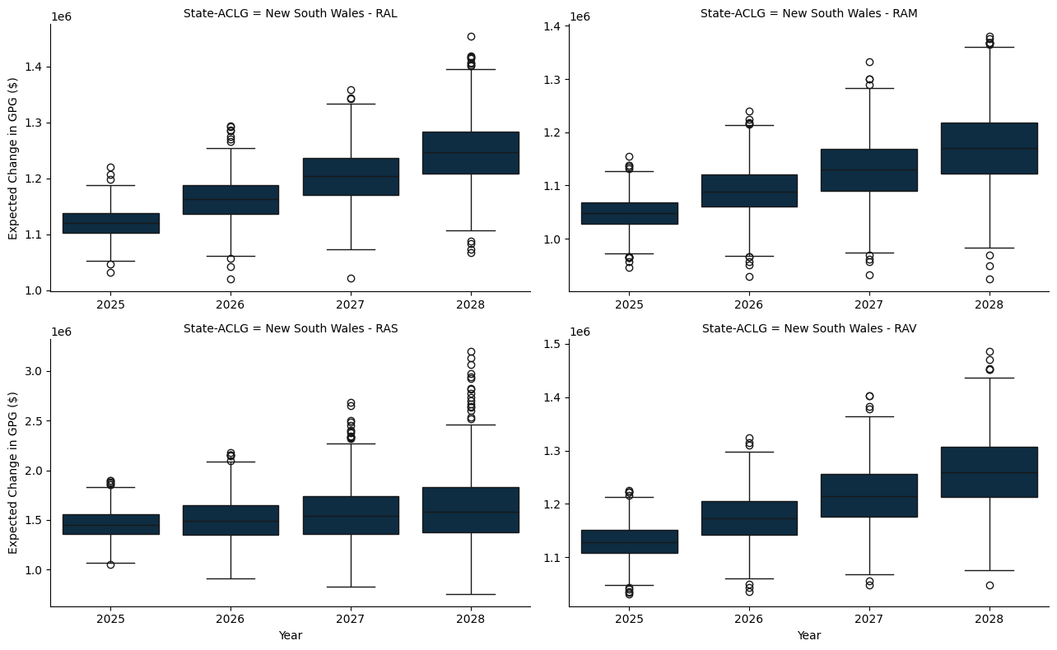

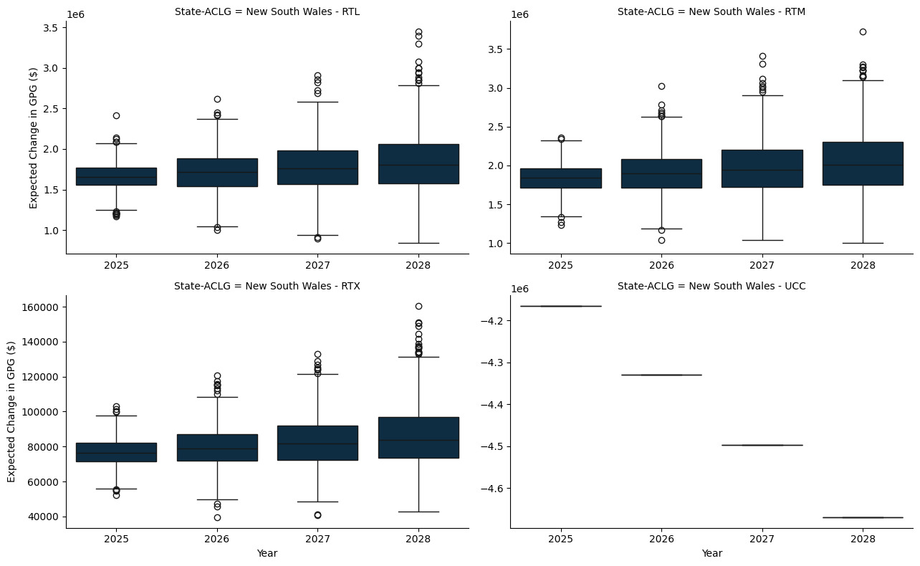

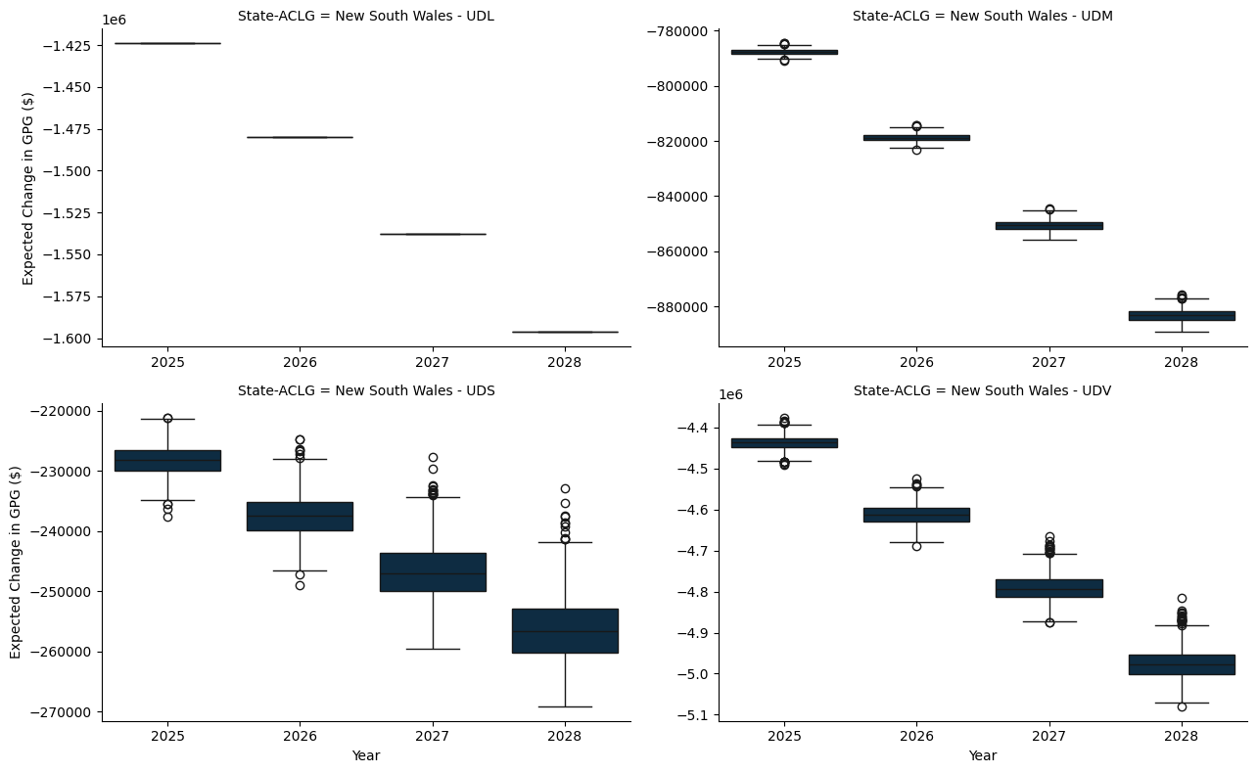

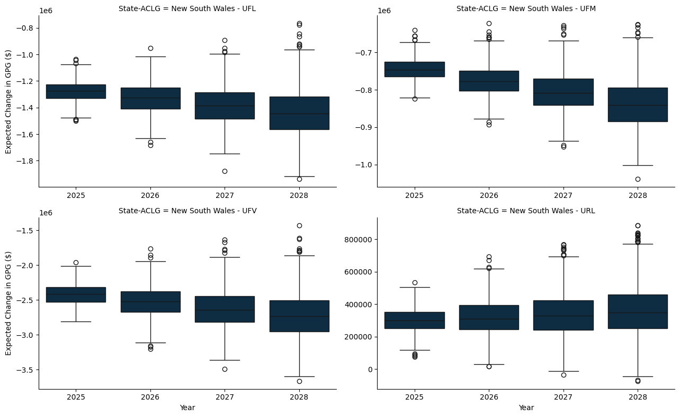

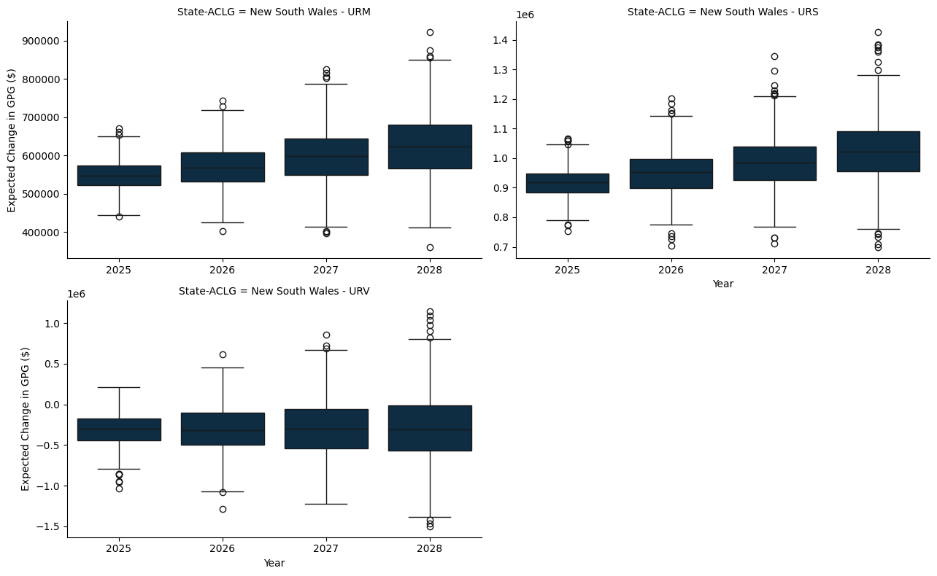

### D.1.2 Victoria

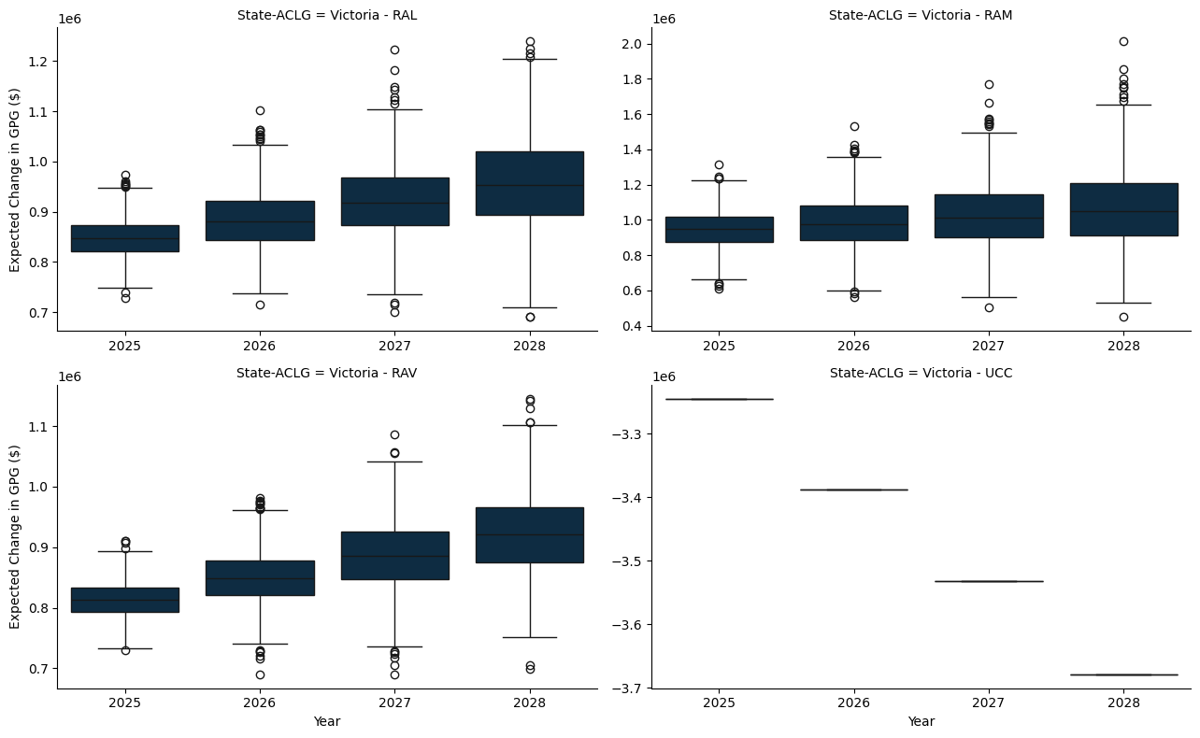

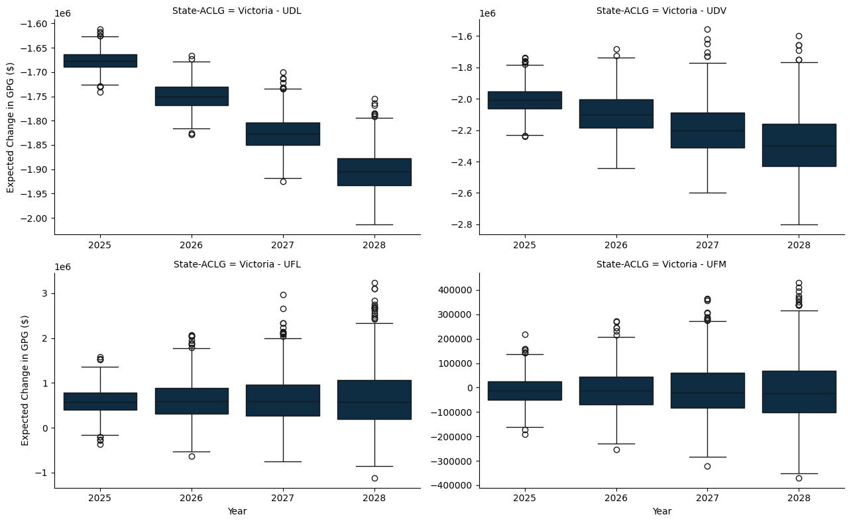

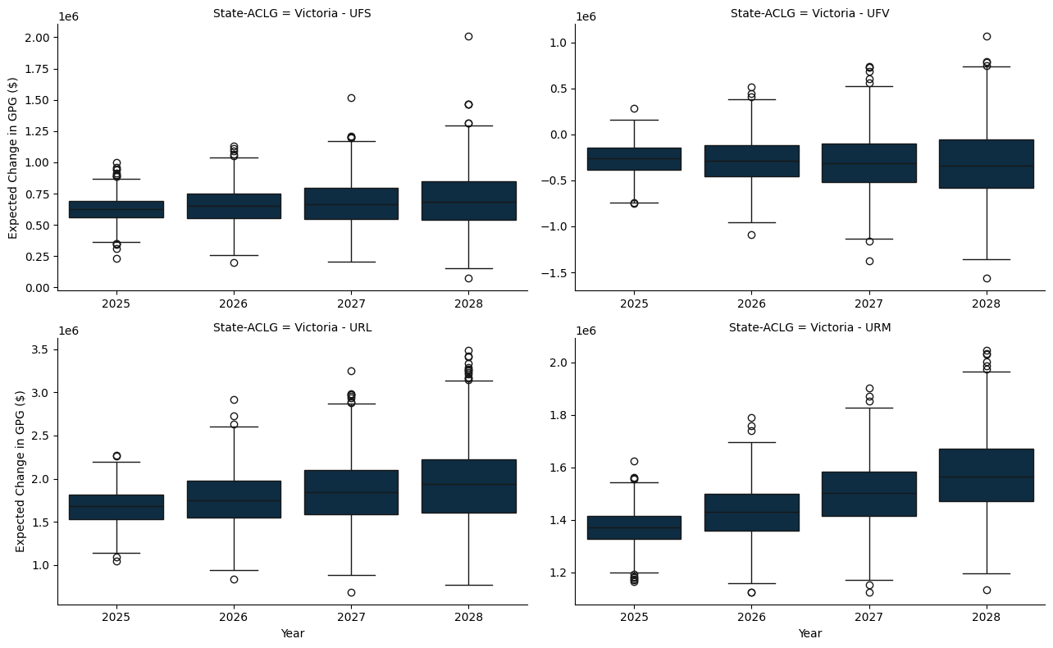

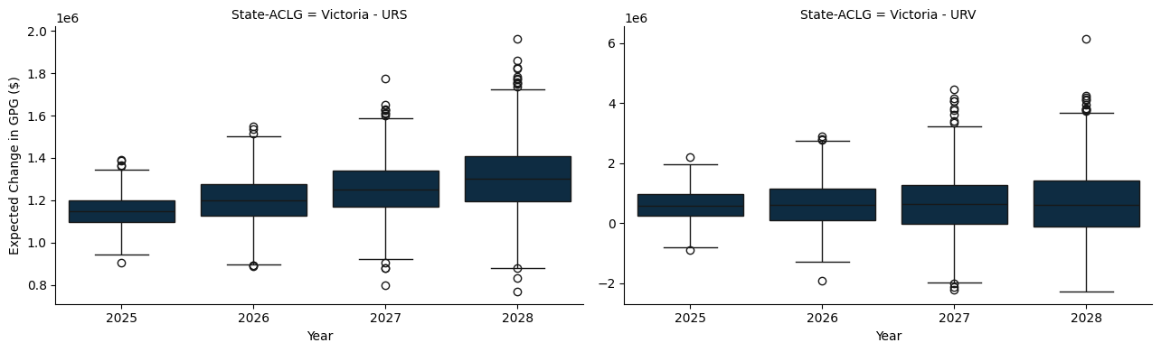

### D.1.3 Queensland

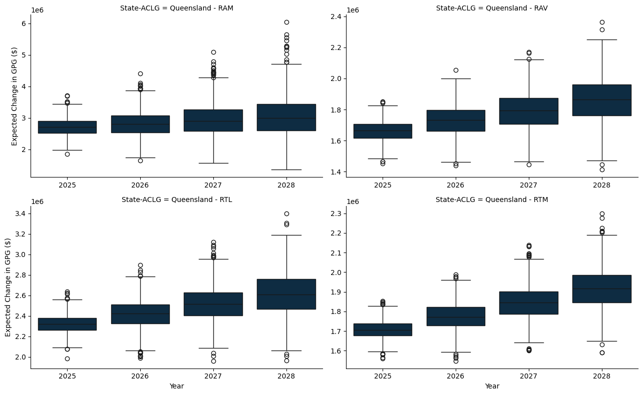

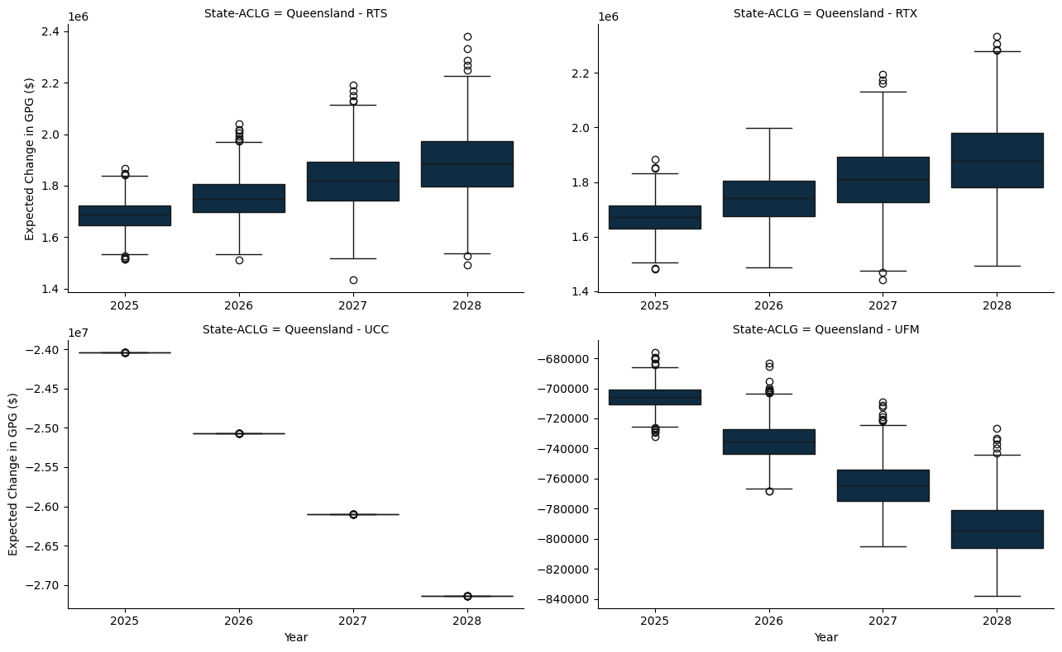

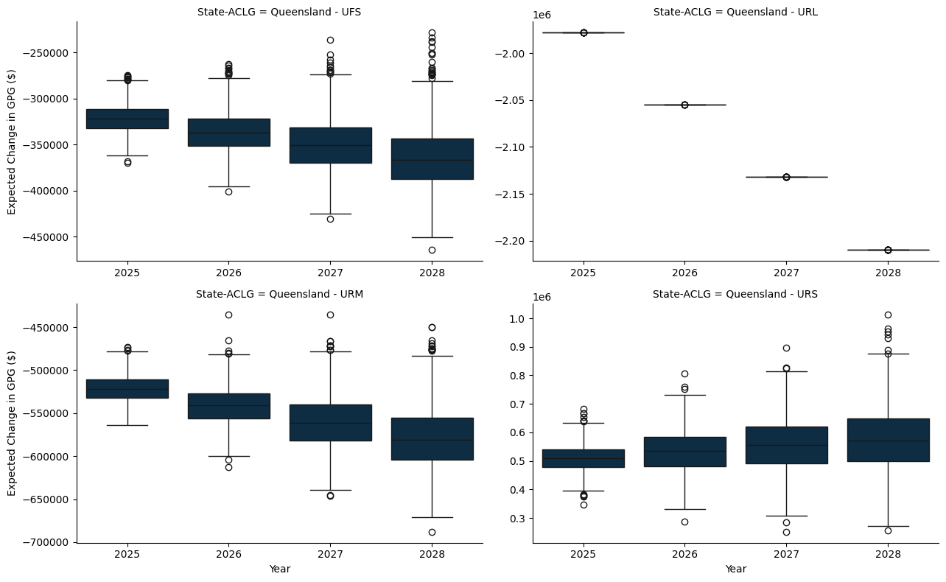

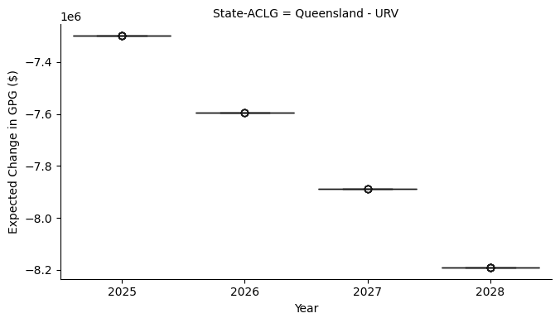

### D.1.4 South Austrlalia

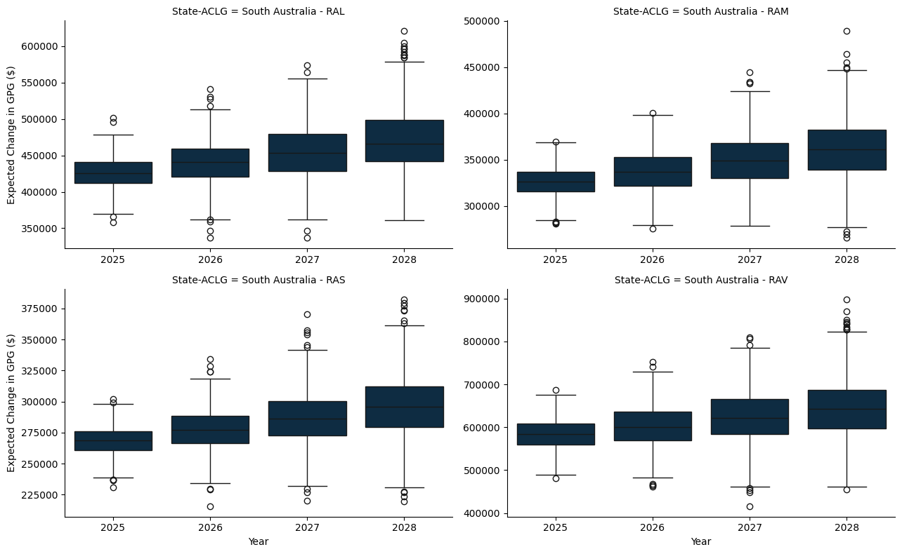

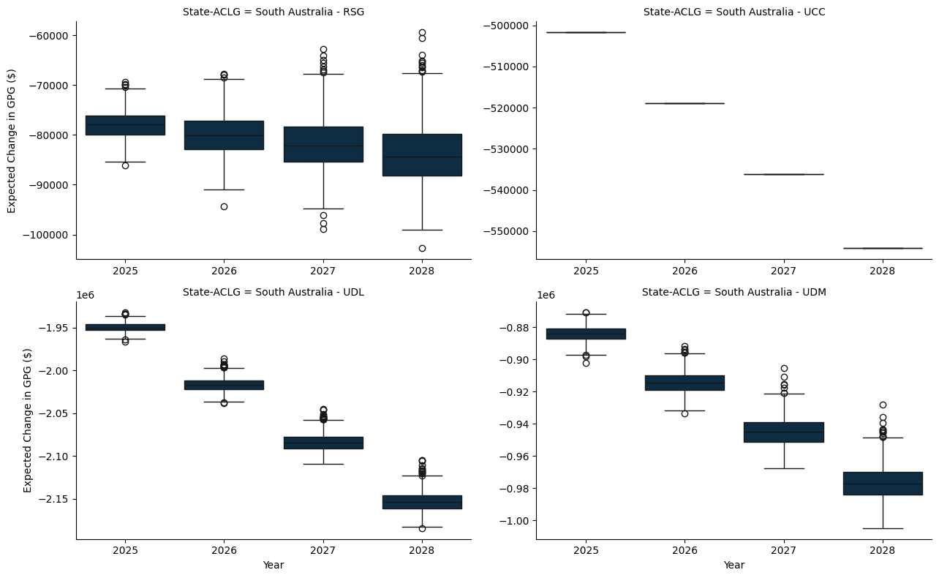

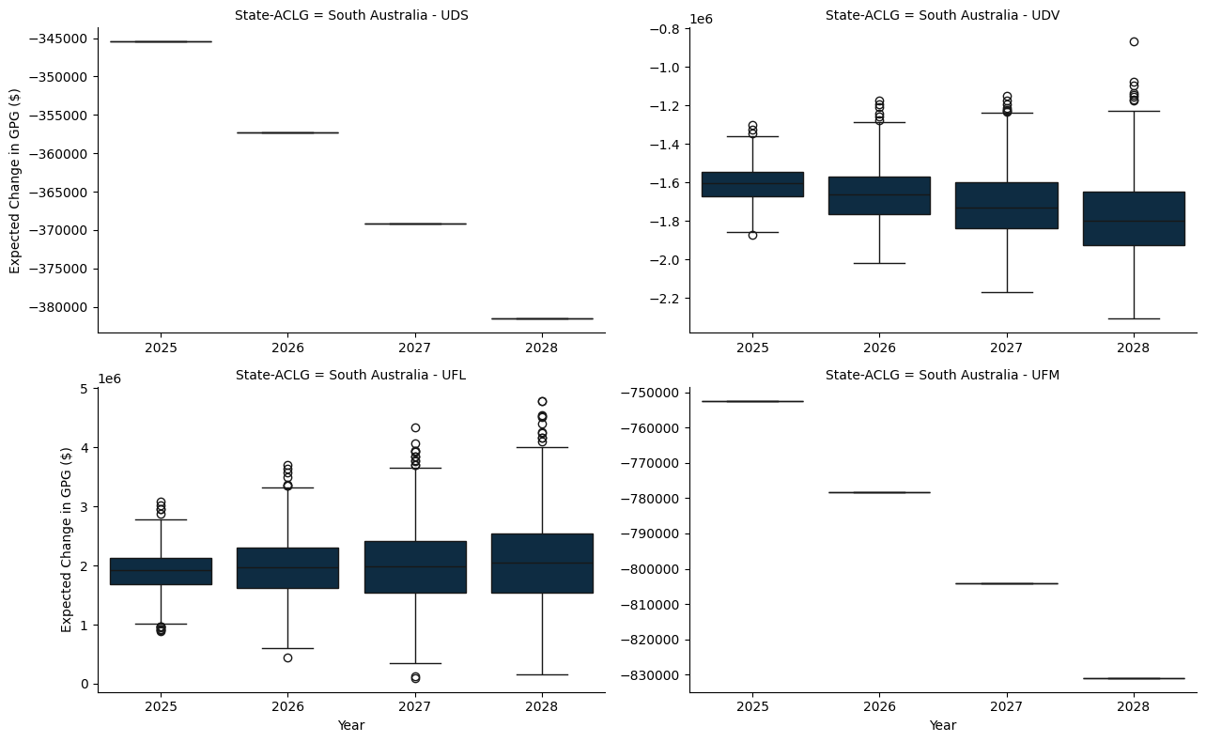

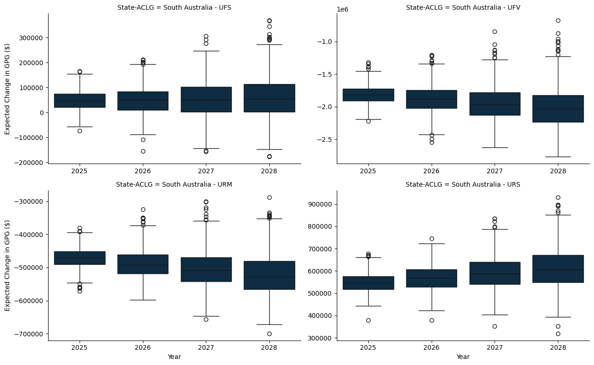

### D.1.5 Western Australia

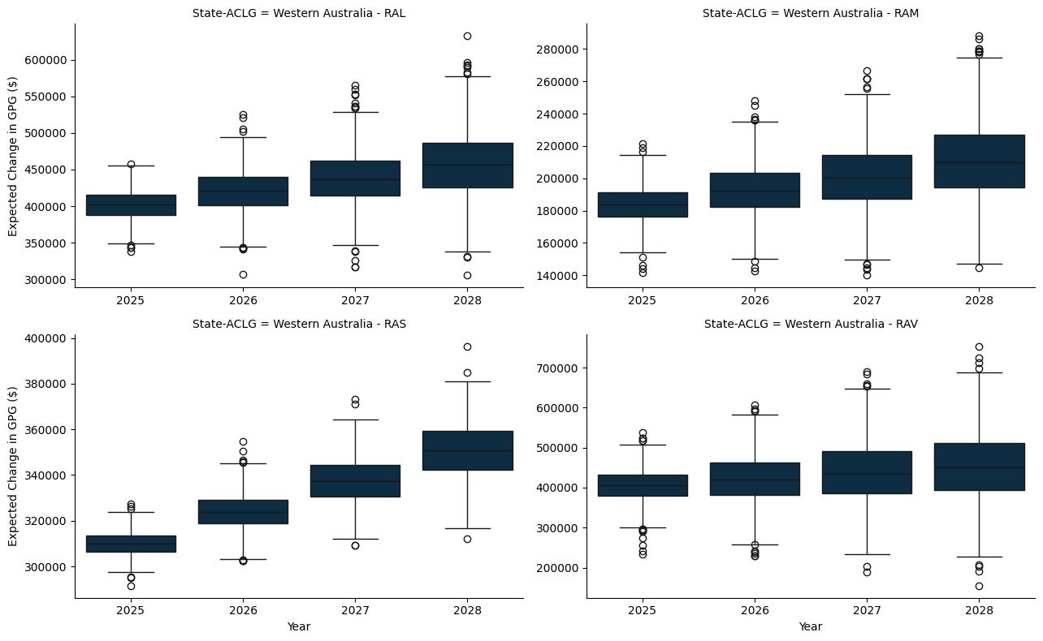

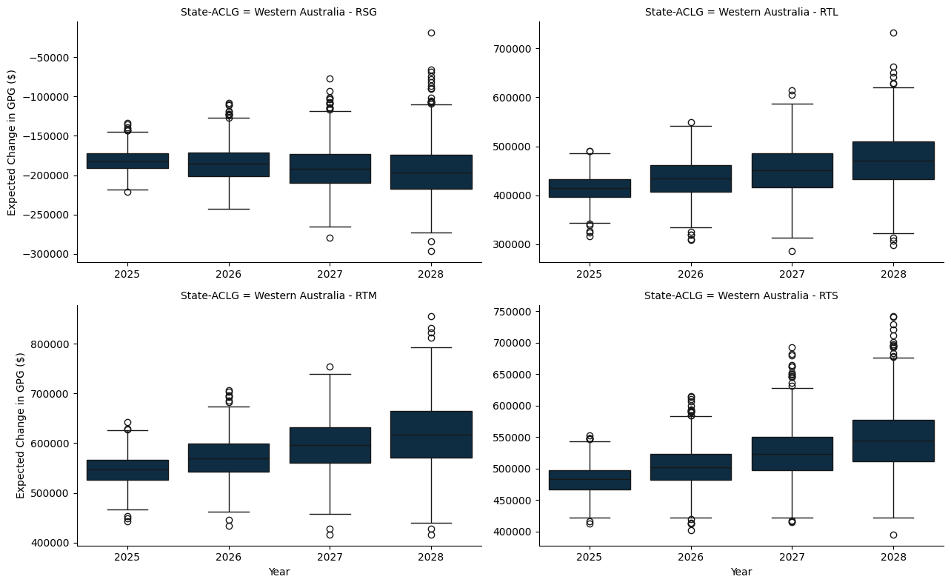

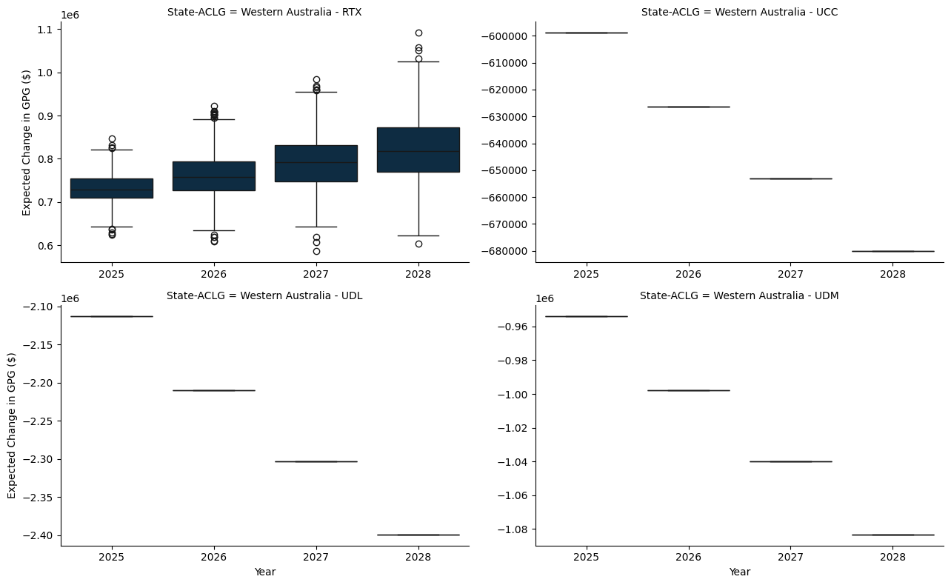

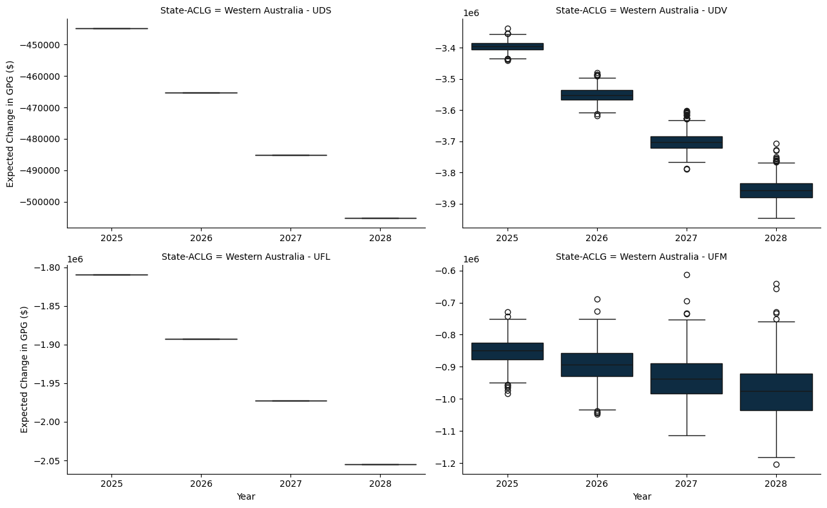

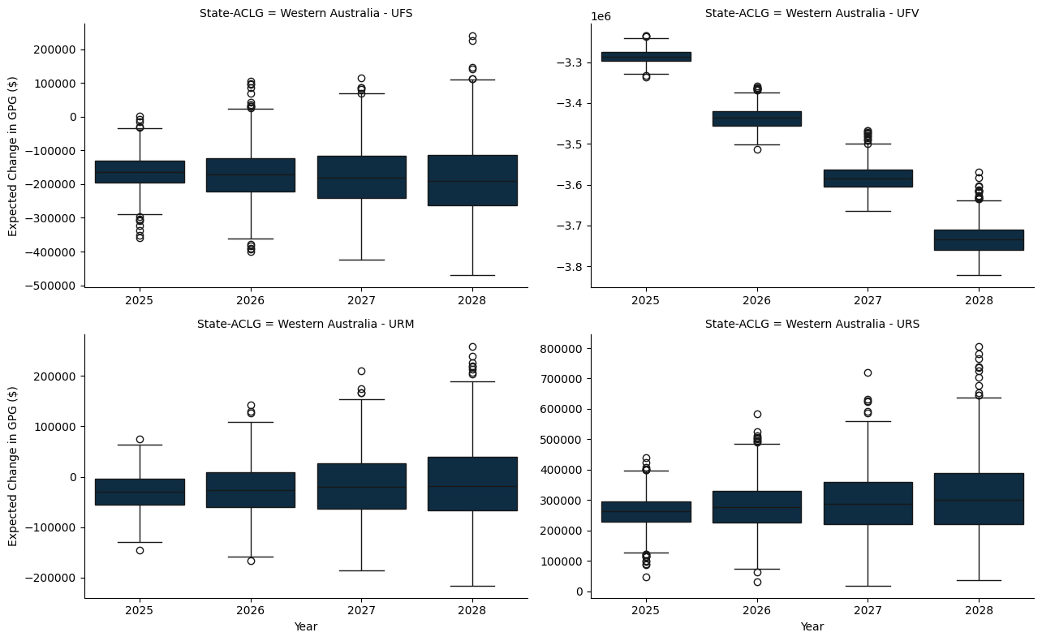

### D.1.6 Tasmania

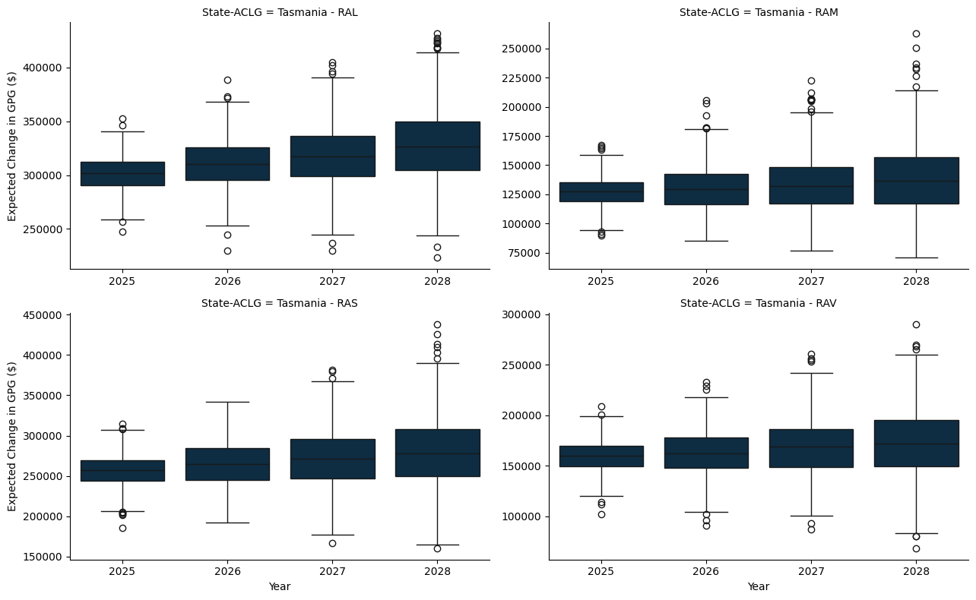

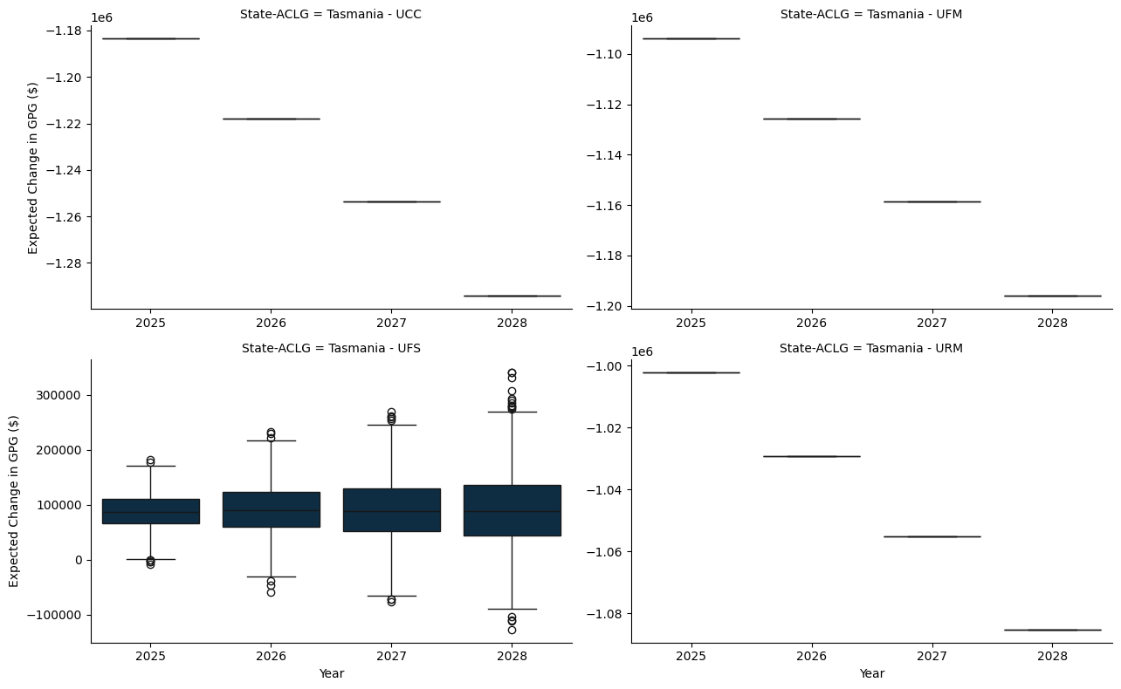

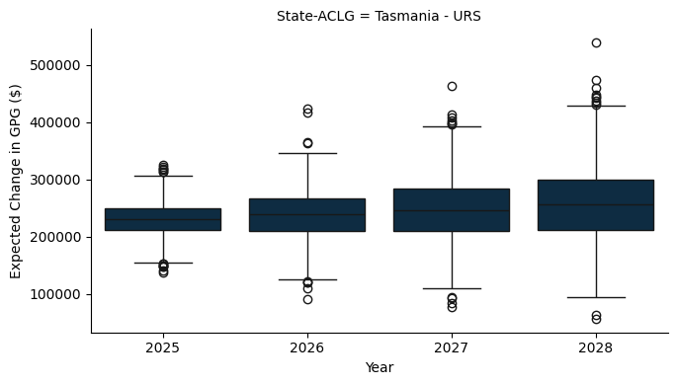

### D.1.7 Northern Territory

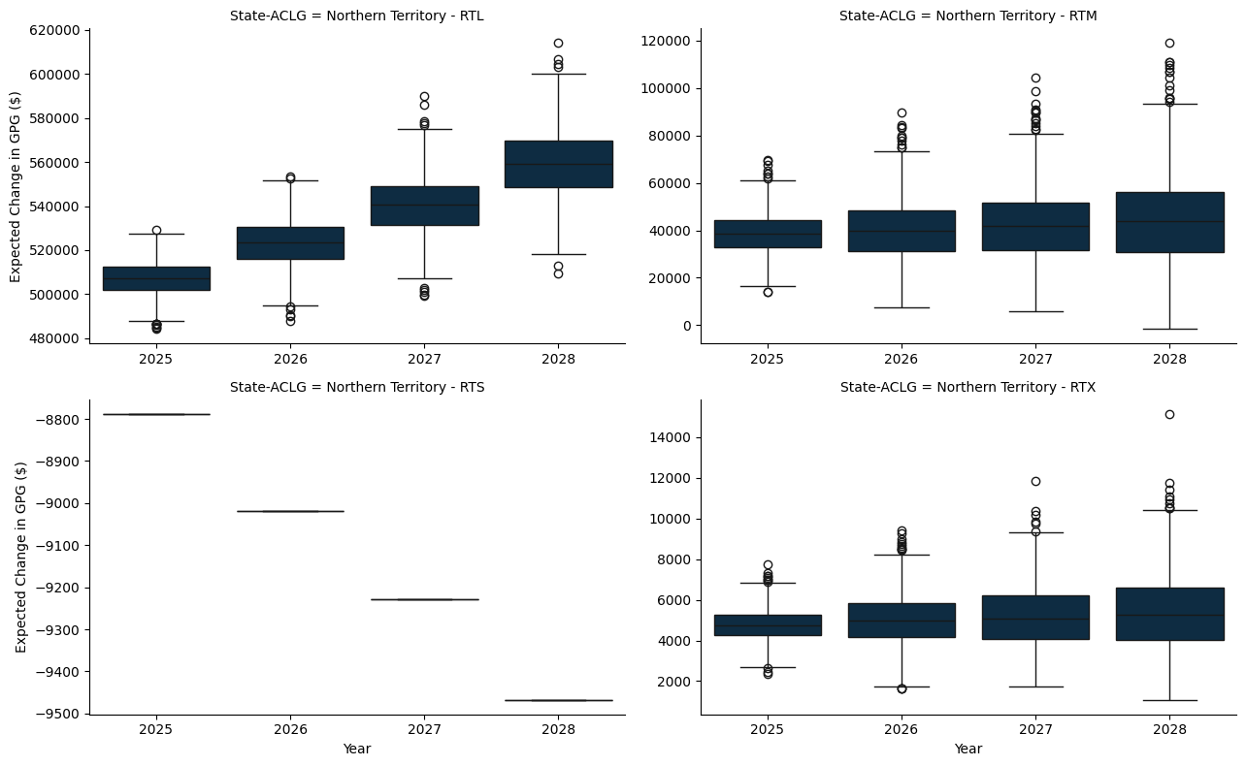

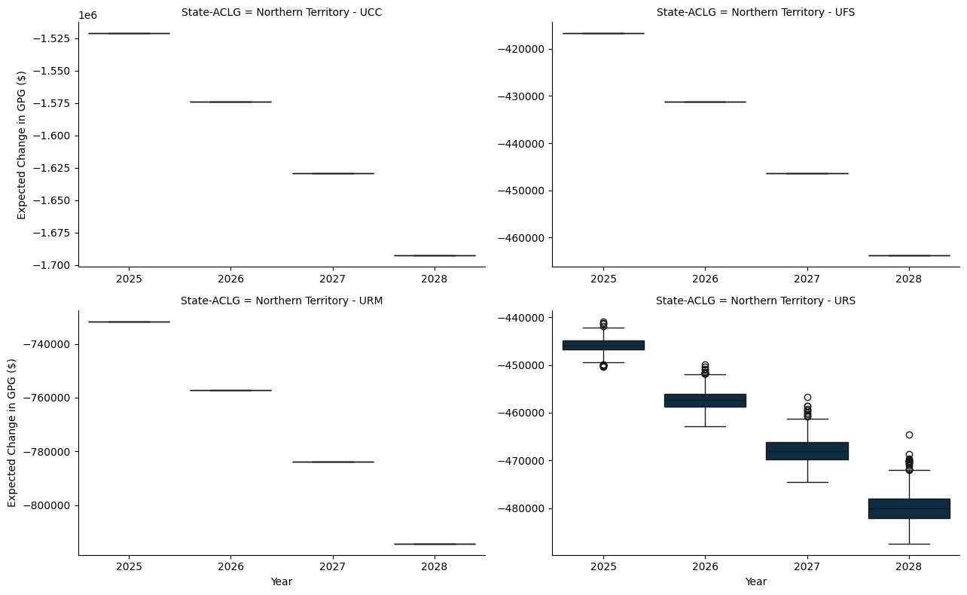

# Appendix E — A 10% Per Capita Minimum Grant - A per capita study

* The model here applies a hypothetical per capita minimum grant constraint, set at 10%, to ensure that each jurisdiction receives at least this proportion of the funds if they were allocated on a per capita basis.
* The per capita minimum for the benchmark scenario is set to 30%, as is the status quo.

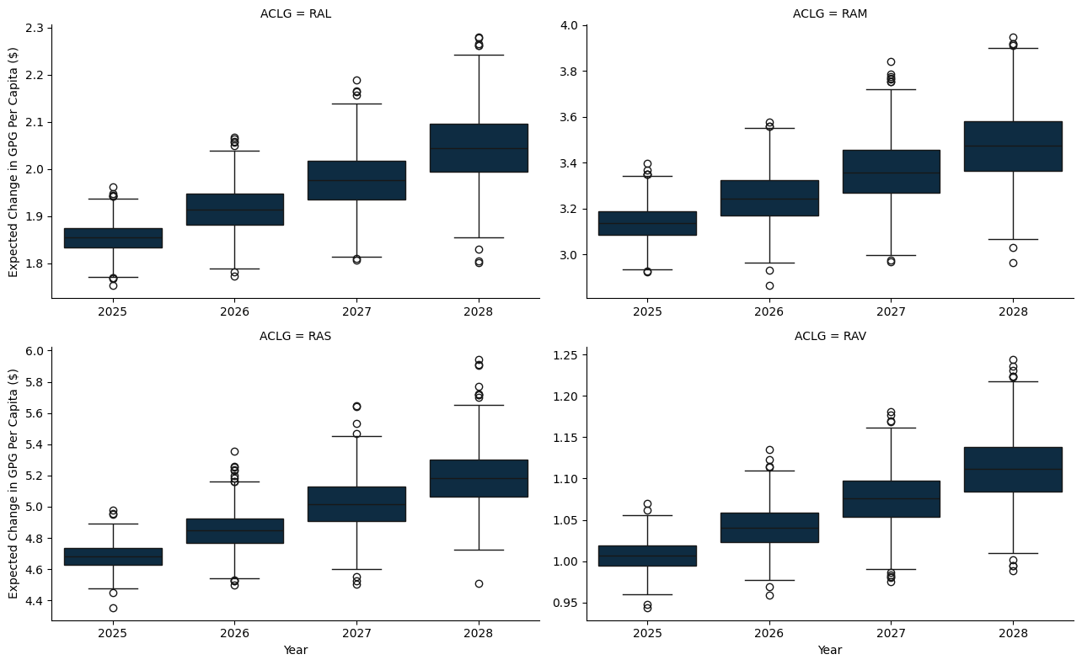

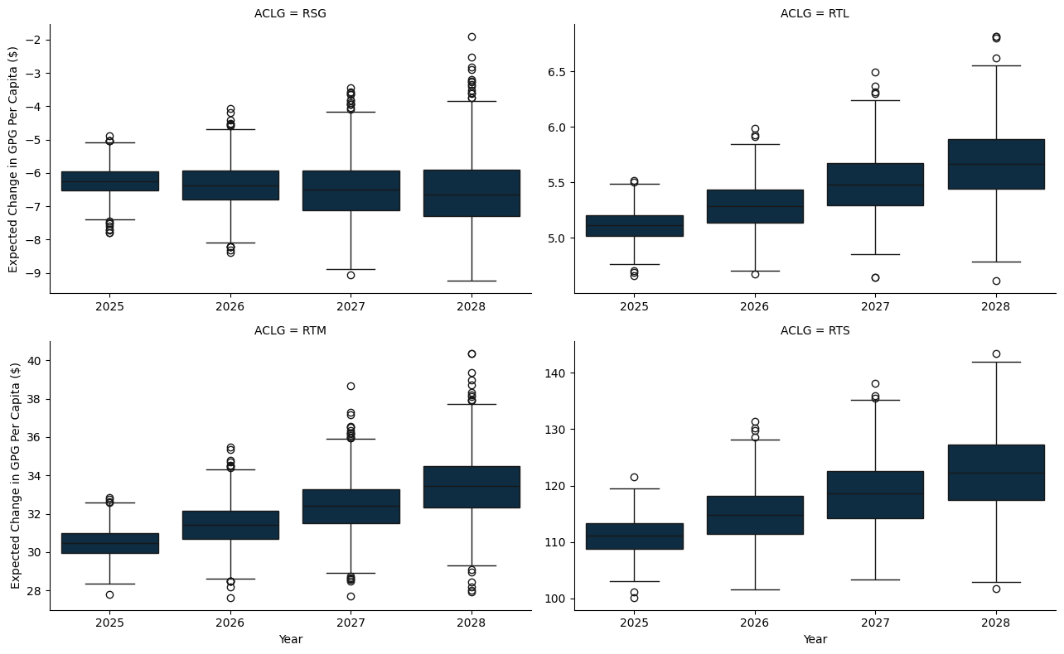

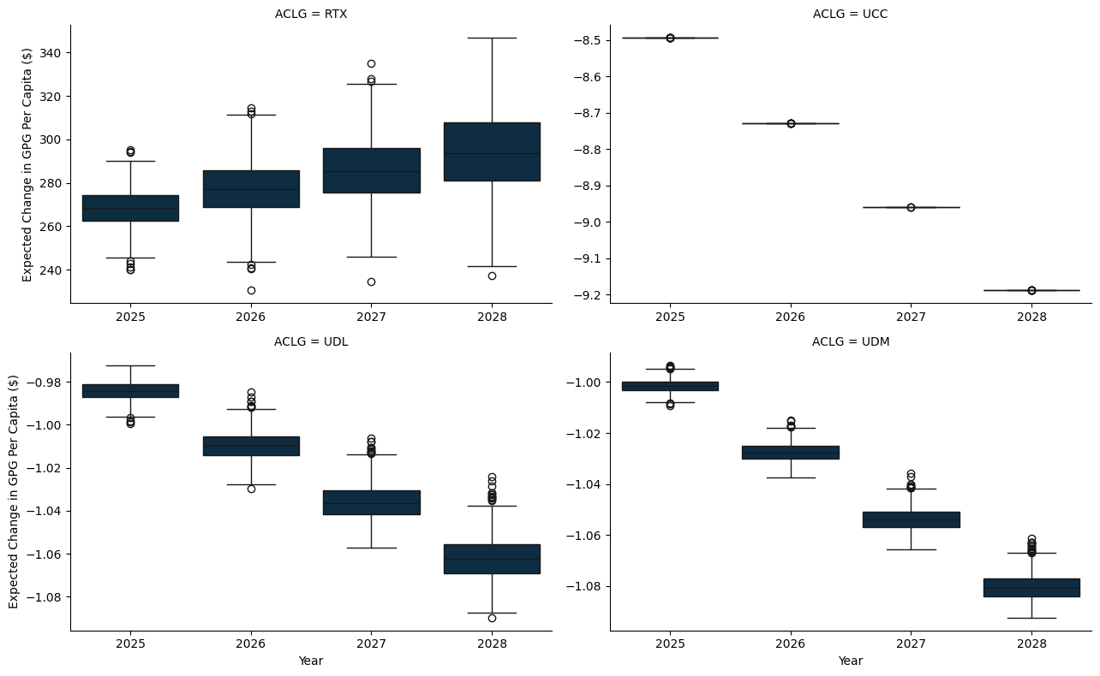

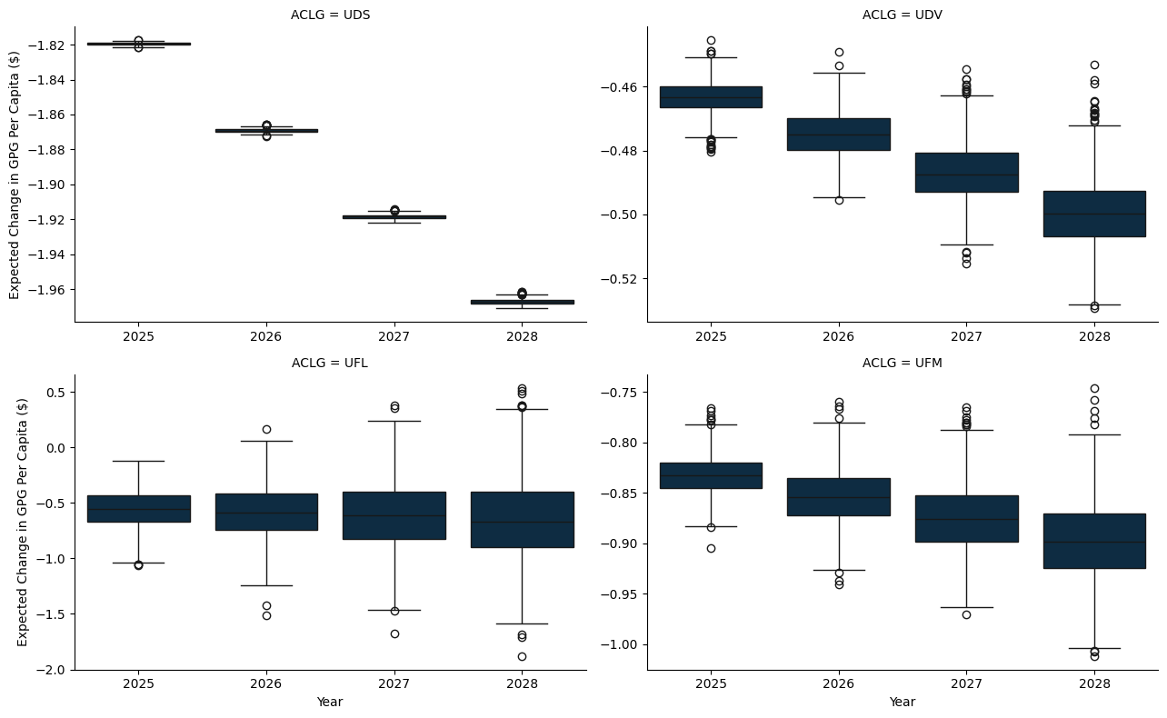

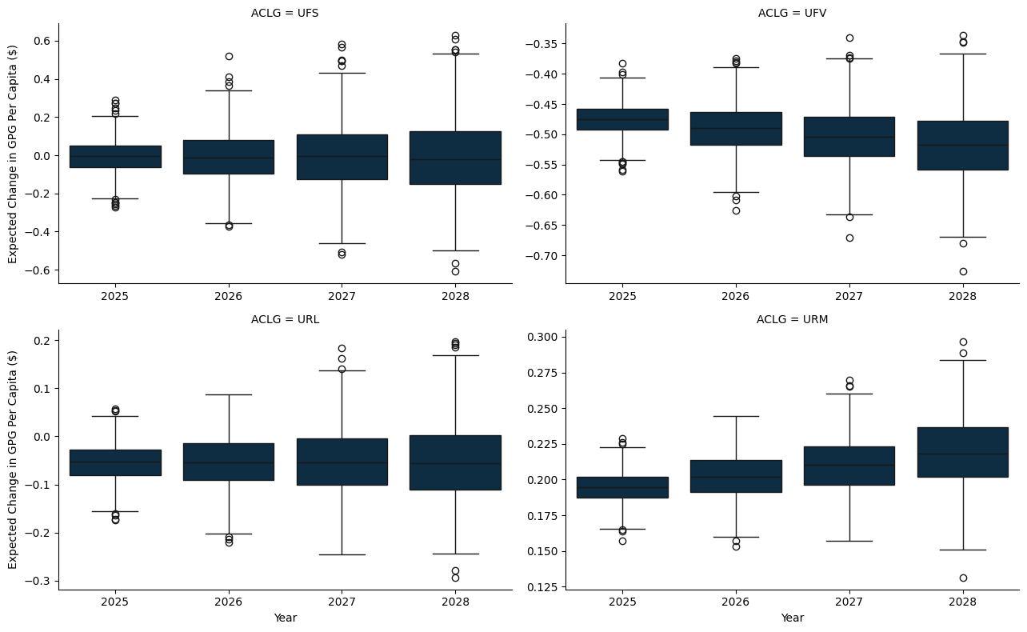

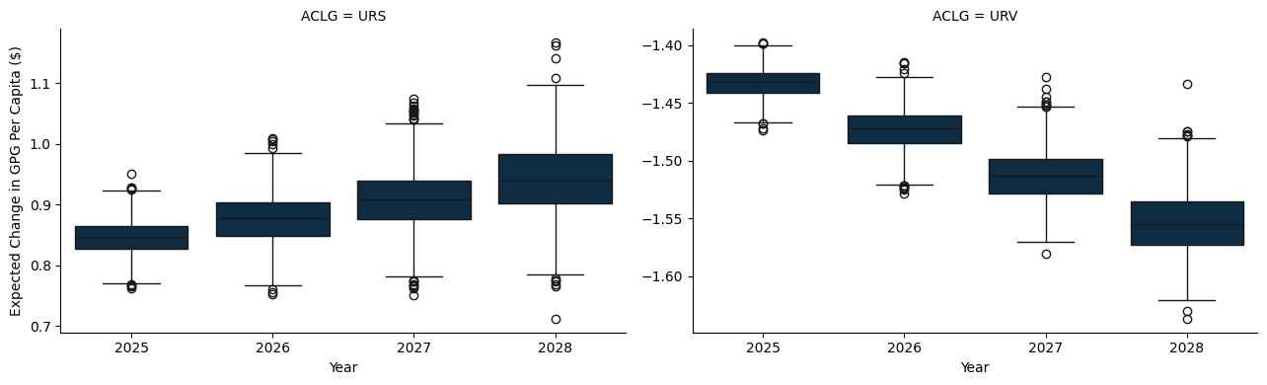

## E.1 A State and Territory breakdown

### E.1.1 New South Wales

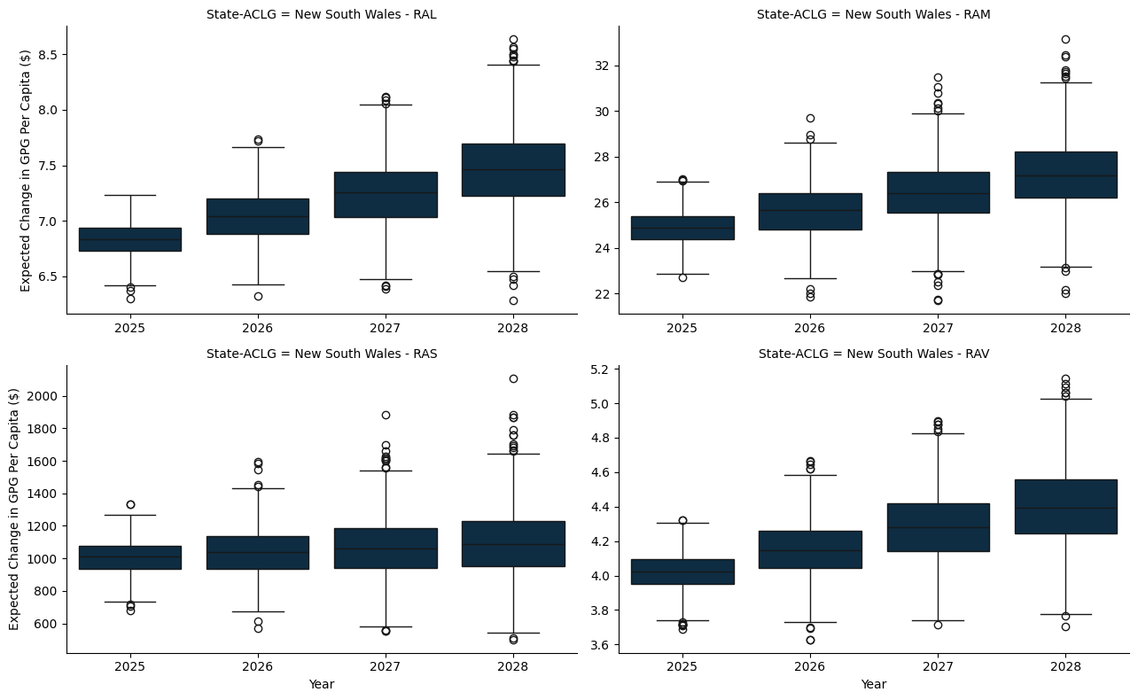

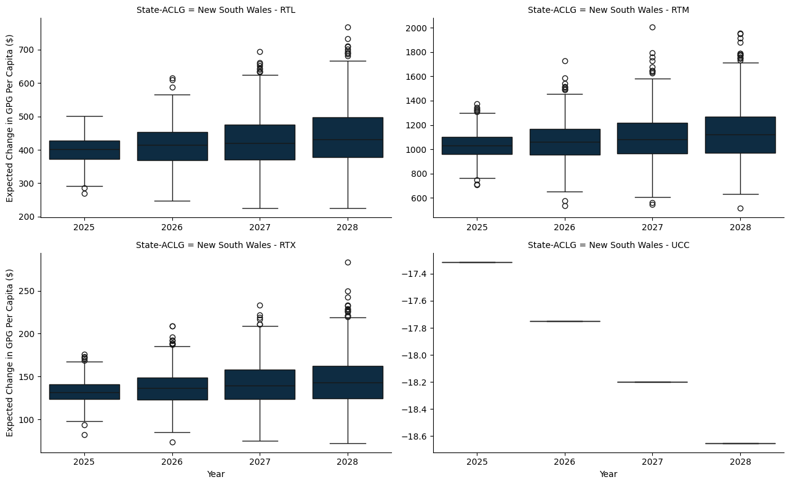

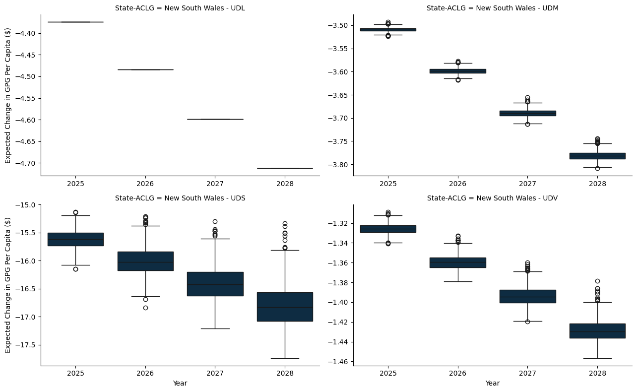

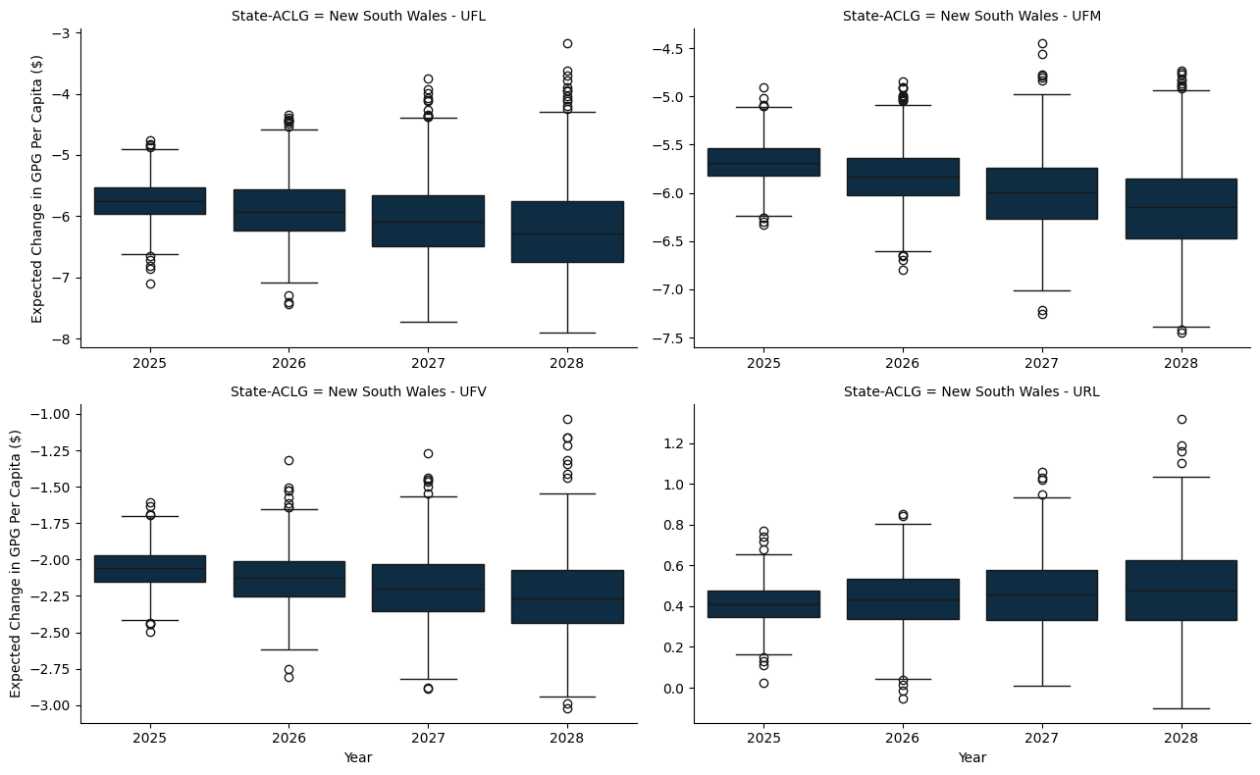

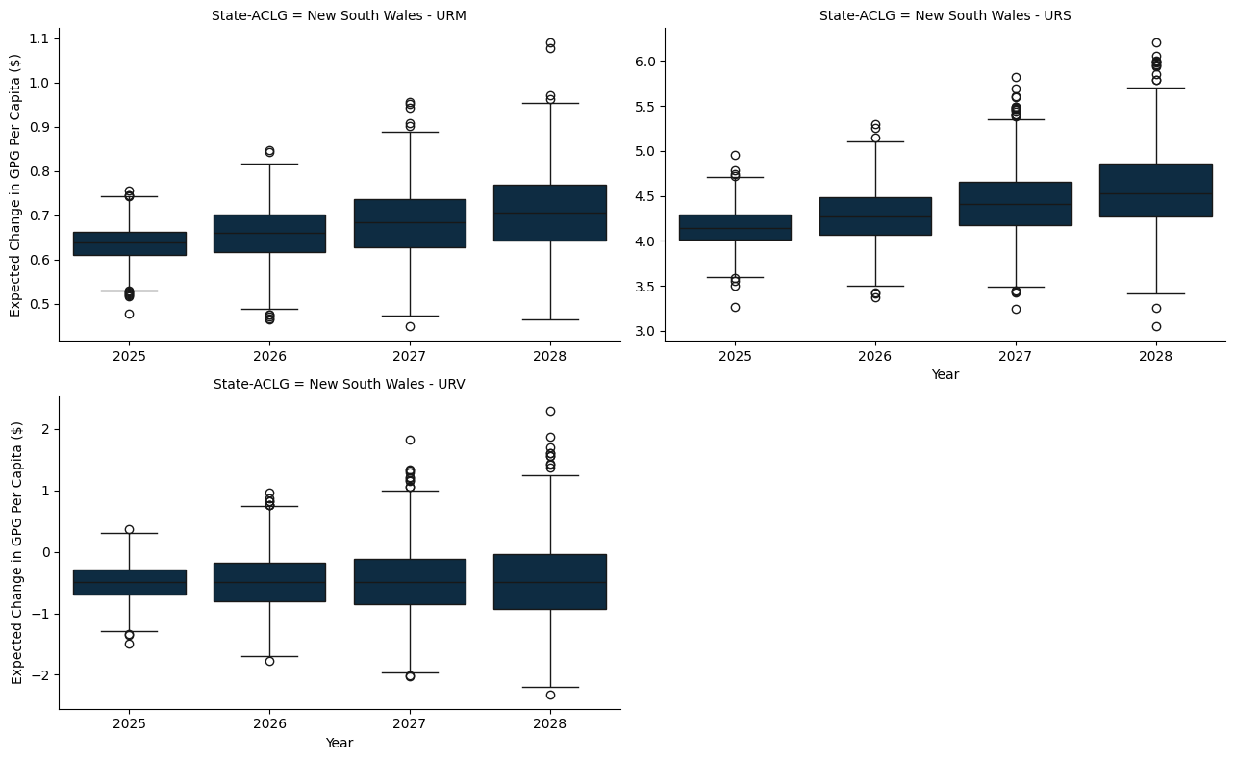

### E.1.2 Victoria

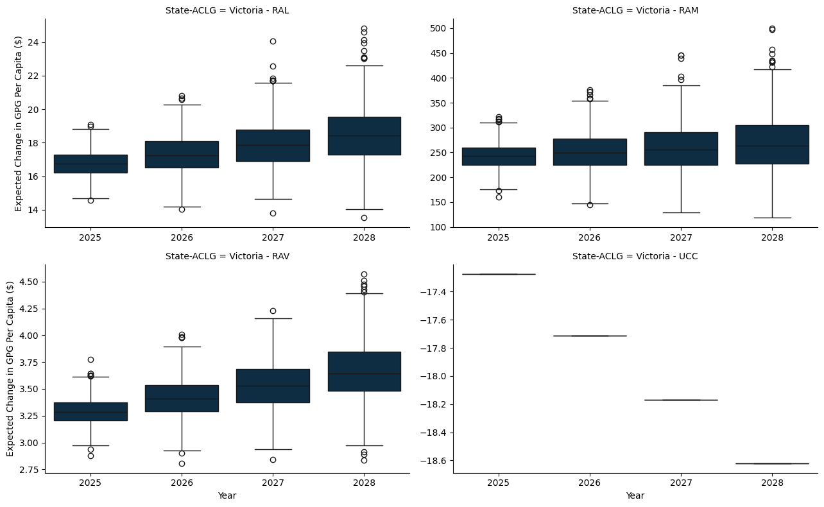

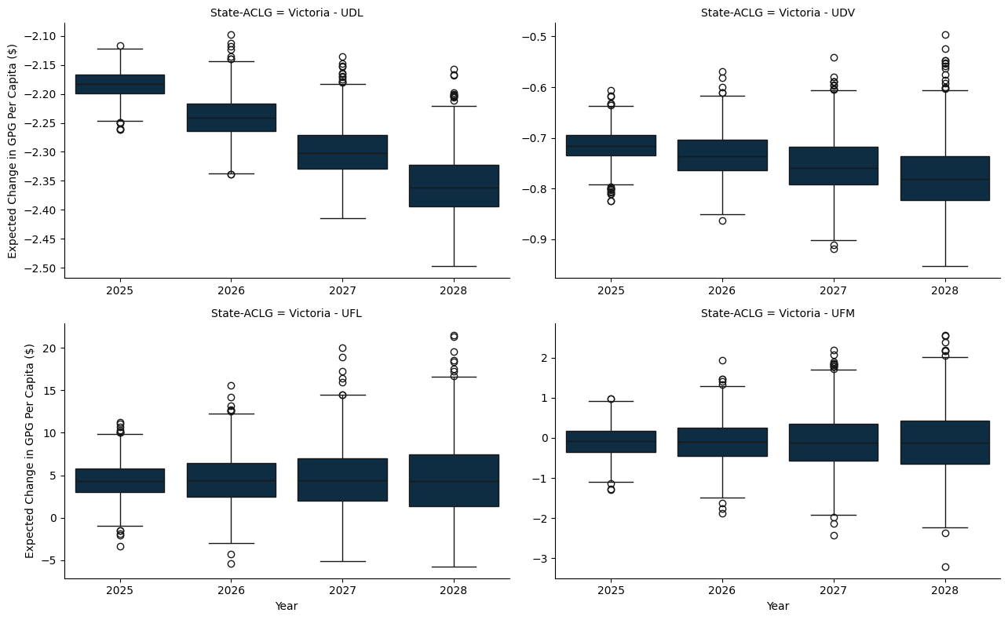

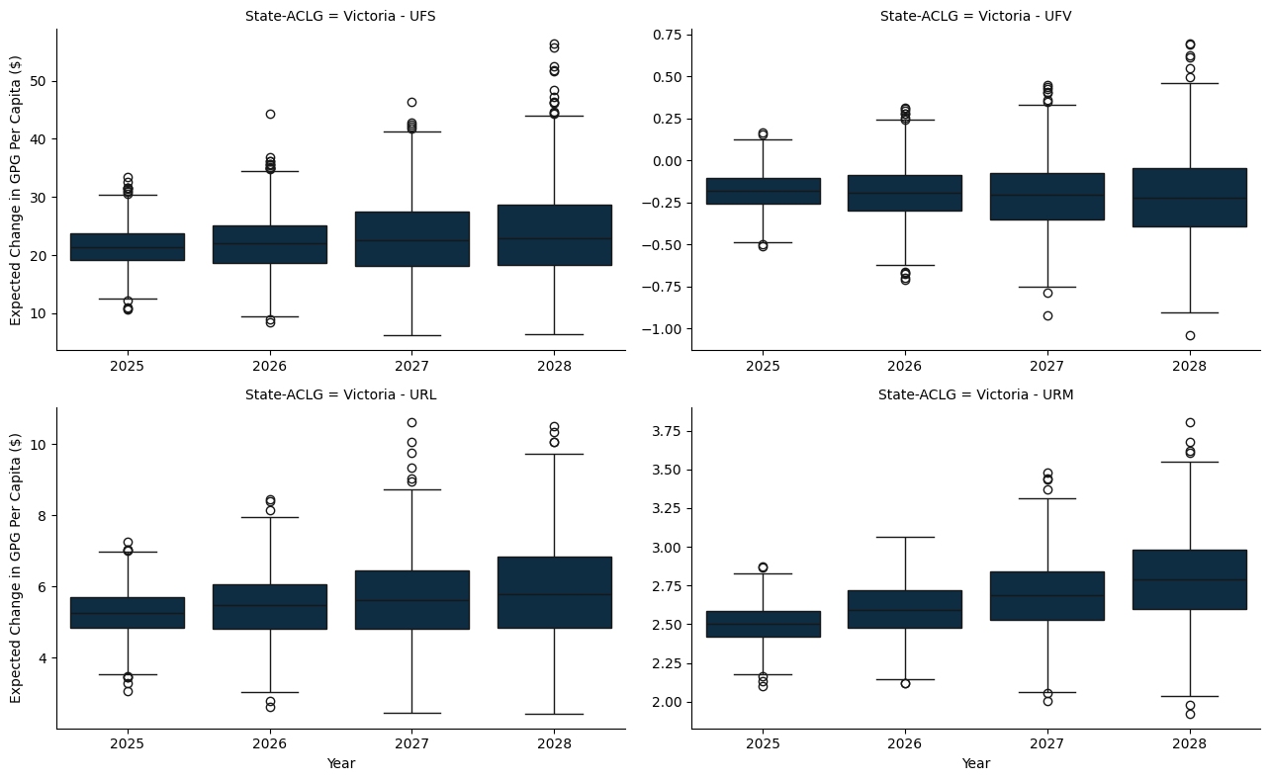

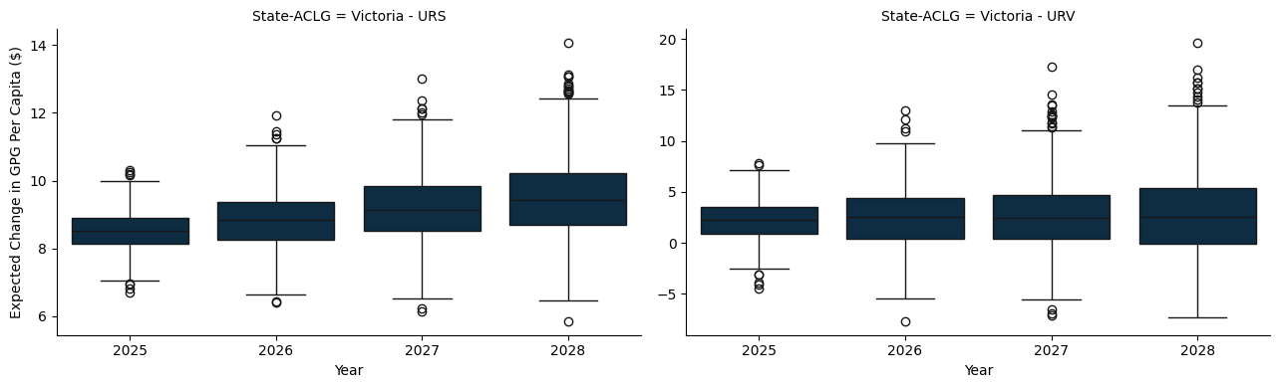

### E.1.3 Queensland

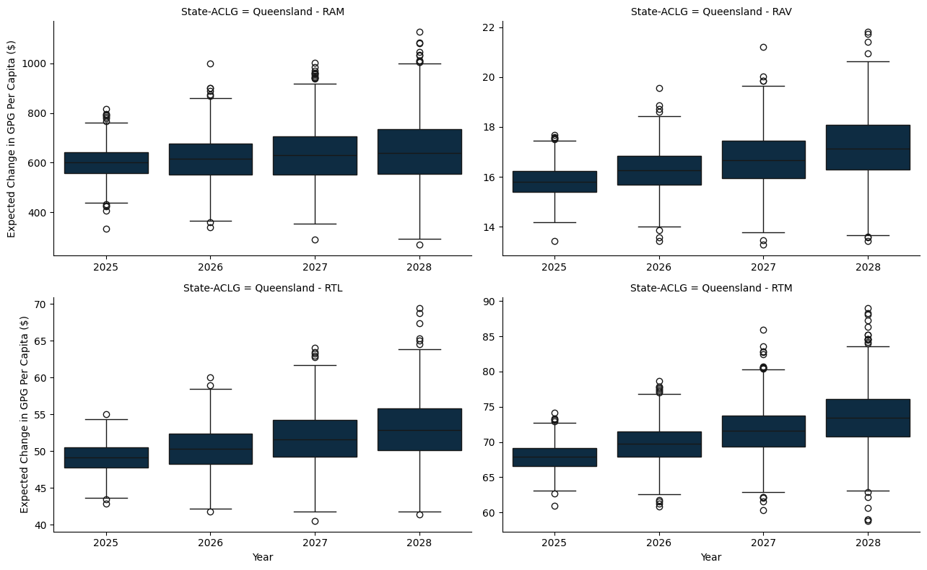

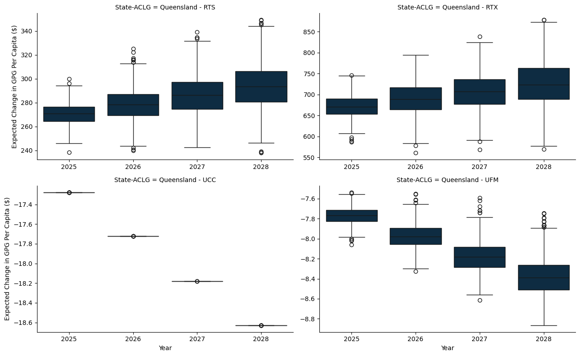

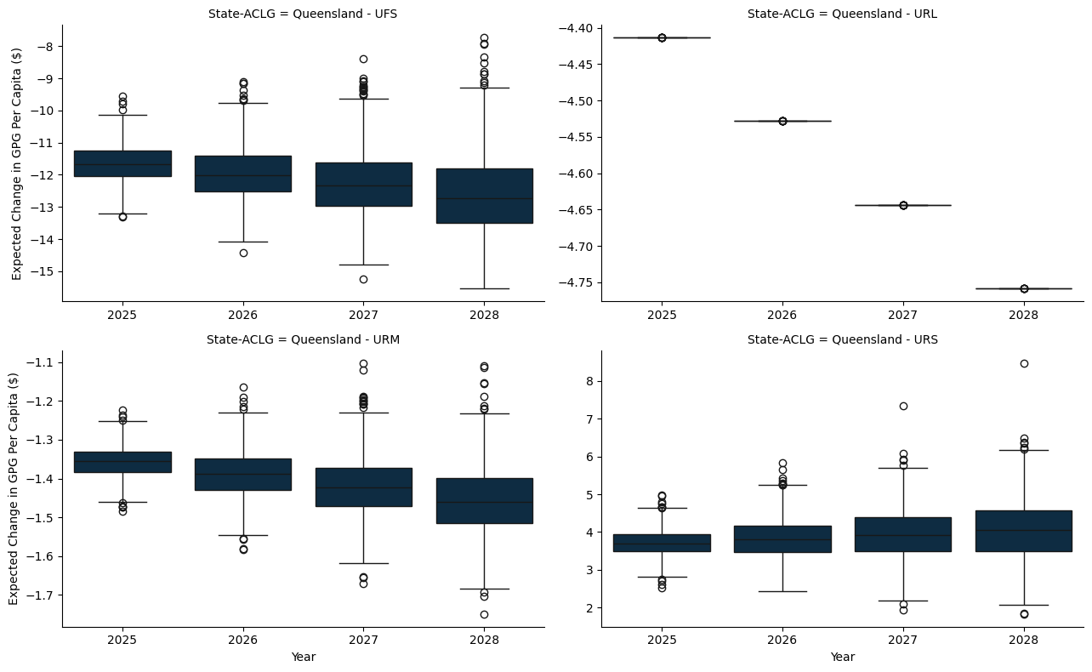

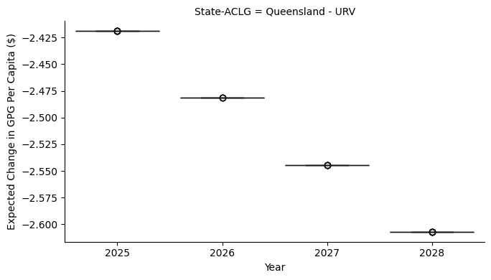

### E.1.4 South Austrlalia

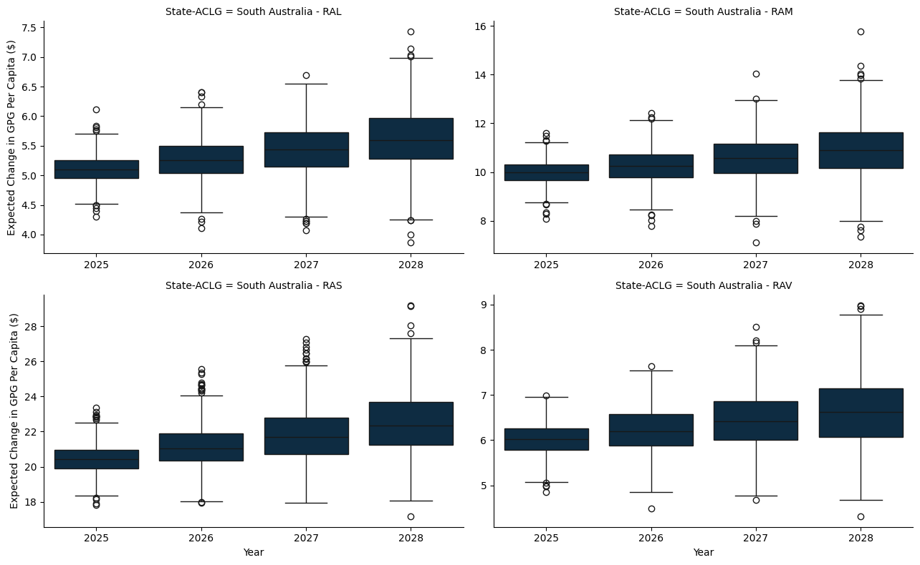

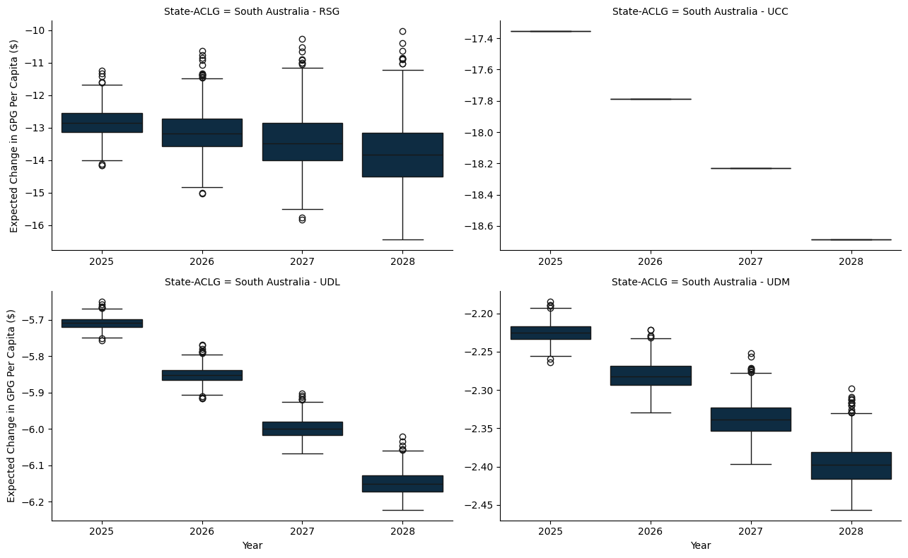

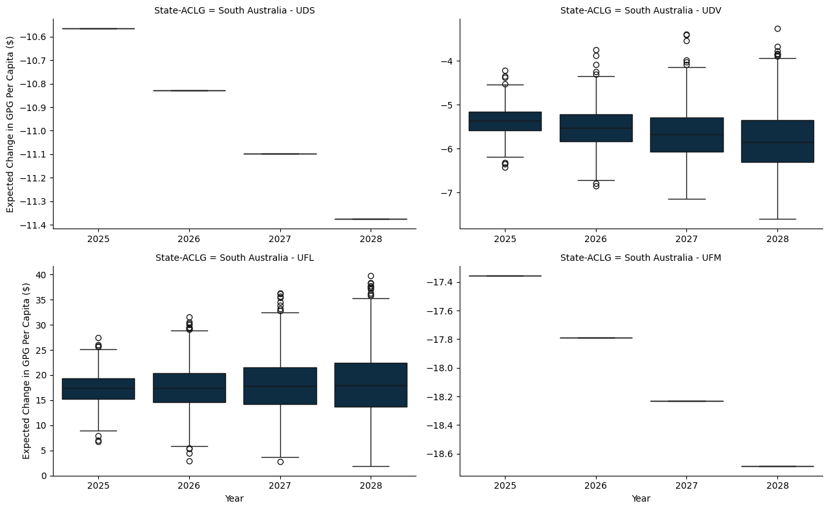

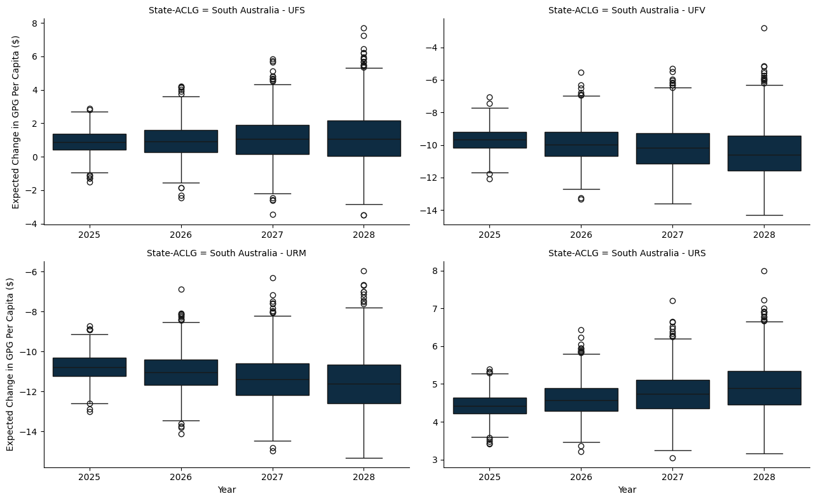

### E.1.5 Western Australia

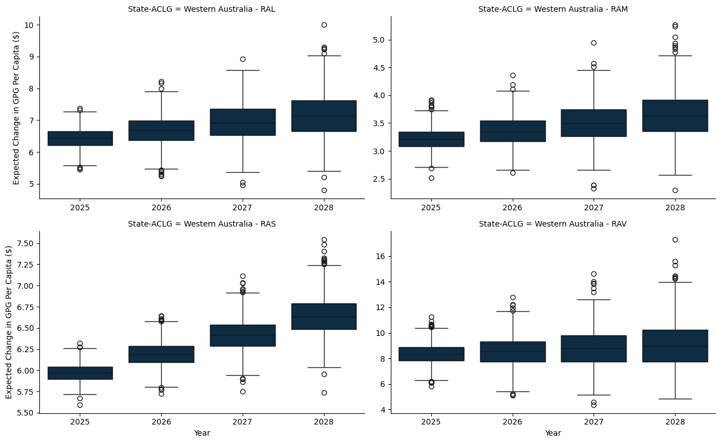

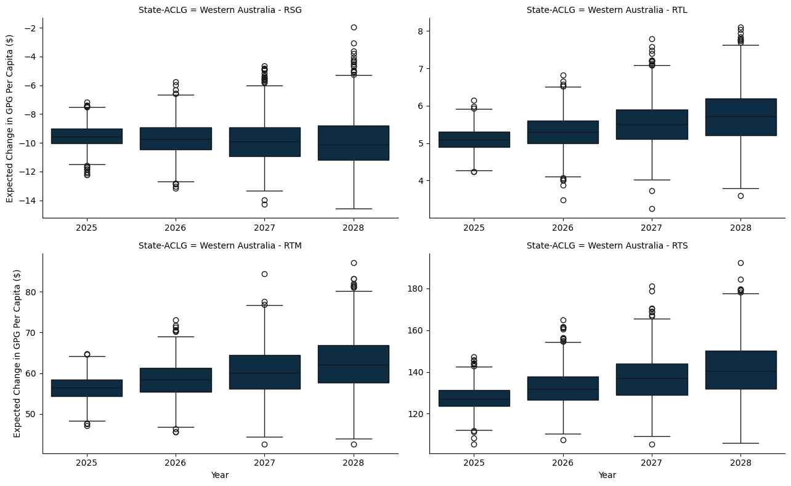

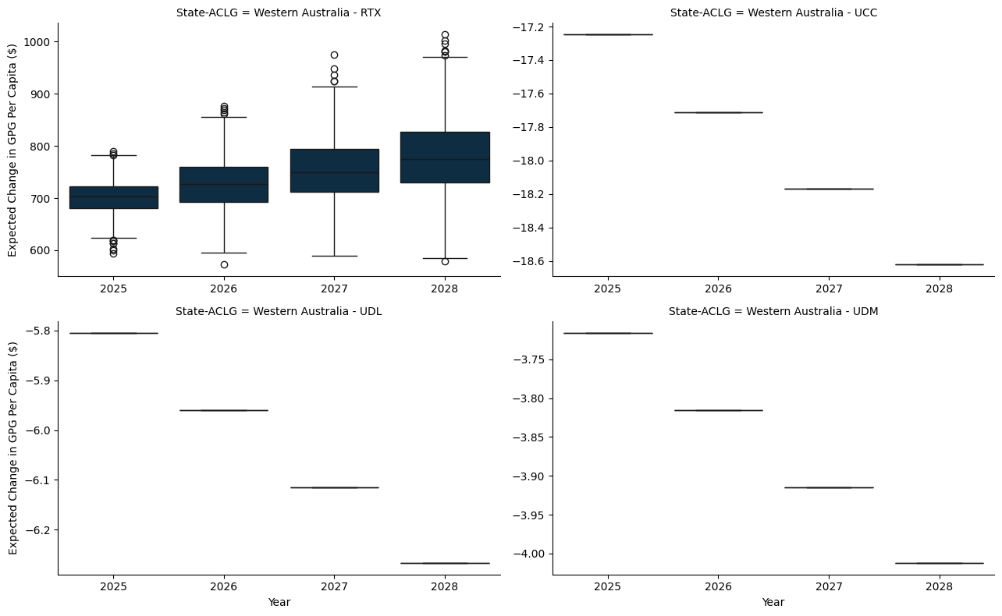

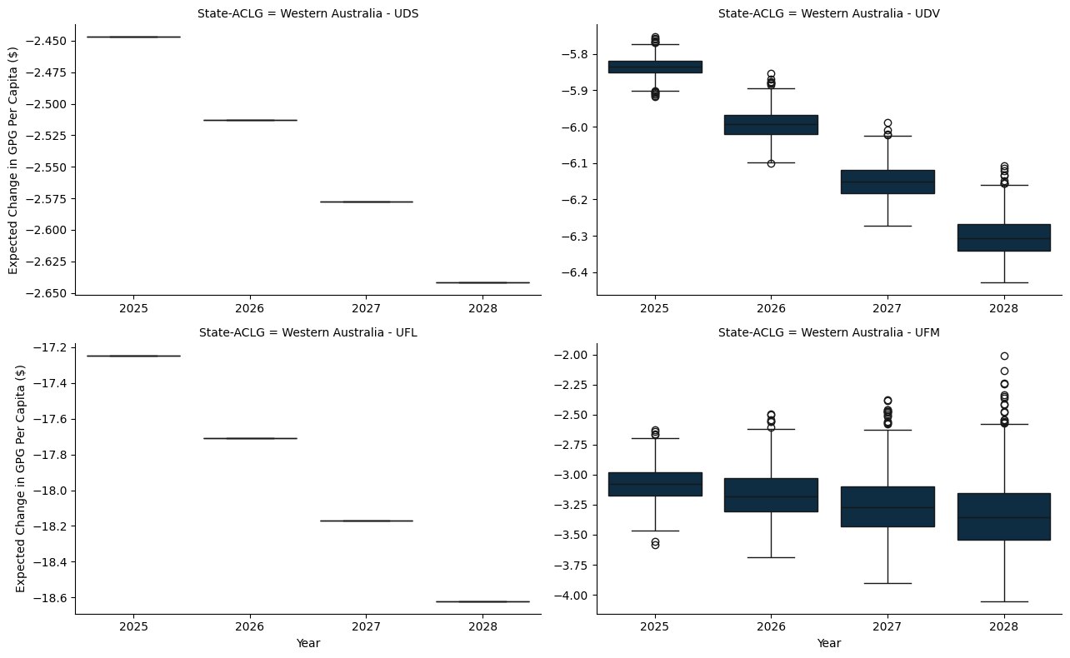

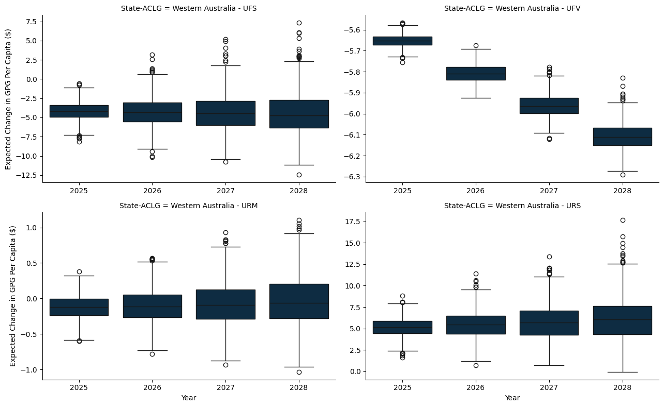

### E.1.6 Tasmania

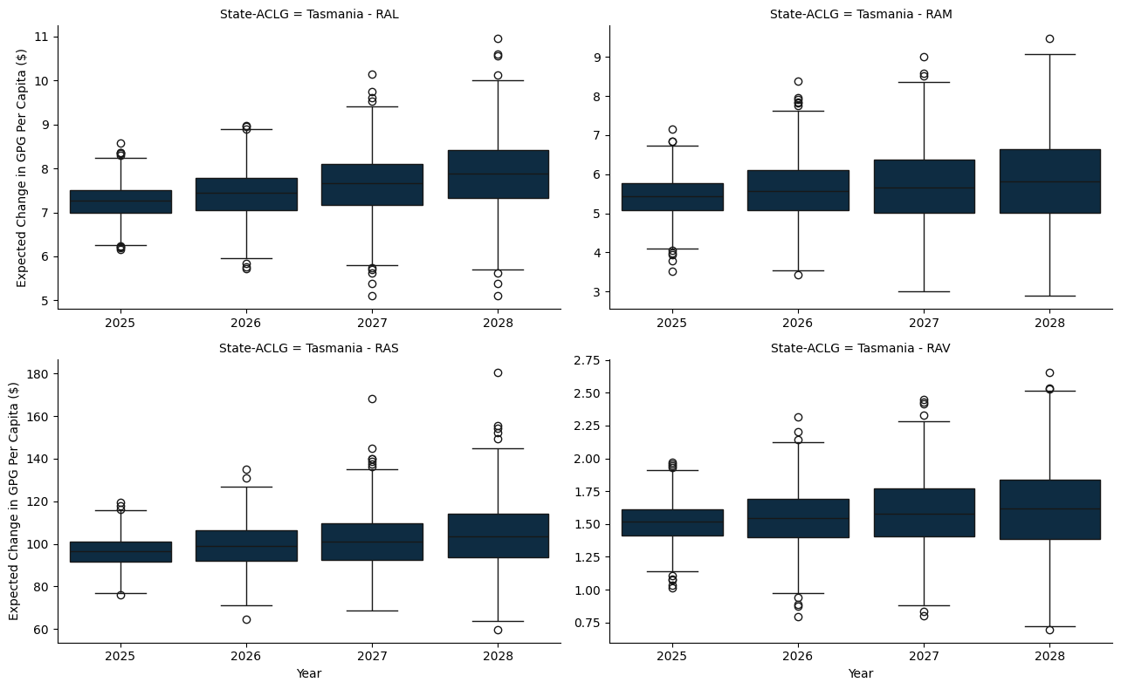

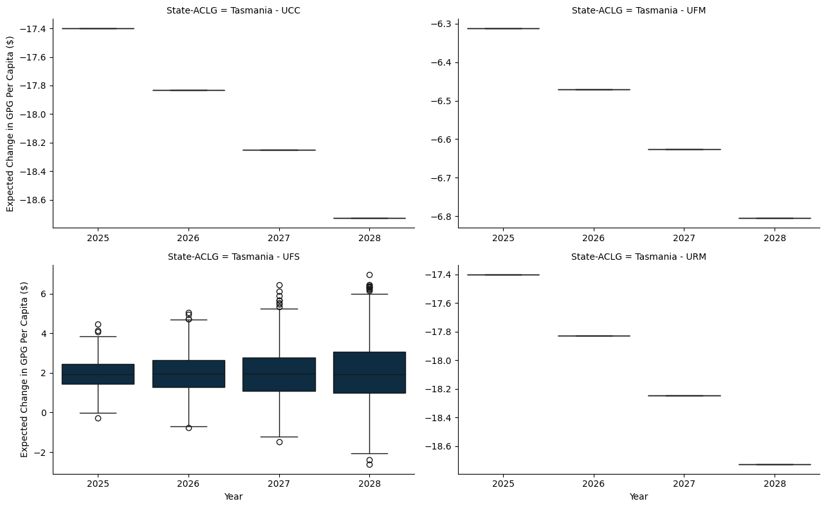

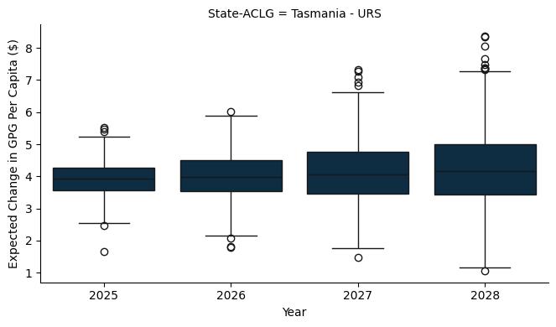

### E.1.7 Northern Territory

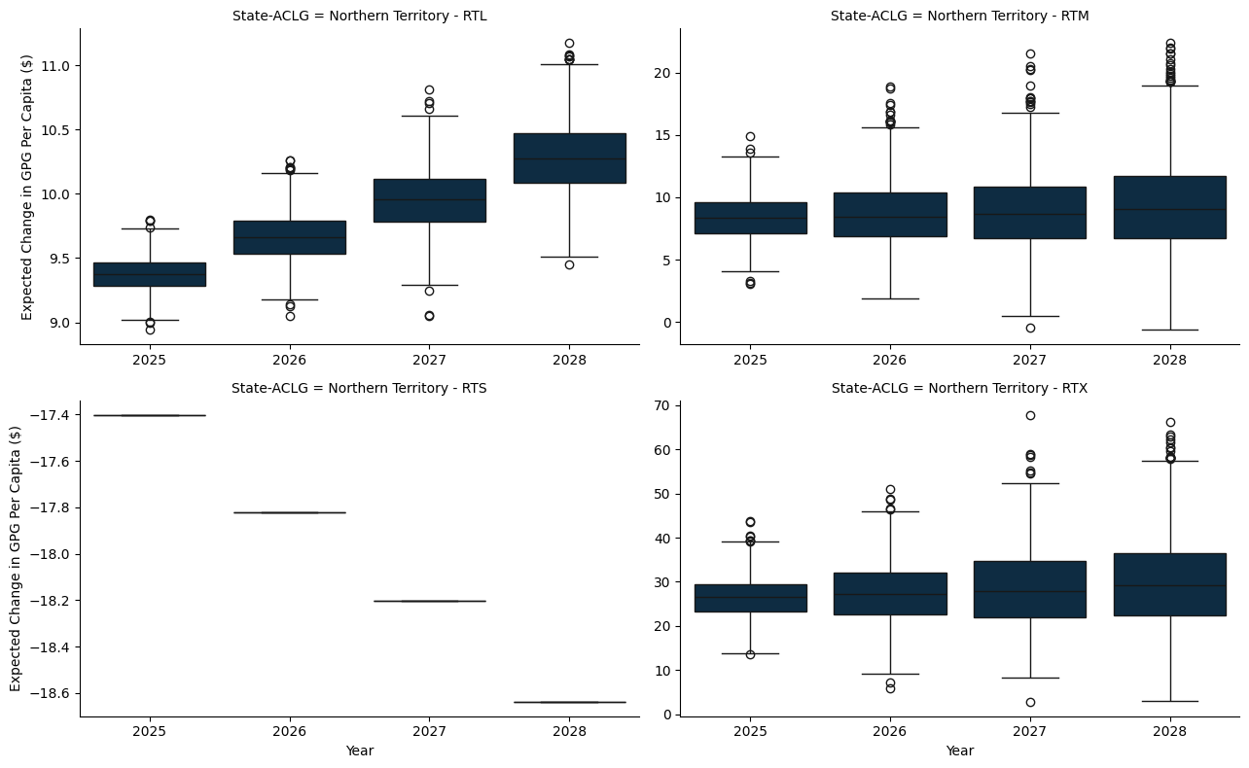

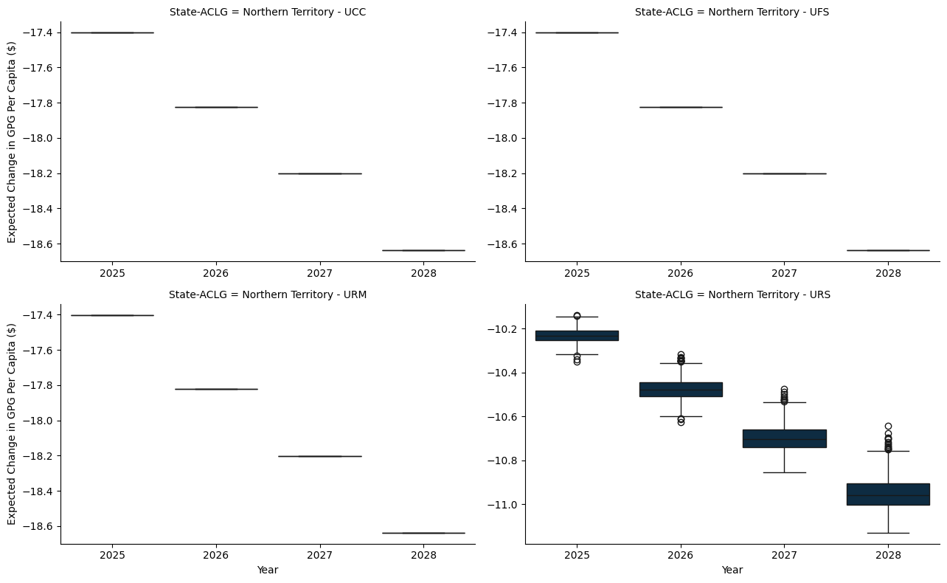

# Appendix F — A World With No Per Capita Minimum Grant - Gains and Losses

* The model here applies a hypothetical per capita minimum grant constraint, set at 0%, to ensure that each jurisdiction receives at least this proportion of the funds if they were allocated on a per capita basis.
* The per capita minimum for the benchmark scenario is set to 30%, as is the status quo.

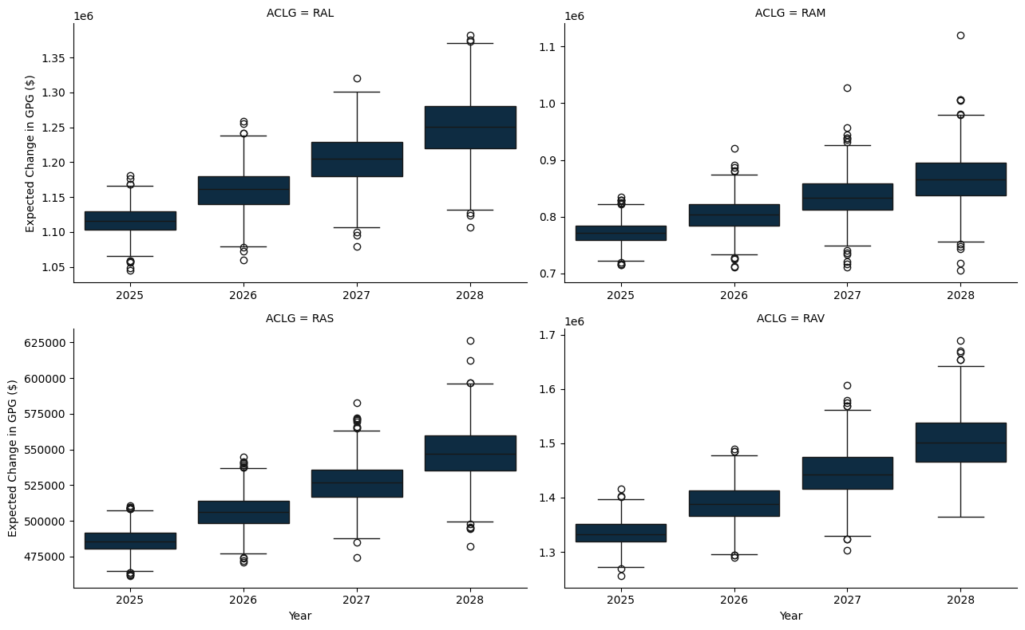

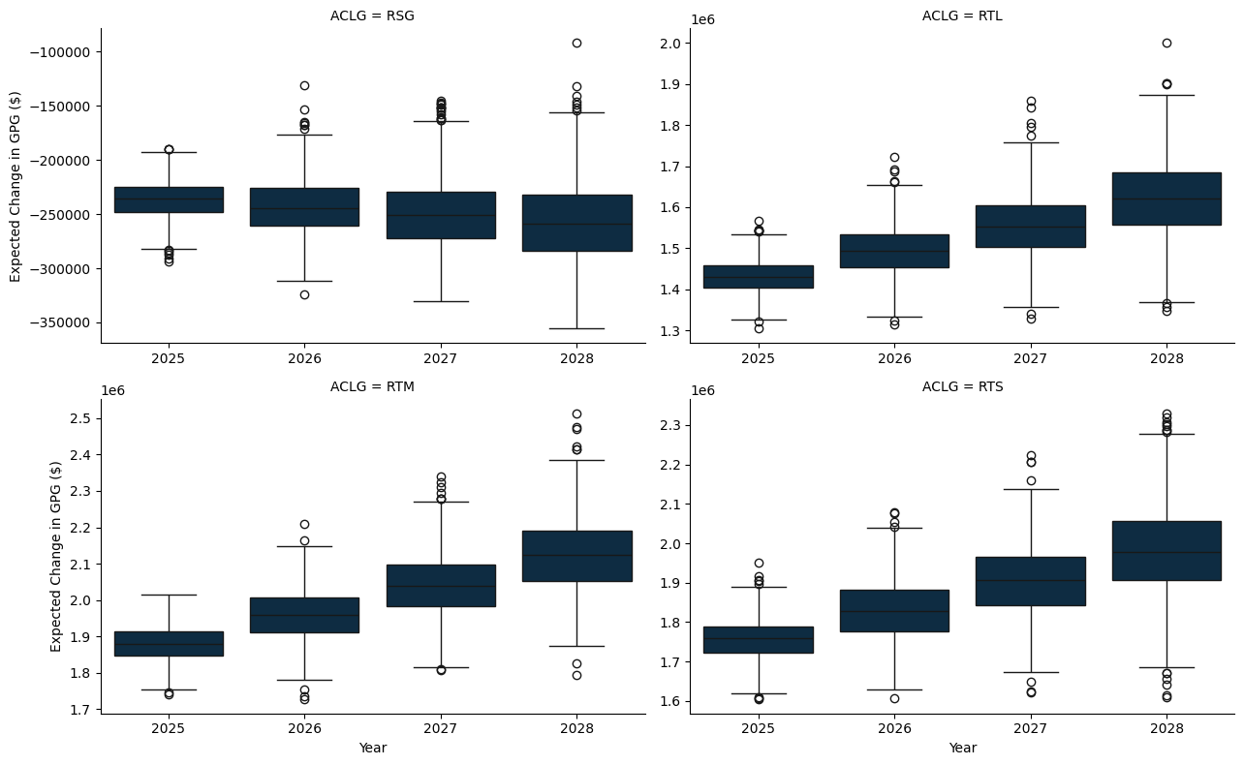

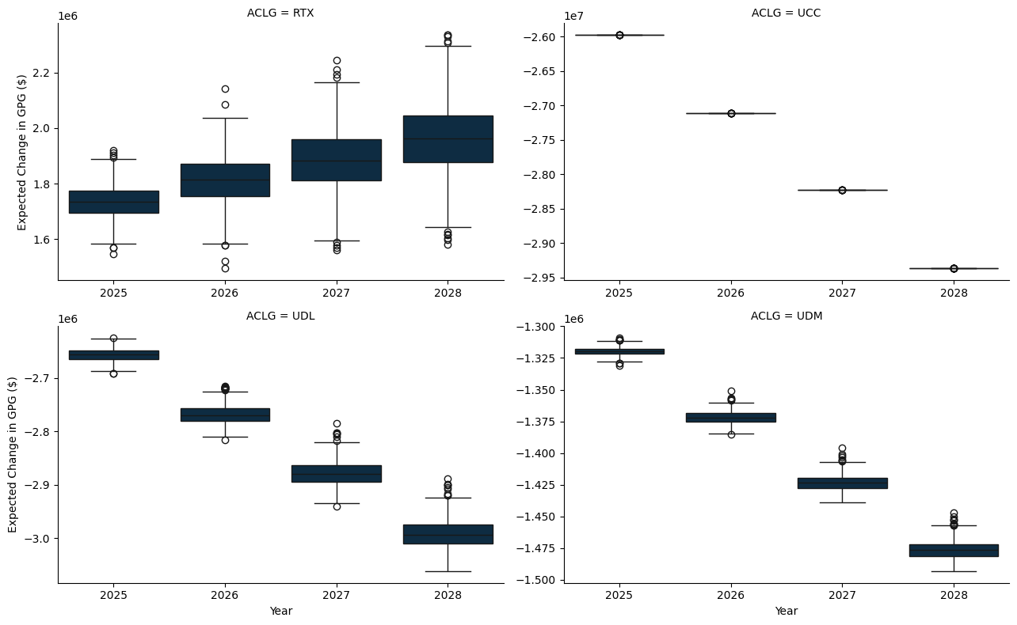

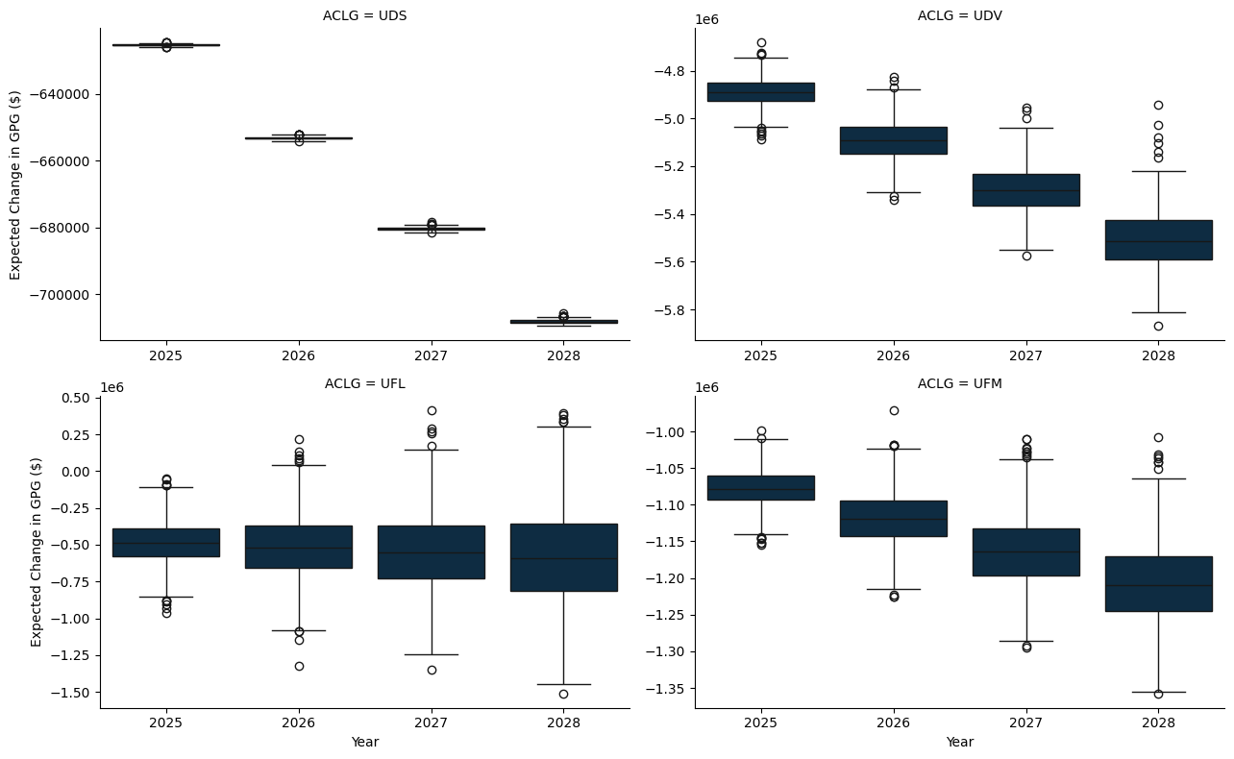

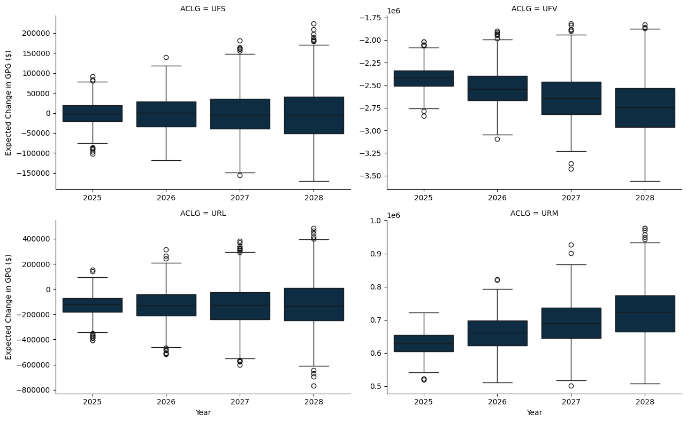

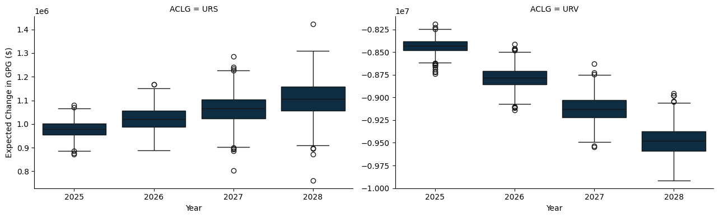

## F.1 A State and Territory breakdown

### F.1.1 New South Wales

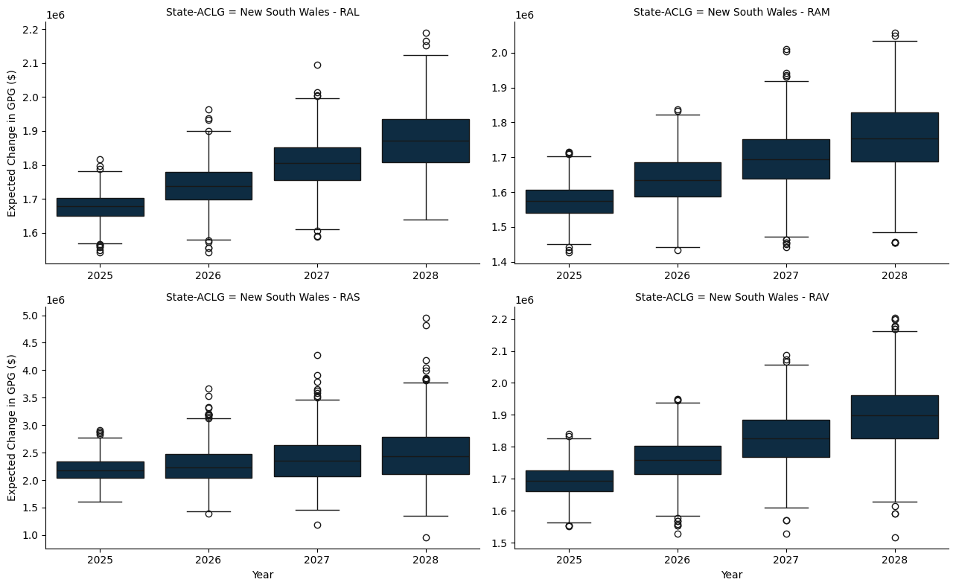

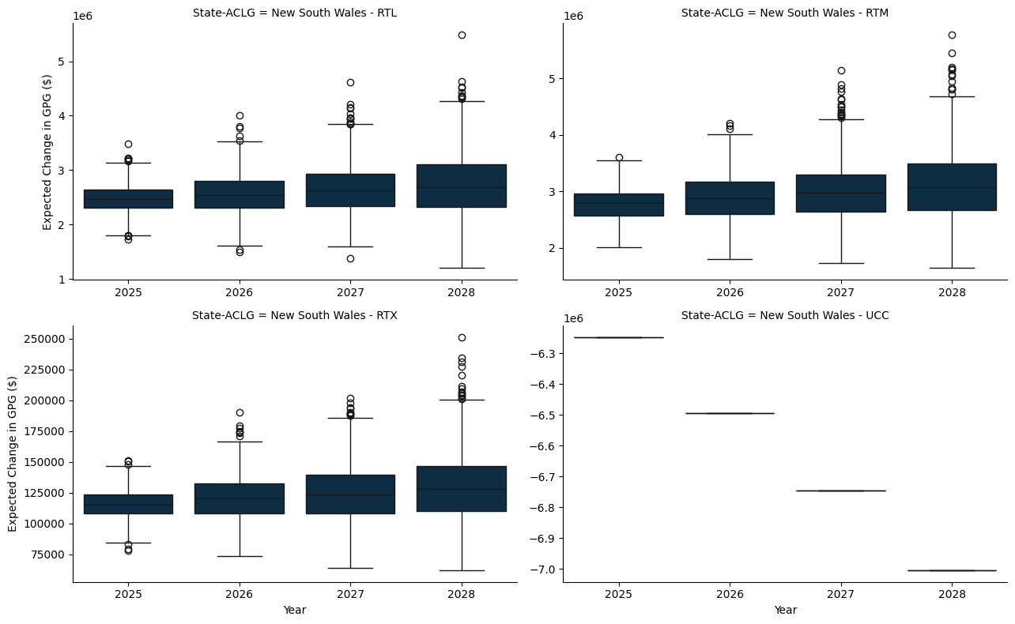

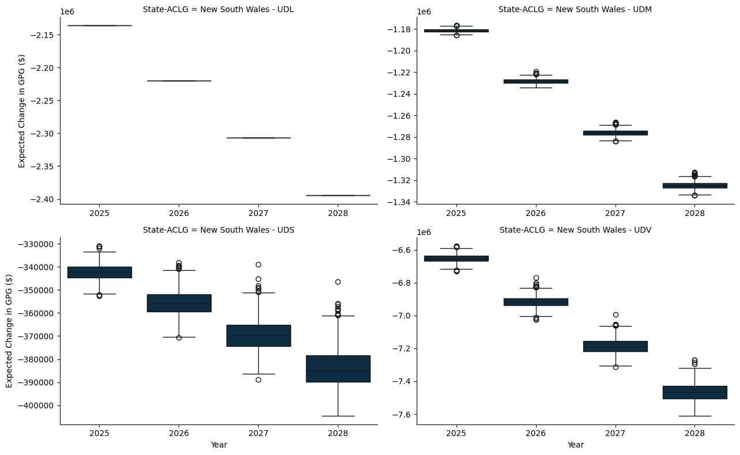

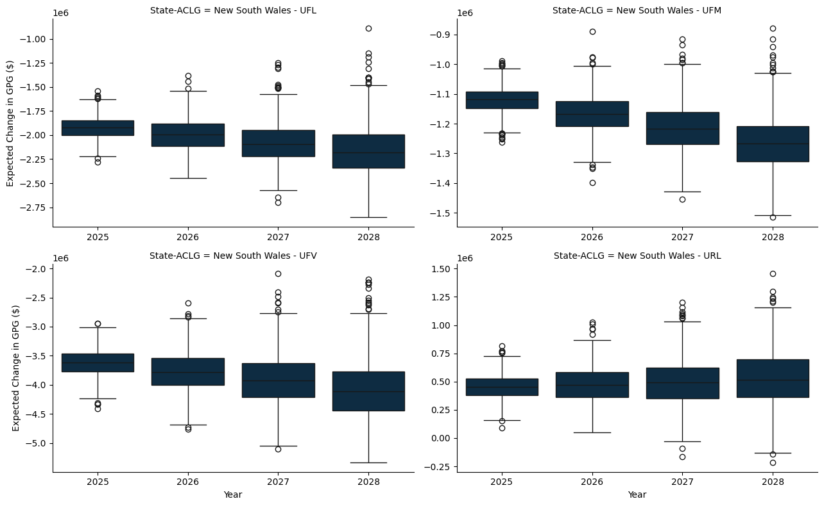

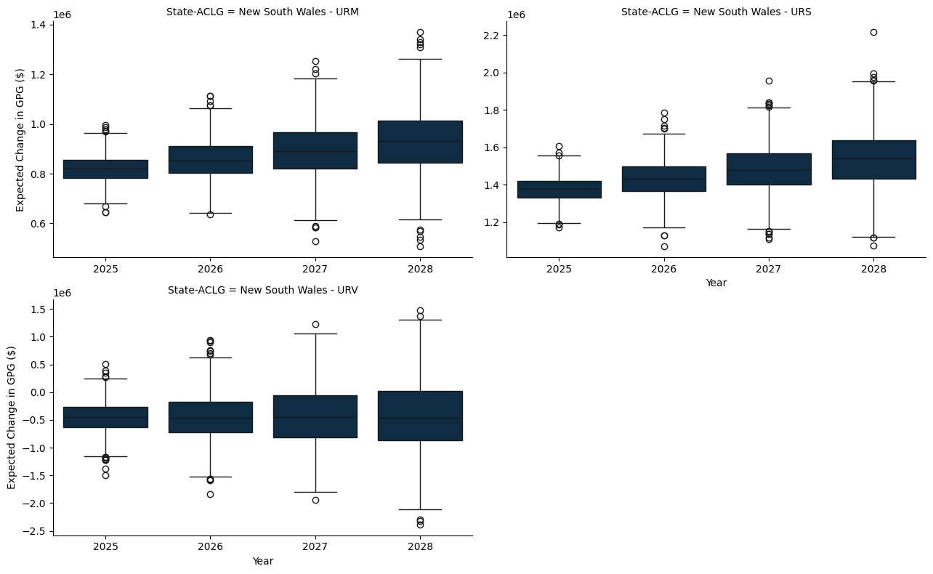

### F.1.2 Victoria

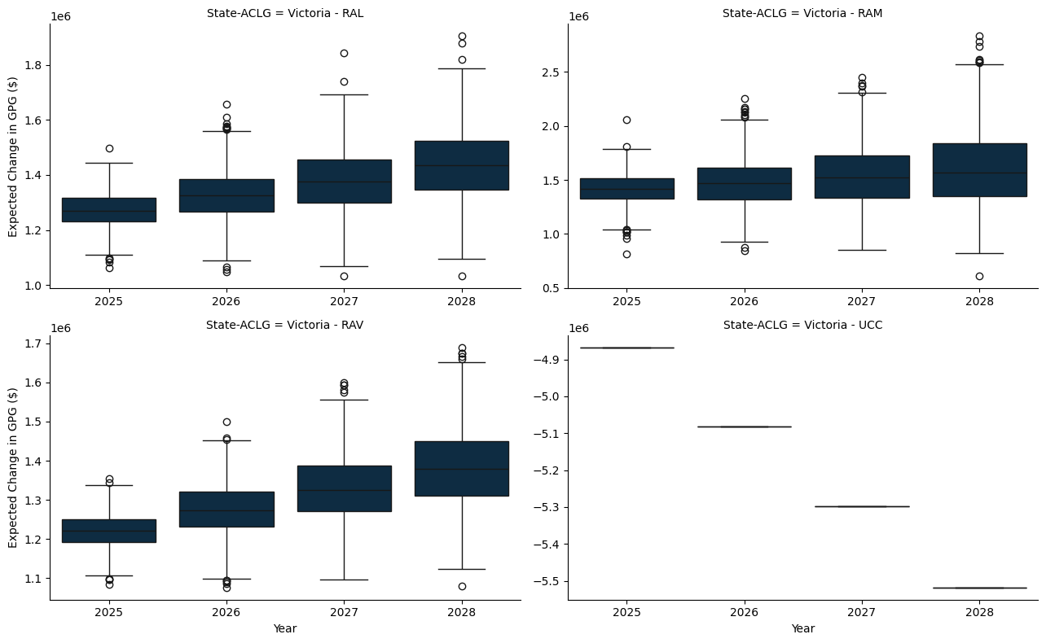

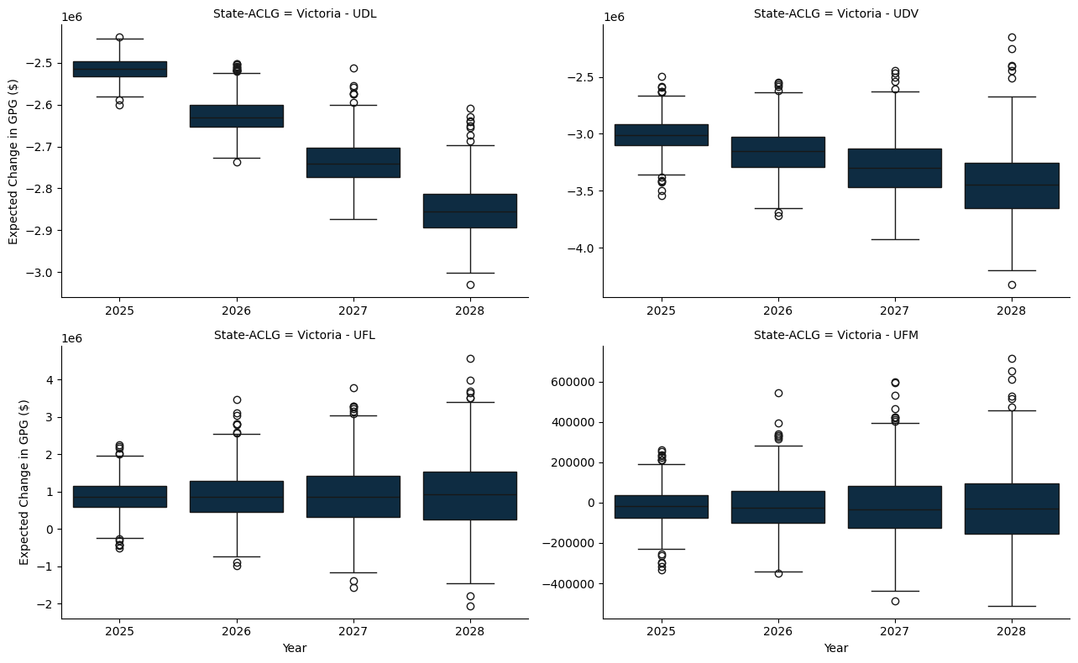

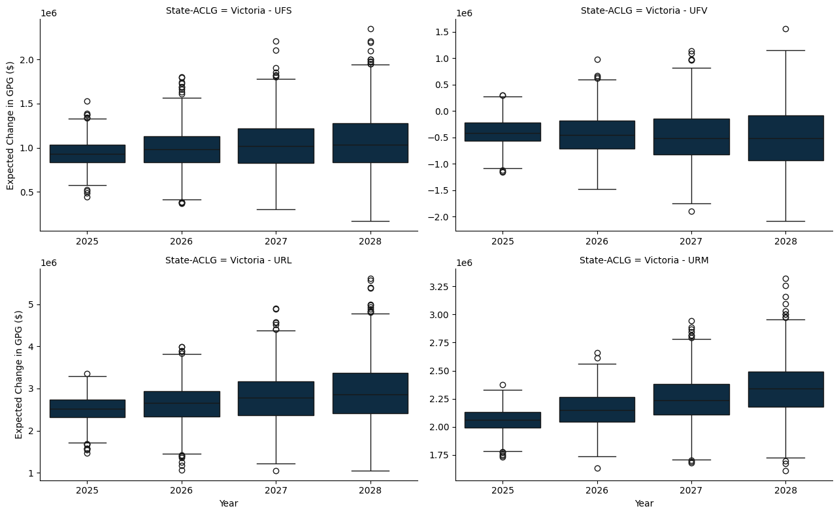

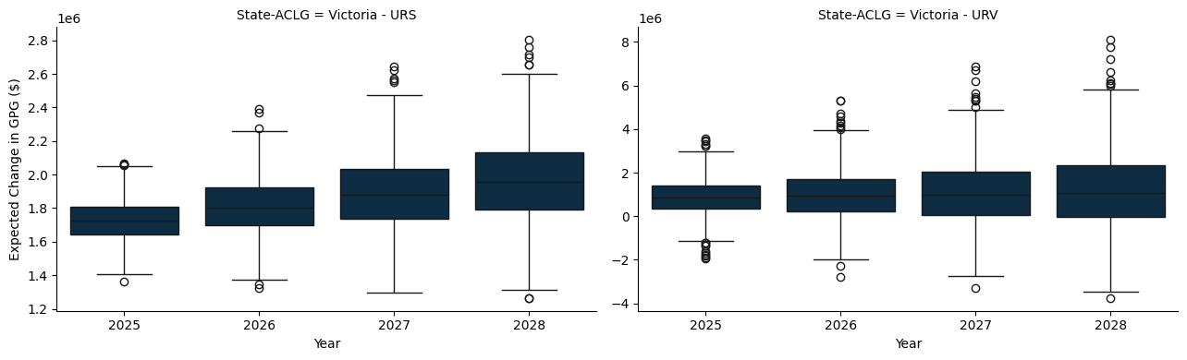

### F.1.3 Queensland

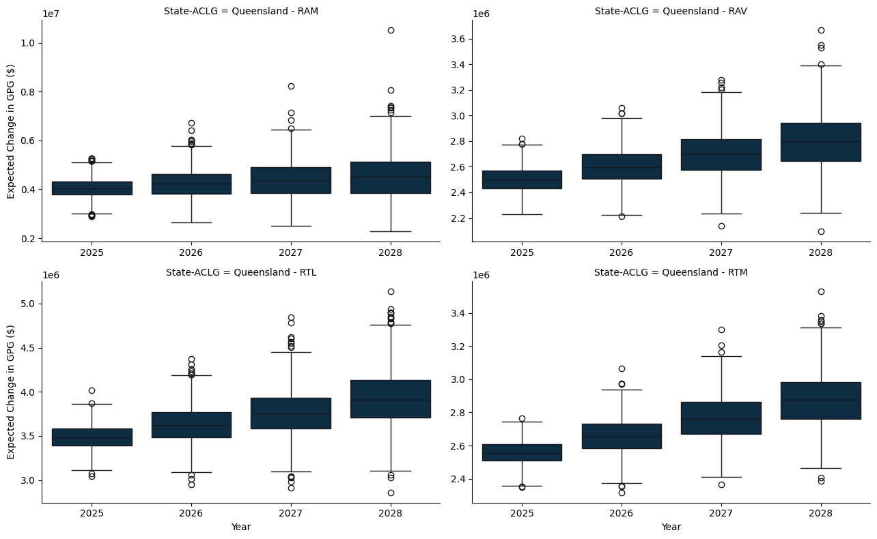

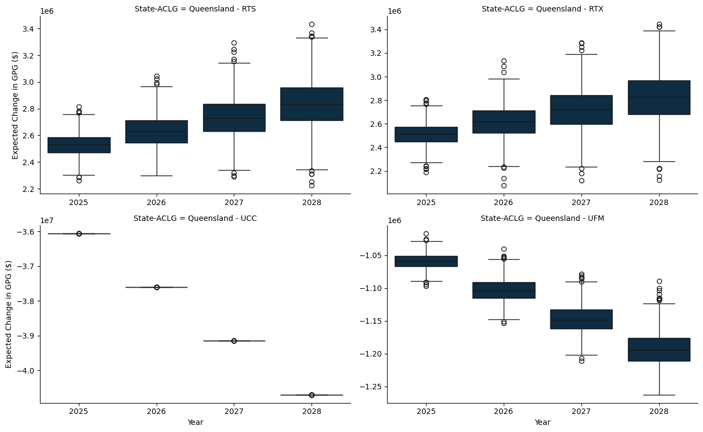

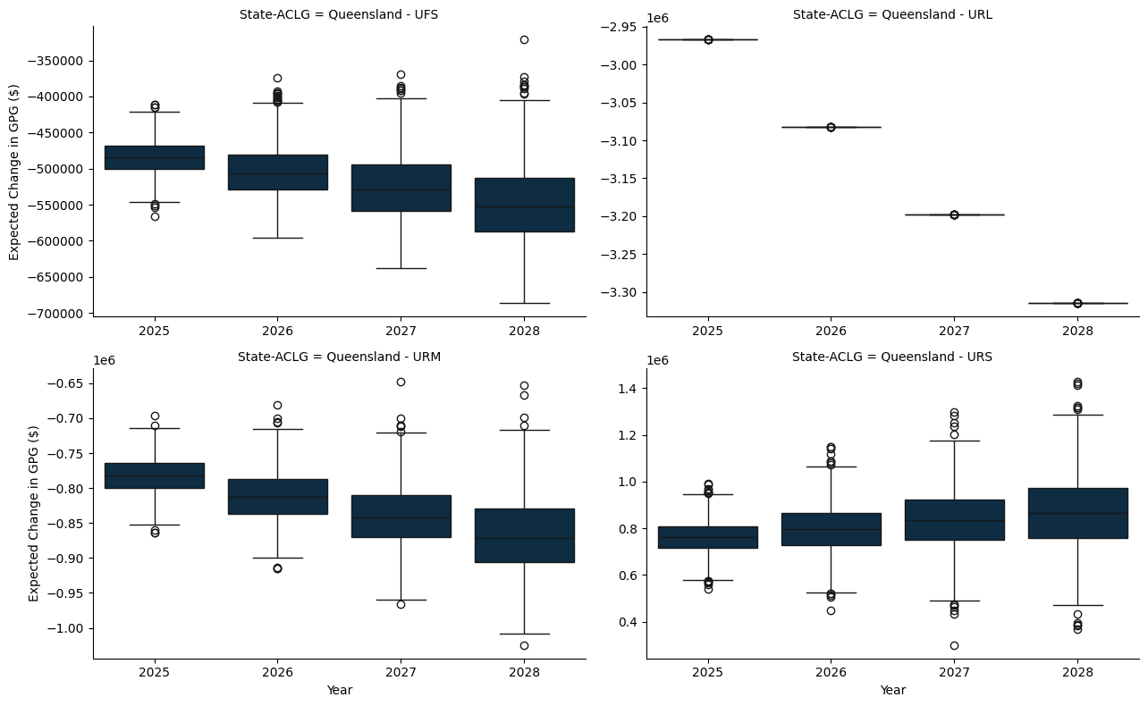

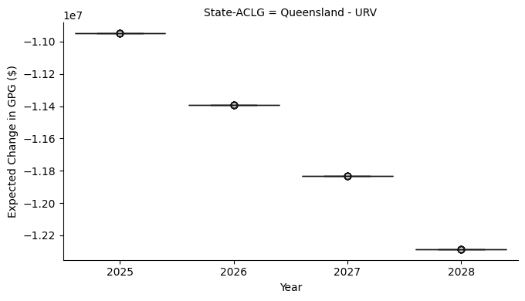

### F.1.4 South Austrlalia

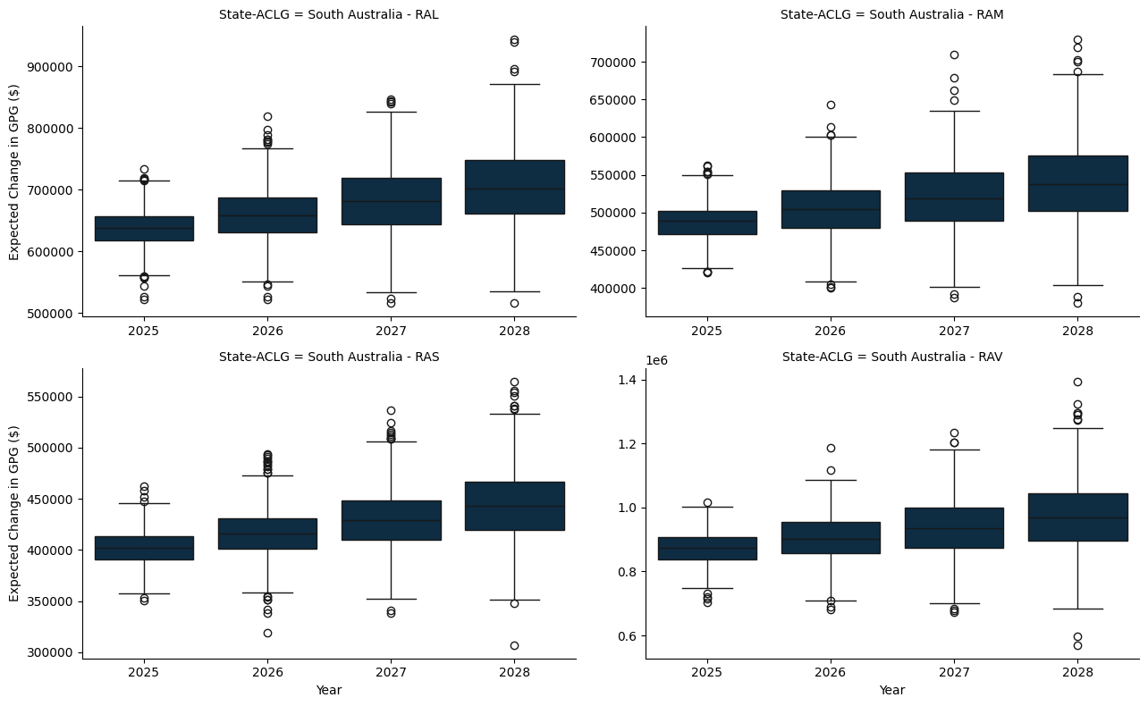

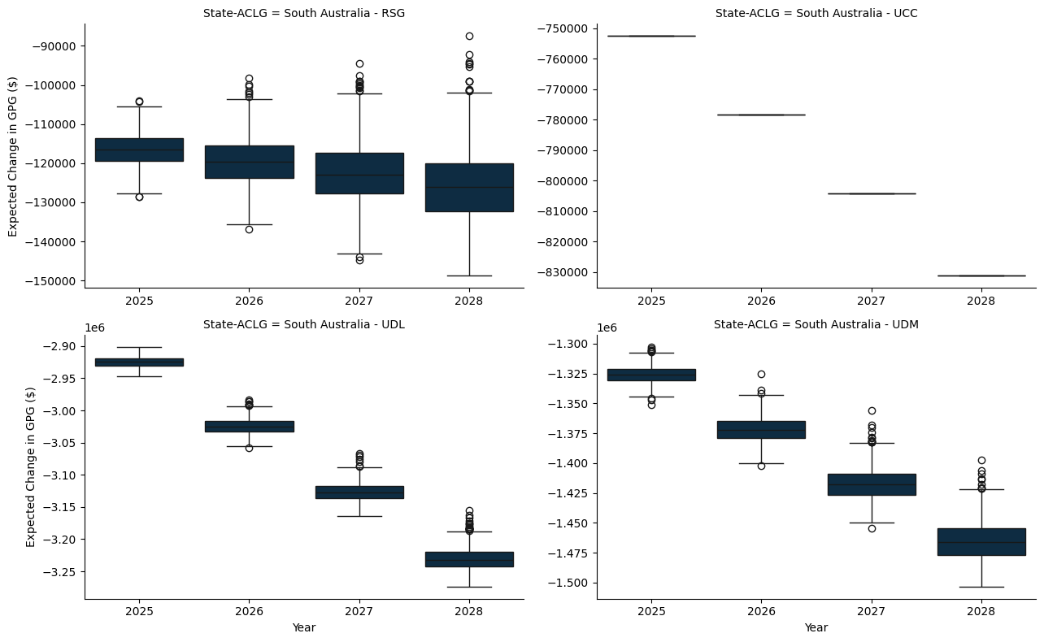

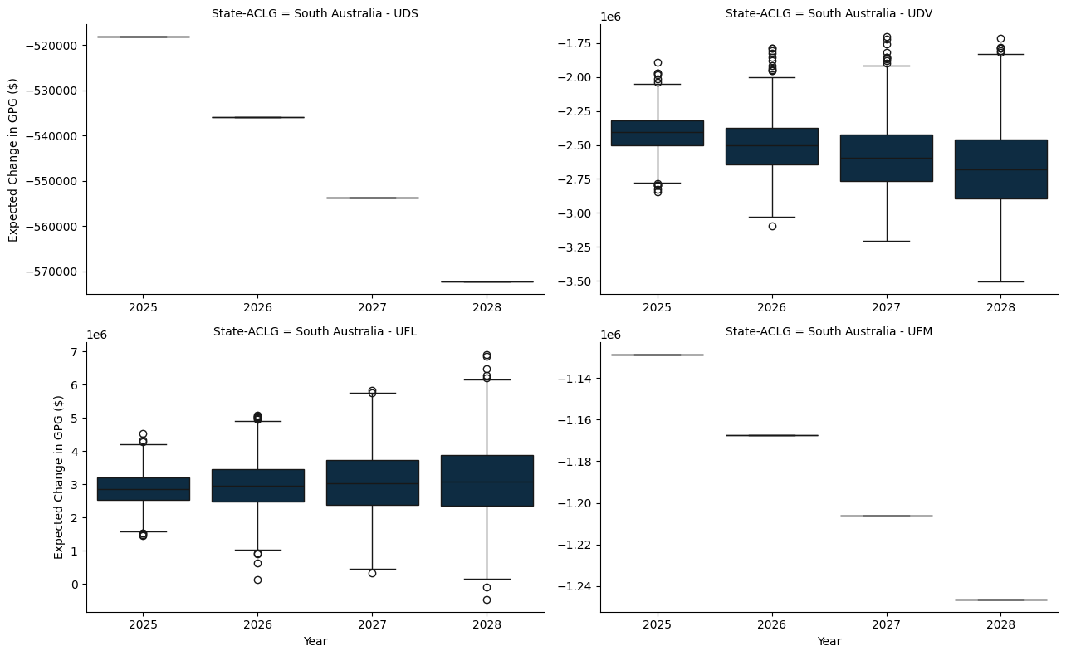

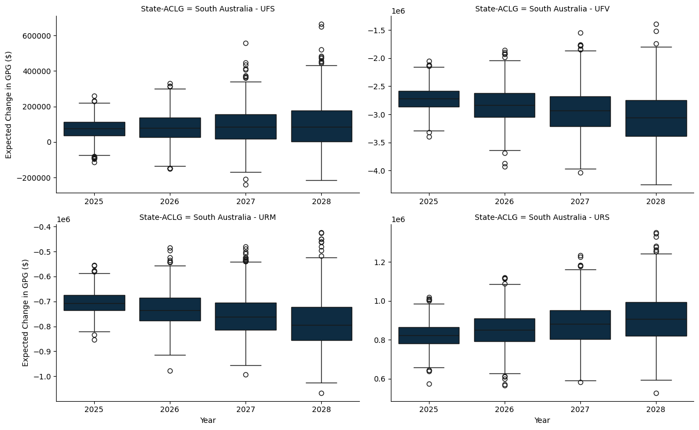

### F.1.5 Western Australia

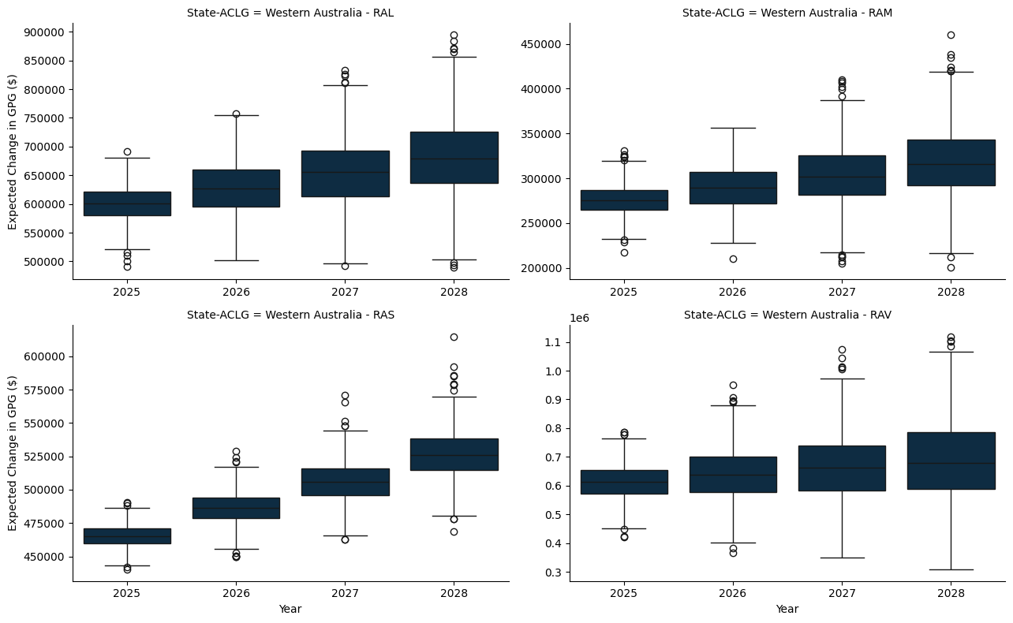

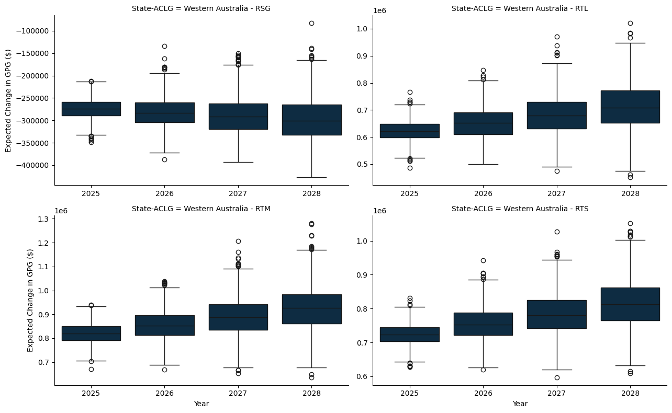

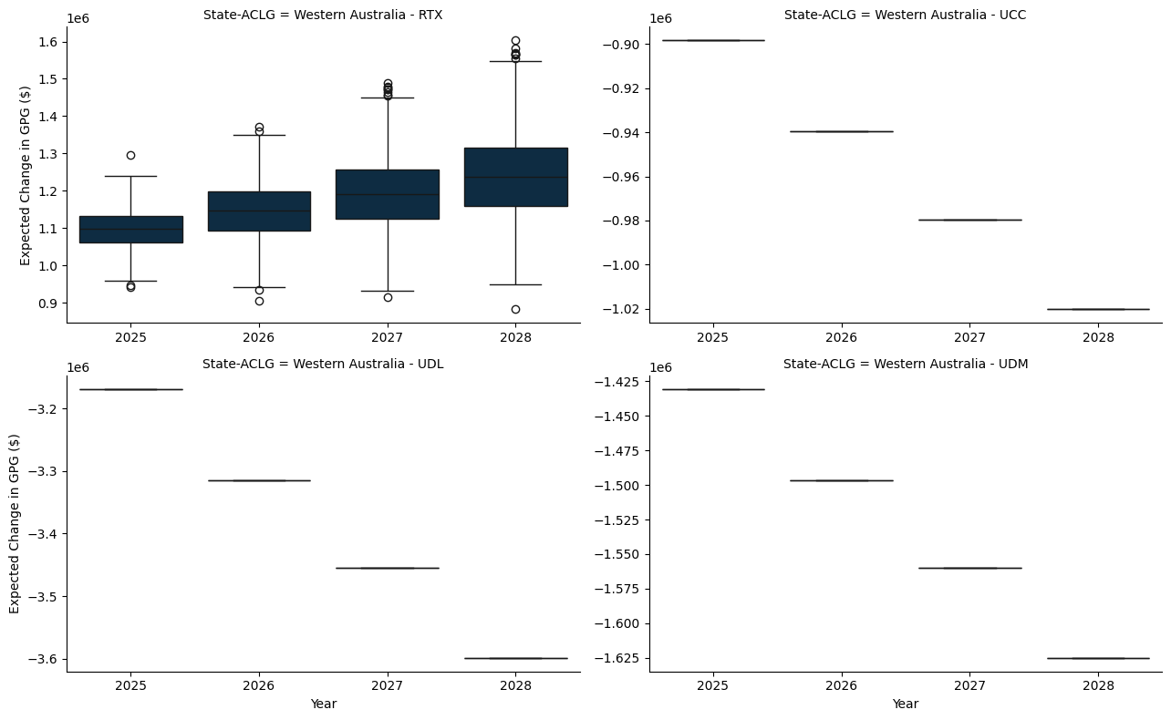

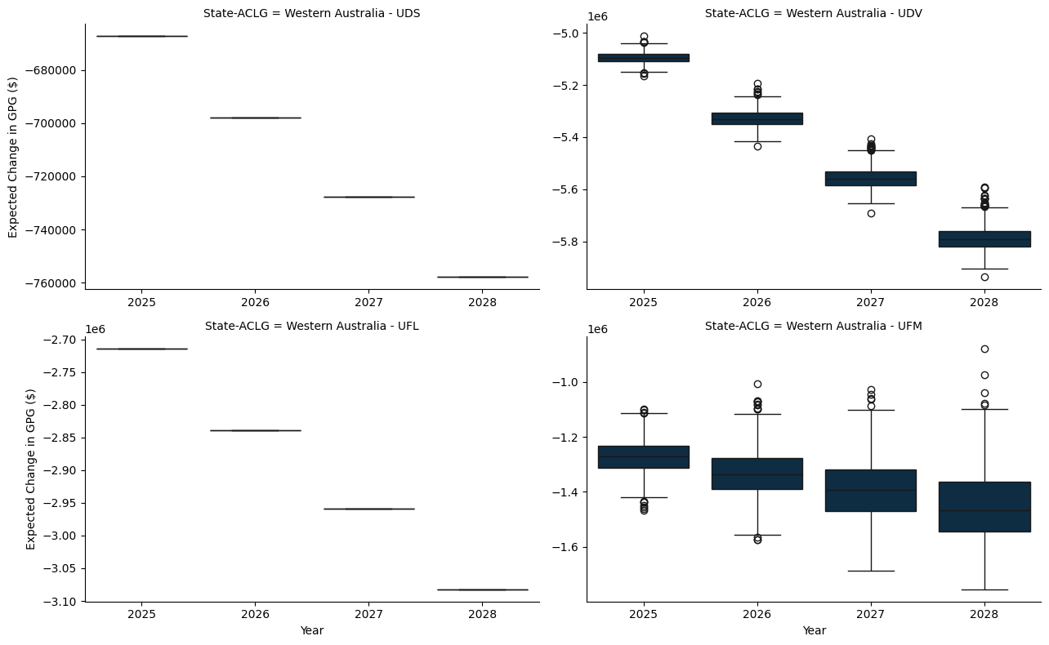

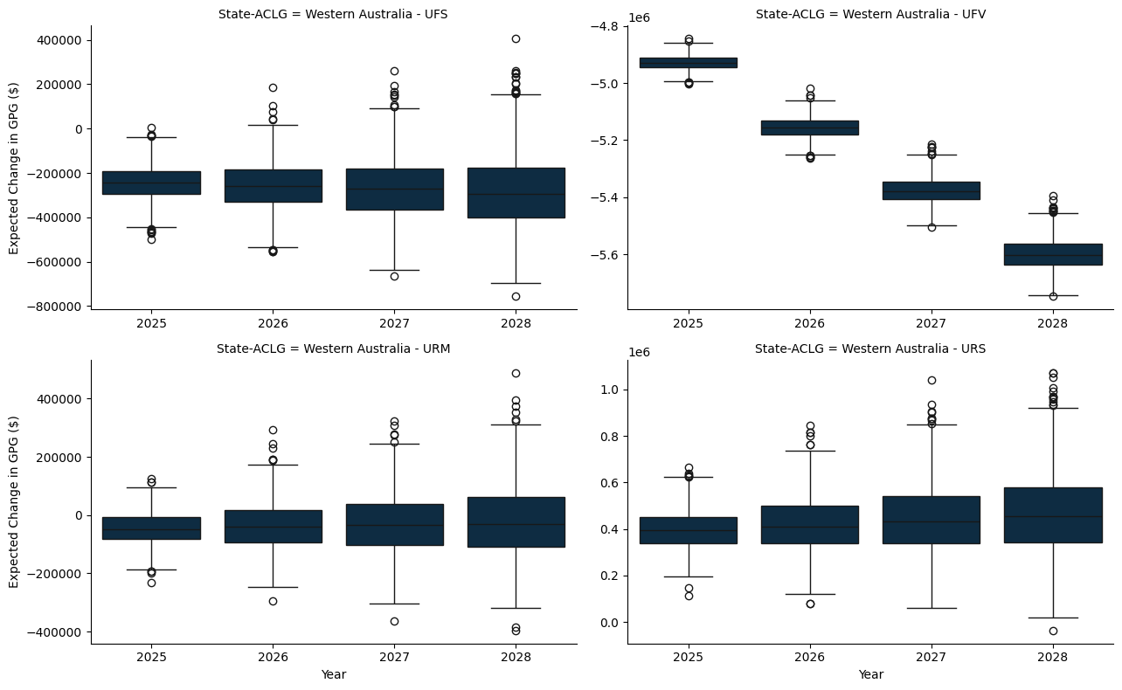

### F.1.6 Tasmania

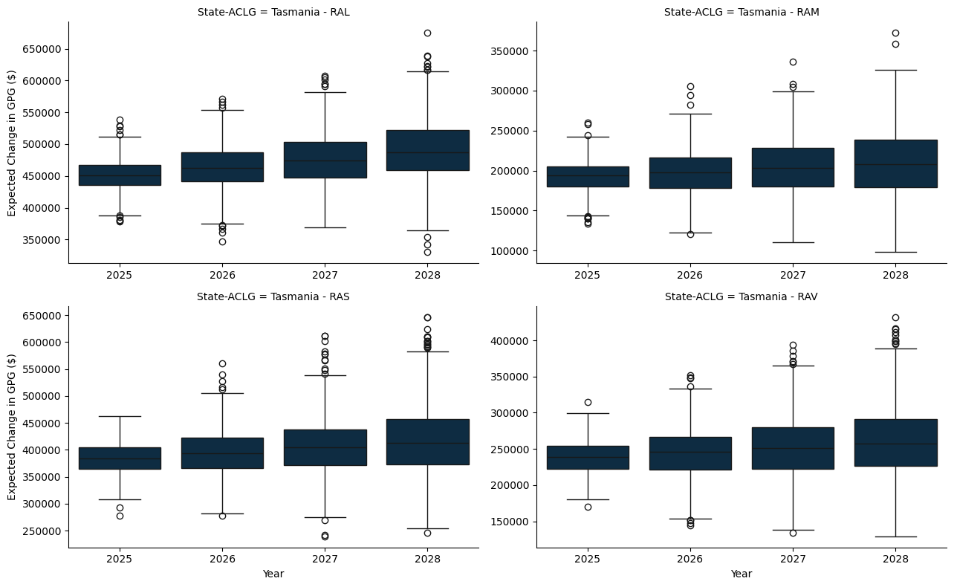

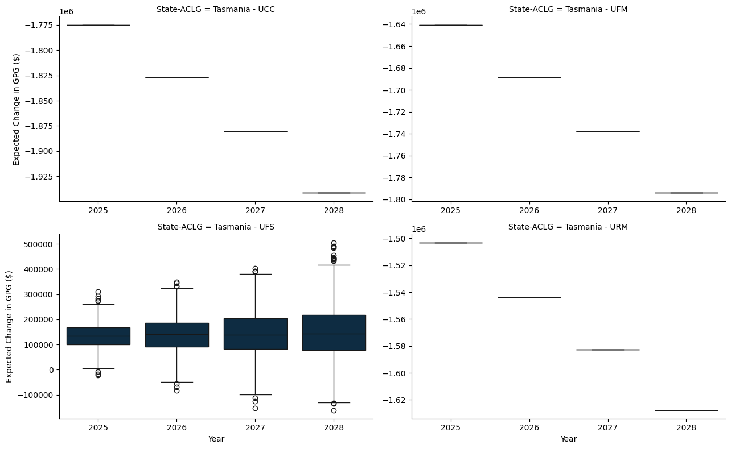

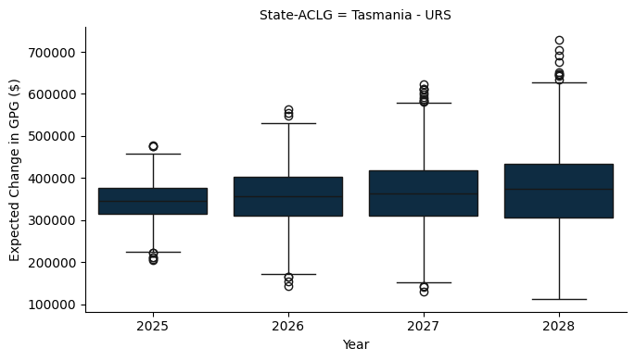

### F.1.7 Northern Territory

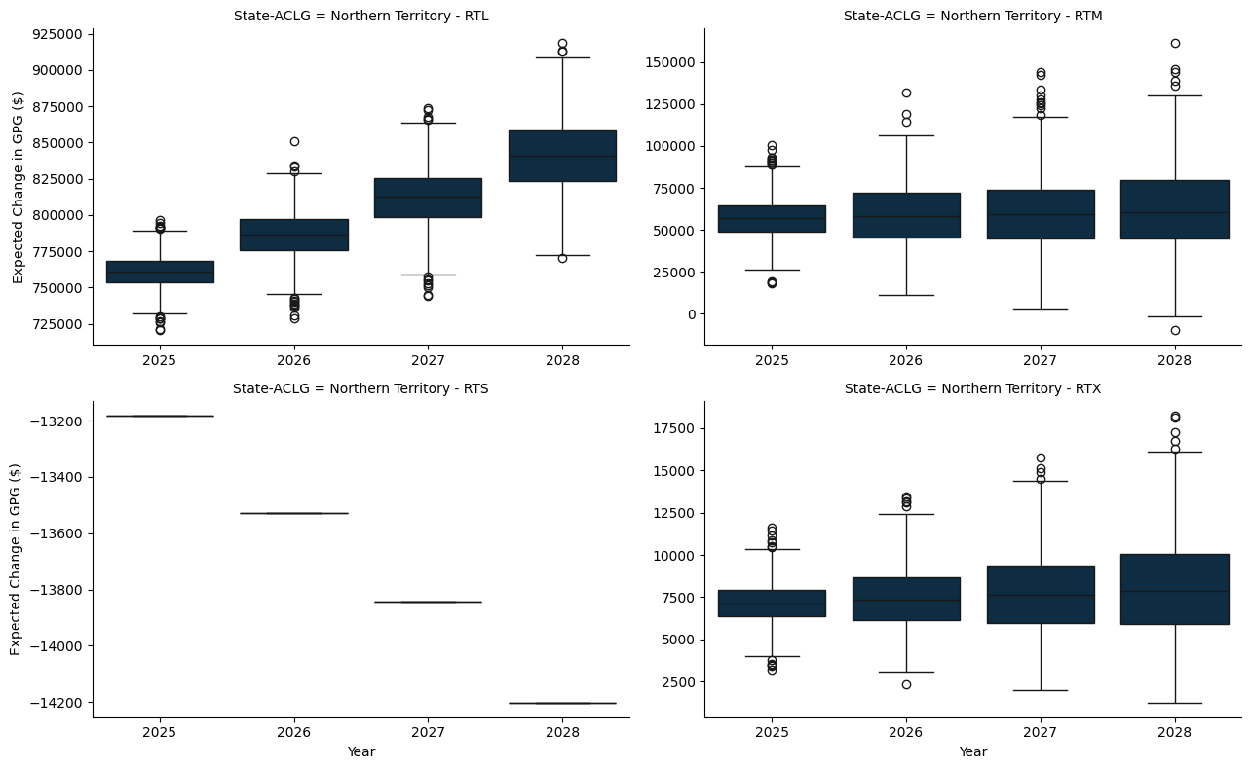

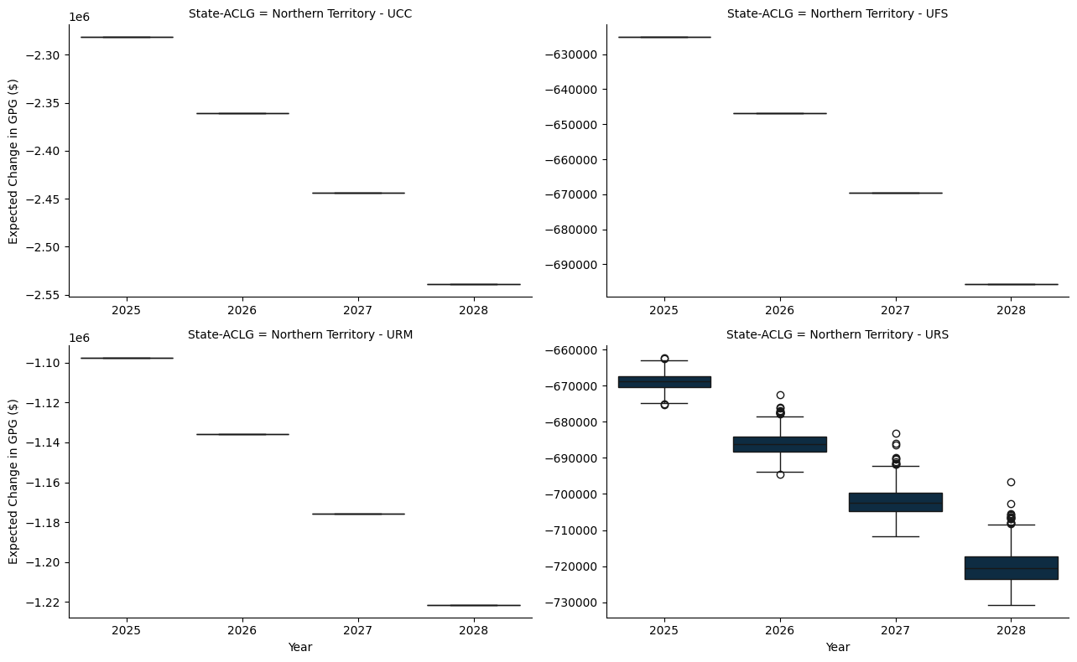

# Appendix G — A World With No Per Capita Minimum Grant - A per capita study

* The model here applies a hypothetical per capita minimum grant constraint, set at 0%, to ensure that each jurisdiction receives at least this proportion of the funds if they were allocated on a per capita basis.
* The per capita minimum for the benchmark scenario is set to 30%, as is the status quo.

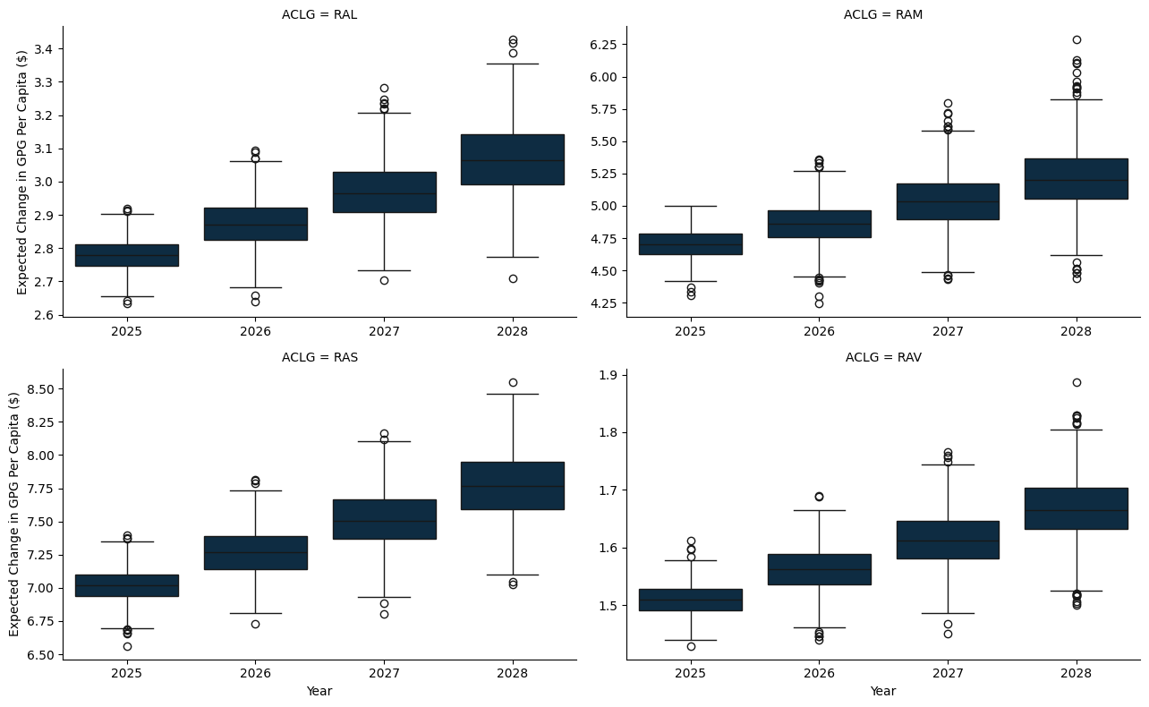

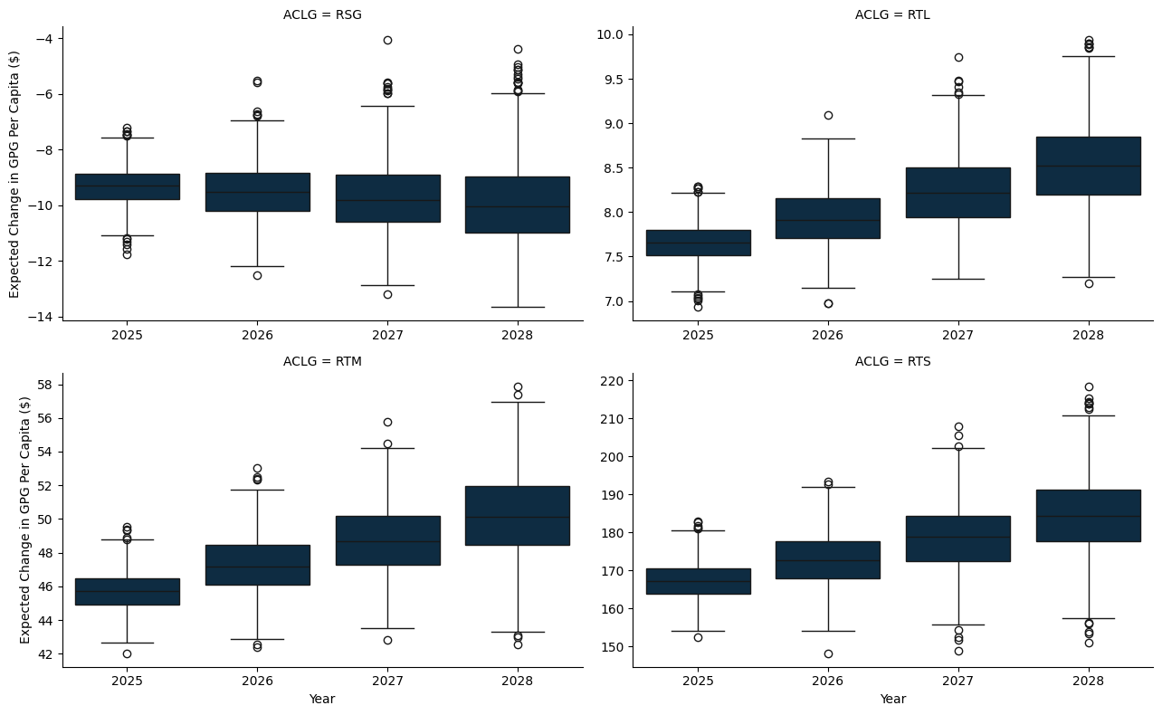

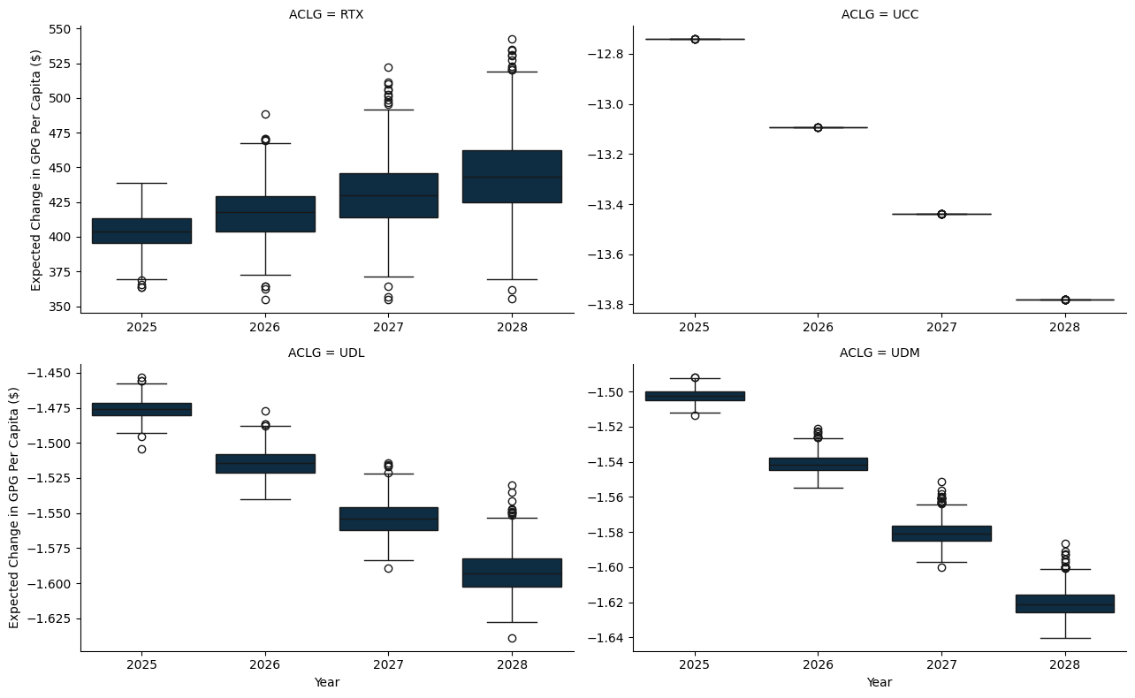

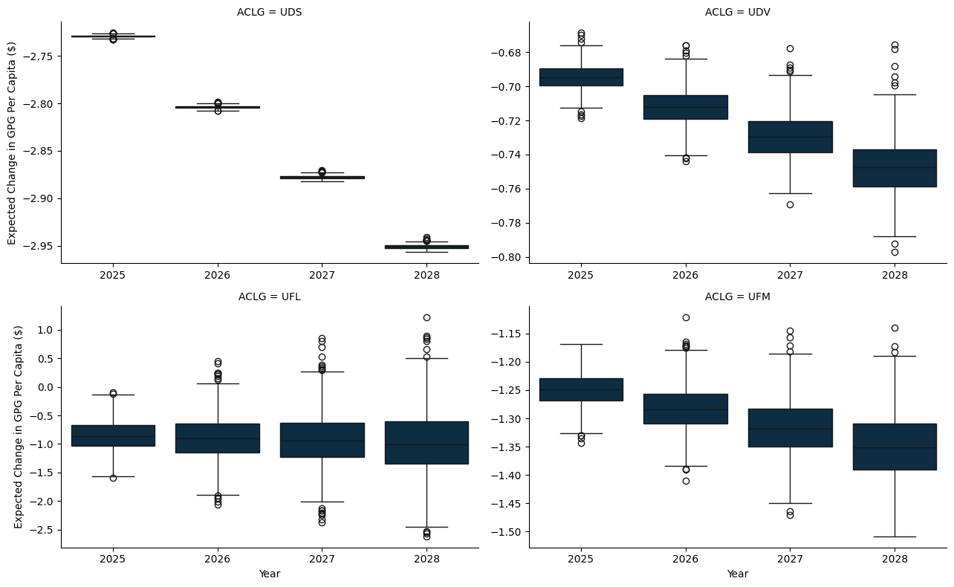

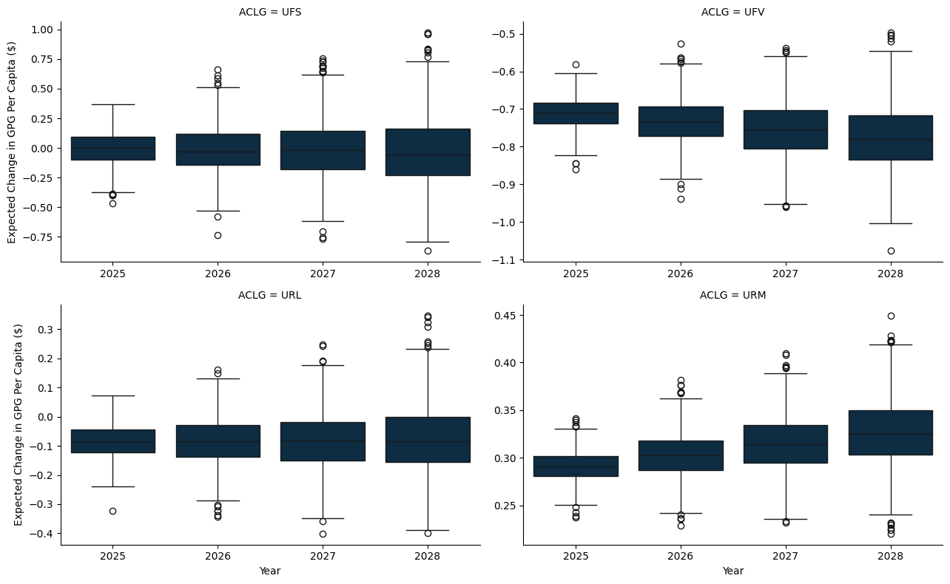

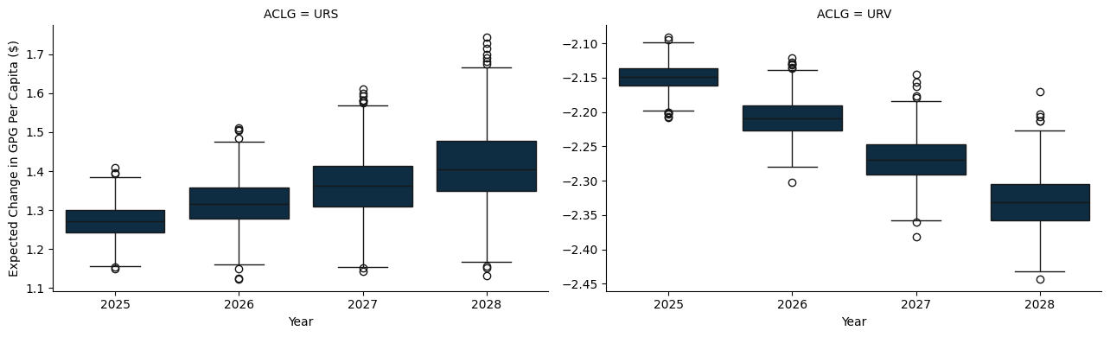

## G.1 A State and Territory breakdown

### G.1.1 New South Wales

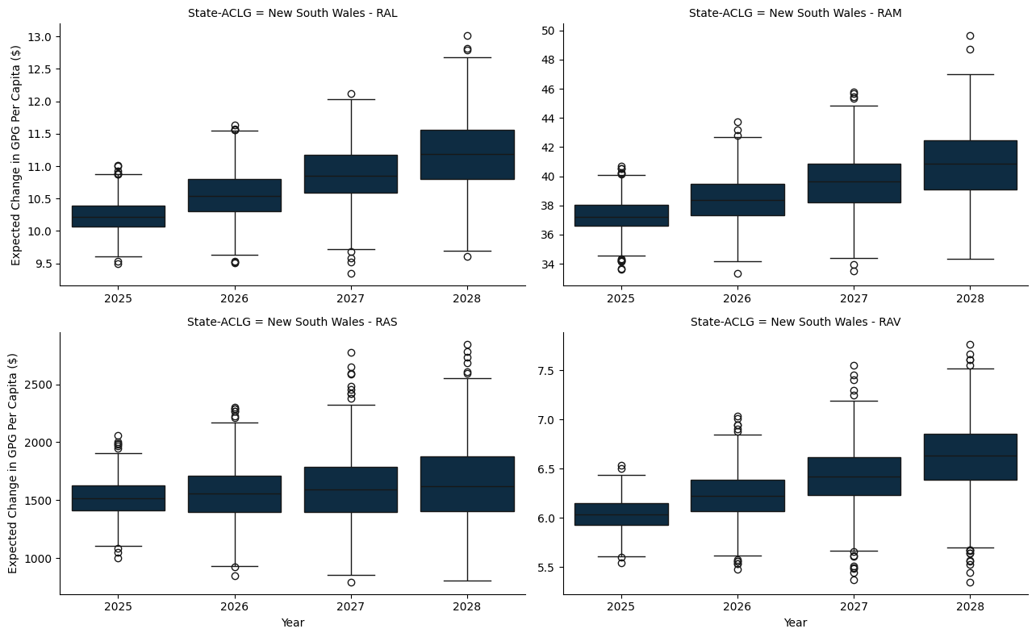

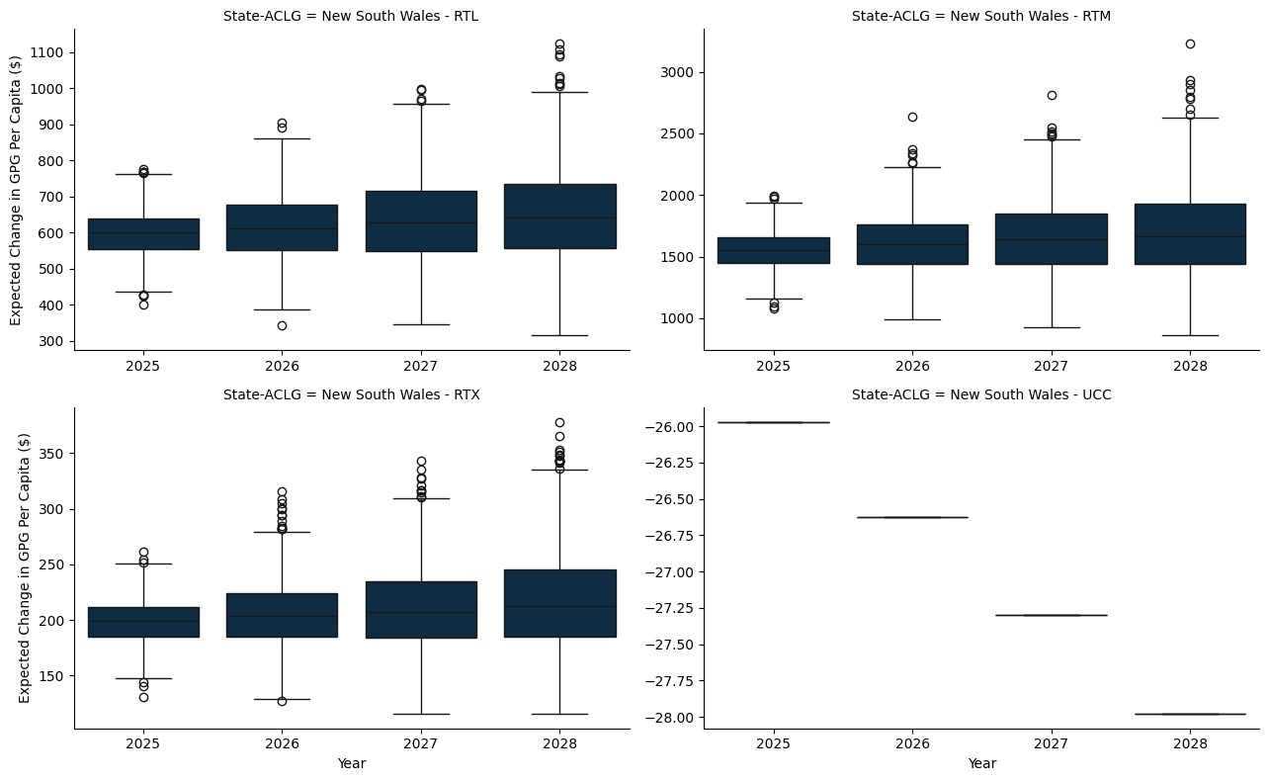

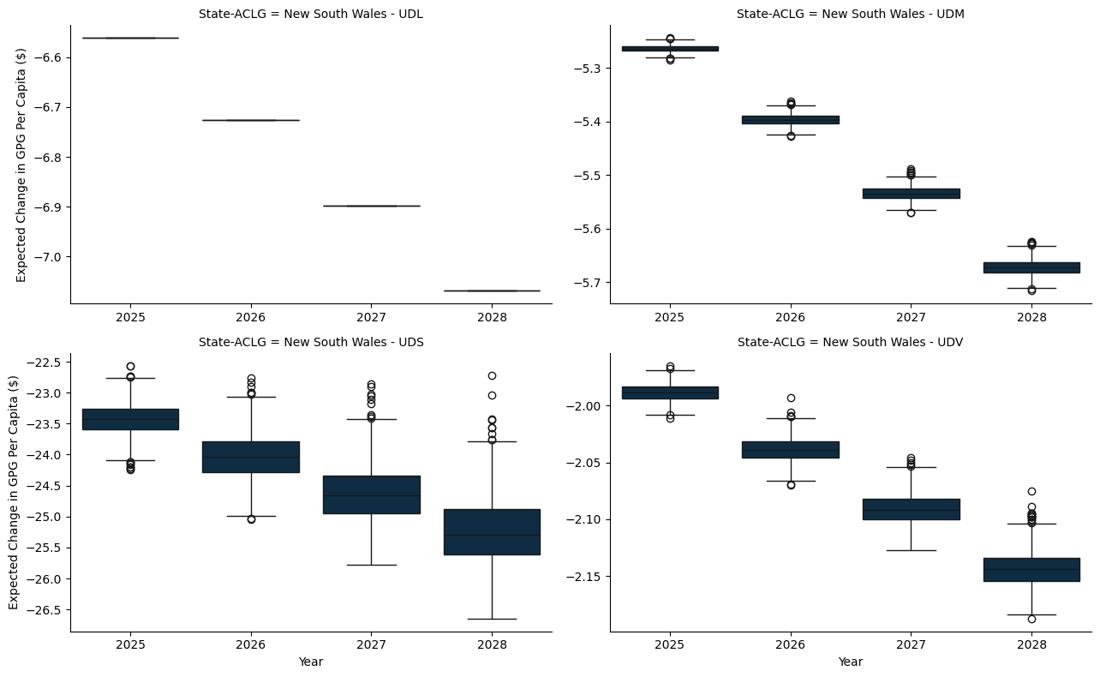

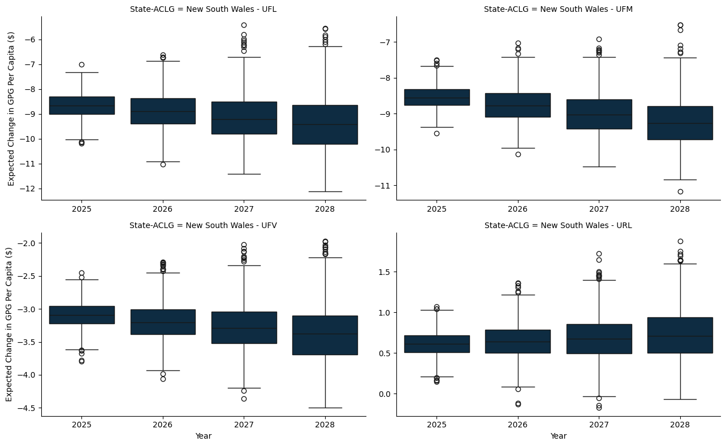

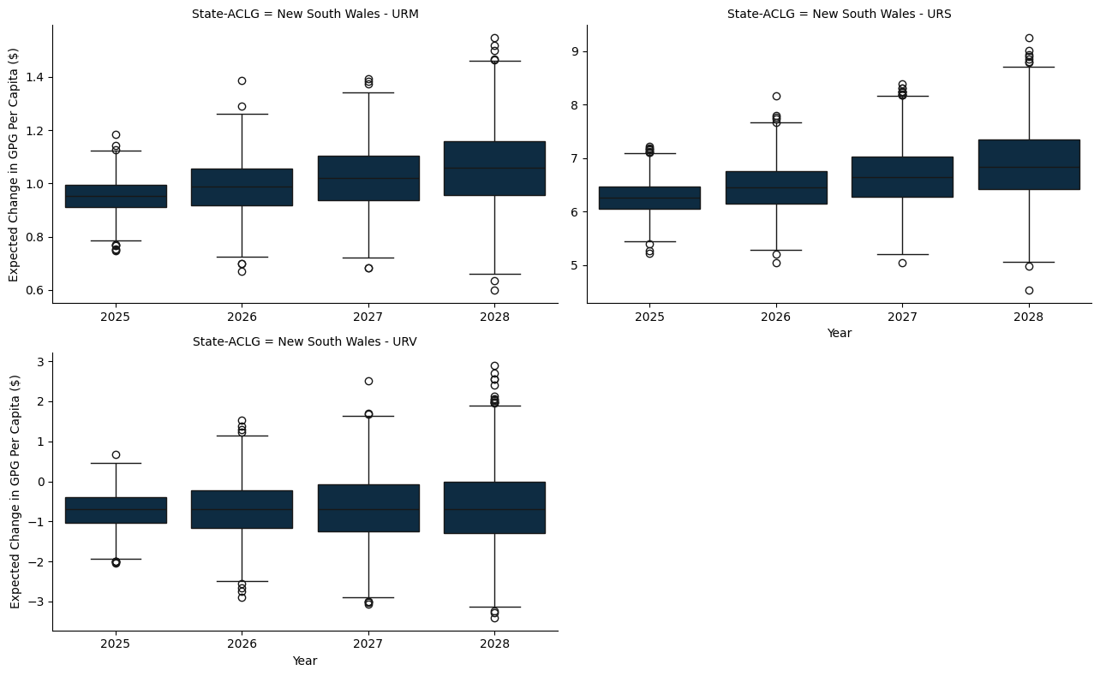

### G.1.2 Victoria

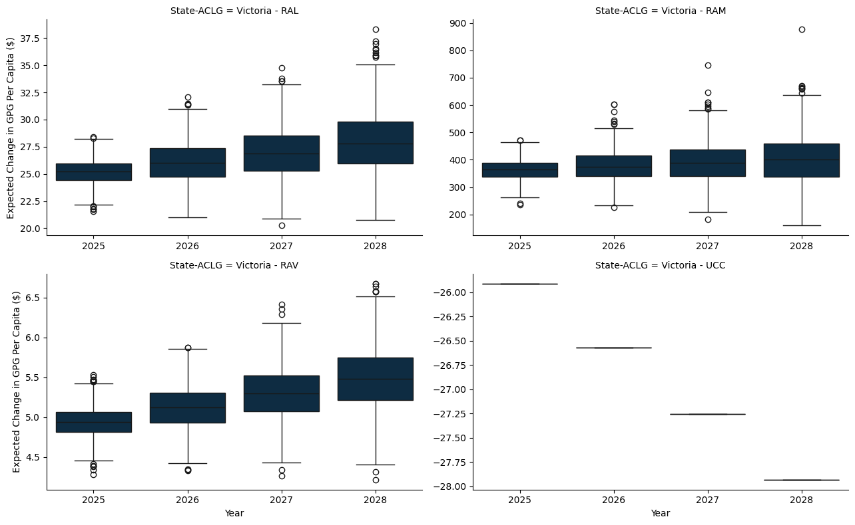

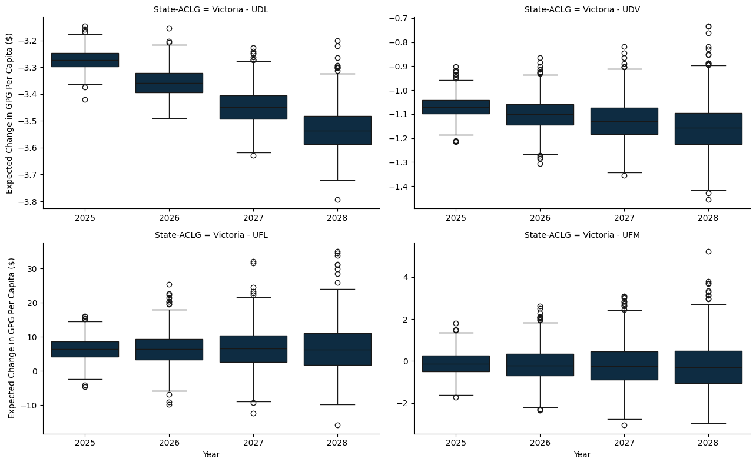

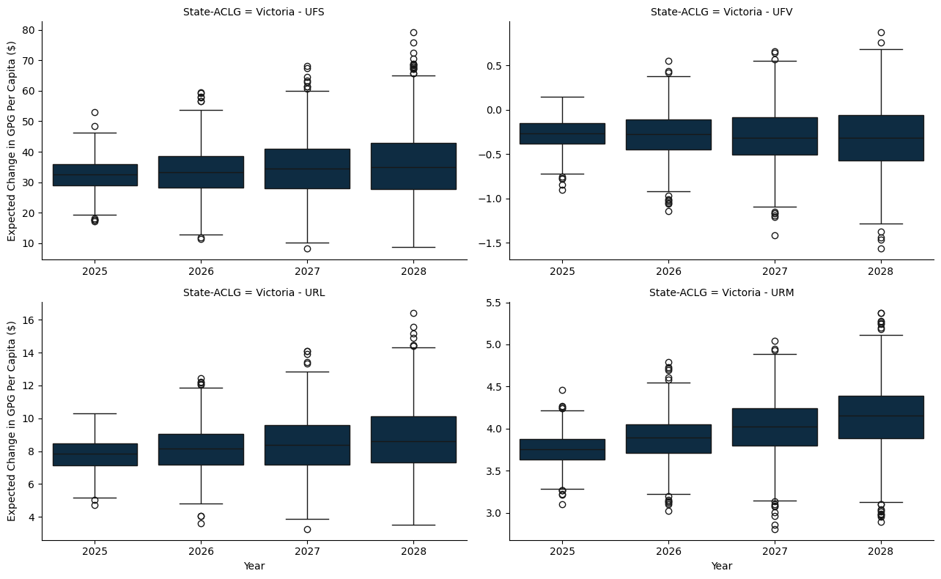

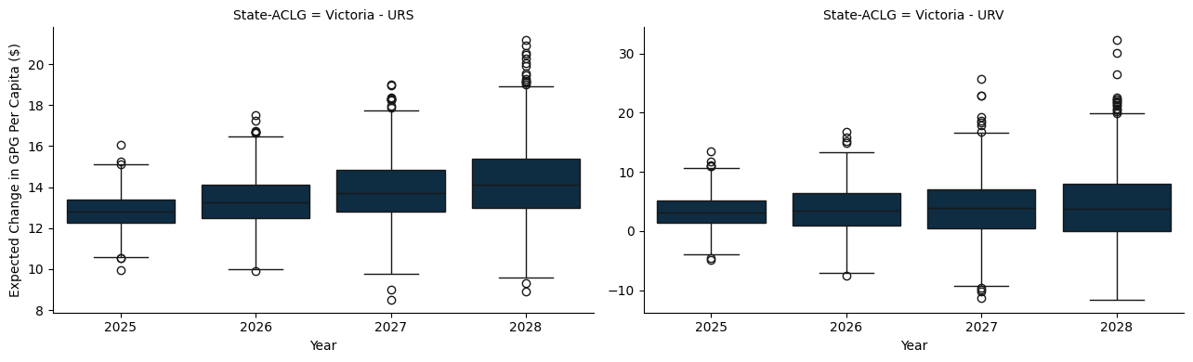

### G.1.3 Queensland

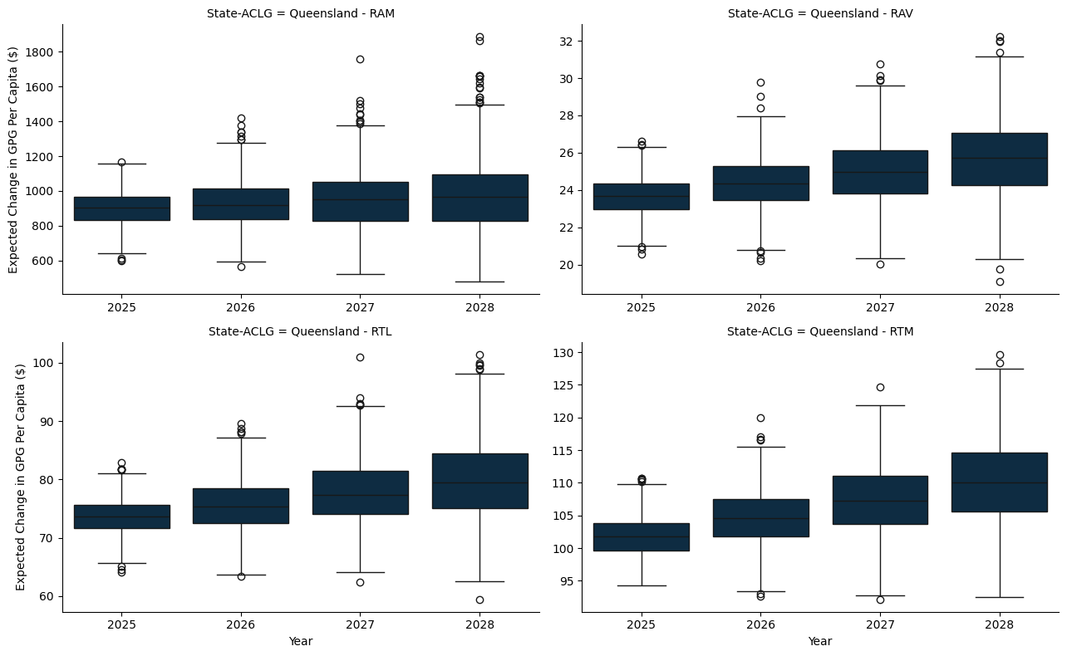

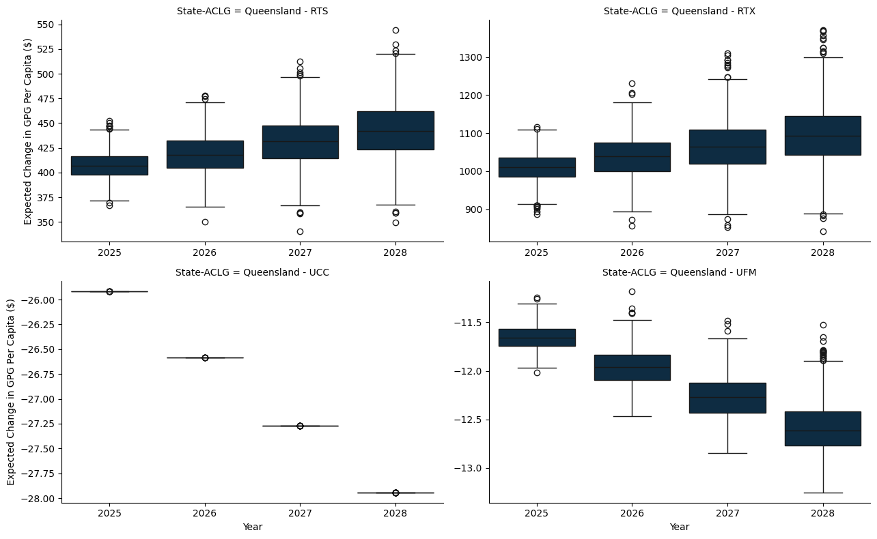

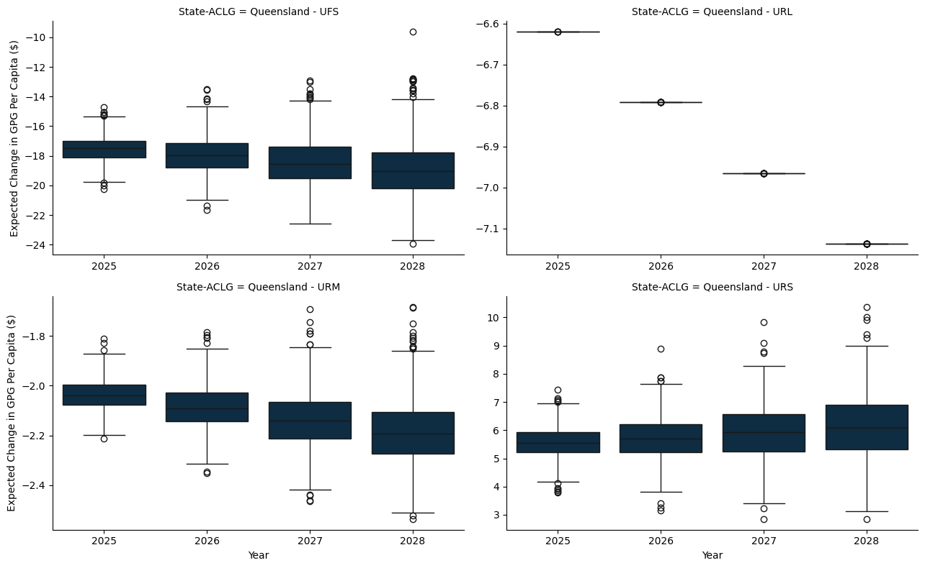

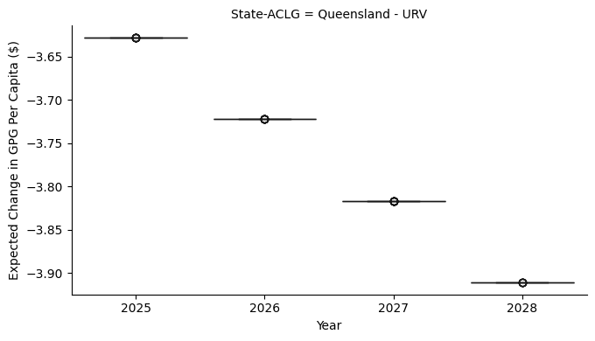

### G.1.4 South Austrlalia

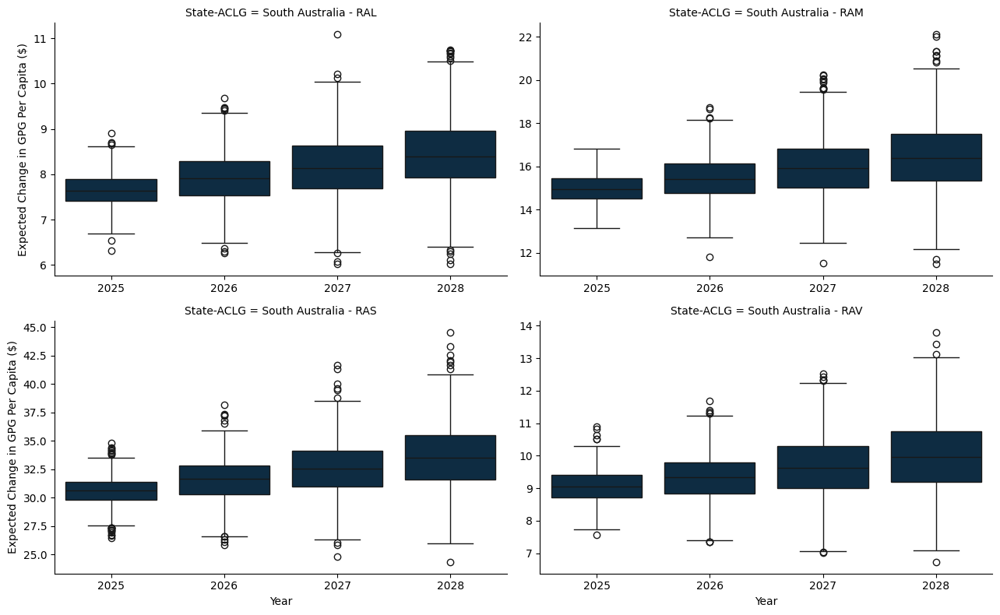

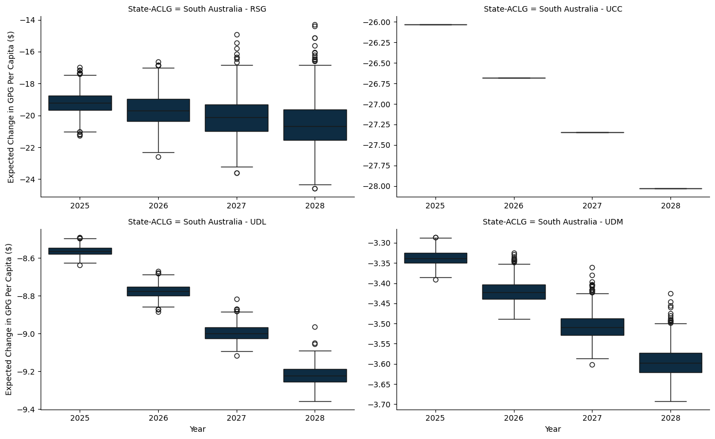

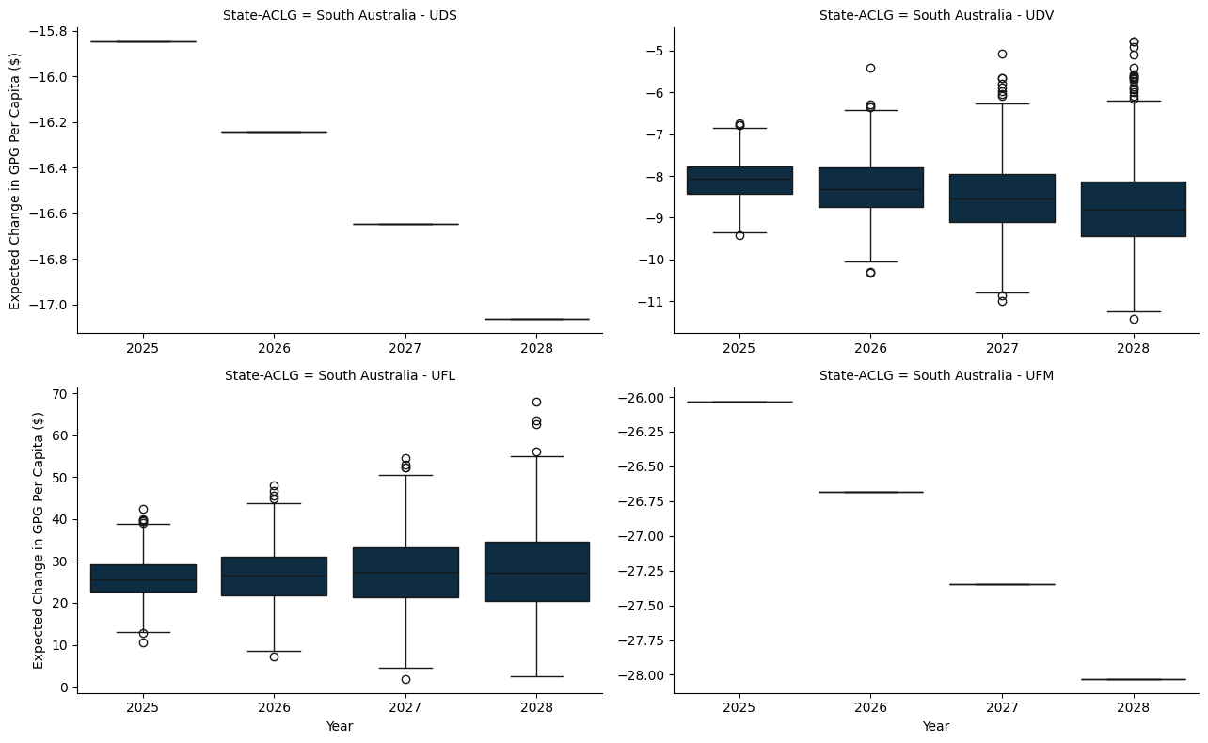

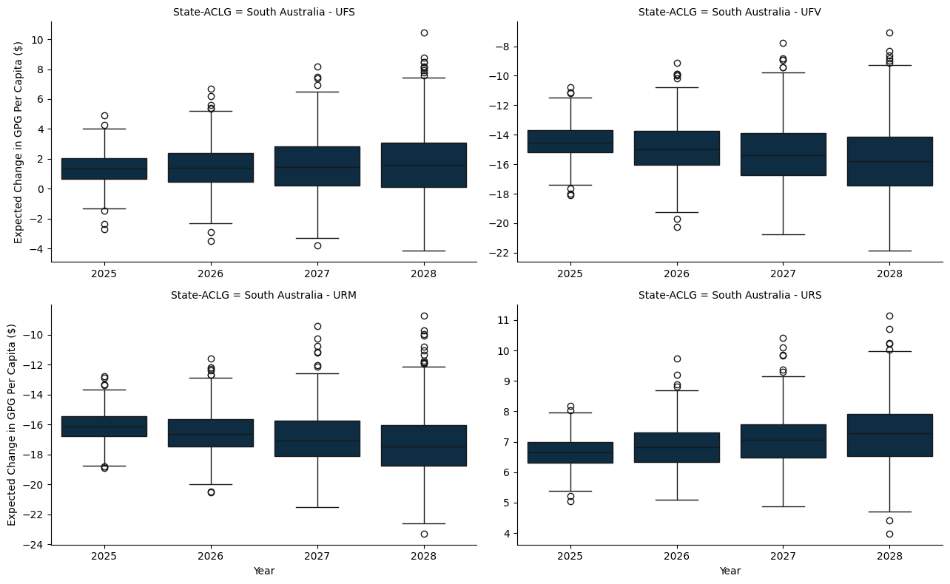

### G.1.5 Western Australia

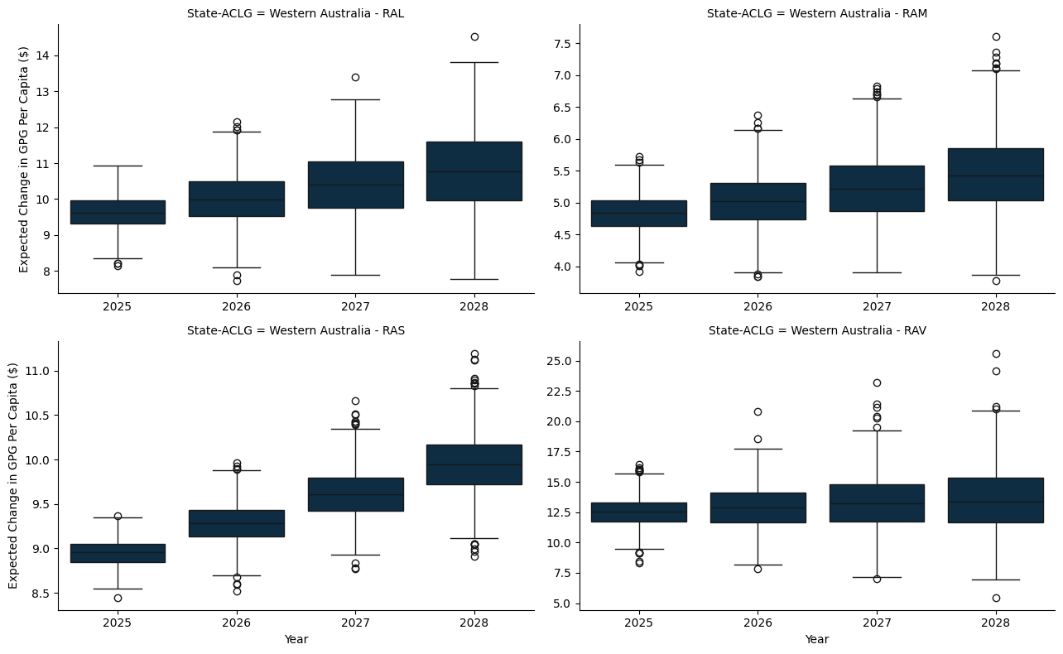

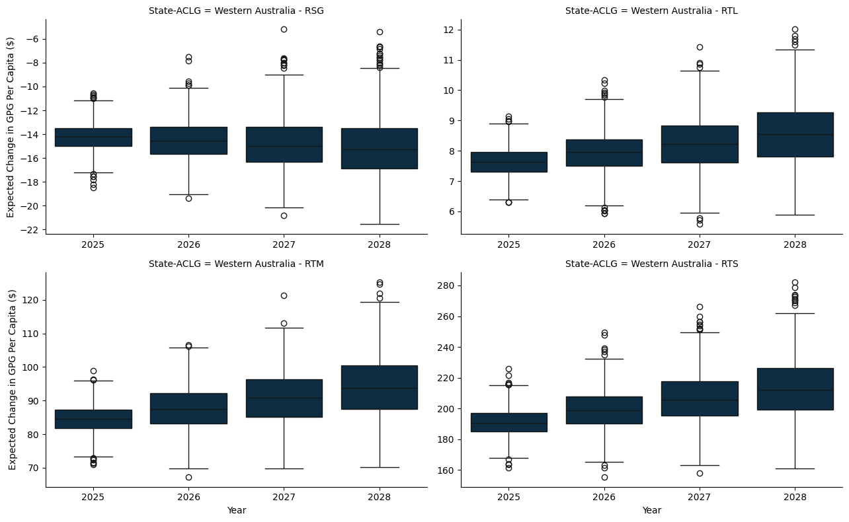

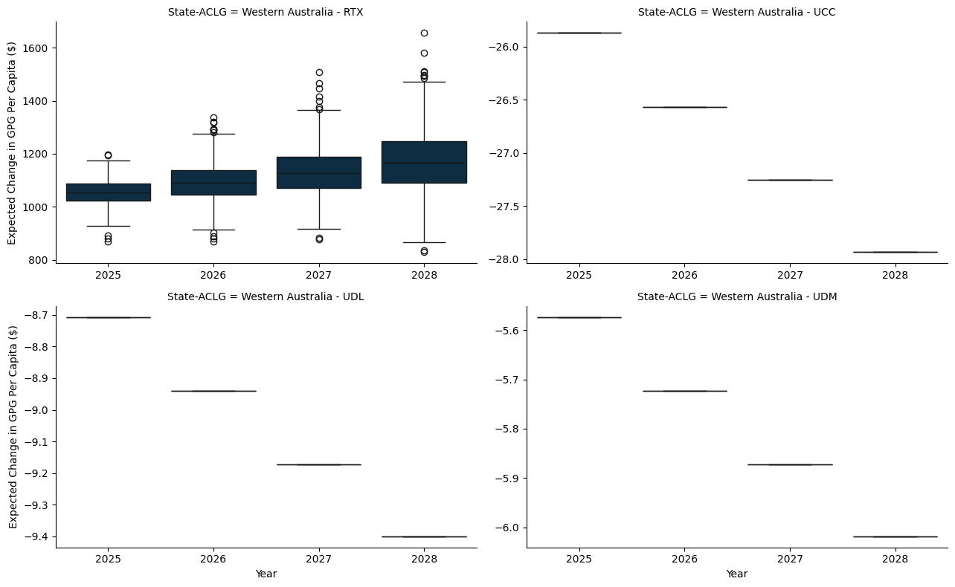

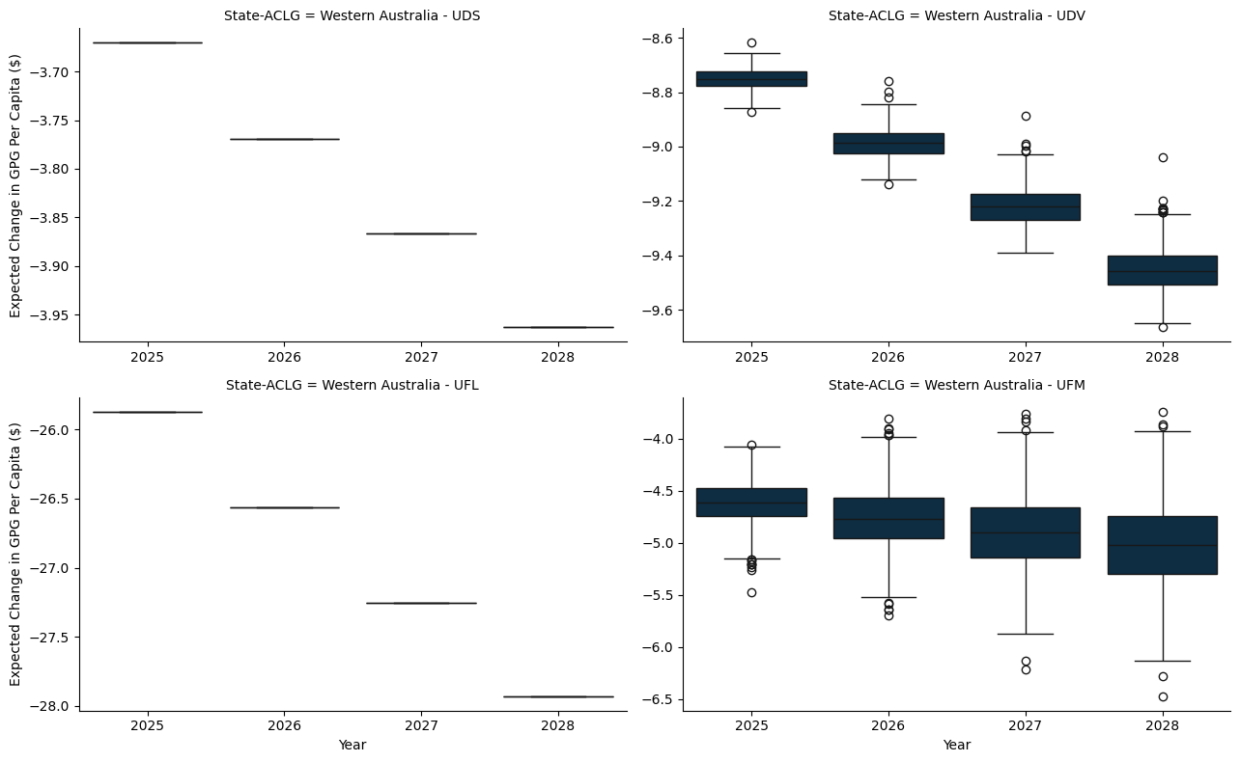

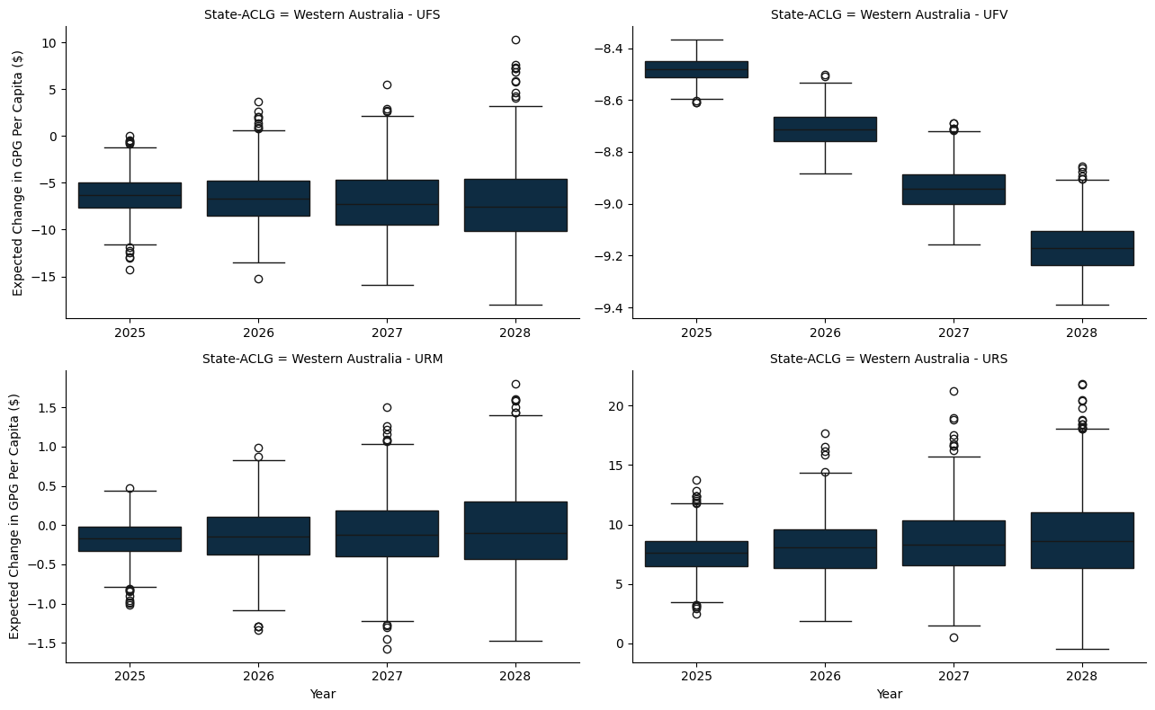

### G.1.6 Tasmania

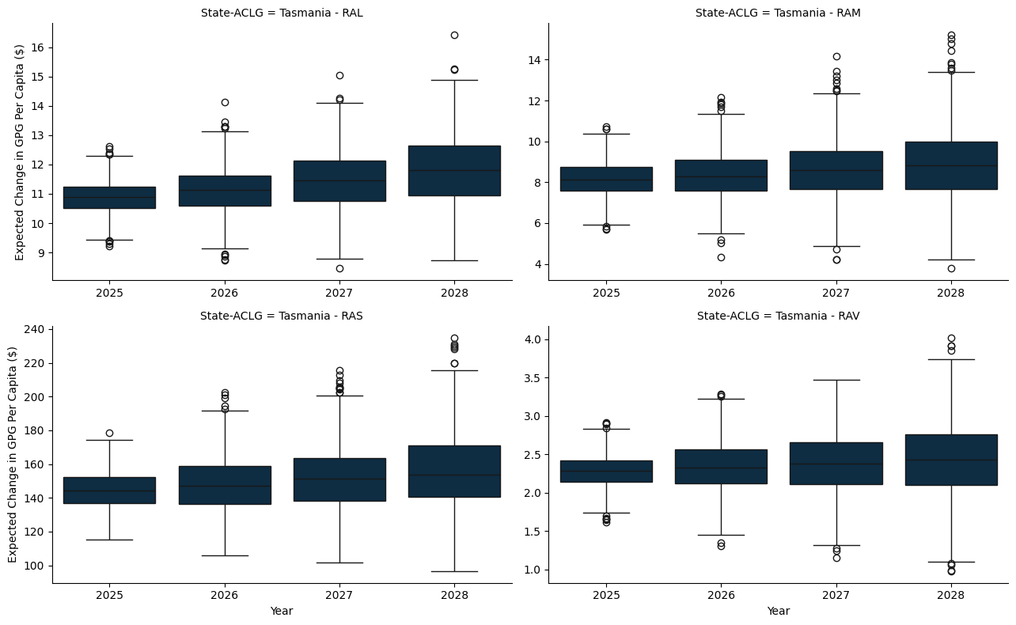

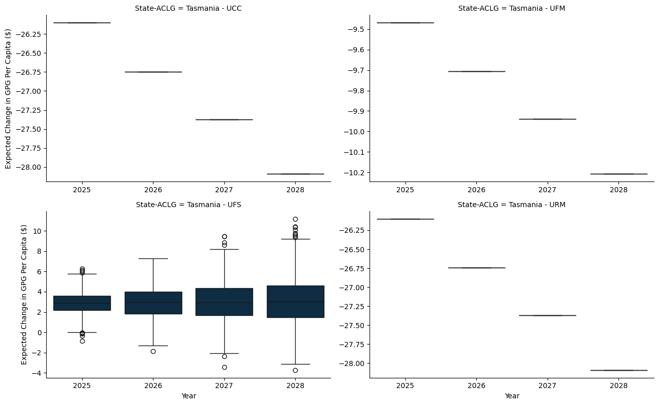

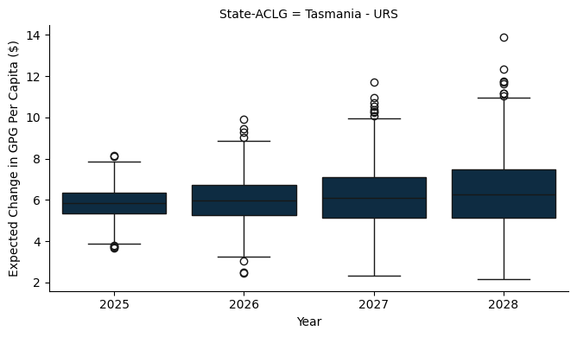

### G.1.7 Northern Territory

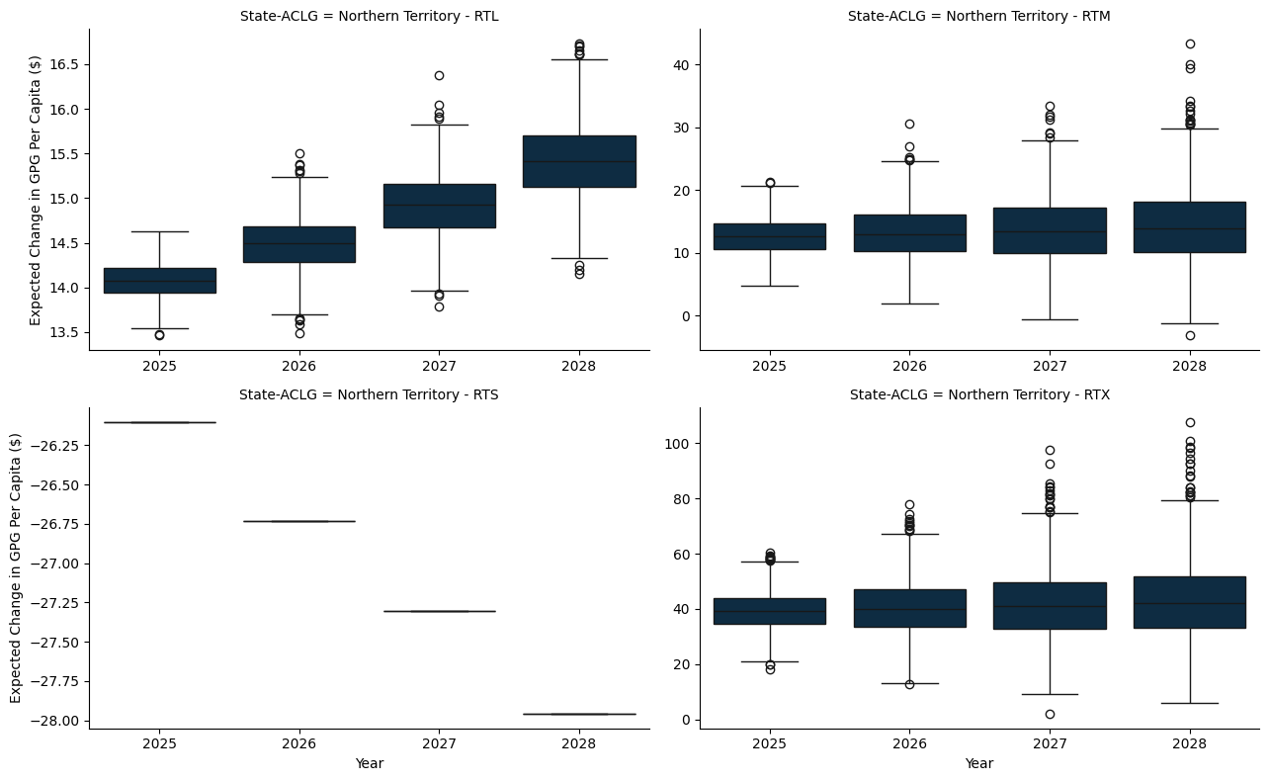

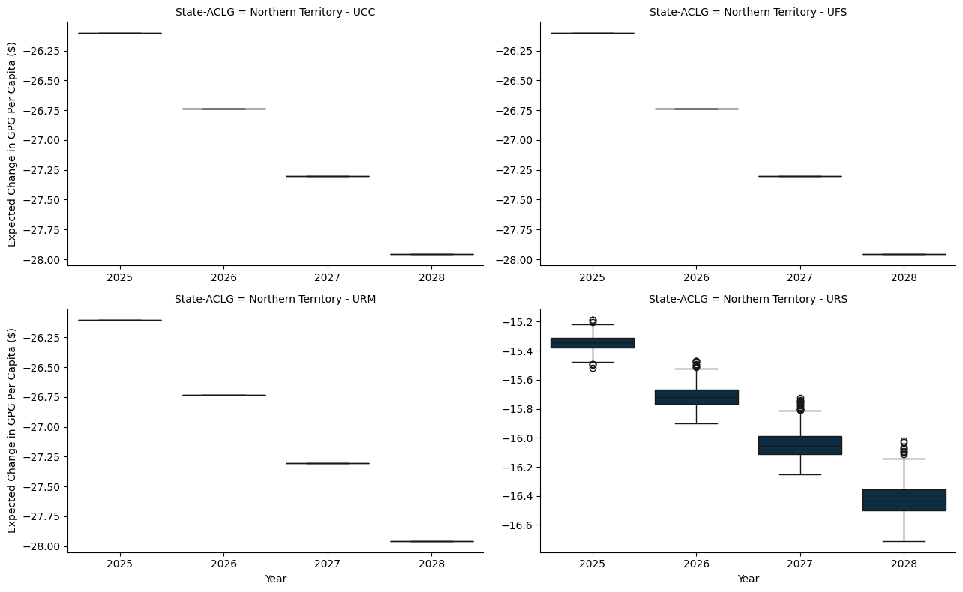

# Appendix H — A note on the Australian Classification of Local Government

| **Step 1** | **Step 2** | **Step 3** |  | **Category** | **Alpha** |
| --- | --- | --- | --- | --- | --- |
| **URBAN (U)** |  |  |  |  |  |
|  | Capital City (CC) | Not applicable |  | 1 | UCC |
| **Pop. > 20,000** | Metropolitan Developed (D) - Part of an urban centre > 1,000,000 and pop. density > 600/sq km. | Small (S) | up to 30,000 | 2 | UDS |
|  |  | Medium (M) | 30,001-70,000 | 3 | UDM |
|  |  | Large (L) | 70,001-120,000 | 4 | UDL |
|  |  | Very large (VL) | > 120,000 | 5 | UDV |
| **Pop. Density > 30 persons per sq km** | Regional Town/City (R) - Part of an urban centre with population <1,000,000 and predominantly urban in nature | Small | up to 30,000 | 6 | URS |
|  |  | Medium | 30,001-70,000 | 7 | URM |
|  |  | Large | 70,001-120,000 | 8 | URL |
|  |  | Very large | >120,001 | 9 | URV |
| **>90% of LGA population is urban** | Fringe (F) - A developing LGA on the margin of a developed or regional urban centre. | Small | up to 30,000 | 10 | UFS |
|  |  | Medium | 30,001-70,000 | 11 | UFM |
|  |  | Large | 70,001-120,000 | 12 | UFL |
|  |  | Very large | >120,001 | 13 | UFV |
| **RURAL (R)** |  |  |  |  |  |
|  | Significant Growth (SG) - Average annual Population growth > 3%, population > 5,000 and not remote. | Not applicable |  | 14 | RSG |
|  | Agricultural (A) | Small | Up to 2,000 | 15 | RAS |
|  |  | Medium | 2,001-5,000 | 16 | RAM |
|  |  | Large | 5,001,-10,000 | 17 | RAL |
|  |  | Very large | 10,001 to 20,000 | 18 | RAV |
|  | Remote (T) - Situated in a remote locality. | Extra small | Up to 400 | 19 | RTX |
|  |  | Small | 401-1,000 | 20 | RTS |
|  |  | Medium | 1,001–3,000 | 21 | RTM |
|  |  | Large | 3,001 to 20,000 | 22 | RTL |